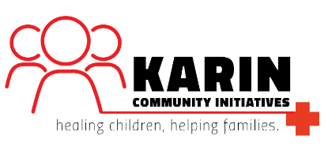

KARIN COMMUNITY INITIATIVES UGANDA
INFORMATION PACKAGE March 2015

Karin Community Initiatives Uganda (KCIU) (formerly Childcare Development Organisation Uganda) has been operating in Gulu District, Uganda since 2001. We are a local non-profit organisation seeking to improve the socio-economic wellbeing of vulnerable and orphaned children, families and the whole community through primary health care and other community development initiatives.

KCIU is best known for its establishment of the Karin Medical Centre (KMC) in the Unyama Parish, and the Agonga Karin Community Health Centre (AKCHC) in the Agonga Parish. These two centres form the basis of health care and community development services for approximately 21,000 people in an area devoid of any formal health care facilities.
With a total of 16 clinical and administrative staff, we are a compact organization with a tireless commitment to provide quality access to health care and livelihoods to families.

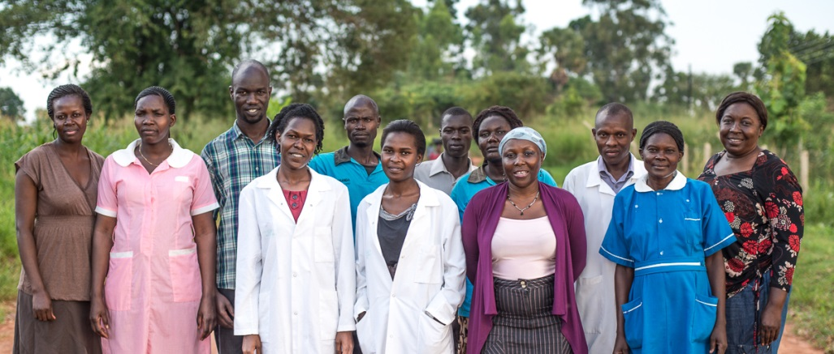

Mission

The overall mission of KCIU is to provide access to quality health care, sustained livelihood and to progressively realize and sustain an individual’s rights to survival, development, protection and participation.

Services we provide

Our services to the community have expanded exponentially over recent years. While we have always prioritized quality health care for children, we have now expanded our focus to include the whole family. In particular, we are providing:
- maternal and child health care services at both of our clinics;
- integrated outreach services in our communities; and
- general outpatient services to the adult population.

We also have other projects that have created livelihood options for rural families:
- Savings and microfinance schemes for women in the community; and
- Dairy farmers program to produce milk for consumption and trade

These projects work together to form our multi-faceted approach to health and development issues within the community.
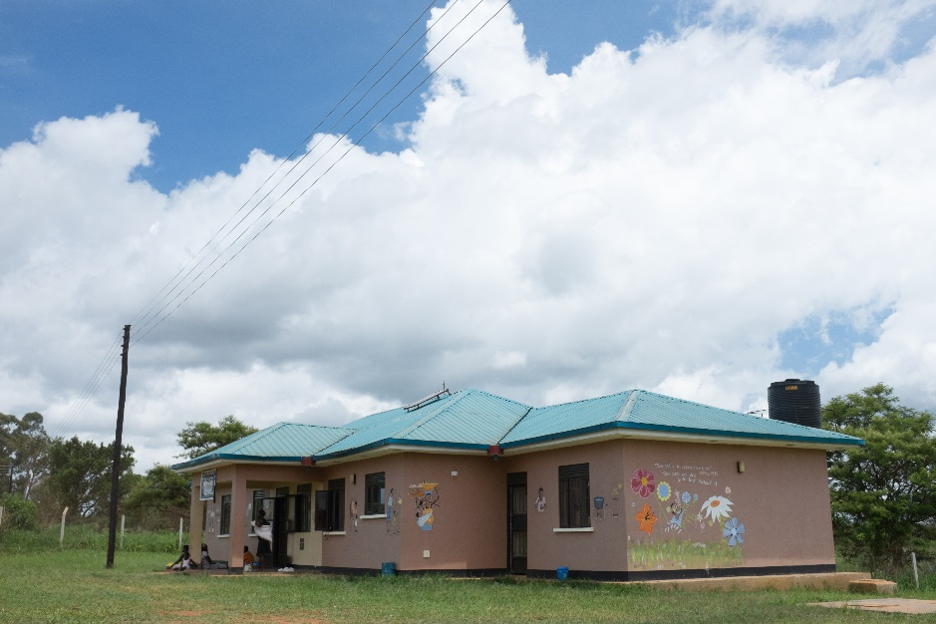
Agonga Karin Community Health Centre

This expansion of services has required the dedication of our development partners through technical and financial support, for which we are exceedingly thankful, especially during these times of global economic challenges. Our accomplishments also are attributed to the insightful leadership from the Board of Directors, our partners and key stakeholders.
KCIU works with all its partners towards the attainment of the Millennium Development Goals and aligns its priorities with the Government priorities of the Health Sector Strategic Plan II (HSSP II) and the National Development Plan and the Peace, Recovery and Development Plan (PRDP) for Northern Uganda.

The HSSP II defines the Uganda National Minimum Health Care Package (UNMHCP) and its four clusters namely:
- Health promotion, Disease Prevention and Community Health Initiatives;
- Maternal and Child Health;
- Prevention and Control of Communicable Diseases; and
- Prevention and control of Non-communicable Diseases (NCD).

Set out below is a brief summary highlighting our current services, classified per the four clusters of the UNMHCP.

Health promotion, Disease Prevention and Community Health Initiatives

Increasing health awareness and promoting community participation and utilization of health services

- Clients can come to our medical centres and receive curative care covering wide ranging conditions such as malaria, pneumonia, intestinal worms, skin conditions, urinary tract infections, acute respiratory infections, acute diarrhoea and the common cold. We also provide treatment for physical traumas.
- On specified days, we educate clients on health issues and illness prevention.
- Prices for services are set extremely low to enable general access from the community which lives off less than $1 USD a day.

Engaging Village Health Teams (VHT) to increase awareness and service outreach

- We acknowledge the significance of VHT participation as they form the key link between local communities and formal health facilities.
- Our outreach program takes our staff into local villages to provide curative and preventative health care.
- VHT’s combined with our outreach programs are a vital way of engaging the community in all aspects of health care. People are encouraged to use all services provided by at the time of visiting, and are recommended to visit KMC and AKCHC.
- We have outreaches every week in different villages of the parish where we provide outpatient services.

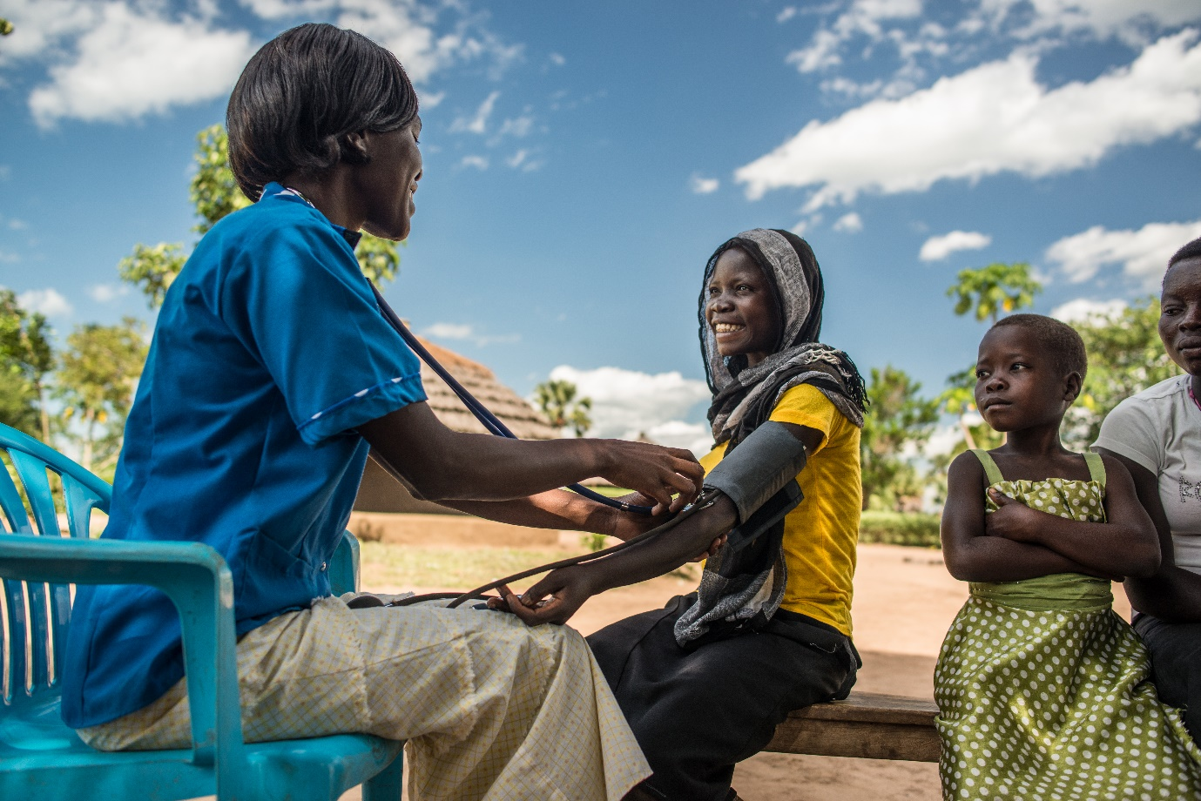
Village outreach program in action

Deliver basic health and nutrition services education:

- Our dairy farm project, in partnership with “Milk Matters Limited” currently works with local farmers to produce and sell milk to Gulu and the surrounding district area.
  - The project is training local small scale dairy farmers on improved dairy management and nutrition. The project encourages people about the benefits of drinking milk or yoghurt, and encouraged to make it part of their diet.
  - Based in Gulu town, Milk Matters creates a market for local farmers who do not have the scale to sell directly to the community. Through our presence, farmers are able to make a living through their milk, and the community is able to benefit from low cost milk products.
  - Milk products include pasteurized or non-pasteurized milk, and flavoured yoghurt.

Maternal and child health

Extensive Immunization program

- We run an extensive immunization program for mothers and new born children. Maternal and child health conditions carry the highest total burden of disease in Uganda with perinatal and maternal conditions accounting for 20.4%. It is one of our core goals to reduce this burden.

Rolling out Sexual and reproductive health interventions (SRU)

- Antenatal Care core interventions have been rolled out in the facilities, however we wish to increase numbers and promote increased use of post natal care.
- Sexual and reproductive health (SRU) interventions especially for the youth groups will reduce the burden especially for young girls have due to sexually transmitted diseases that see them dropping out of school.

Promoting family planning methods across the community

- Family planning is the process of controlling the number of children in a family and the intervals between births, particularly by means of artificial contraception or voluntary sterilization. We try to attend to as many families as possible through VHT outreach programs and asking them to come in to the clinic for a consultation.
- Women are encouraged to bring along their partners, and are given the option of various contractive products: implants, IUCD, condoms, and contraceptive pills.
- Mothers are beginning to understand the importance of family planning and now have confidence in using long term methods since they will be attended to in the event of any concerns.

Communicable disease control

Testing and Treatment for HIV/AIDS

- HIV/AIDS continues to have a high prevalence in the surrounding area.
- We have established reputable testing and counselling services at the health facilities for both expectant mothers and couples seeking HCT service.

Testing and Treatment for Malaria, Tuberculosis and other communicable diseases

- Malaria remains one of the most important diseases in Uganda in terms of morbidity, mortality and economic burden. It is a major risk factor for children under 5 years old.
- We have a laboratory facility that provides testing and treatment services for malaria and other communicable diseases.
- With partner support, we have implemented the distribution of Long Lasting Insecticide treated Nets (LLINs) and ensured early and effective case management, both of which are effective in reducing the number of malaria outpatient cases.
- Through VHT and outreach programs we educate the community on prevention of malaria and other communicable diseases.

Prevention and control of non-communicable diseases

There is an increasing number of patients attending to the clinic with hypertensive cases and diabetes. With most of them being vulnerable and elderly, they only visit the clinic when they are extremely sick. The challenges that most of them have is the cost of medical fees, driving them to succumb to pain and misery. However, health education and providing medicines to this vulnerable group can improve their quality of life.

In addition to the growth that KCIU is experiencing, technical expertise is therefore, inherent within the organisation for project planning, implementation, training and mentoring, monitoring and evaluation and financial management.

Future Outlook

We plan to implement a number of exciting new programs in the short to medium term.

Completion of the maternity ward at Agonga Karin Ccommunity Health Centre(AKCHC) and the Construction of out-patient and maternity wards at Karin Medical Centre-Unyama (KMC).

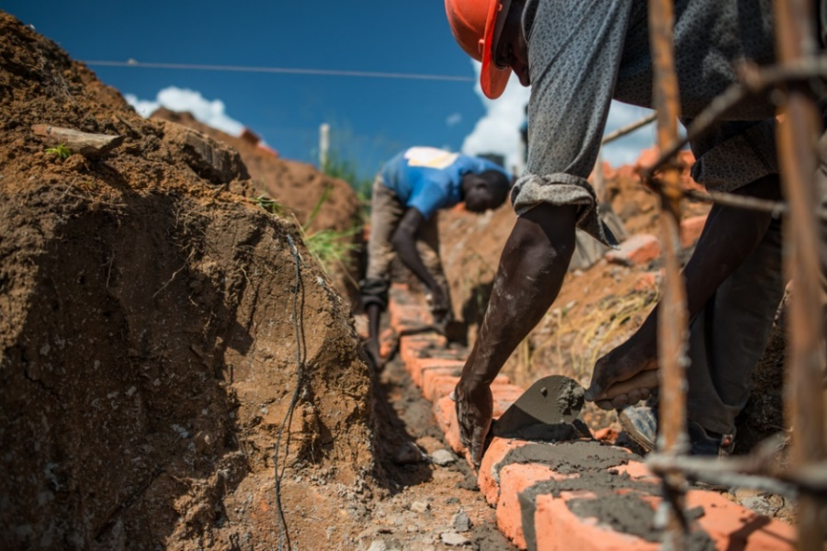
The maternity centres will enable mothers in hard to reach areas to access these services. While we do provide antenatal and post-natal services, there is a pressing need for dedicated health facilities to assist women during child birth and care for their new born children.

Laying the foundation for the construction of the maternity wards

Enabling peer support among pregnant and post natal mothers.

This is a basic health and nutrition program that can be delivered at the clinic and through the VHT’s especially for expectant mothers. The clubs meet monthly to hold dialogue on pregnancy, nutrition and health, hygiene and sanitation, welfare of their children and household members facilitated by VHTs. This program will be incorporated with life skills activities for children.

Final Word

As can be seen, KCIU is dedicated to servicing the surrounding community through a variety of integrated and connected programs. We recognise that no single solution can be used to deal with the multitude of issues that people face in the area.

We are proud of the diversity of services that we have been able to provide since our inception in 2001. Growing from helping people trapped by a senseless war, we are committed to rebuilding the community that still desperately needs our services.

There is so much potential for growth and development in the area, and we are always open to developing new partnerships that can help us move forward. In particular, we greatly appreciate the guidance of external expertise that can provide the catalyst for new and exciting developments. We are flexible and always on the look-out for new initiatives.

Thank you for taking the time to read about our organisation, we hope that you have enjoyed learning about what we do. If you wish to know more detail about any other aspect of our organisation, please do not hesitate to contact us.

With God’s Blessing,

Mrs. Hope Okeny

