KARIN COMMUNITY INITIATIVE UGANDA (KCIU)
OUTREACH REPORT
Project Title: Mobile Clinic for Rural Health Access – “Care for All” Initiative
Reporting Period: January - November 2025
Compiled by: Programs Department
1. Executive Summary
Between January and November 2025, Karin Community Initiative Uganda (KCIU) conducted a series of mobile clinic outreaches across rural villages in Northern Uganda. These outreaches successfully brought essential healthcare closer to underserved communities, providing general medical care, maternal and child health services, immunizations, and health education directly to their doorsteps.
A total of 650 beneficiaries were served directly through these sessions. Despite logistical challenges such as limited transport and bad weather, the program continues to make a measurable impact in improving access to primary healthcare and fostering community health awareness.
2. Background
Many rural communities in Northern Uganda still face serious barriers to healthcare due to long distances, poor road networks, and poverty. In response, KCIU launched the “Care for All” Mobile Clinic Initiative — a fully equipped health unit on wheels that travels to underserved villages, delivering comprehensive healthcare services.
The project has a total fundraising goal of $93,053, with $54,628 remaining, supported by 151 donors and 3 fundraisers.
Challenges during this reporting period included:
- Bad weather affecting turnout.
- Limited transport (only one motorcycle available).
- Budget constraints reducing coverage.
- Poor road access in remote areas.
- High facilitation expectations from field staff.

Location / Village | Services Provided | No. of Beneficiaries
Bungatira Primary School | Immunization, free consultation, eye and dental care, ANC, PNC, HIV testing, Health education, malaria screening and treatment | 143
Awonyim Cuk Wot Tek |  | 245
Bungatira Central School |  | 81
Amoyokoma Junction |  | 36
Oding |  | 35
Olano |  | 110
 | Total | 650

3. Objectives of the Outreach
- Offer preventive and promotive health education.
- Deliver maternal, child, and reproductive health services.
- Strengthen community awareness and disease prevention.
- Build consistent linkages between KCIU clinics and the communities served.

4. Outreach Activities Conducted
Note: Specific service lists for locations other than Bungatira Primary School are to be confirmed. The provided summary of activities below reflects the general scope.

Summary of Activities:
- Conducted health education on hygiene, malaria prevention, and family planning.
- Provided immunization, antenatal care (ANC), and screening for common illnesses like malaria and HIV.
- Offered general medical consultations and treatment.
- Referred patients needing advanced care to partner health facilities.
5. Achievements and Results
- Multiple outreaches conducted in at least 6 villages.
- 650 people received direct medical services.
- Hundreds of children immunized against preventable diseases.
- Dozens of pregnant women received antenatal care and follow-up.
- Increased community participation and early health-seeking behavior.
- Strengthened collaboration with local leaders and Village Health Teams (VHTs).
6. Challenges
- Limited transport and fuel for field operations.
- Weather disruptions affecting access to outreach sites and turnout.
- Shortage of medical supplies and equipment.
- High patient turnout compared to available staff in some locations.
- Need for essential diagnostic tools (e.g., centrifuge, portable ultrasound).
7. Lessons Learned
- Community involvement and local leadership are crucial for effective mobilization.
- Integrating music, dance, and drama enhances participation during health education sessions.
- Early planning and coordination ensure smoother outreaches.
- Continuous monitoring strengthens service quality and accountability.
8. Recommendations
- Increase outreach frequency in hard-to-reach areas.
- Strengthen logistical support and staff facilitation.
- Procure additional diagnostic and medical equipment.
- Enhance collaboration with District Health Offices and VHTs.
- Mobilize additional funding to sustain and scale the mobile clinic project.

9. Conclusion
The KCIU Mobile Clinic continues to serve as a lifeline for remote communities in Northern Uganda. Through these outreaches, we have demonstrated that accessible healthcare can truly change lives. Reaching 650 beneficiaries in this period alone underscores the critical need and positive impact of this initiative. With continued donor support, KCIU remains committed to ensuring that “Care for All” becomes a lasting reality for everyone, everywhere.
10. Annexes
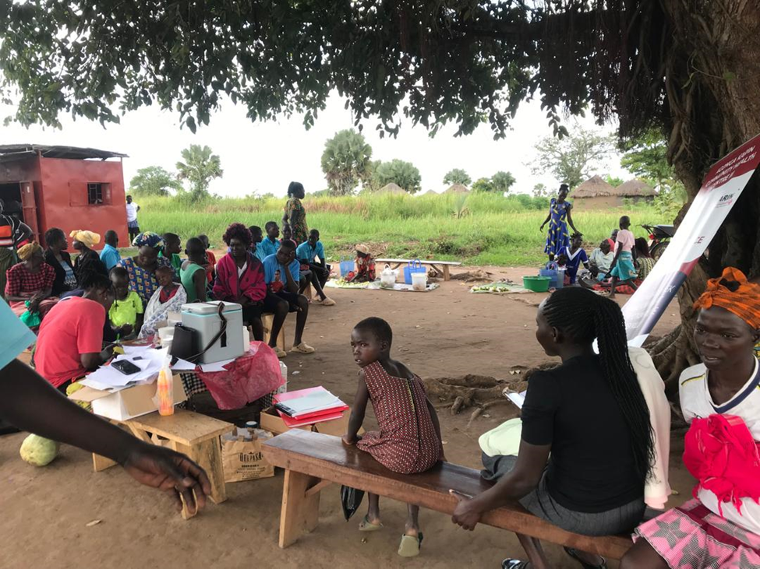

Integrated outreach in Awonyim village; immunization, malaria testing and treatment, health education were conducted
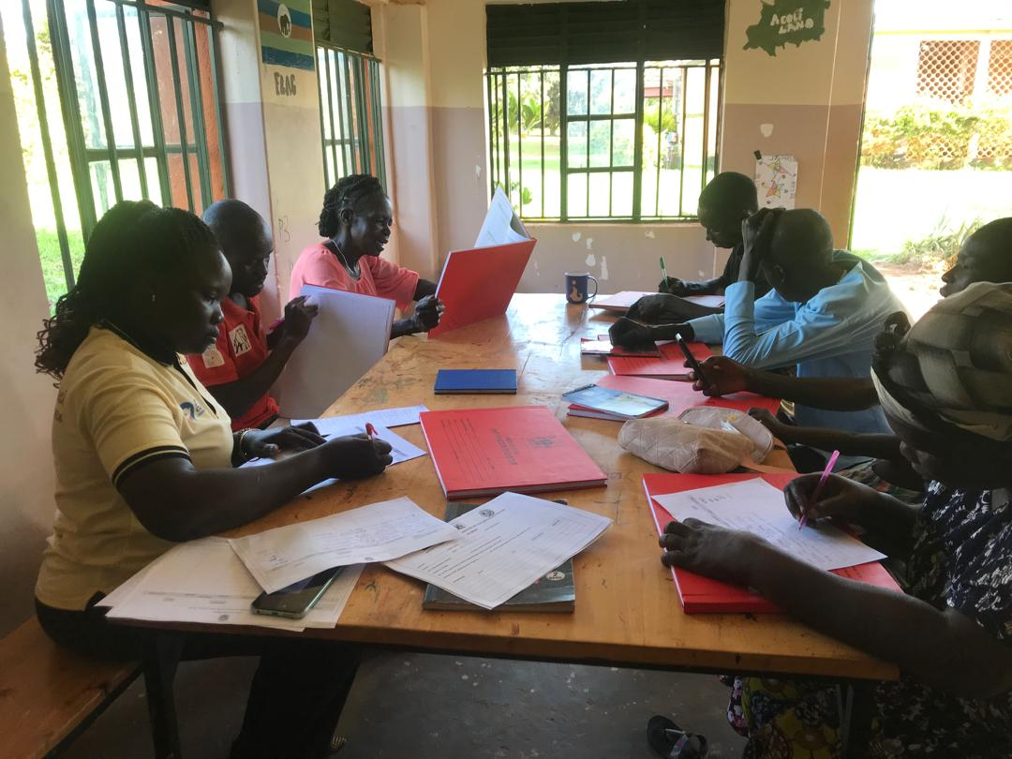
The VHT quarterly meeting session: meeting focused on equipping members with new reporting tools and reviewing impact reports generated from their recent community engagements.

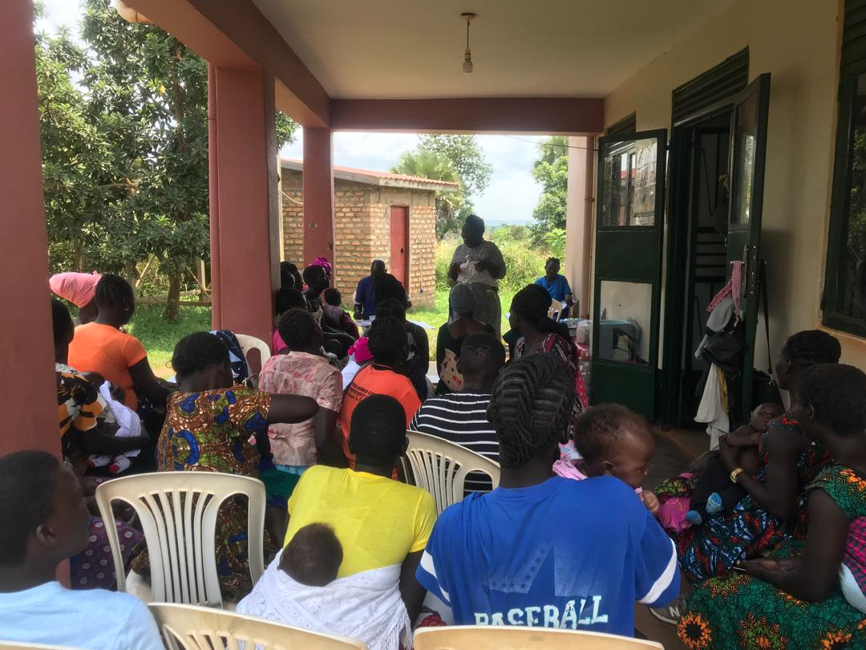

A Mother sharing knowledge to fellows on how to use condoms, during health education session

