Bringing Healthcare to Their Doorstep
Mobile Clinics and Community Outreach: 2026 Project Update
Karin Community Initiative Uganda (KCIU)

In Northern Uganda, the nearest health center can be hours away on foot, and even a short trip by transport can cost more than a family can spare. Karin Community Initiative Uganda (KCIU) is closing that gap by taking care directly to the communities that need it most.

Impact at a Glance
50+  outreach activities |  | 12  villages reached |  | 600+  community members served

Services provided included general consultations, malaria and HIV testing, STI and typhoid screening, blood pressure checks, health education, referrals, and linkage to continued care.
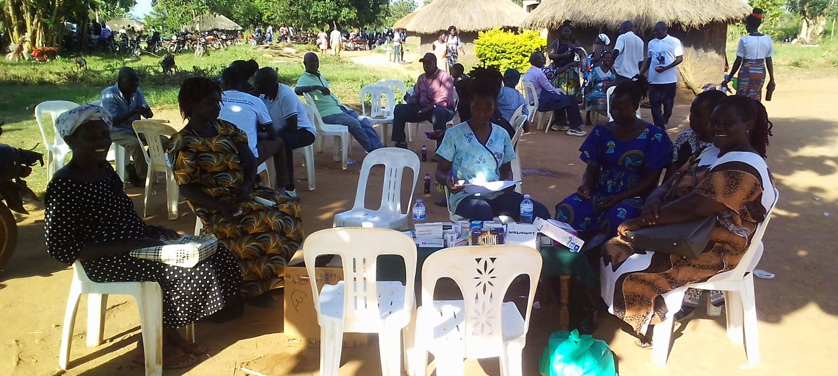

Why Mobile Clinics Matter
Many rural communities live far from the nearest health facility, and some villages have little or no access to essential services. Transport costs add a further barrier. The people most affected are:
- Older people who cannot make long journeys
- People with disabilities who need physical support to travel.
- Low-income families who cannot afford transport or time away from work
Mobile clinics remove these obstacles by meeting people where they live. They allow illness to be identified early, provide basic treatment and screening, offer referrals for further care, and bring health education directly to families.

Community Spotlight: Lutuk Village
Lutuk Village shows why this work matters. Nearby health facilities are limited, and residents would otherwise have to travel further to be seen. Through mobile outreach, KCIU brings both services and information to their door.
The visits do more than treat individual patients. Health workers use them to engage the wider community, hold health talks, answer questions, and strengthen understanding of prevention and early treatment. In this way, care and knowledge reach people who might otherwise be left behind.
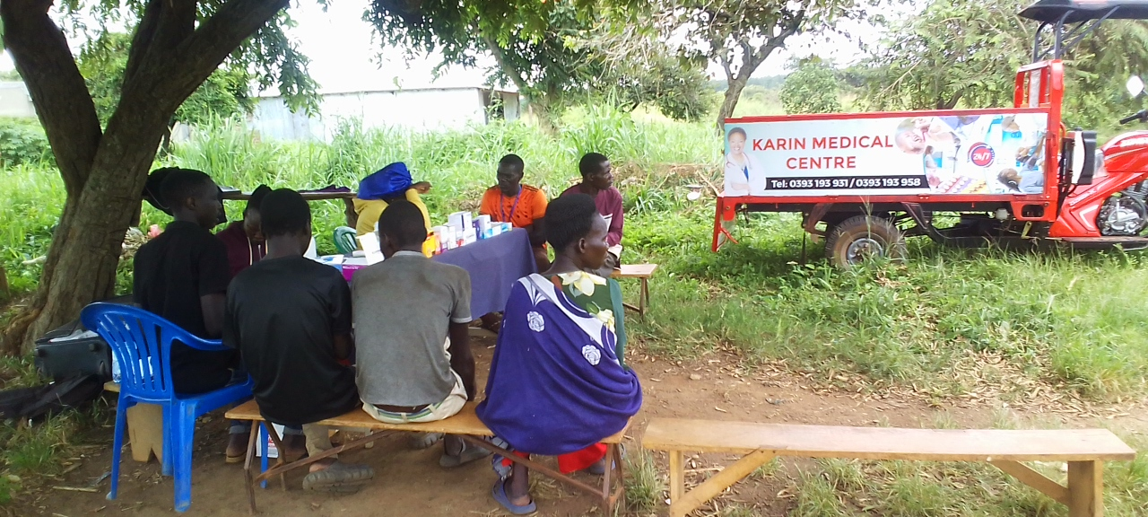

Thanks to You: A New Tuk-Tuk
Because of your generosity, KCIU has acquired a tuk-tuk tricycle for our mobile clinic work. It has strengthened our ability to reach villages far from established health facilities and gives us a practical foundation for growing this vital arm of our healthcare delivery. Thank you.
Looking Ahead
Our goal is to visit more villages, and to return to each more often, so that both essential services and health education are within easy reach of every household we serve. Growth will depend on continued support for:

- Transport facilitation
- Fuel
- Medicines
- Outreach supplies
- Other operational costs

With your sustained partnership, we can extend mobile clinics to more underserved communities and make sure that distance, disability, or limited household resources never stand between a person and the care they need.

Stand with us. Help us bring healthcare to every doorstep.

