amHealth Pilot Project
Greetings from Healthstore!
After a long process of searching for an EMR to suit our needs of digitizing our clinical operations, we have been able to settle on amHealth, a practice management and patient engagement solution that improves reliability and efficiency in healthcare. It helps create and improve the patient-clinician relationships for improved health outcomes that we need at the primary care level.
CFW clinics has adopted amHealth for a 10 week trial period in 8 clinics across Western, Nyanza, Central and Nairobi regions. Training was carried out in a span of two weeks where users at the clinics had a whole day hands-on training with on-site follow up visits by the trainers in each of the clinics. A total of 16 users were trained on using amHealth.
The clinics use all features of amHealth - patient record management, appointment calendar, walk-in queue, check-in and out and group and individual messaging to patients. In two weeks, 2,071 patients have been registered in the system across the select clinics, over 2000 messages sent out to patients in form of notifications of next appointments, thank you messages, health tips, follow up messages and marketing campaigns for the clinics.

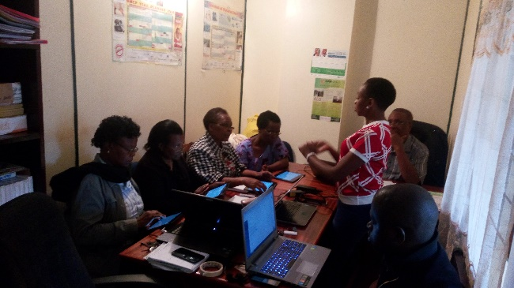
amHealth training session in Embu Office

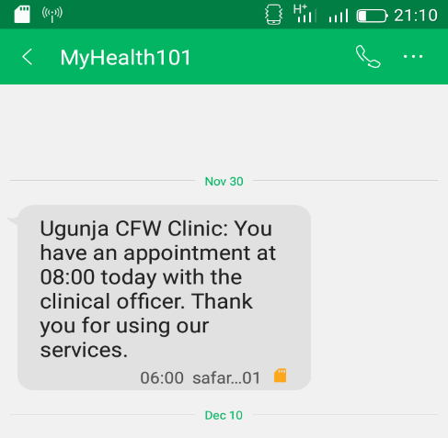
sample messages sent out from amHealth at CFW Clinic Ugunja

Ugunja Clinic NHIF Accreditation
Good news! During this last quarter of the year, our second CFW clinic in Ugunja was accredited by the National Hospital Insurance Fund (NHIF) to provide services to NHIF members. Recruitment is currently ongoing within the community to have patients select our CFW clinic as their preferred primary care provider of choice under the capitation scheme provided by NHIF.

CEO Scott Hillstrom’s Visit
CFW Clinics Western region was again lucky this quarter to host our CEO Scott Hillstrom who was able to have a one on one chat with our top performing franchisees Janet ( Fahelma CFW clinic ) and Mary (Bumala CFW clinic ). The aim of this visit was to get to hear from the horses’ mouths what the two have done to be successful and also look at the option of future support to the franchisee to create the room for a multi-unit franchising model. In addition to this visit, Scott was able to visit Bondo cluster for the first time since inception of CFW clinics and the joy of the visit was evident on the face of the franchisees who were more than happy to host him.
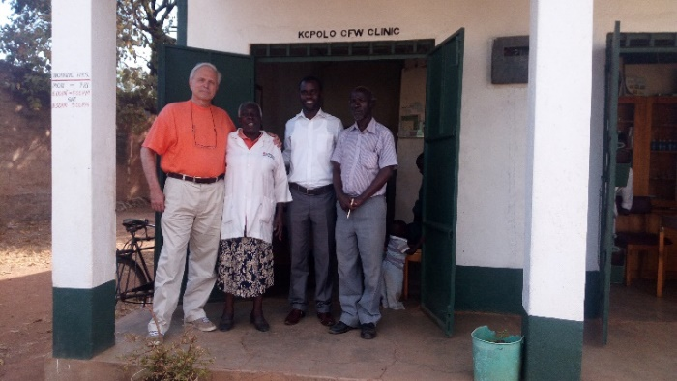
From left to right, CEO Scott Hillstrom, Merab (CFW franchisee), COO Dr Walter Obita and Merab’s spouse

The Healthstore team would like to thank you for your support this year and wish you blessings over the Christmas festivities and a happy 2017.

