Background about Project Wezesha (2014 Update)
Project Wezesha has been working in Western Tanzania since 2009 to increase educational opportunities for children in 5 villages in the Kigoma Region. Our two primary projects are the Scholarship Program and the construction of a government Secondary School. Below are some highlights. Of course, you can read about so much more here: www.projectwezesha.org.
Scholarship Program
Partnering with Girls Education International
In 2013, Project Wezesha launched a new girls scholarship program, in partnership with Girls Education International. Through this program, we are able to support 30 additional girls! They just completed their first year of secondary school in October. They are very grateful for the opportunity and look forward to 3 more years!
Congratulations to Hindu and Khadija!
We have been supporting Hindu and Khadija for 6 years. After 4 years in secondary school, we helped them continue with 2 years of vocational training. We are happy to share that Hindu and Khadija graduated from the Vocational Education and Training Authority (VETA) where they studied for careers as administrative assistants.
Before studying at VETA, neither of them knew how to type or use computers. During this program, they have learned about shorthand, typing, using Microsoft Office, communicating via email, and browsing the web for information. Each of them participated in two field placements (internships) in the Kigoma Region. They became members of an office community and developed skills that will serve them in various types of office settings around the country. In addition, both of them have continued to develop their English language skills and overall confidence.
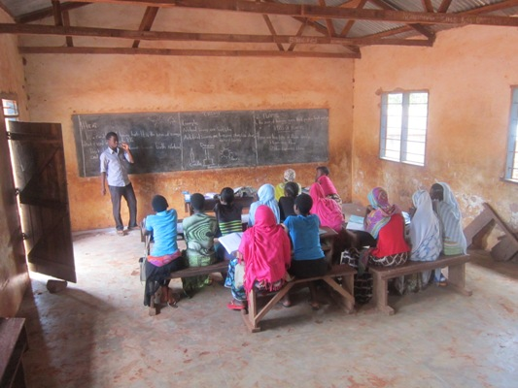
Congratulations and Thank You to Saidi, Dibeit and Tumsifu!
Saidi, Dibeit and Tumsifu are three of our brightest scholarship students. We have known Saidi and Dibeit since our first trip to Kiganza village in 2008 when they were in primary school. There was no question that they would join our scholarship program once they moved into secondary school. They, along with Tumsifu, went on to earn places at the top of their respective classes in 3 schools around the country. They completed their national exit examinations in October and anxiously await the results, which determine if they will get the opportunity to attend Form 5 & 6 (High School!). We’re sure they’ll make it!
In the meantime, the boys are helping us out! They are working with our new students to offer after school tutoring. They meet at Kagongo Secondary School and tutor the students in various subjects. We are paying them a stipend for this work. Finding tutors for our students has been an ongoing challenge … and now, we’ve employed our very own graduates to do the teaching! What a great full circle this is! Check out Tumsifu building knowledge with his peers (above)!
Construction of the Secondary School
Building Amahoro Secondary School has been an ongoing, long-term labor of love for all involved. At present, we are weeks away from opening the first phase of the school so that Form I students can start their secondary school experience right in Mgaraganza village.
Meeting Local and Regional Leaders
This past August, we visited the regional leaders from various Ministries in the government. I was invited to a meeting in Kigoma town to address the leaders and share my gratitude, concerns, and hopes moving forward. We expressed our gratitude about their recent commitment to contributing to the construction of teachers' houses and laboratories for the school. We noted our concerns about the pressure of fundraising and challenge of meeting the opening day deadline. We stressed the need for the government to continue their support until the end. We also shared our enthusiasm for the possibility of teacher education and teacher exchange in the future. They applauded our efforts and echoed our hopes and excitement.
We also met with the Kigoma District Commissioner, Mr. Maneno who guaranteed his support for this project. Mr. Maneno is new to his position as of this year. He made a trip to the village to visit the school and meet with the local village leaders. He was very impressed by the work that had been completed thus far. He gave speeches of praise to the local leaders, community members, and workers. He also promised to do everything in his power to make sure the school opens in January 2014. And - we have a Headmaster, Mr. Kumenya, ready to start the school off to a strong start!
Meeting with the Children
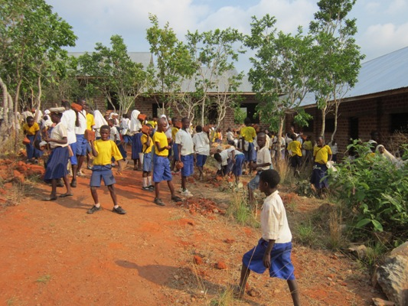
Our most important stakeholders are the children. There are a handful of them who are present at the school for every gathering of the leaders (mostly because they live next to the school). The kids showed us their twist on using the classroom space in the months leading up to the school opening.
In September, Lucas rallied the students of Mgaraganza Primary School to come and do a clean up at the secondary school. They came with brooms and tools to prepare the assembly area in front of the classrooms. Of course, they didn't harm any of the lovely trees that will shade them as they have their daily morning assembly (see photo)!
Please be sure to check in with us from time to time to see what we’re up to! You can find us on Facebook (www.facebook.com/ProjectWezesha) and visit our site (www.projectwezesha.org).
Asante Sana!
Sincerely,
Rai Farrelly and Lucas Lameck
Co-founders, Project Wezesha

