Gulf for Good: Update Report, November 2012
Introduction
Gulf for Good is a charity that organises adventure challenges in support of needy children around the world. Each Challenge raises much needed funds for a handpicked charity that is working with disadvantaged children in the region where the Challenge takes place. To date, we have organised 40 Challenges, for over 860 participants. Through this, we have raised over US$ 2 million for children’s charities around the world. Our key objectives are ‘Giving Kids a Chance around the World’ and ‘Having Fun whilst Helping Others’.
Challenge and Charity updates
The paragraphs below provide a short overview of the progress made by several of our recently supported charities. Further details can be found on our website: www.gulf4good.org.
- In November 2011, we held the “UAE Cycle Challenge”, which passed through all seven Emirates in just five days. The supported charity was the Al Manar Charity School in Ajman. Following a slow start, we are delighted to announce that the first phase of our work (refurbishing two science laboratories) has just been completed. Our Charity Director visited the school last week to see the finished labs. Further projects are being finalized, and may include installation of new playground equipment and provision of further learning resources for use across the school.
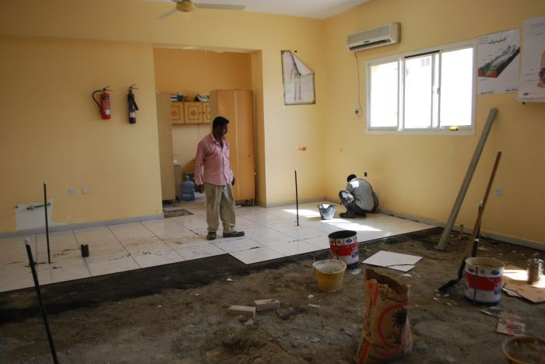

One year earlier, in November 2010, our “Revolutionary Ride” took Challengers on a 5-day cycle trek across Cuba. The sponsorship raised by this Challenge has supported the Haiti Hospital Appeal, and specifically the building of a maternity and children’s ward at the hospital in Quartier Morin. In October 2012, we made a further payment to the charity to fund additional emergency equipment. This will enable the establishment of an Emergency Power System, to ensure constant power supply to the hospital even when there are power outages in the main system.

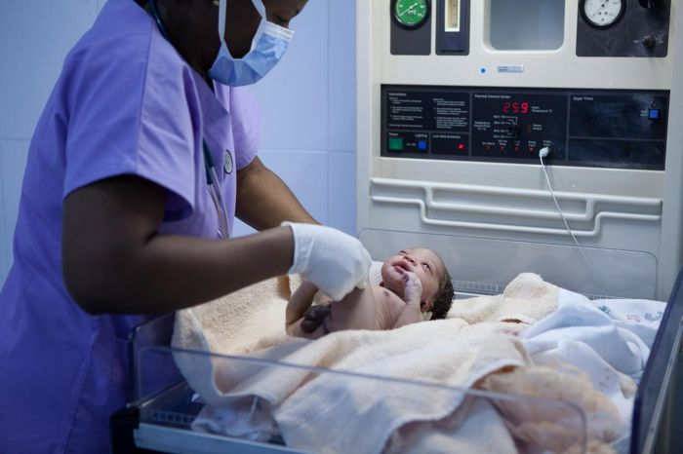
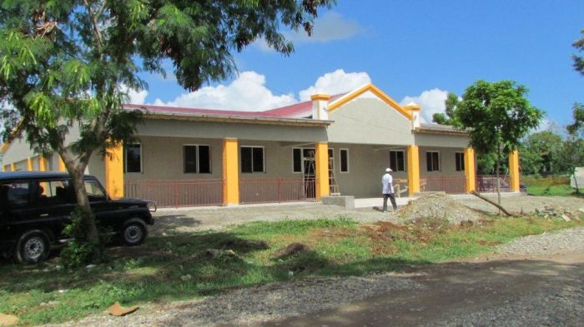

In July this year (2012), we held one of our most popular challenges for the sixth time: the ‘Trek to the Roof of Africa’. This is a 6-day trekking adventure to the summit of Mount Kilimanjaro (5,892m altitude). The sponsorship raised by the two groups of Challengers exceeded US$100,000. It will be given to the Amani Children’s Home in Moshi, Tanzania. Amani works to rescue children from the street, helping to reunite them with their families where possible, and providing ongoing care where needed. Currently, there are 75 children living at the Armani Home. Our sponsorship will be used to build a Drop in Centre in nearby Arusha town, to further Amani’s work with street children there.

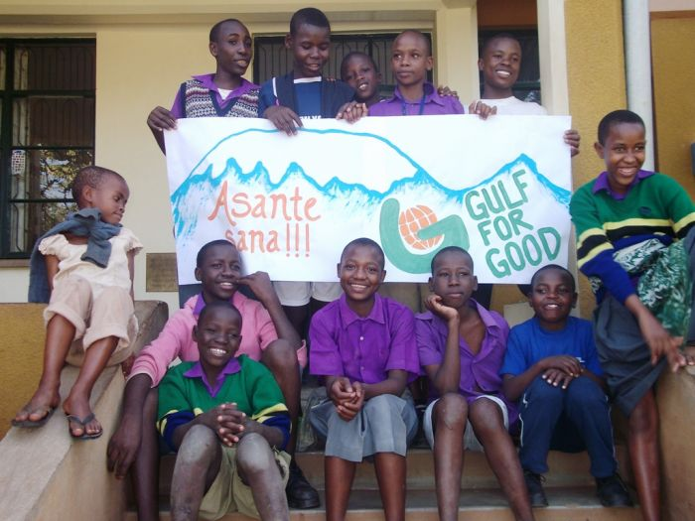

We have just welcomed back the participants from The Road to Mandalay Challenge in Myanmar (Burma). The participants completed six-days-of hiking and cycling. The money raised by this challenge, will be given to ‘Child`s Dream’. This charity works to empower marginalised children and youth in the Mekong Sub-Region. Our support has enabled the rebuilding of the OCK secondary school in rural Mandalay, giving hundreds of poverty-stricken children the chance of education beyond the basic primary level.

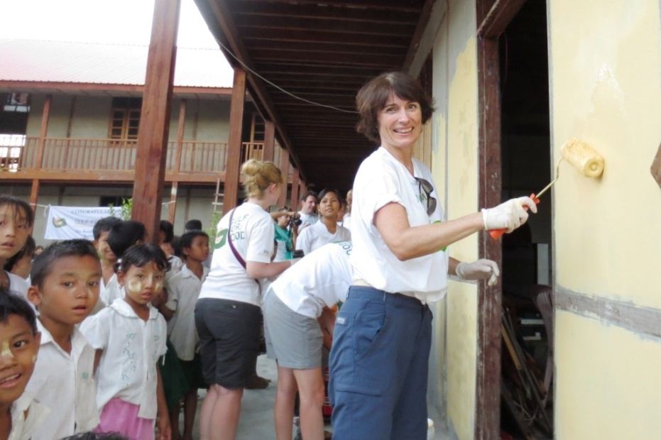

Looking ahead

We have four exciting Gulf for Good Challenges planned for 2013: The Great Asian Cycling Challenge (Vietnam and Cambodia), The Palestine Trail, The Alternative Inca Trail (Peru) and The Great Himalayan Adventure (Uttarahkand, India). All of these Challenges will support children’s charities working in the local area.

We really want to thank all the recent supporters of Gulf for Good through Global Giving. Your generosity has greatly encouraged us. With your support, we can continue to help children around the world, through our Challenges. Without your help, that would not be possible! THANK YOU!

