WOMEN WITHOUT BORDERS - WWBK 2011



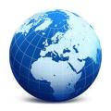
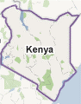
wwbk 2011
Women without borders kenya
Tel: +254 712 507040/ +254 0717 277770

Women without borders kenya

wwbk 2011
Women without borders kenya
Tel: +254 712 507040/ +254 0717 277770
wwbk 2011

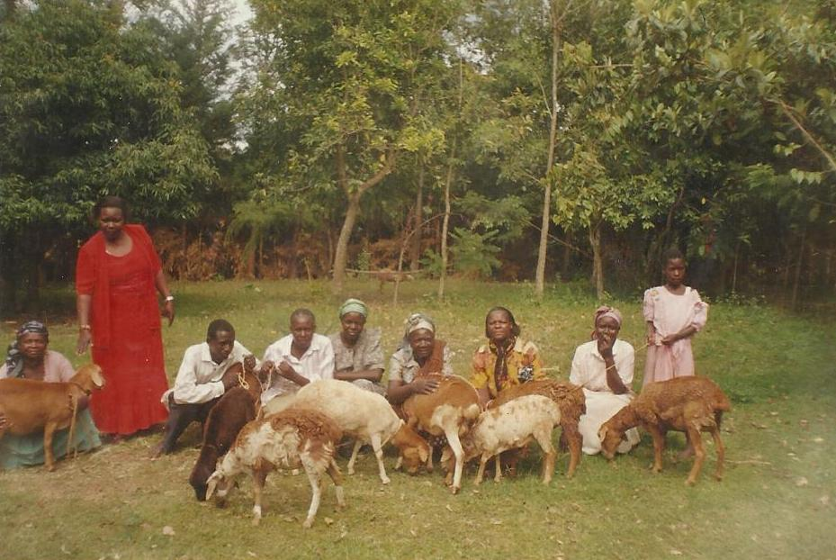
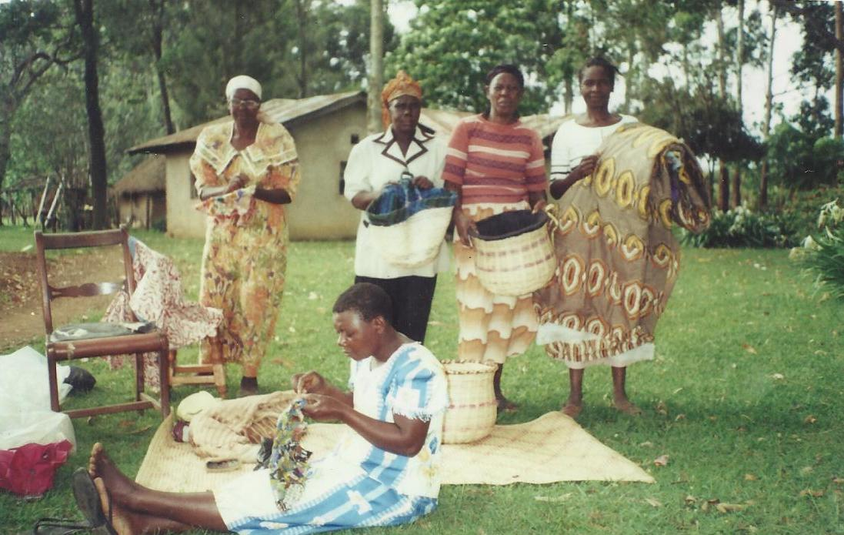

wwbk 2011
Women without borders kenya
Tel: +254 712 507040/ +254 0717 277770
wwbk 2011
Women without borders kenya
Tel: +254 712 507040/ +254 0717 277770
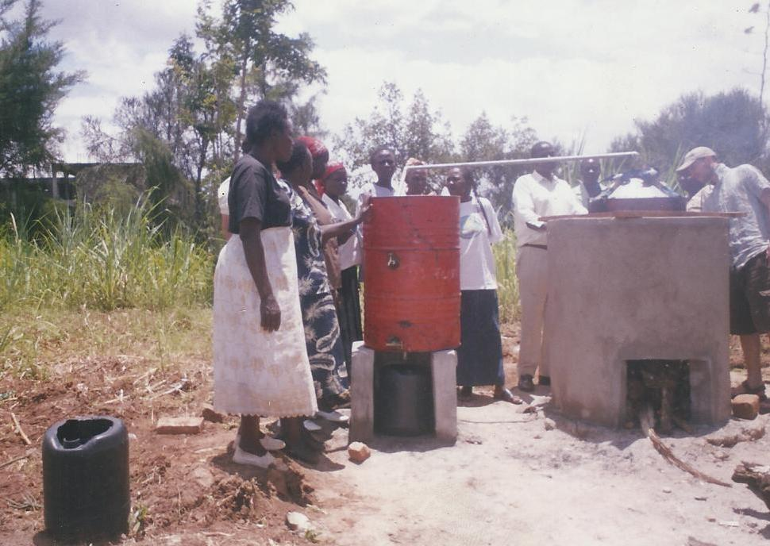
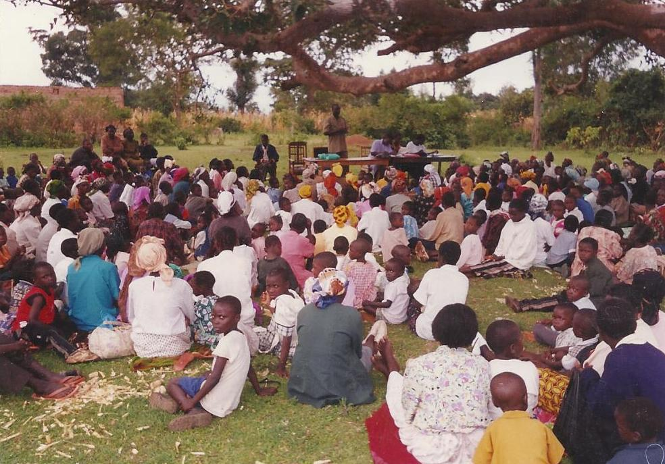

Tel: +254 712 507040/ +254 0717 277770

Email: womenwithoutborders@yahoo.com

WOMEN WITHOUT BORDERS KENYA
2011 ANNUAL REPORT
Dear Reader,
WWBK is glad to present to you our Annual Report for the year 2011.
WWBK is a national organization operating in Western and North Rift Provinces of Kenya. Specifically in Bungoma county and Tranzoia county. The total population is approximately 4 million. The area is highly potential for agriculture but some portions of land are not fully utilized due to lack of farm inputs and skilled labor.
The major food crop is maize, but is mainly used for subsistence purposes and less for sale. Other crops are beans, bananas, cassava, and sweet potatoes.
The main cash crop is sugarcane.

During the annual general meeting held on 28th of June 2011, there was a major reshuffle to the Board of Directors of the organization as follows:
- Mrs Everline Chikamai, who is the District Public Health Officer in Mt Elgon replaced Gladys Sabwami as the Chairperson.

- Mrs Edith Mukasa, the AIDSRelief Project Accountant in Friends Lugulu Mission Hospital, replaced Mrs. Florence Asiyo Masake, as the Treasurer. Edith is a trained accountant by profession and is also taking a degree in Business Management at Moi University.

- Mrs. Janipher Machio, who is an Assistant Lecturer at Moi University retained her position as the Vice Chairperson, in charge of Capacity Building and Child Welfare.

- Mrs Emily Manyasi, who is a lecturer of Entrepreneurship at Machakos Technical Institute of Science and Technology retained her place as member. She is in charge of Micro enterprise Development for women. She is also studying for a degree at Egerton University.

- Ms Florence Ndukuyu retained her position as the Director and Board Secretary. She studied in Canada as a Social and Community Development Worker. She has attended several conferences on women development in Colorado, USA. She has a previous experience of 28 years in this field. She worked with Christian Children’s Fund, and Academy for Educational Development – USAID Development Agency in child Development ,Sponsor relations.

We hope the new Board of Directors will take this organization to upper heights by spearheading for fundraising in order to achieve the goals and objectives of the organization.

Since the organization is still young, it has limited resources and funds to manage most of the activities. However, we managed to reach some women groups through funds raised by board members and donations from friends.
We realized that the reason why many rural women can not access loans from banks and microfinance institutions is lack of knowledge and skills, this makes them develop fear, so our organization has spared time and resources to work closely with these groups and they are coming up.
Reproductive health is one of our major programs, capacity building of the community based organizations, microfinance (table banking) activities carried out by some of our groups.

Challenges

- Cultural beliefs hinder change
- Scarce resources make it difficult for the group to reach the needy
- Through observations and general statistics, 56% of the population lead life below the poverty line.
- In the past months most parts of the country has suffered from drought and this has led to death of livestock and a stretch of famine. Most households have been affording only one meal per day and some even going hungry for days.
- Due to the poor eating schedules and diets, we have had many children affected by malnutrition and other diseases, e.g. waterborne diseases like typhoid, diarrhea and vomiting
- Lack of proper infrastructure makes it difficult for effective communication such that although one has extra food, transporting to other parts of the country is a challenge due to poor roads.
- Many people in the rural areas have not accessed electricity, this makes studying difficult and therefore vulnerable children are not able to cope with the education pace of school programs.
- Many children, especially girls, drop out of school due to poverty levels and forced marriages
- Number of orphans is high due to the HIV/AIDS scourge

WOMEN WITHOUT BORDERS KENYA

HISTORY

Women Without Borders Kenya is a registered local NGO under the NGO Board, operating in Kenya

WWBK was established in July 2007 after the felt need of the local community understanding of several issues that affected women and children. With deep consideration members found that women are faced with a lot of challenges especially on issues such as their sexual rights, stigma towards people living with HIV/AIDS and generally rights of a girl child, have not been attended and as such many have lost their lives.
Women are the World!
This is the reason why women without borders resolved to register the NGO to meet
Goal No. 3 To promote gender equality and empower women
Goal No. 4 Reduce child labor the needs of women and children as per the 8 millennium development goals especially:
Goal No. 5 Improve maternal health
Goal No. 6 Combat HIV/AIDS, Malaria and other killer diseases

Its main objectives are:

To improve the livelihood of vulnerable children/orphans, and women towards sustainable development, by:
- Eliminating gender disparity through women empowerment.
- Equipping women with skills and knowledge so that they can participate in development and be involved in decision making in issues that affect them.
- To ensure that women access renewable energy e.g. use of solar panels, improved cooking stoves and fireless cookers to reduce smoke in the households.
- To ensure that orphans and PLWHA are reached and home based care is done to them.
- To introduce new technologies to women
- To protect women against sexual violence and other inhuman experiences.

OUR VISION
A society in which women and there communities participate effectively in their own development.

OUR MISSION

To empower those communities we work with, so that they uphold the rights of women and children. To enable them play a healthy and active role in the society.

GOVERNANCE

The organization is managed by five Board Members elected by the Annual General Meeting. These are the chairperson, Vice chairperson, Secretary, Treasurer and one member.
The management committee consists of Executive Director assisted by other members of the organization. The role of the management team is to work towards the realization of the organizational Mission and goals.

The Project

To improve the status of young women and youth on sexual and reproductive health through capacity building of national and rural stakeholders, by advocating and implementing their programmes and also pressing for policy change to policy makers.

PROGRAMMES/ACTIVITIES

- Reproductive health

Pano’s Briefs U.K says:
Young lives are at risk. Every five minutes a young person somewhere in the world commits suicide, often because of abuse, sexual violence, heartbreaks through intimate relationships, alcohol and drug abuse, unwanted pregnancy and unsafe abortions, infections with STI/HIV and anxiety about being physically attracted to members of the same sex.
Every year up to 2 million girls and young women are at risk of undergoing genital mutilation and some forced marriages.
Young women face particular risks because of their biology, discrimination regarding access to information and services, and because of constraints imposed by societies on their behavior. As a result they are vulnerable to a triple threat of unwanted pregnancies, unsafe abortions and sexually transmitted Infections that can render them infertile or even kill them.
These are some of the insights that affect young girls in our communities that require attention.
There’s need to empower women economically by educating them on IGAs so they can be able to stand for themselves financially even after the demise of their husbands who are traditional breadwinners. These will enable them pay their children’s school fees and pay their day to day bills.
Pano’s Briefs U.K says:
Young lives are at risk. Every five minutes a young person somewhere in the world commits suicide, often because of abuse, sexual violence, heartbreaks through intimate relationships, alcohol and drug abuse, unwanted pregnancy and unsafe abortions, infections with STI/HIV and anxiety about being physically attracted to members of the same sex.
Every year up to 2 million girls and young women are at risk of undergoing genital mutilation and some forced marriages.
Young women face particular risks because of their biology, discrimination regarding access to information and services, and because of constraints imposed by societies on their behavior. As a result they are vulnerable to a triple threat of unwanted pregnancies, unsafe abortions and sexually transmitted Infections that can render them infertile or even kill them.
These are some of the insights that affect young girls in our communities that require attention.
There’s need to empower women economically by educating them on IGAs so they can be able to stand for themselves financially even after the demise of their husbands who are traditional breadwinners. These will enable them pay their children’s school fees and pay their day to day bills.

Through this programmes we have managed to reach the community through team work with Ministry of Public Health, Bungoma East District. The district hospital has been of great help by providing logistics material, resources, and technical expertise.
- Advocacy meetings
- Provision of birth control pills and promotion of condom use
- Create awareness in the community on demerits of unsafe abortions
- Educate women on what one is required to do if they are victims of rape or sexual violence
- Information on the dangers of early pregnancies e.g. distorted education and at times bad medical conditions.
- Education on risks of contracting HIV/AIDS through unprotected sex.

- Capacity Building
- Trained 10 women groups in group dynamics, leadership skills good governance and keeping records.
- Choosing available project through problem identification, analysis and action plan

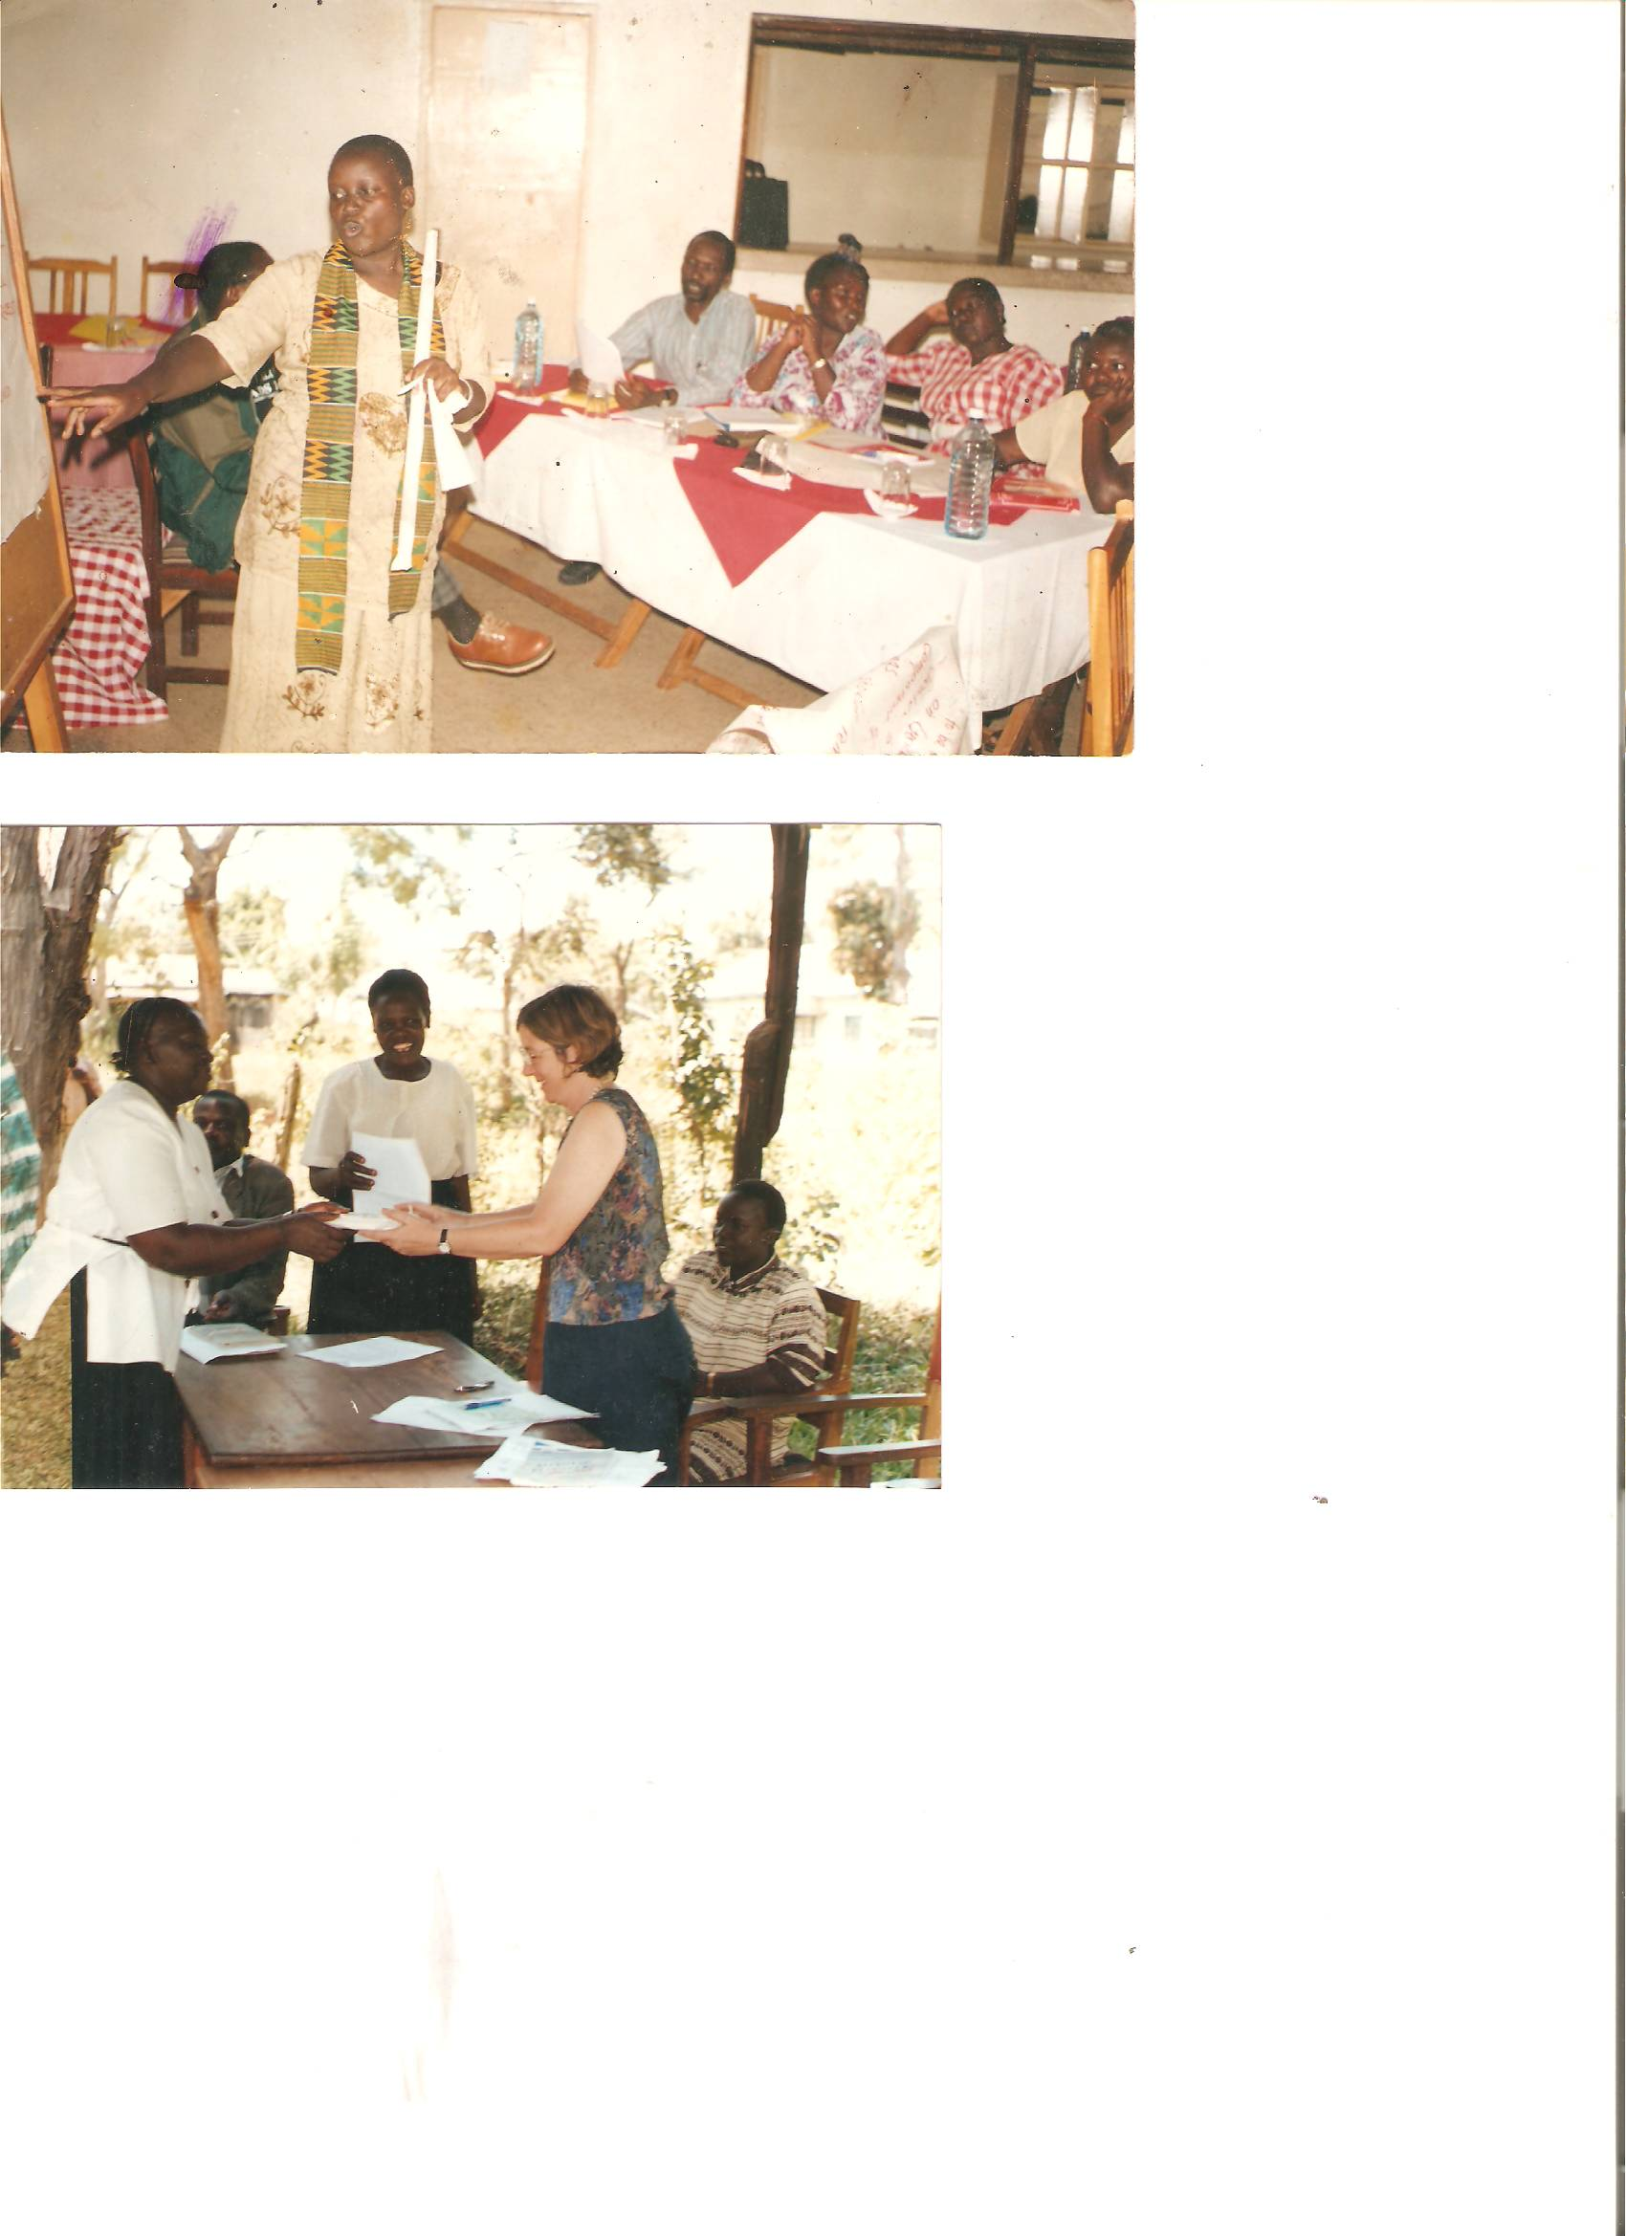
WWB-Kenya assist women groups to raise funds from other sources. Above one of our groups was funded by American embassy. They are signing MOU

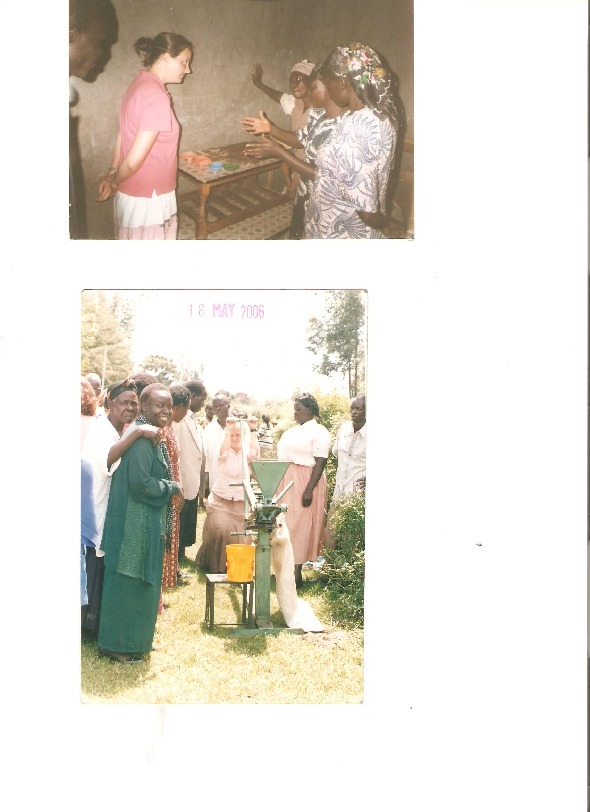
Women explain how they process medicinal soap to American peacecorp

- Micro finance for women
- 5 active groups e.g.
- Mufubi women group – orphan support with bednets,blankets and food: soap processing
- Bokoli mentors – handcrafts, making of fireless cookers, food value addition, making of bedcovers out of patch work.
- Amka Self Help Group – Beadwork, making of baskets out of banana fibres, horticultural farming e.g. tomatoes, onions, cabbages, and poultry keeping.
- Chikhabi Women Group – sunflower Oil processing (machine was donated by the American Embassy).
- Banana Investment self help group is a mixture of women and men. They have come together to plant bananas which they sell, but if improved, this can produce banana chips.

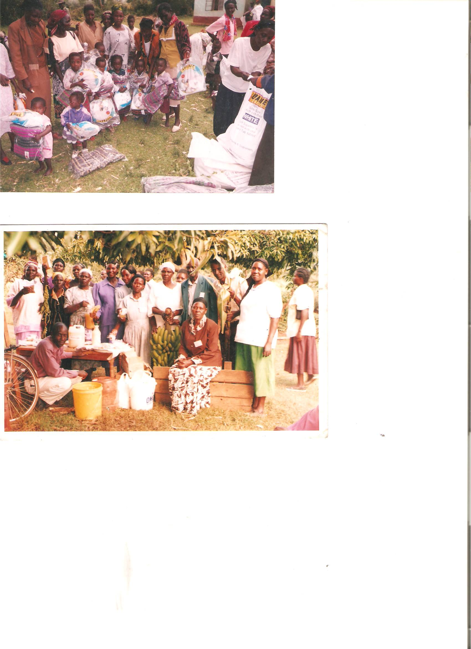
To reduce poverty in the household we assist women to utilize their local resources , by improving the quality and sale as a source of income*Women with their products)

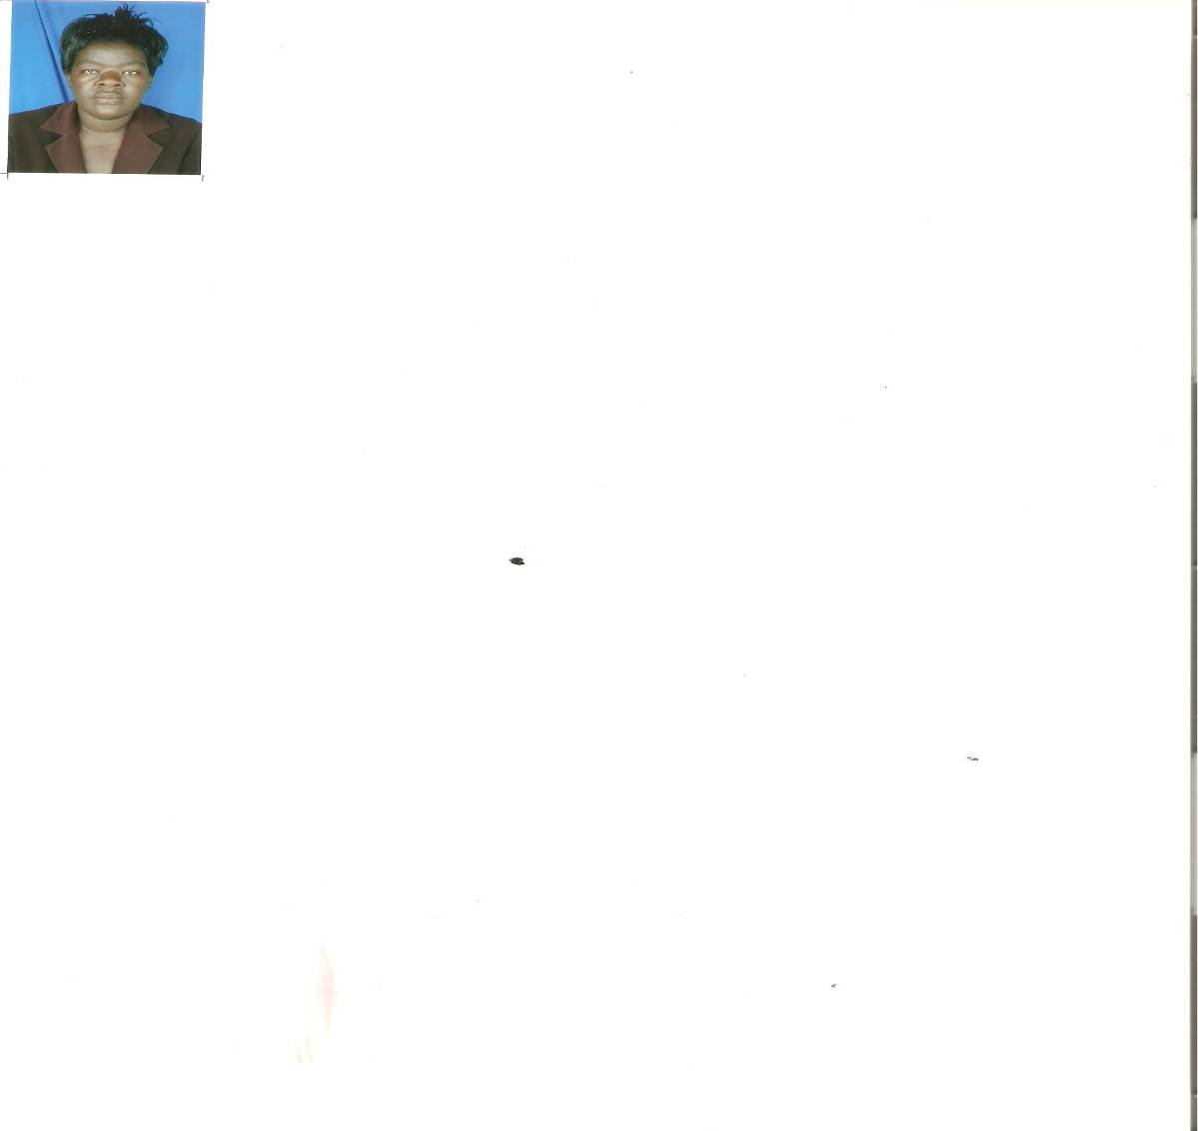
Our compliments goes to the Board of Directors for the tireless fundraising that has enabling the organization to carry out this activities, our heartfelt gratitude’s goes to the groups that made our work successful. our special thanks goes all who made their donations to make this work successful and final we appreciate the hard work of our Executive Director for linkages and Networks.

