EMPOWER INDIAN TRIBAL ADOLESCENT GIRLS

OVERCOME OPPRESSION

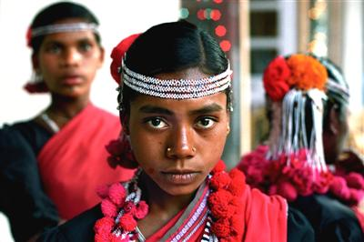

Adolescent girls form a vulnerable critical sub group of population as they are at vital phase of life. Adolescents in India, form 22.8% of the population. It is projected that by the end of the year 2011 there will be 107,649 million adolescent girls (age group 10-19). In India as in other developing countries women are subjected to gender discrimination, National Family Health Survey-III4, points to the gender gap in nutrition & health Data. The girls miss out on basic education, are pushed into early marriages because of social and cultural norms which lead girls to be economically dependent & experience poor health. Early marriage leads to early pregnancy which results in low weight babies.

The need of imparting life skills – ability for adaptive and positive behavior that enables individuals to deal effectively with demands and challenges of every day is well acknowledged by experts and emphasized by WHO (1993).

In spite of available services from government it is observed that adolescents have refrained from taking benefit of these services, due to absence of awareness and friendly staff, working hours that are inconvenient to adolescents and lack of privacy and confidentiality, etc. The need of functional programs is acute in remote tribal areas. Girls Gaining Ground (GGG) project initiated by Baradrone Social Welfare Institution (BSWI) is one such program to showcase a sustainable model for reaching & empowering the adolescents in such areas.

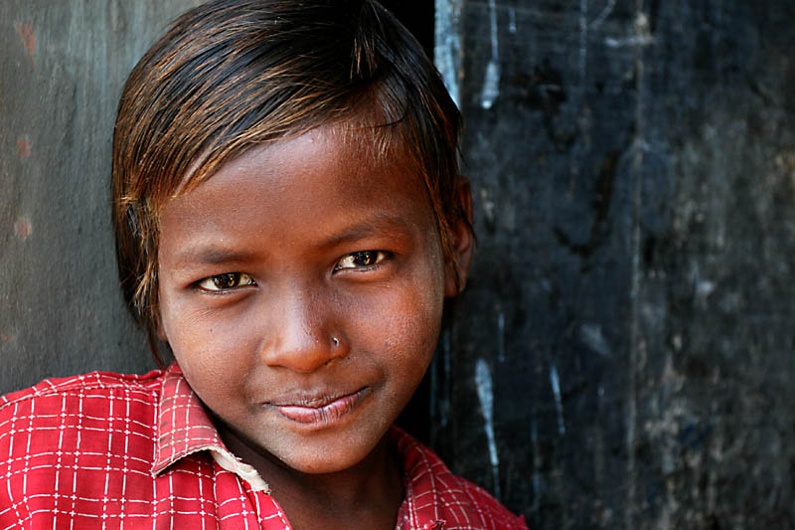

ABOUT THE ORGANISATION – BSWI
MISSION STATEMENT
Baradrone Social Welfare Institution (BSWI) is dedicated to accelerating social and economic changes amongst the resource-poor and the marginalized sections of the rural and urban societies of West Bengal.
VISION
- To contribute to building a society where all people can gain access to education, health care, and employment opportunities and where people can realize their full potential.
- To build a trusted bridge between the dreams and aspirations of individuals who care about suffering people and their realization
- To build a professional organization that is secular, transparent, credible and accountable for all its activities.

Genesis of the organization – BSWI
Baradrone Social Welfare Institution (BSWI), was set up in the year of 1961 in the form of a small rural text book library for encouraging non-school going / dropout children by providing text books and free tuition by the educated village youths. Over the years, the goals and philosophy of BSWI was transformed and gradually it took the shape of a benevolent integrated rural development organization. Since its inception, many individuals and organizations of distinction have embellished BSWI and with their active cooperation and contribution; today BSWI is considered as a resplendent, translucent and reputed organization in the state and abroad. BSWI is working in the remote parts of West Bengal, where planned interventions to address human problems are yet to be launched. It helps people to be equipped with skills, capacities, values, awareness, self-help and opportunities, by dint of which they can come forward and demand their legitimate claims.

BSWI has a bold vision for creating a world where every person lives with dignity, respect and the opportunity to achieve her or his potential. BSWI is committed to improving the lives of the poor and marginalized through social and economic development processes. Since the year of 1985, BSWI has partnered / has been partnering with foreign agencies like Action-Aid, Oxfam India Trust, Bread For the World, Canada Fund, Irish Embassy and others in child-centered community development programmes. Over the years, BSWI has reached to more than 25000 children in various villages of West Bengal. BSWI has been providing training and technical assistance in non-formal education, community development, maternal and child health, school governance, integrated literacy, small enterprise development, micro-finance, HIV/AIDS education and awareness and women’s empowerment. BSWI also works to strengthen literacy, adult basic education and health programmes in collaboration with government departments. BSWI’s projects are designed to contribute to individual growth, as well as to community and area development.
Marked by persistence, energized with an entrepreneurial spirit, honouring the wisdom of our partners in the field and the people who benefit from our work - BSWI ignites the flame of self-advancement, the birthright of every human being.
STRATEGY & PROCESS OF BSWI
BSWI restricts itself in the following sectors :-
- Education & Awareness
- Women’s / Girls’ Empowerment
- Community Health & Family Welfare
- Livelihood Systems.

Genesis of the project:

In 2010, the project called Young Girls’ Alliance, was conceived by BSWI with the goal of contributing to halving the rate of child under nutrition by 2015. Work of Young Girls’ Alliance rests on the principle, that effective multi-sectoral partnerships between Government, Corporate and Civil Society can co-create solutions for addressing the complex problem of child under nutrition and can make a major contribution to radically reducing the prevailing rates in India by value-adding to the efforts of government by addressing gaps in implementation of various interventions at each stage of the ‘life cycle’ i.e. adolescence, marriage, pregnancy, delivery and child hood. The ‘ Alliance’ as part of its many other initiatives started a community empowerment & behavior change model for adolescent girls (called GIRLS GAINING GROUND) through a multi-sectoral partnership in 3 tribal blocks of Malda, West Bengal to create ground for empowerment of about 10,000 adolescent girls through capacity building initiatives on life skills.

The GGG project is focusing on the larger agenda of reducing child under-nutrition by investing in girls’ empowerment, and improving their knowledge of and access to government programs/services, and nutrition/health education by multi- sectoral partnership with State Health & Nutrition Mission, foreign donors and agencies etc., who can provide technical expertise, content, training and capacity building, monitoring & evaluation, and funding support.

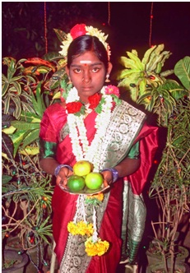

This model aims to -
- Empower members of adolescent girls’ groups to become self-confident, well-informed and responsible decision makers, by creating awareness especially in the context of health and nutrition, and building their life skills;
- Address issues of child and adolescent health and nutrition at the community level through the members of the adolescent girls’ groups; and
- Through these groups at community level, advocate for issues related to child and adolescent health and nutrition.

This project will build on the examples of various successful adolescent girls’ programs to create safe spaces, enhancing the girls’ self-image and their role in society, and building their decision-making and leadership skills.

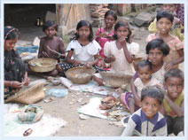

Project Methodology:

In each of the project blocks, few adolescent girls from hamlets remotely located with limited means of transport and low on many health indices will be chosen for empowerment through group formation, life skills enhancement, and helping them learning by doing. Local people’s associations and Gram Panchyats with the support of government functionaries will play the roles of Nodal organizations for executing the project. After an extensive initial assessment , BSWI identified 30-40 communities/villages from the area. And from each community / village / school 20-30 adolescent girls are identified for the intervention. These enrolled girls will undergo continuous training on life skills, health and nutrition aspects as per the pre-defined modules. The module will be for a period of 6 months with flexible 3-4 sessions per week.

The training in each community/school will be conducted by trained facilitators specially identified from the same communities for this project. Prior training for the facilitators will be provided by a team of master trainers belonging to BSWI. The training of facilitators will be for 20 days (in two sessions of 10 days each). The master trainers and coordinators will also provide continuous support to the facilitators throughout the project execution. The support will be in terms of initial hand-holding, observing and taking corrective measures to ensure quality and appropriateness of training, providing administrative support, monitoring, reporting and feedback.

In each area the project will be executed in two phases; first phase covering about half the communities / villages / schools and the second phase covering rest of the villages and schools. The project will complete the first phase with half the targeted number of girls (5,000 completed out of 10,000).

During the project execution, all adolescent girls will also be tested for anemia twice at the time of enrolment and final completion of training with the support of the health department. In addition, required treatment will be prescribed and provided to those girls who will be found to be anemic. Apart from this, the girls will be linked to other government schemes through the village level government functionaries such as Gram panchayat, Anganwadi Workers and Auxiliary Nurse Mid-wife, etc.

Training module will be developed under the guidance of State Health Department and the National Rural Health Mission (NRHM) that is a India Government initiative and will be further strengthened to tailor-made to the specific needs of this project by Media Matters with support from of experts drawn from various other organizations and experts.

Preparatory phase of the project will include mapping existing rural organizations (youth, women’s etc.) and government-run adolescent girl programs in the target areas; reviewing and adapting changes to state’s adolescent girls training module and designing the project’s research and evaluation model.

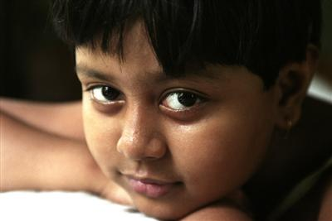

Implementation Phase will include following steps –

1. Selection of communities and schools: Selection of implementation sites (villages and schools) from the 3 tribal blocks which are most backward & have reported large number of deaths due to malnutrition.

2. Selection of implementing organizations: having good infrastructure, implementation capabilities, having working presence in these areas.

3. Formation of NGO team: (a project coordinator and two assistant project coordinators-cum-trainers and facilitators) to execute and to mentor adolescent girls. Coordinators and assistant coordinators will be experienced women professionals with social work background and will be selected by the respective NGOs. Facilitators will be married or unmarried woman residing in the selected villages, educated till 10th class or more, preferably having past experience of working with community selected with the consensus of village leaders.

4. Training of the Trainers: Training of project coordinators on project execution process, training module and training methodologies in two stages of 10 days each.

5. Training of Facilitators: To make the facilitators capable to handle the tasks required training will be provided to them by the assistant coordinators-cum-trainers. Facilitators will be constantly supported, monitored and supervised by NGO coordinators and local government departments (tribal welfare, health and nutrition).

6. Formation of adolescent girls groups: The Facilitators will enroll and form group of 25 to 40 girls in village after getting informed consent from parents of girls, Similar Girls groups will also be formed in local schools from girls of 5th to 9th standard with permission from Principal of school.

7. Taking the girls through the GGG module: the girls groups will be taken through GGG course, structured in 3 sections

a) Sessions: These sessions will be on critical subjects like health, hygiene, nutrition and life skills of ninety minutes each, classroom based, will be held twice every week, providing safe space to share experiences, stories and also to simply bond with each other create songs, make paintings, an opportunity for the adolescent girls to gain knowledge, discover individual potential and strengthen group cohesiveness.

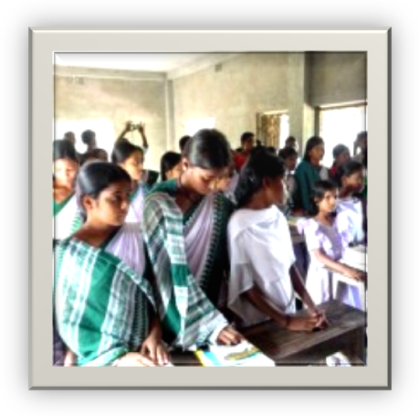

b) Field Projects: During the first two months, the groups of girls will go for field visits once a week to get oriented to village structure and available resources, and then each group will select a topic which will have important relevance for village development. They will explore the issue to understand thoroughly and undertake project-based activity once a week for the remaining six months. An opportunity will be created for 'learning by doing'.

c) Outreach Activities: Once a month, an outreach activity will be undertaken with the purpose of creating an opportunity for interaction between each group of adolescent girls and the community. The girls will be given an opportunity to demonstrate their skills and learning.

8. Providing additional vocational skills: Courses on entrepreneurial promotion and vocational skills will be followed upon completion of these trainings. The vocational trainings will site specific as per the choice of girls groups and market demand.

Monitoring and Evaluation of the GGG Project:

1. To ensure that the project will proceed along well in time frame and work plans, the ‘Alliance’ will monitor the project through monthly progress reports of activity along with case studies (to be sent by each NGO coordinator which they will prepare by compiling reports to be received from facilitators) and by regular visits to the sites and interactions with the girls and facilitators.

2. A Qualitative assessment of the first phase of the project will be done by students of Master of Sociology at the North Bengal University at Malda as part of their summer assignment which will provide insights on various issues which will be utilized for improvisation of the 2nd phase.

3. A Quantitative evaluation will be carried out by Institute of Rural Management Anand (Gujarat) by comparing the defined indicators between baseline survey before the intervention started with an end-line survey after implementing 1st phase of the program with about 5,000 girls. The research design will include comparing baseline sample survey data of randomly selected adolescent girls enrolled in the Life Skills course in the randomly selected villages of 12 out of 3 bocks where the project will be implemented with the end line sample survey data which will be randomly taken from the girls who will enroll and participate in the Life Skills course. A total of 500 girls at base line and 500 girls at end-line, from 3 tribal blocks of Malda district will be interviewed. At the base-line, 500 girls will be randomly selected from the community and 300 girls will be randomly selected from the local schools. At end-line, the community-based sample will be 500 girls and the sample of girls from schools will be 300 girls.

Analysis will be done in two parts (a) to measure knowledge, perceptions, and skills, and (b) to gauge areas of self-esteem and self-confidence. The indicators in the questionnaire will focus on changes in knowledge, awareness, and perspectives as a result of the key domains of the GGG modules. For the end line survey, questions on the life skills course will be incorporated into the questionnaire to measure the perception of the participants regarding the efficacy of the course A software program will be prepared in ‘Epi data’ for data entry. The data will then be transferred to ‘Stata’ for data analysis.

Project Impact:

The project will impact Girls, their Families, Community and Government Functionaries.

Impact on Adolescent Girls:

The project through its non-formal education & practical trainings “learning by doing” will empower the adolescent girls in recognizing their nutritional needs which will enable them to communicate their needs about nutritious foods to parents which will lead to improvement in family diet, in building self awareness, in appreciation of physiological changes (growth, menstruation, etc) happening to them, to cope with personal and menstrual changes with confidence and to take decisions and negotiate them in their favour will result in delaying of early marriage. There will be significant gain in knowledge about child health & child nutrition and growth & using this information in future when they will become mothers will make difference in reduction of child malnutrition, morbidity and mortality. The confidence to be gained will be utilized by the girls to seeking health care services and other services like provision of water, street lights, sanitation from village functionaries, by raising issues in village Panchayat meetings and getting useful responses.

Many of them will undergo Vocational skills training which will liberate them further with economic independence and allow them to have say in family decision.

Following key findings on knowledge, perceptions, skills and practices will be observed in adolescent girls through the quantitative assessment. The percentages in brackets will be the increases to be observed between baseline and end line quantitative surveys.

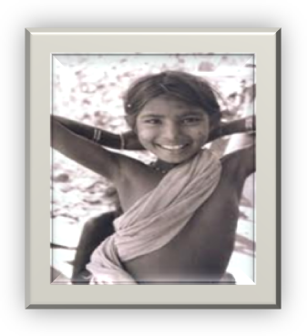

Nutrition: A significant increase (from 40% to 90%) in knowledge regarding frequency of meals taken (three) per day, an increase in knowledge regarding iron-rich food items and increase in consumption of green leafy vegetables (60% to 85%), consumption of drumstick leaves, consumption of rice flakes, and consumption of salad will be observed at the end line as compared to the baseline.

Anemia: Significant change in knowledge about Hemoglobin levels, symptoms of anemia (20% to 70%), prevention of anemia and iron folic acid tablet consumption (from 8% to 60%) will be achieved at the end of the first phase as compared to the baseline.

Education: A significant difference will be achieved in the schooling status of the girls; (90 percent at end line). Major reasons for girls for not attending school or getting dropped from school will be changed; their parents will be interested in getting the girls educated, and will want them to continue their education by improving the economic condition of their household. However at the end line, a significantly larger proportion of non-school going girls will complete an undergraduate college degree, as compared to the baseline.

Aspirations: Most of them will want to become teacher, ANM, many will want to be in Police and few will want to become doctors post training. There will be significant change in girls wanting to attend vocational training.

Age of marriage: Significant increase in desire to delay in marriage, knowledge of ideal age of marriage (30% to 80%), perception that friends desire to delay marriage; ability to convince parents to delay marriage citing disadvantages of early marriage (25% to 70%).

Child Health & Nutrition: Significant increase will be achieved in knowledge about early initiation of breast feeding (45% to 90%) and appropriate weaning practice (25% to 100%); of birth weight; perceived prevalence of malnutrition in children; perceived causes of malnutrition (33% to 93%), knowledge of growth monitoring & growth charts (59% to 83%); immunization of children; and knowledge on Diarrhea Management (14% to 70%).

Reproductive Health Knowledge: Significant change in knowledge about physical changes during adolescence; menstrual health, use of locally prepared sanitary napkins; knowledge of conception; ante-natal and post natal care, correct knowledge of consumption of iron folic acid tablets; knowledge on institutional delivery; knowledge about contraception; knowledge on correct use of oral pills; knowledge about RTI/STI; HIV/AIDS.

Adolescent Rights, and Participation in Co-curricular activities: It will be observed that the girls who participated in the GGG project will show significant improvement in their awareness about their rights, and improved participation in co-curricular and community activities.

Self Esteem: Through both qualitative assessment and quantitative surveys and also frequent site visits it will be observed that the project will bring about a considerable improvement in self esteem of the girls in terms of building their self image, communication skills (ability to communicate in front of others, to freely speak to mother about changes in body, to express thoughts to friends, to talk freely with their father, etc), negotiating skills (able to get permission from parents for things they like to do; able to get permission to attend life skill program; able to convince parents not to get married before the age of 18 year; etc), mobility (confidence to go about in village alone; the fear to travel alone and feel restricted from going out alone; confidence to travel outside village, etc), decision making, school achievements, peer approval, and self efficacy (to have good qualities as their friends; to take responsibility of household work; to feel confidence of working outside; to feel that parents are proud of them; to be satisfied / happy with oneself; satisfied with relationship within family; etc).

Impact on Families of Girls: The girls will demanded nutritious consumption of iron rich food three times a day; it will make the whole family aware of constituents and need of balanced diet. Personal hygienic knowledge will also result in construction of toilets in their houses. Negotiation by girls to delay marriage beyond the age of 18 years will lead to desirable effect on community. However not all Parents will be prepared to cope with social change, having grown up in hierarchically structured and interlinked social and caste groups, certain changes will take more time to appear on the horizon.

Impact on Community: The project will have a visibility to the adolescence as a crucial segment of ‘Change Agents’, they will be able to negotiate favorable response within community. Girls will be able to negotiate with Panchayati Raj Institutions (local governance) for the issues which will be beneficial for village with community support. Many of the girls will be attending meetings of SHGs (Self Help Groups) to maintain records, help in calculations of the financial transactions.

Impact on Government Functionaries: As part of curriculum the girls will visit various units of government health system, observe activities, interact with health and other village functionaries, and will take their help for corrective measures as part of their project activities, which will result in net working with village government functionaries. As the girls of first phase, who will have completed the course, attend AWC / Sub center to meet and help the functionaries, government functionaries will gain extra helping hands in villages. At many places girls will be instrumental in organizing monthly immunization camps, Health Nutrition days by assisting ANM, AWW. They will assist government health workers to enroll pregnant mothers for ANC check up, will help them for weighing children, and will help in health education of mothers groups on benefits of institutional deliveries.

Conclusion:

The impacts to be achieved by this multisectoral working model (GGG project) will show that despite various practical challenges in collaborative efforts of various partners including local government empowerment of adolescent girls will be achievable which will enable them to negotiate with parents and community to take informed decisions to shape their lives. The partnerships and targeted investment can lift girls out of poverty and ignorance and will protect their rights – and in doing so can meet the Millennium Development Goals.

