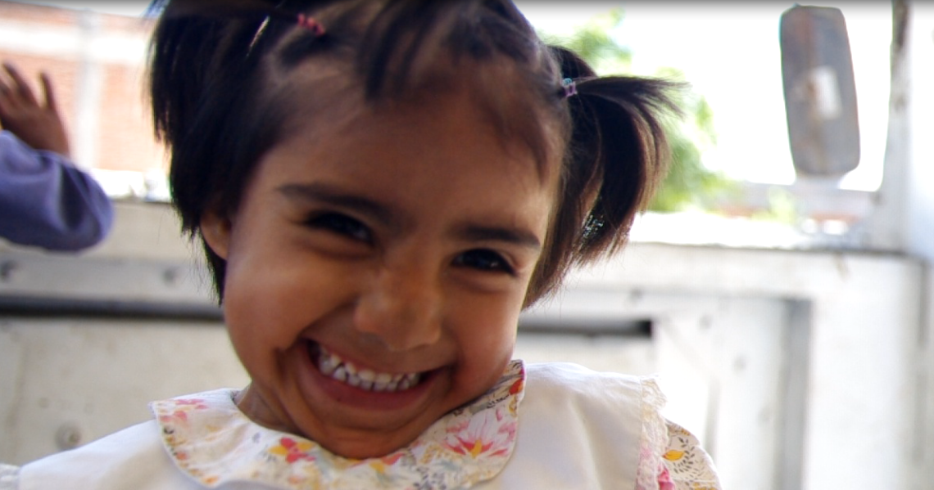
Photo credit: Ian Pollard, www.ianpollardimages.com

Give Yasmín and 52 other children in Oaxaca, Mexico a safe home. It’s this EASY:
Text GIVE 9406 to 80088 to donate $10
For more information visit: www.expandcasahogar.com or e-mail Ariana at: ariana@expandcasahogar.com

