Detailed Project Proposal for:
Earnesta Child and Youth Development Project

Project Title:
“Empower 60 Ugandan Women to raise out of Poverty”.

Project Summary:
Earnesta Child and Youth Development Project is embarking on a one year programme to combat household poverty in Pallisa District, in its quest to improve the lives of the most disadvantaged people and Communities of Uganda.

Dubbed “promoting and establishing income generating activities for the most disadvantaged people and communities to raise out of Poverty”, the programme is aimed at improving the vocational and entrepreneurial skills of Women and Youth and to increase the access of rural women and youth in Pallisa District to household income generation and productive assets that enable self-reliance or enjoyment of life. The programme will further more increase the access of girls and marginalized children to quality basic education, medication, clothing, food, and well-being. These women and youth will be trained in Information Technology (I.T), beads making/art and craft, tailoring and entrepreneurial skills.

Earnesta Child and Youth Development Project is requesting funds that will support in the establishment of a quality vocational and entrepreneurial skills training centre for people, communities and families of Pallisa district that want to raise out of poverty or embrace development in their areas of jurisdictions. Part of the funds will be used in improving or renovating her five (5) existing demonstration farm buildings to be turned into a quality entrepreneurial and vocational skills training centre within the first quarter of the year 2012. Purchase and installation of Vocational and entrepreneurial skills training equipment as well as illustrations materials will follow.
Training and education will start immediately in the second quarter and end in the fourth quarter of the very year. Facilitation of the programme will be by partnership or hiring expatriates, mobilisation and supervision will be done by grantees or organisational staff.
The project or programme is strictly for only one year. It will run from January and end in December, 2012.

Requested funding amount.
Earnesta Child and Youth Development Project is requesting $ 57,335

Donation Options
- $ 10 will help to mobilise and sensitise 5 Sub-counties of Pallisa District.
- $15 will help to improve and or renovate 5 (Five) buildings to be turned into a quality vocational and entrepreneurial skills training centre.
- $20 will buy and install 20 singer or phaff manual sewing machines [188 make] to start a tailoring and Fashion design training centre.
- $25 will buy 6 designing and electric tailoring machines.
- $30 will help to buy 500 metres of clothes, 50 Packets of Sowing Threads and 50 tins of Lubricant oil.
- $40 will buy 10 pieces of Computers including other accessories like printers, Scanners, power back ups, Cartridges and tonner and a fastest modem to start an information system and technology skills training for the unemployed youth.
- $50 will help to train 60 women and 50 youths in entrepreneurial skills like business starting and management, writing of accounts, loans management in a period of one month.
- $60 will support in paying 2 tailoring professionals for twelve months or one full year.
- $70 will help to pay two beads professionals and train 50 women living with HIV/AIDS in beads making for one week.
- $80 will support in paying 4project implementers (organizational staff including monitoring for 12 months (one full year).
What is the issue, problem or challenge?
Due to the current global economic crises, HIV/AIDS and rural poverty in the Pallisa District Community that have sent even more people unemployed, living poorer and migrating from rural areas to urban centres or cities in the neighbouring towns searching for employment, yet are neither competitive in the labour market nor become self employed. Some of these people are youth, women and children who have lost their families to HIV and AIDS diseases. As we are continuing to support free HIV/AIDS Counselling and Testing, currently, we have 60 women tested HIV Positive. Majority of them have also lost their husbands who are always the bread winners. Most of the time, they come back and us for what we can do for them to continue supporting their family as well as coping up with this most stressful kind of life. Supporting for their living independently is the only way forward.

Additionally, of all the issues or factors given above, “household poverty” is the single biggest factor preventing children from realising their right to education, medicating, nutritious food and well-being. The program aims to improve children’s lives and reduce the incidence of poverty that tends to flow from one generation to another. The effects of the current global macro-economic crises have played themselves out at the micro household level through crises shortages of food and fuel, the loss of employment, and the forced liquidation of family assets. Pallisa District being a rural district is currently being hit severally by this economic crisis. Most homesteads are not even saving any pence and are greatly concerned about their future in terms of health, education of their children, clothing, shelter, food and well-being.

The situation is being compounded by the absence of Vocational and entrepreneurial skills, Income Generating Activities or opportunities for the rural women and youth that could help to improve their family income generation. Bearing the brunt of this are children who are often pulled from school and or given less nutritious food. It is these educationally and nutritionally deprived children in Pallisa district that are finding it difficult to “Catch-up” and as a result become caught in the visions cycle of poverty. Being an orphan and at the same time living with HIV/AIDS is a sure sentence to poverty in future. Say, Earnesta Child and Youth Development Project.

Earnesta Chid and Youth Development Project will implement this programme through a right based approach to development, ensuring the participation of children, youth, women and families within Pallisa District. Instead of providing them money, Earnesta Child and Youth Development Project is very sure that establishing and supporting with them a quality vocational and entrepreneurial skills training centre, their life can considerably be improved through a diversified approach and competitive effort to household income generation opportunities or rehabilitation and productive assets that enable as well ad promote self-reliance, an opportunity to become part of a larger solution for their community.

How will this solve the problem?
Supporting for the establishment of a quality vocational and entrepreneurial skills training centre and educating women and youth will greatly help to reduce on the unemployment problem, provide and promote productive assets or opportunities that enable self-reliance among the disadvantaged communities of Pallisa district. This opportunity also will help to curb down the vicious and intergenerational cycle of poverty among children that tend flow from one generation to another in the rural communities of Pallisa district and Uganda as a whole.

Potential long term impact
The Project will educate 60 women, 50 youth and 50 children allowing them to raise out of poverty which will provide for their families’ health, food, education, shelter and well-being.

Project Message
I grew up in a rural community of pallisa district, here in eastern Uganda where women had minimal access to the basic forms of education and income generating activities, through this project we are turning these same women into a productive workforce in managing their own affairs.“Being productive is a meaningful way of being self-reliant”. Says, Mubala Moses; Executive Director; Earnesta Child and Youth Development project. Project Globalgiving gives me this opportunity.

Key Words:
Earnesta Child and Youth Development Project is located in Pallisa District, here in Eastern Uganda. It strives to improve the lives of the most disadvantaged people and communities of Uganda through vocational and entrepreneurial skills training. In this case, we are going to support women living with HIV/AIDS, unemployed youth and orphans and vulnerable children from Pallisa District to learn to earn a living on their own, thus, promoting skilled hands for self reliance.
BUDGET
Budget Breakdown:
Exchange Rate: 1 US dollar = UGX 2700

No. | Item | Quantity | Unit Cost  US$ (Dollars) | Total Amount  US$ (Dollars)
1 | Purchase of Singer/ Phaff (188) Sowing Machines | 20 Pcs | $370 | $7,400
2 | Purchase of Phaff / Singer Electric Sowing (188)and Designing Machines | 6 Pcs | $926 | $5,556
3 | Improvement of the Existing Farm buildings to be turned into a Vocational Training Facility | 5 blocks | $2,593 | $12,965
4 | vocational trainers monthly payments | 2 Persons for 12 months | $296 | $3,552
5 | Purchase of beads training and illustration materials (For one week) per Sub-county  - Flip Charts  - Mark pens  - A4 Sinarline spirals Note books  - Shorthand Notebooks | 5 Dozens  5 Dozens  100 pcs  100 pcs | $13  $3  $4  $2 | $65  $15  $400  $200
 | - Beads facilitator’s allowance | 2 Persons of 5 Weeks | $372 | $1,860
7 | Community Mobilization and Sensitization | 5Sub-counties | $186 | $930
8 | Entrepreneurial skills training for women, and youth unemployed | 5Sub-counties, each one week | $372 | $1,860
9 | Programme management  - Purchase of office computers and accessories | 2 Dell Laptops | $1,111 | $2,222
 | - Office Salaries and Wages | 4 Persons for 12 months | $889 | $10,668
10 | Purchase of Desktop Sumsung/ hp computers for Training youth in information technology | 10 Pcs | $741 | $7,410
11 | Continue monitoring and evaluation of the programme | 12 Months | $186 | $2,232
 | GRAND TOTAL |  |  | $57,335

Photo Gallery for Earnesta Child and Youth Development Project

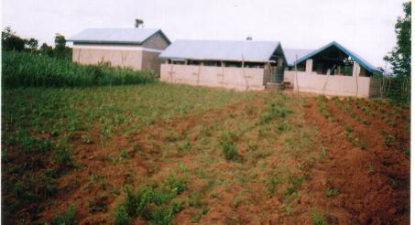

A completed ECYDEP piggery and goat demonstration farm with food supplements grown on the other piece of land. The food grown for animals is sweet potatoes, maize and cassava. [Funded by PEPFAR]

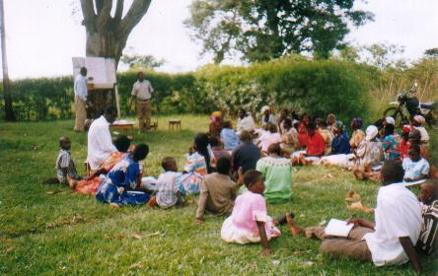

Beneficiaries training in piggery and goat rearing. The motorcycle aside was their transport quickly used. [Funded by PEPFAR]

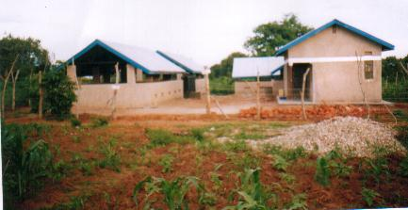

The front view of the newly finished demonstration farm. This was immediately after completion. [Funded by PEPFAR]

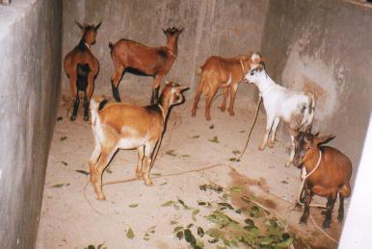

Goats in their section or component of the demonstration farm. [Funded by PEPFAR]

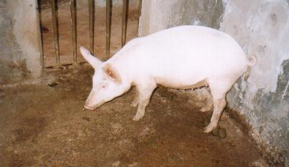

A pig in her living room at the ECYDEP Demonstration farm.

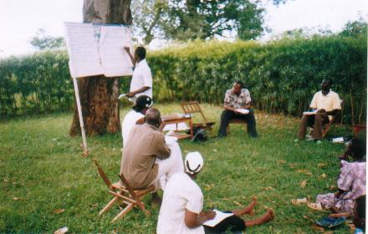

Facilitators are busy with their work training OVCs and PLWHAS and as well as ECYDEP staffs including the Project Coordinator sat at the far right of photo background

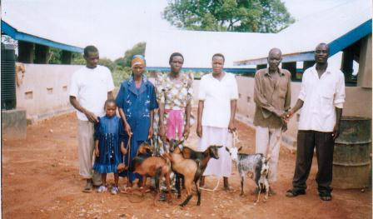

Beneficiaries (PLWHAs) taking a photo with a Project Coordinator with the area L.C. representative after being gifted their goats (animals)

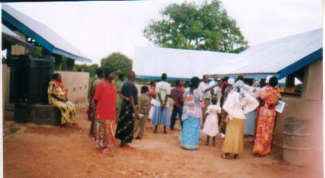

Trainees are being showed the intensive system of piggery and goat management at the ECYDEP newly constructed Farm. [Funded by PEPFAR]

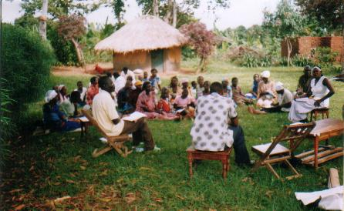

Trainees in group sessions or discussions as the training goes on. The facilitator was training using a local language Lugwere.

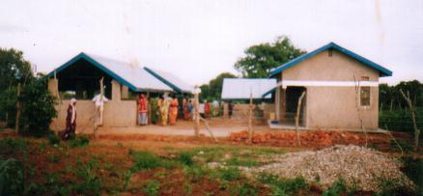

Trainees inspecting and learning how intensive system of management is built both inside, outside and the kind of roofing required. But ECYDEP demonstration farm was built well and all the requirements are in place.

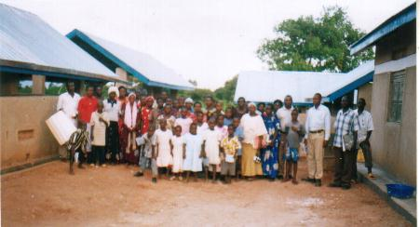

The trainees, Facilitators, ECYDEP staffs and project coordinator pose for a photo soon after finishing the Training.

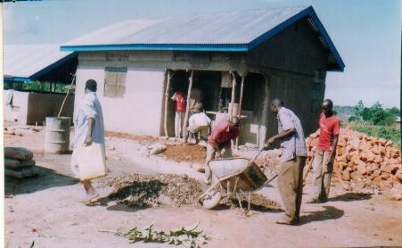

Bags of Cement aside while construction progresses. Men at work finishing up the main store of the farm and records office.

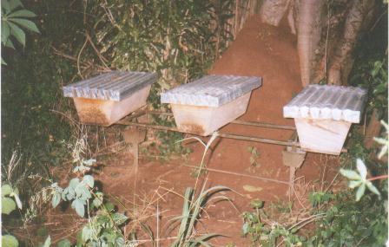

An apiary for ECYDEP. This was a self help project sponsored by the former peace corps volunteer: Jessica Dyer. Bees are happy in their Bee hives. A project Coordinator who trained with Peace corps volunteer in Bee keeping manages the apiary.

