Hope Warriors Children’s Charity- Who we are

Our Philosophy – Our Programs
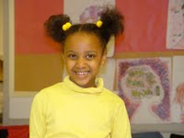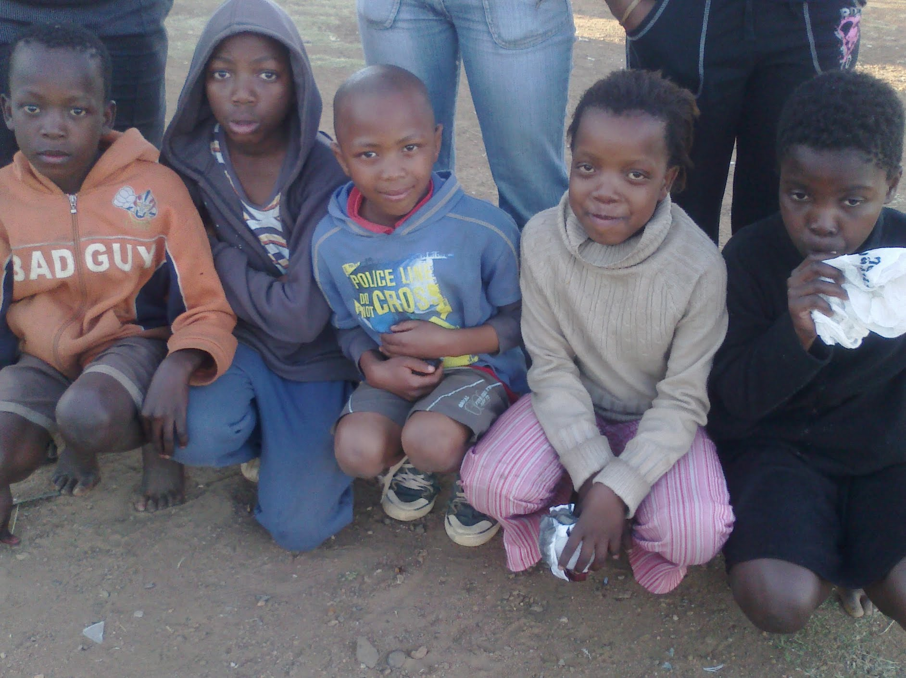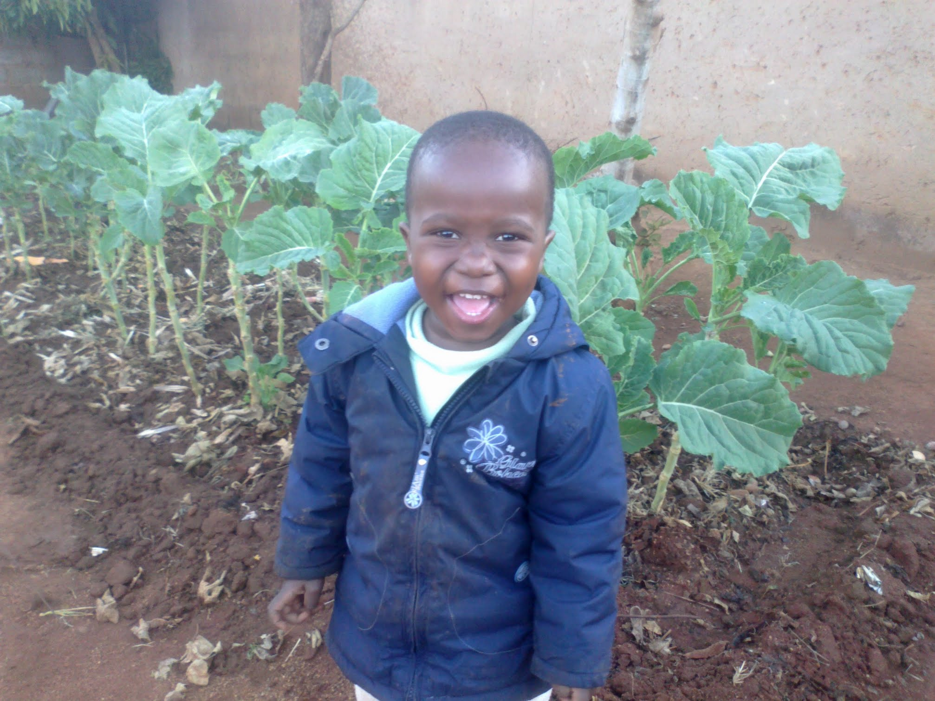
Instill 'HOPE' into the children! Think of the children. They are the future, their past is gone...
Many a times life is made worse by the hopelessness we carry because of our past experiences. We more often fail to achieve some simple steps because we count ourselves finished, judged and condemned already. The truth says the contrary. There are people throughout history, who 'had no background', with no trace of a positive thing to hold on to. But they have made it in life.
Such examples are inspiring, and a declaration that the past must not determine one's destiny. Children therefore need 'hope' to be spoken into their lives, through practical aspects to help them to a better future.
Various interventions will thus be implemented, based on child's needs, and much as described in the programs description.
It is our hope that we can give the children and youth hope 'on a personal level' and that this will translate into transforming their lives, enabling them to move on to healthy adulthood. Ultimately, everyone benefits: the children and the larger society.

Programs Description

The programs incorporate many modalities in the context of instilling hope through education, empowering the children and youth through 'family' like relationships and helping the children and youth to live their lives to the full regardless of their past challenges. This is achieved through the following programs:

1. Education: Ensuring and facilitating the children and youth's access to education - school fees, uniforms, stationary, pre-school for toddlers, bursaries for tertiary education, after school homework assistance, computer literacy, exam preparation classes and career guidance

2. Support: Providing of psychosocial support, counseling and spiritual support to ensure the children and youth get over their past, and move on to their destinity

3. Life Orientation: Open discussions and awareness on HIV/AIDS, crime, substance abuse, bereavement and loss, so as to equip the children to deal with the ills of society that they meet with on a daily basis. Partnership with schools to address substance abuse problems in schools

4. Food and material help: Availing material support, such as food, shelter and clothing to ensure the children live normal lives

5. Play: Making use of the play therapy; children playing in a safe and controlled place, than in the streets where they become exposed.

6. Referrals: Assisting children, and making referrals if necessary, for birth certificates, child support grants, foster care, and identity documents

7. Research: Conducting research on the issues affecting orphans and other vulnerable children and youths, as well as taking part in lobbying for the rights, care and upkeep of these.

8. Income generating projects: Establishing income generating projects for orphaned and vulnerable youths.

Hope Warriors Children's Charity will implement these programs and initiatives in the belief that each child has special gifts that can lead them to a purposeful life, and they have the ability to reject negative influences such as gang involvement, alcohol and drug abuse, sexual promiscuity and violence. The children's past must not dictate their future, and more so, it is the responsibility of every human being, company or organization, local or international entity and all governments to 'open up arms' and help these children. Families are breaking down, and thus if it becomes everyone's concern, the plight of these OVCs and youths can be alleviated.

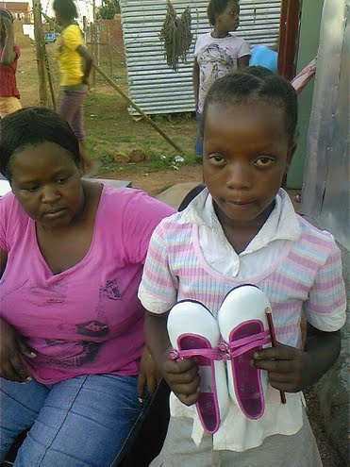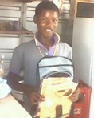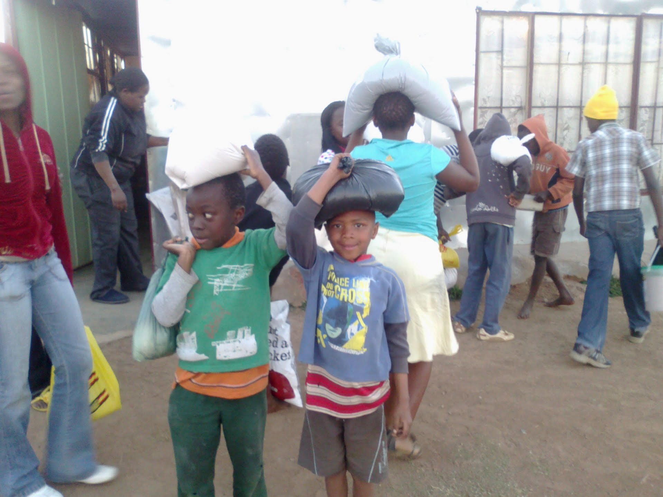

How you can help us
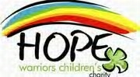

We need your support that we may remain of service to the children. HWCC values the ability of individuals, small companies, as well as Multinational corporations in making a difference. We are currently meeting in a shack (local church), and our needs include:
- school fees, bursaries
- school uniforms, stationary
- used desktops for computer literacy classes
- clothing/blankets/shoes
- toys, jumping castles for play
- food parcels- for meals at the centre, and for some kids to take home
- Container to use as office/ building of our own
- chairs, printer, office stationary
- stove & refrigerator for storage and cooking of meals at centre
- vehicle for picking up of donations, meetings
- bicycles/motor cycles (x 3) for Child Care Workers
- T-shirts for staff and children- with HWCC logo

The approach:
Individuals and companies alike can choose what they would like to sponsor, be it on a once off, or regular basis. You may 'adopt' a given child/youth, and choose to cover only that child, or you may avail for a number of children. We have learnt that a once off donation is of great essence, for it takes the beneficiary to another level. Regular sponsorship helps the beneficiary into the future, with less worry, being assured of the support. At HWCC we treasure individual donors, as well as family donors, companies and corporations. No donation is small, for indeed a broken spoon can mean much to some needy someone; a day's meal is treasured, as it makes getting to the next day easier. Thank you in advance for touching these precious souls through your donation.

Donations
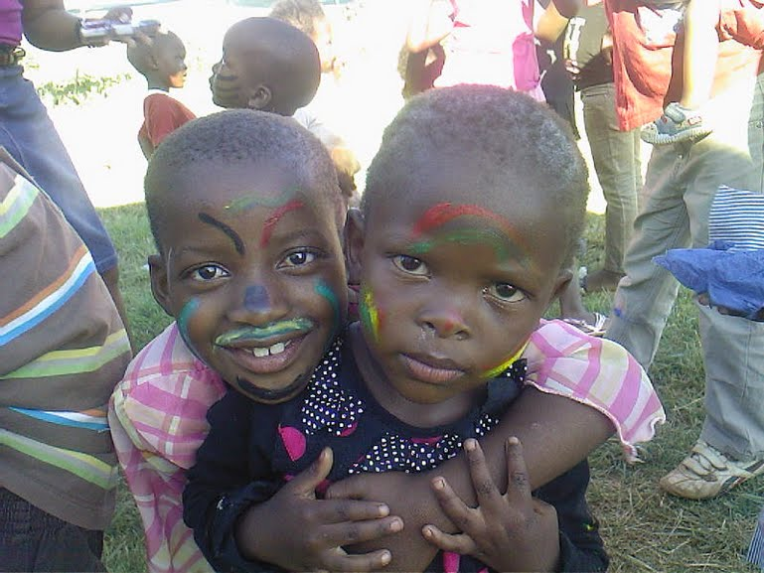

To donate:

South Africa
First National Bank (FNB), Cheque Acc; 62315440735; Branch 250107; Swift code FIRNZAJJ

