HEALTH DIET FOR COMMUNITIES IN CAMEROON
Nutrition Training on Healthy diet at Bova II Buea

Introduction

During the Nutrition training in Bonakanda, the FORUDEF banner and the training workshop cardboard attracted the attention of the president of a CIG in Bova II. He came into the community hall, and met with us. After a few questions and some discussion, we realized that the CIG in Bova II (Green Hills) village has many common objectives with FORUDEF. The “Green Hills” CIG works with bee hives for honey production, but also nursed various fruit trees for both the honey quality (conservation) and the villagers’ eating habits. One of their objectives was to improve their Nutrition profile, but they lacked expertise. Hence, meeting FORUDEF’s on-going training on nutrition in another village was like a dream come true at a time of their need for expertise knowledge on nutrition in their CIG specifically, and in the Bova II village at large.

Furthermore, FORUDEF paid a visit to the group and their demonstration farm, FORUDEF decided to work with Green Hills. Training days for Phase I & II were scheduled the same day. This report states the events of Phase 1& 2, the theory and cooking practical.

1. Objectives and Expectations (phase 1&2)

Phase 1&2 of the program focused on teaching and implementing the basics of nutrition and balanced diet. It was a mix of theory, visual supports and practical incorporation, as a sort of follow up evaluation process to observe if they understand and can put in place the concept of balance and healthy diet.
Before moving on to the cooking practical, phase 1 ensured a strong fundamental knowledge about nutrition, and established the relationship between balanced diets and health. Cooking practical served as a medium for mistakes and corrections. Mistakes created space for improvement and made the demonstration even more efficient. Our theory and demonstration also enabled them to learn new recipes and ways of retaining nutrients. It was expected that participants would leave the cooking practical with a more visual idea of how to feed their families in a healthy way. Members would be able to identify signs of malnutrition and knew the steps to undertake to solve it.

2. Phase 1(theory)
On Monday, August 5th 2013, the staff went to Bova II. We arrived there exactly at 10am, on time for the training. About 4 members had arrived before us. We started at 10:45am, with 9 members out of 12.

We followed the “Training Plan” and divided the tasks between each other. The first part of the training was completed at 1pm. We then had a nice lunch break where we served a balanced snack (watermelon, cakes, and groundnuts). After a 30 minute break, we played a short review game and continued with the second half of Phase I. Susan then joined us and wrapped up the training session.

We finished the training around 3:30pm, took some group pictures and organized Phase II, which was scheduled for
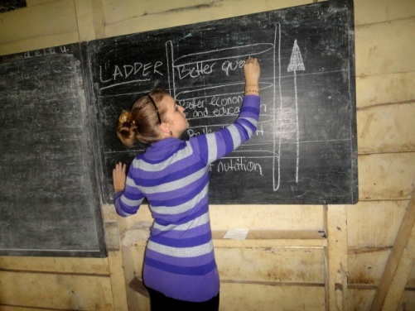
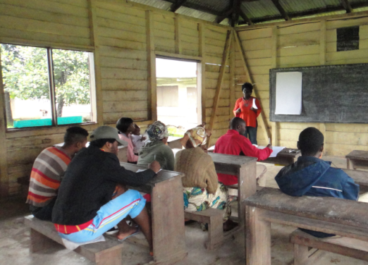

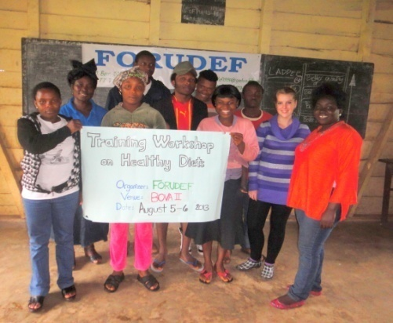
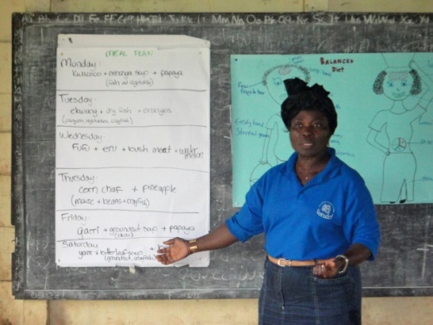

Training session

3. Phase 2(cooking practice)
The cooking practical was what followed the theoretical Phase I. Once participants were enriched and comfortable with the nutrition basics and the different types of foods, FORUDEF and the CIG carried out a cooking demonstration where we applied both old and new recipes and techniques.

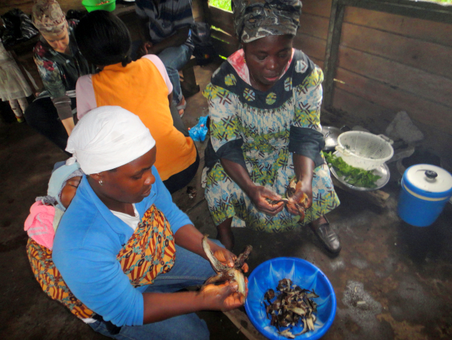
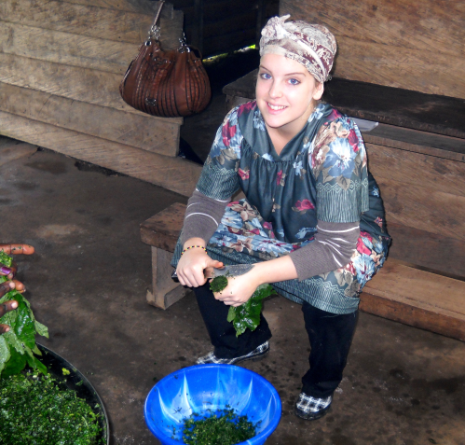

Practical Session
4. Process

We already had boiled the beans, ground the groundnut, and prepared the pepper/ginger/garlic combination. Two fire stands were ready.

We were done with all dishes around 3pm. Before eating, we analysed the meals. The team pointed out that the porridge was balanced (yams, bush meat, and sweet bitter leaf). However, the amount of vegetable the group had put into their porridge was extremely small compared to the significant quantity of cocoyams. Also, once the sweet bitter leaf was in, they let it boil for 45 minutes. In comparison, Susan put the vegetables in the “ndole” for about 5 minutes to ensure – once again – nutrient retention. Then, we explained how our balanced meals were made of cheap foods available around Bova II, yet were very nutritious. Occasion was given for observations, questions, answers and remarks.

Conclusion

As elsewhere, the training in Bova II was very successful. The attendance rate and the members’ punctuality reflected their commitment and interest. The small flaws in the participants’ “cocoyam” porridge allowed us to make corrections and show how small improvement to recipes they already know can make a big difference. ‘Green Hills’ is ready to move on to the next phase. Occasional review sessions will maintain their strong knowledge and interest about nutrition and health. They understood the value of knowledge and trainings like the one FORUDEF provided.

“with what we have learned, we will never be the same again. We had the food but did not know the better mix” . Mojoko, a participant

We thank our GG donors for their support and wish them a prosperous and wonderful year 2014.
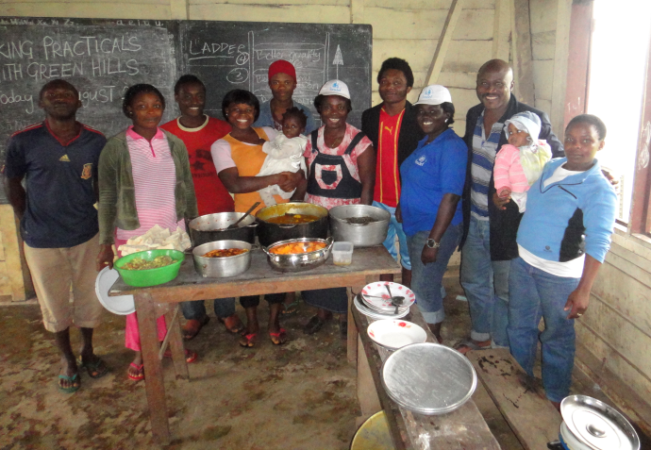
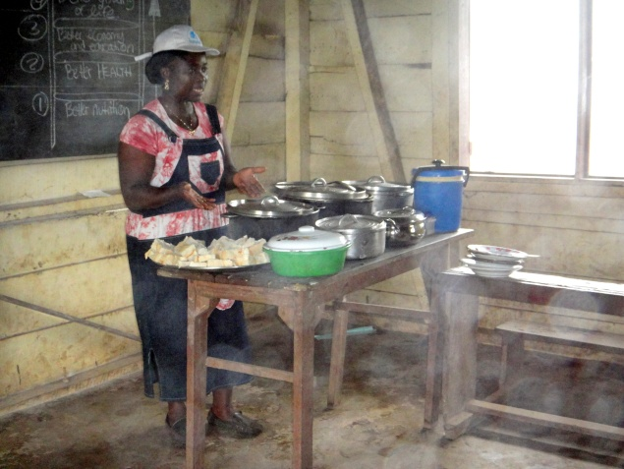
Trainer
Greenhill CIG after cooking practice

