Legacy Foundation
Expand Biomass Briquette Training Capacity in East Africa:
Long Version Proposal

PROJECT SUMMARY

Legacy Foundation plans to strengthen the biomass briquette training centers and network in East Africa. Through provision of a biogas grinding equipment, communications technologies, training and marketing materials and transport resources, the project will:

- increase the direct income of over 1000 women as new biomass briquette producers in Tanzania, Uganda, Kenya and the South Sudan
- decrease deforestation/ fuel wood demand by tons per year.

Definitions:

Biomass Briquettes: Fuel briquettes are a low cost, locally made fuel for cooking or heating that offer an alternative to the use of firewood. Fuel briquettes are made from combustible compressed and dried grass leaves, straw, other agricultural waste products or scrap paper and cardboard.

Biomass Briquette Training: Certified trainers teach the participant the invaluable technique of making fuel briquettes, a lowcost, locally made fuel for cooking or heating that offer an alternative to the use of firewood. Fuel briquette businesses have proven to be a reliable form of income for local producers while preserving the environment by using only combustible, compressed and dried grass leaves, straw, other agricultural waste products or scrap paper and cardboard.

PROBLEM STATEMENT

It is now widely recognized that deforestation is occurring at pandemic rates throughout the developing nations. In general, these forests are not being denuded for construction or even industry but rather for fuel wood production/use. The deforestation is so predominant that complete denudation is forecast in many areas, in the next decades, not the next century. It is also well known that many people earn their income from fuel wood and charcoal production, distribution and sales. In many nations this employment constitutes the single largest form of employment in the informal sector, a sector of the national economy which provides the major source of income in the developing nations . In short, forest destruction will continue unless an equally attractive employment opportunity is found in the provision of a sustainable fuel alternative.

SOLUTION

The Legacy Foundation started work with biomass briquetting in 1994 while on assignment in Malawi. Cooperating with the University of Washington’s College of Forest Resources, the Foundation adapted the theory and developed practical extension techniques and programs in rural settings with community members who were desperate for income and alternative sources of fuel for cooking their food and maintaining basic household sanitation. Through outreach, training and dedication to the technology, Legacy Foundation helped to spread biomass briquette technology to over 40 countries. Through interactions with these projects, it has become evident that, support to capacity building for trainers in established training centers leads to exponential expansion of the technology and consequent local employment and environmental conservation. Through Biomass Briquette Training Units, the biomass briquette production process spreads and becomes more self reliant and sustainable.

Evidence proves that one of the main successes of the Legacy Foundation work has been in the support of training of trainers and training services. The trainers in rural and urban centers become a dual resource in that they provide briquettes in their local communities while providing wide-spread training support to a region or country. In this context, Legacy Foundation has tried to support networking amongst the producers and trainers so that they become more reliant on the briquetting community for problem solving and project development.

PROJECT PROPOSAL:

In order to strengthen the briquette trainers network of training services , Legacy Foundation would like to provide funds to the following five training services in East Africa. This support has the potential to encourage exponential growth and success for the individual training centers and the LF network of briquetters.

Five specific training service project were selected for support because of their already established briquette production activities and progress in providing training and biomass briquette support in their country. The projects range from a fully established training service in Kenya to two start ups in Tanzania and the South Sudan. Each project is described briefly below:

Project # 1: Mkombozi Women’s Group: Lushoto Region Tanzania

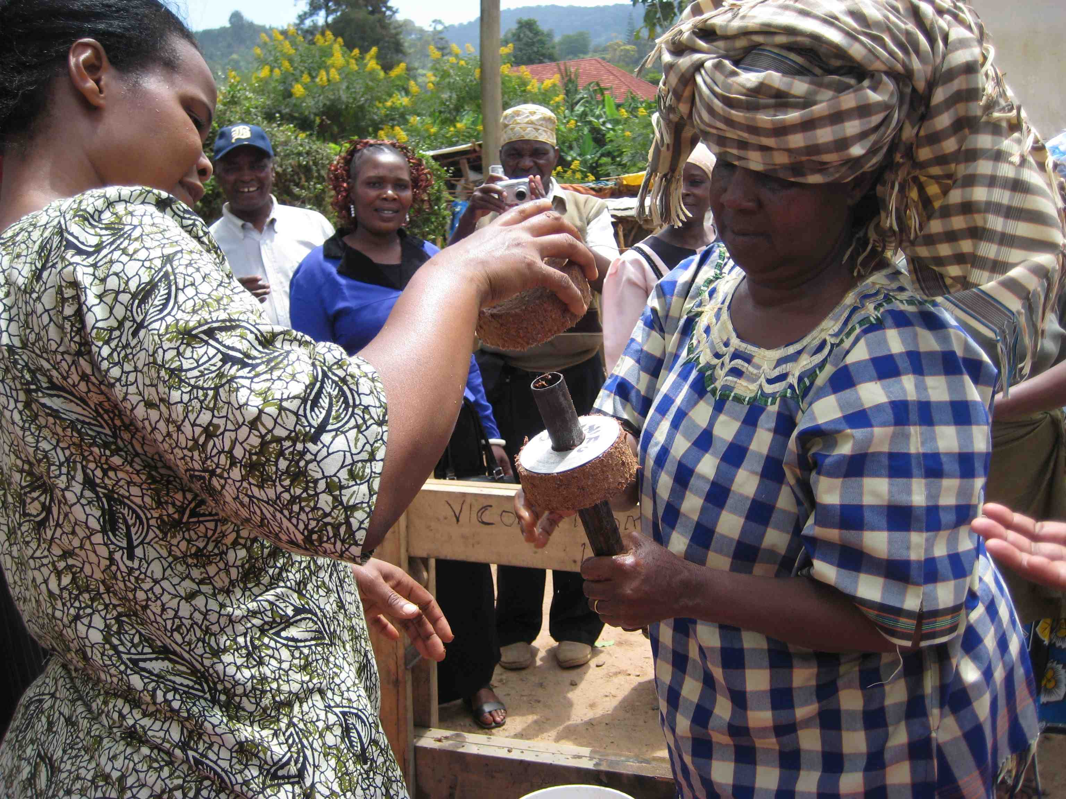
Caption: Mkombozi Briquette TOT 2009

Issues/Progress/Need
It is now widely recognized that deforestation is occurring at pandemic rates throughout the developing nations. In general, the Usambara forests in the Lushoto region of Tanzania are being denuded largely for fuel wood production/use. It is also well known that many people in the Lushoto region earn their income from fuel wood and charcoal production, distribution and sales thus creating a more complex problem. The women of the Mkombozi Group recognize that forest destruction will continue unless an equally attractive employment opportunity is found in the provision of a sustainable fuel alternative.

The Mkombozi Women’s Group is organized to produce biomass briquettes as a fuel wood and charcoal alternative. The group members were trained in the art and craft of biomass briquette production in 2007. At that time, they learned how to manufacture the briquette press technology and produce burnable and biomass briquette. They found that biomass briquettes made of easily and freely available agricultural waste products ( leaves, grass, straw) could replace their use of firewood and charcoal as a fuel. Once they were fully involved in the technology, they requested further training so that they could spread the word and skills and train others. Legacy Foundation then returned to train them as trainers in 2009. They are now an active briquette producing and training organization. They have trained many others in the biomass briquette making process, but need further assistance in developing the capacity of their training services to reach a wider audience. One key element lacking has been the ability to market their services in a professional and comprehensive manner. Legacy Foundation provided them with training in marketing techniques, but Mkombozi’s training center does not have the financial resources to put a comprehensive marketing plan into place. Their request therefore is for $1000 to enhance their marketing capacity for their training services.

Goals
- Substantially reduce, the rate of deforestation in Tanzania, especially in the Usambara Mountain region
- Establish a market for biomass briquettes as a fuel wood alternative
- Strengthen the market for biomass briquette training in the East Africa region

Project # 2: Myumboni Women’s Group Kenya: Leaders Mary and Francis Kavita

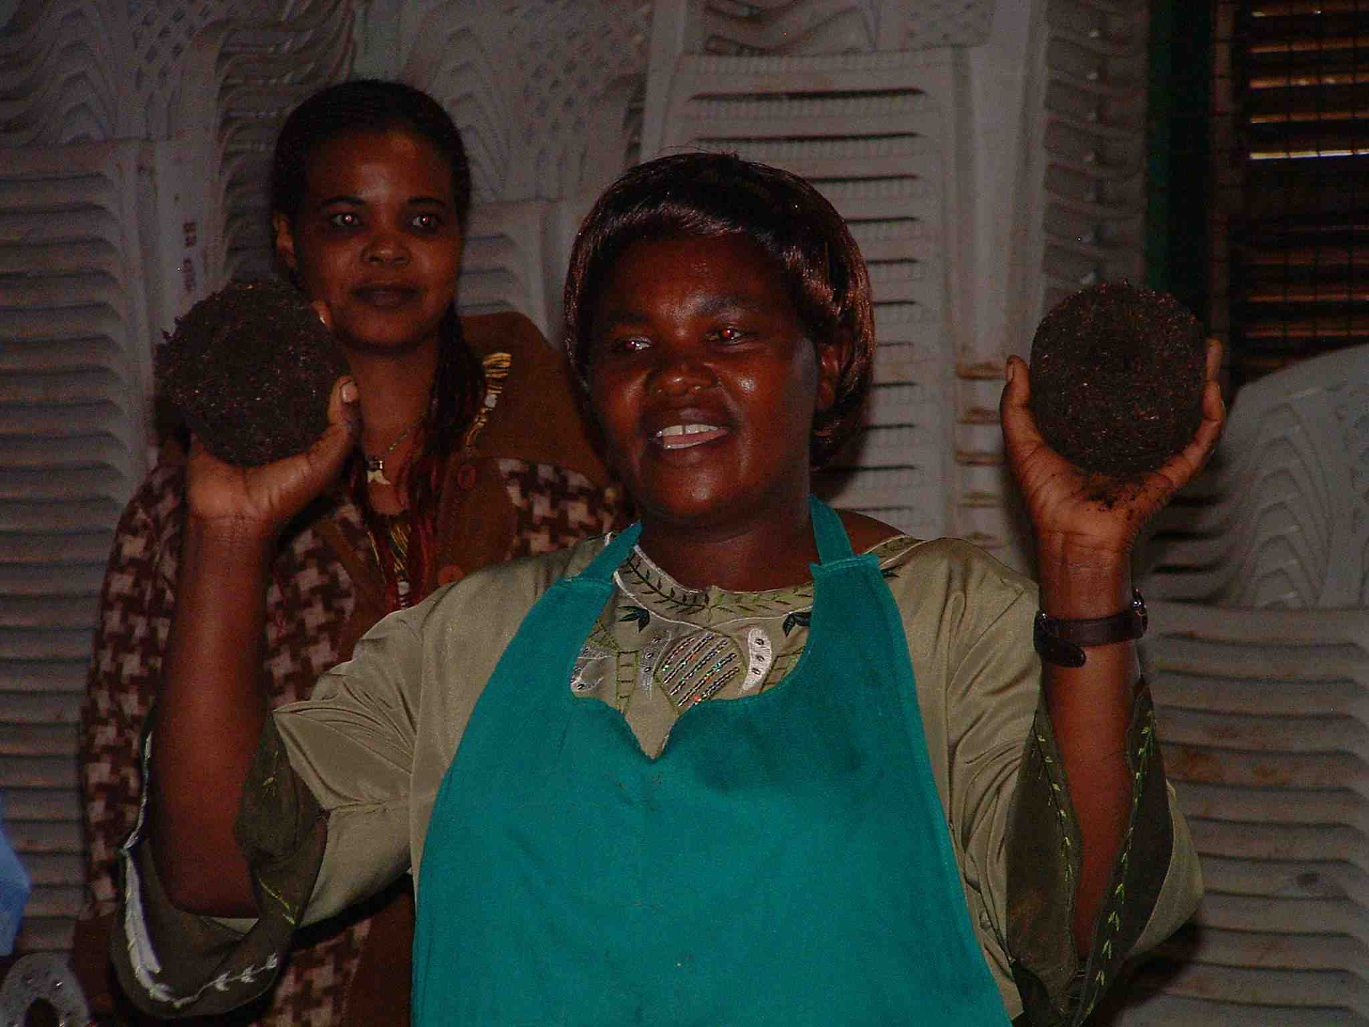
Caption: Mary Kavita proudly displaying briquettes to trainees

Issues/Progress/Need
The Myumboni Women’s Group initially received training from Legacy Foundation in 1999. Since then they have trained groups in Kenya, Tanzania and Uganda. They have extensive experience in both in provision of the briquette technology and in providing training of producers and trainers. Further, their own group is now self reliant in briquette sales in their region in Kenya, decreasing the need for and use of firewood as a local fuel.

Mary and Francis Kavita are the leaders of the Myumboni Group and use their cell phones as their main means of communication. Legacy Foundation refers them to various training options, but currently they receive emails through their son who lives in Nairobi. He receives their emails, prints them and then sends them by snail mail to Mary and Francis. Their simple and affordable need to expand their business is for a computer and a mobile modem so that they can improve their ability to communicate quickly and efficiently with potential clients in the region. Their request is for adequate funding to provide them with the necessary communications and marketing equipment to further spread the word about their excellent training capacity: portable modem, camera, computer.

Goals
- Substantially reduce, the rate of deforestation in Kenya and the East Africa Region
- Expand a market for biomass briquettes as a fuel wood alternative
- Expand a market for biomass briquette training in the East Africa region
- Progress

Project #3: Soroti Women Cooperative Union Ltd: Uganda
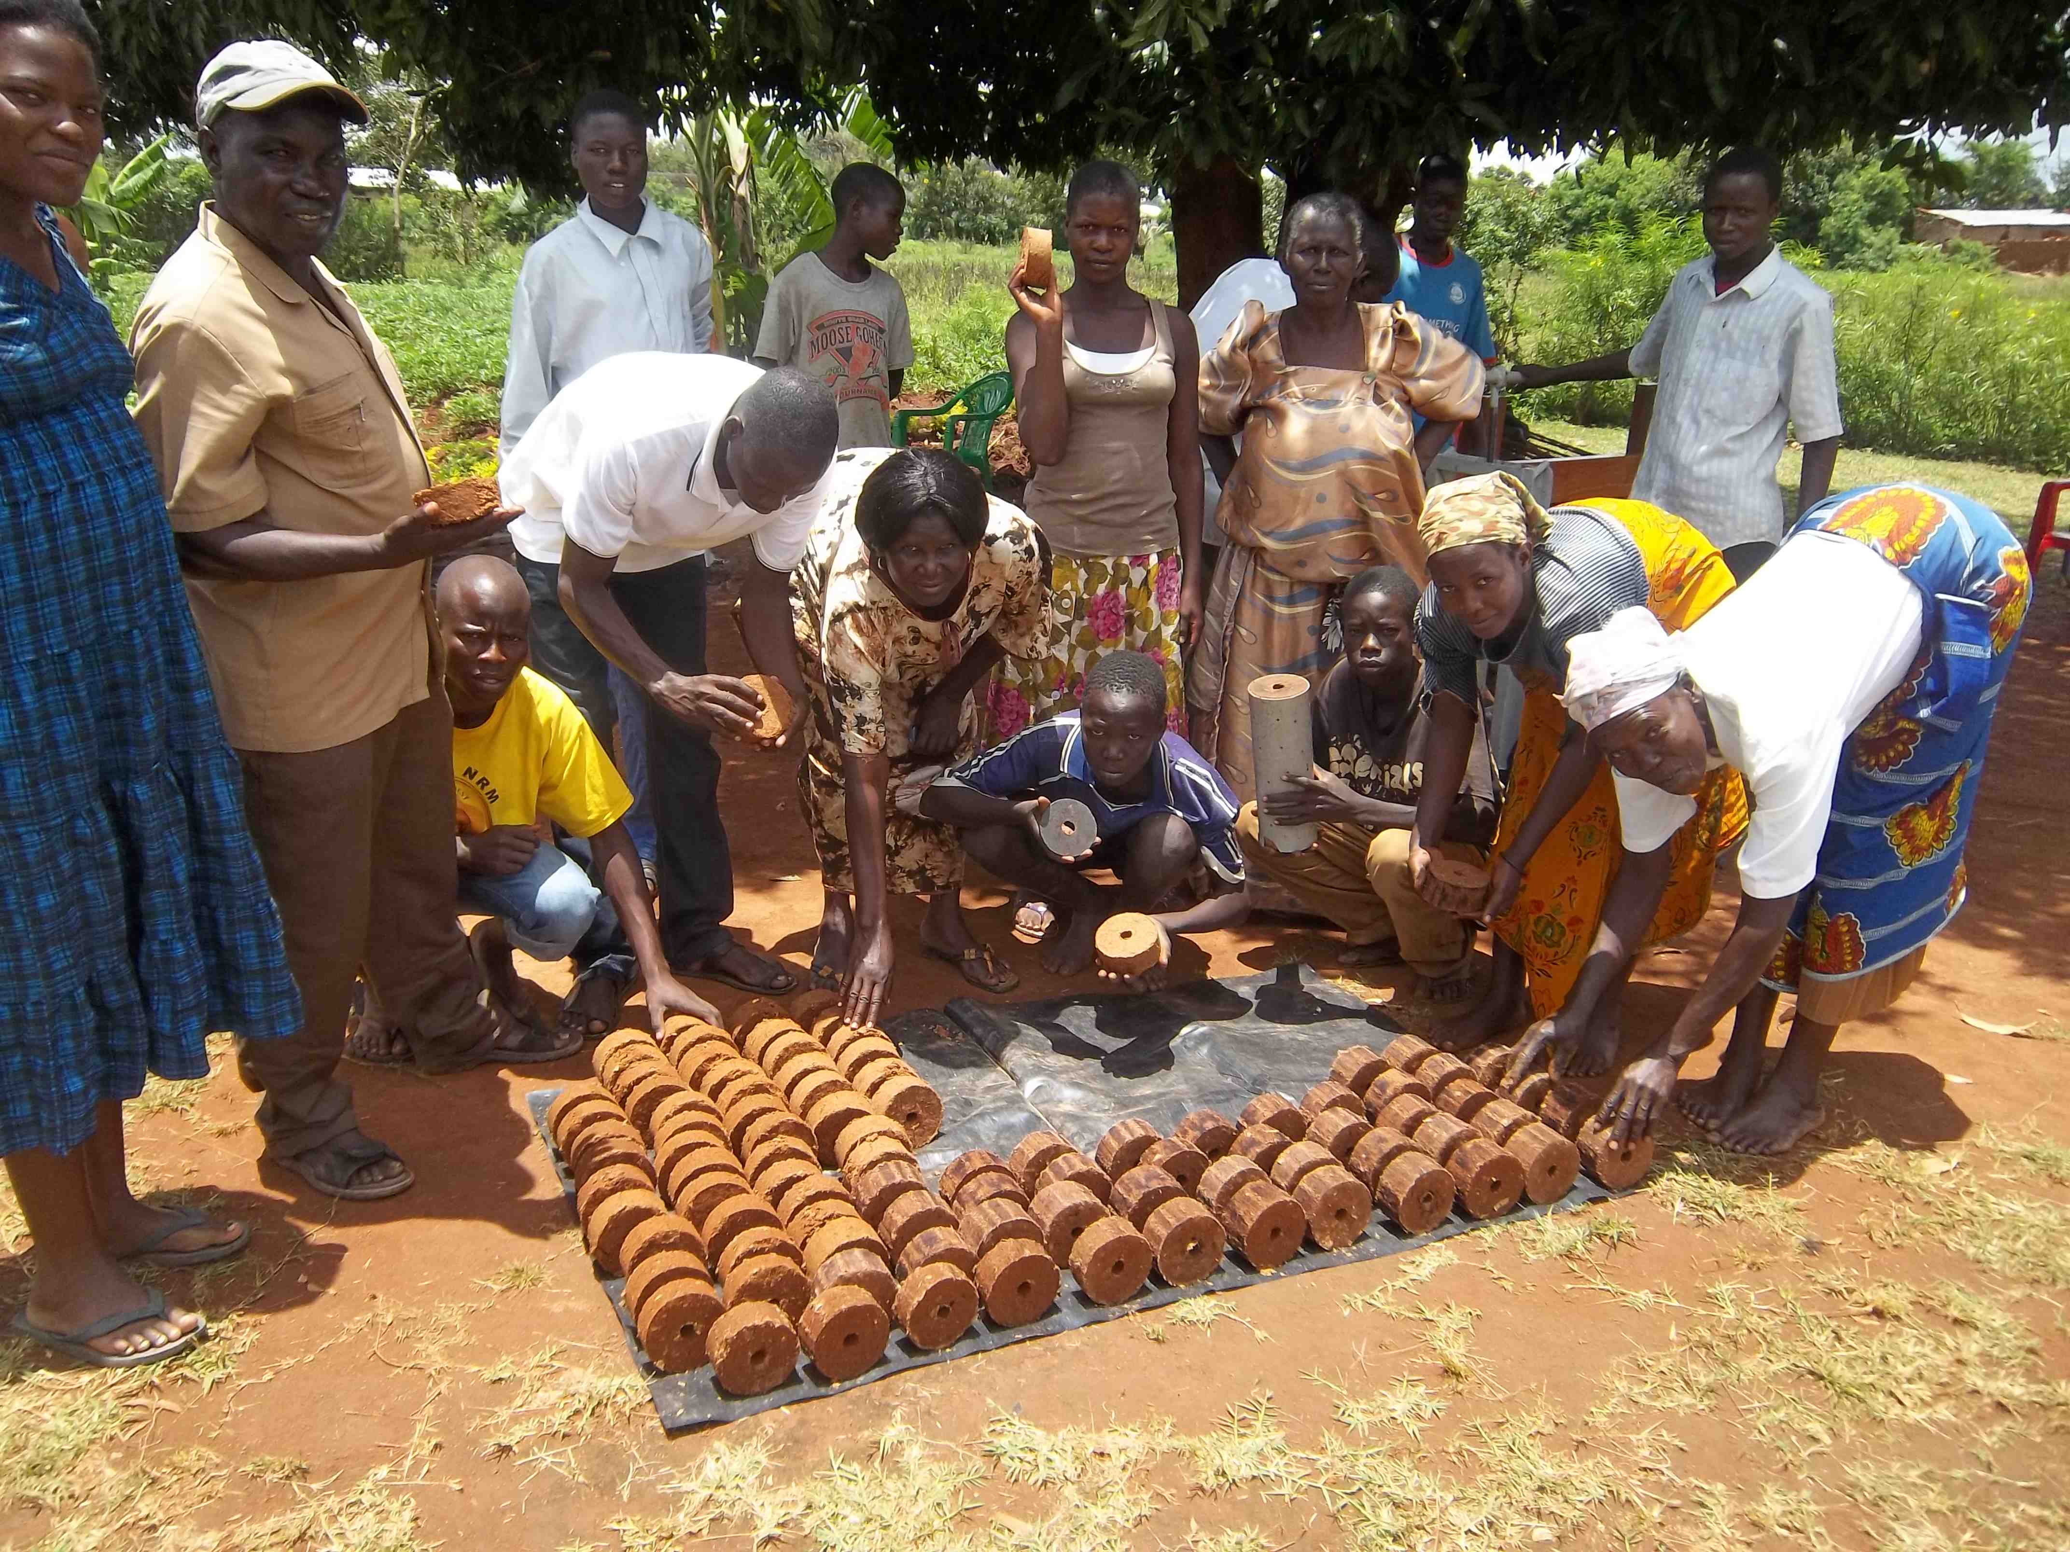
Caption: Soroti Group with their briquette production

Issues/Progress/Need
The Soroti Women Cooperative Union, Ltd, works with women’s groups to increase their capacity to be self reliant. Margaret Amongin, one of their leaders, received training in biomass briquette production in 2009 through the Legacy Foundation training of trainers program. Since then they received another small grant to help develop briquette making technologies. They have done some training in neighboring communities, but need support to provide food and lodging to local groups during the training program.

In addition to biomass briquette training the povide micro loan services for women in business, entrepreneurship training for women and youth, socio psychological support for HIV/AIDS infected and affected, commerical agriculture training and economic empowement for most vulnerable thru savings and credit training. Their current interest in environment conservation begain as a result of the biomass briquette training in 2009. They believe that ‘through persistence, hard work and research they shall be able to expand their work and provide more comprehensive support to their local communities.

Their initial request to increase their capacity and improve their reputation as biomass briquette trainers is for funds to provide a comprehensive training of women and youth groups including food and lodging for these small scale village groups.

Goals
- Substantially reduce, the rate of deforestation in Uganda, especially in the Soroti Region
- Expand a market for biomass briquettes as a fuel wood alternative
- Provide biomass briquette training to women’s groups in the Soroti Region/Uganda

Project #4: Women’s Biomass Training Center: Wau, Western Bah El Ghazal, South Sudan.

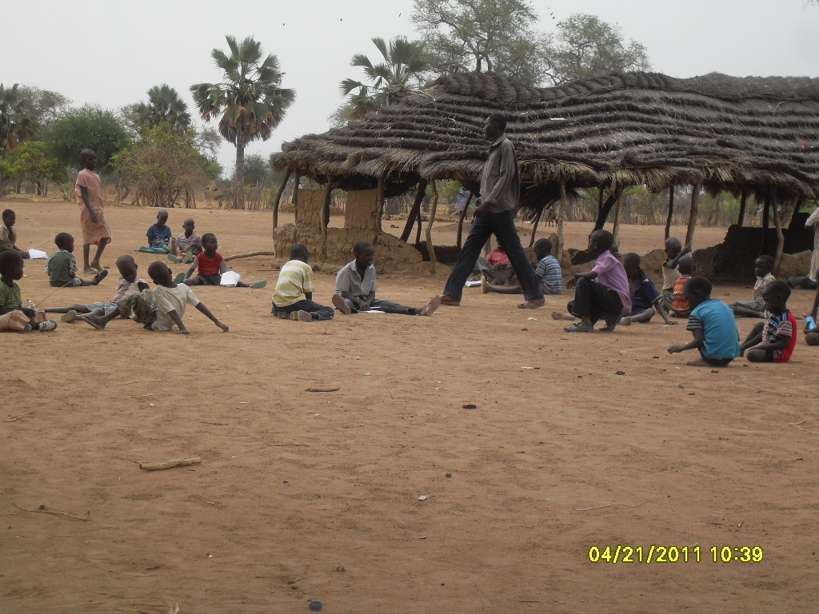
Caption: Current School/training center for Wau Village Sudan

Issues/Progess/Need

James Ochieng, from Kenya, has been instrumental, through his own resources and application for grants to support women’s group in the Southern Sudan. These women are mostly refugees and require considerable support to establish themselves in their new home region in Southern Sudan. James has established the business training center and has the goal to use briquettes both as a fuel and as a carrier for plants in a tree nursery. Their goal is both to make briquette and plant trees to support the environment and provide income to the women. Therefore the want to use as many packets as possible to create as many nurseries as possible. They have already started collection of the plastic bags for the nurseries but want to replace these with briquettes. They want to showcase biomass fuel from waste as the main alternative to firewood in the region. They therefore require general support to establish their training services, construct briquette presses and provide training to the various local women’s groups.
$1000 will provide training center/school start up materials, building materials, briquette production equipment, training resources, reforestation equipment.

Goal:
- Make three million briquettes
- Construct enough presses to provide one to each women’s group in the area
- Establish a nursery for at least 50,000 trees
- Provide income to local women.

Project # 5: Furaja Women’s Group: Hai District Tanzania

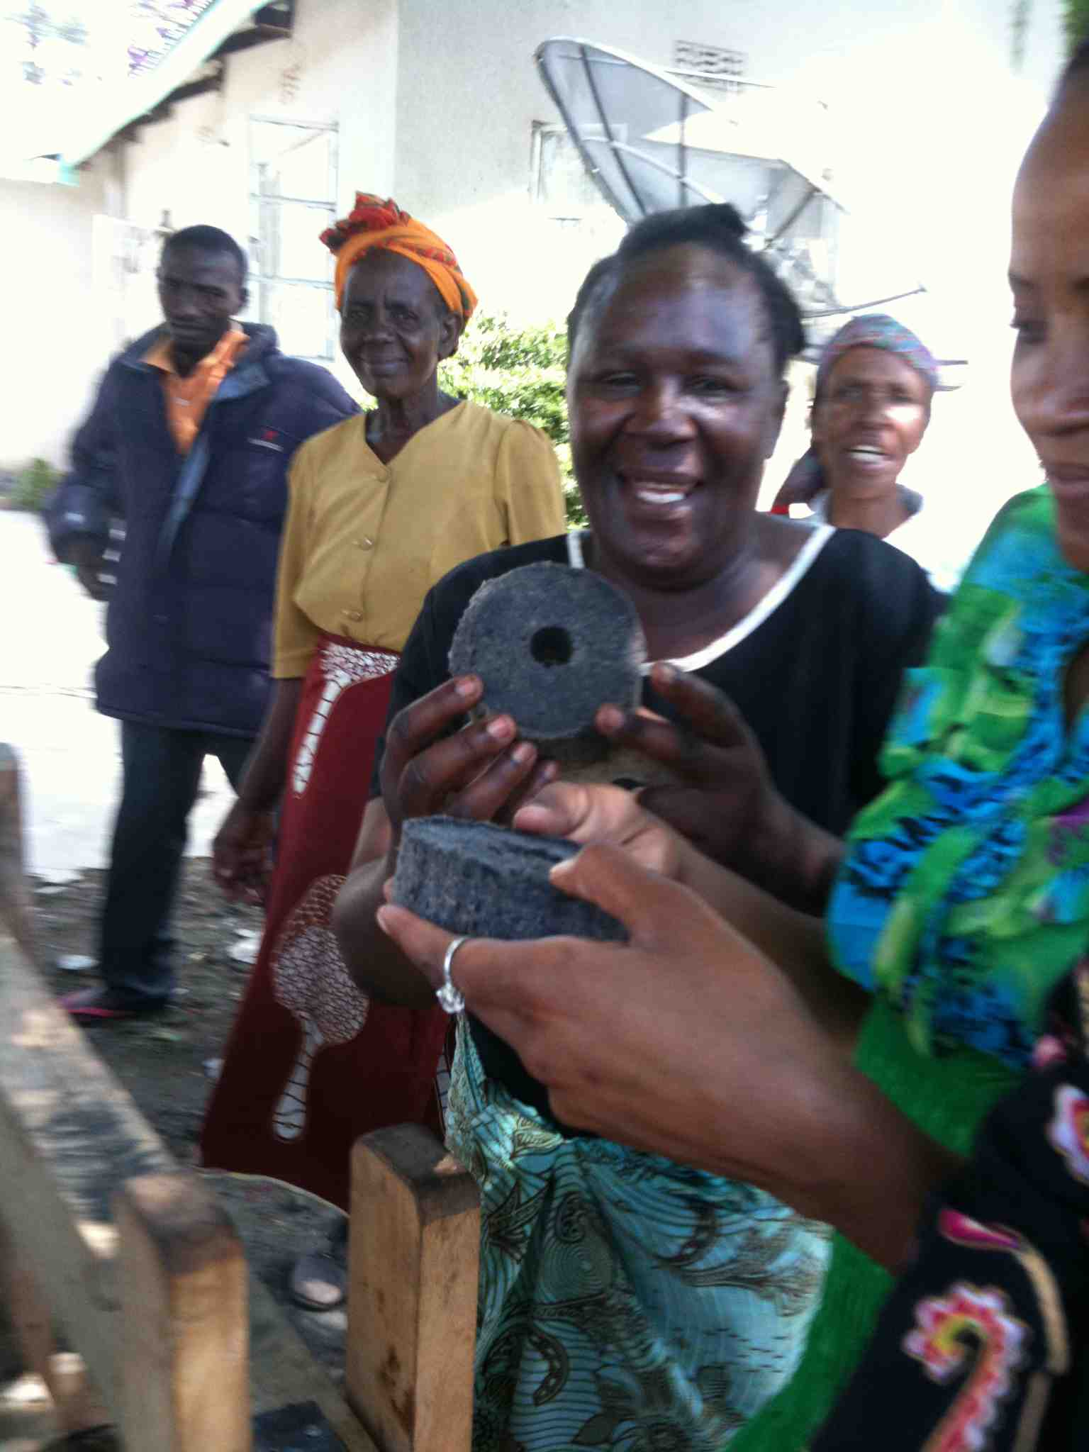
Caption: Furaja participants please with their briquettes.

The Furaja Women’s Group was organized to support women who are widows. They formed the group in 2005 and now have a membership of about 25 women ranging in age from 30 through 55, all of whom are the sole support of their families. They started their income generation activities by making and selling soap and recently heard about briquettes. The requested and received training from the Mkombozi Women’s group (see above) in October 2011 and are already actively producing high quality briquettes. Legacy Foundation staff visited their project in November 2011 and were impressed with their energy, commitment and growing expertise at briquette making.

Issue/Problem
The women are trying to earn a viable income to support themselves and their families. They see the briquettes as an excellent option but do not have the capacity to respond to the wide market they could reach. Furaja is ideally located along the Arusha-Moshi Highway in an area where charcoal is very expensive. If they were able to market and sell their products they could gain substantial income. Their impressive competence at running their soap business and briquette production bodes well for their success with some support for their business.

They need a maize mill to process materials and increase their capacity to produce a large number of briquettes in a short peridod of time. It has been proven the processing of materials is the most time consuming and expensive part of the process. With a maize mill they could increase production and potentially sell their briquettes along the main highway, thus also creating more publicity for biomass briquettes. They are requesting $1500 towards the purchase and installation of a maize mill for processing briquette materials.

OVERALL LONG TERM IMPACT OF THIS SMALL INVESTMENT

There is the old saying: Give a person a fish, they will have a meal: teach that person the art of fishing and they will eat for life. A key to making this work is ensuring that the fisherman or woman has all of the materials necessary to maintain their fishing business! This approach to capacity building has been the cornerstone of the training of trainers programs conducted by Legacy Foundation since 1999. The training of trainers approach and establishment of training services ensures that when the training is completed, the participants have the tools to start on their path to independence.

There may be bumps in the road or potholes, but the trainees have the skills to work their way forward. With minimal support to the trainers and their services, they have the potential to increase their own income while decreasing their use of fuel wood and thus conserving the environment.

