Livelihood for the poor peoples with Waste Management Program

Back ground
Aceh Province in general and in particular West Aceh Regency, is an area that has been wracked by decades of conflict, and then severely affected by the tsunami in 2004. During rehabilitation, a lot of development done and it provides many jobs and specifically West Aceh, unemployment was recorded 7600 people, whereas a lot of resources that should be processed and it can absorb the workforce in large numbers.
Fields such as waste management, rubbish strewn around the town, and very disturbing scene and for that we are from the of Acehnese Solidarity for Humanity Organization do a program that is expected to help people in getting jobs while trying to invite the community to create a clean and beautiful environment.
Waste management that we do have ongoing for 1.5 years, since January 2010 to the present by performing garbage collection around the town of Meulaboh, Calang and Jeuram conducted by employing 5 pedicab drivers, 3 collector, two warehouse workers and 7 women - working mothers, sorting, cleaning, drying and packing waste that is ready to be sold to a plastics factory that processes ore into finished goods. The whole work is arranged in or managed by a Fundraising Manager, under the supervision of Deputy Director.
In the journey, many of the problems we face, such is the result of lack of skill we have, then the lack of existing infrastructure and the latter is small due to the existing capital, so the business is growing but slowly. As a result of the three problems mentioned above, difficulties or challenges that we have is:

- The lack of skills resulted in only some types of waste that can be managed or only a few types of products that can be generated.
- Lack of facilities and infrastructure such as machinery, cars or rickshaws owned had an effect on many types of waste that is not managed, such as leaf litter plastic, cardboard, paper etc.
- Limited capital causes the entire activity is slow and this activity can only employ a little worker, but still a lot of people around the location of activities that need work.
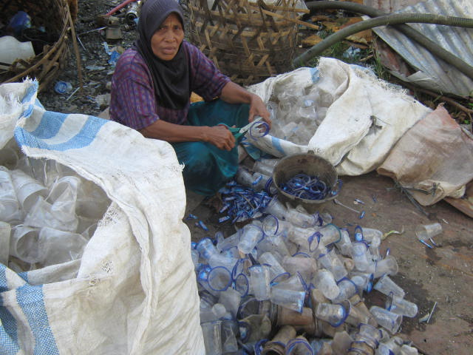
At the beginning of the activities, ASoH cooperation with local collectors who already have considerable experience in the management of plastic waste, which ASoH acts as a small part in the venture capital owners who then get the sharing of the profits. Today we perform independently of plastic waste management by setting up a business entity with the name " UD Damai Mandiri" located in the Gampa Village, Johan Pahlawan subdistrict with Plastic waste recycling efforts.

With 50 million Rupiahs in addition to supporting basic capital, machinery and warehouses installation support by AJWS New York, this business is walking slowly, because it is supposed to venture capital is needed at least more of 200 million rupiahs. This activity is under the control of Deputy Director who is fully responsible for all types of transactions and operational activities, or the manager directly underneath this is the Manager of fundraising activities that do all kinds of activities related to fundraising that is done, either through business organizations and other forms that are revenue for the all of the organization program.

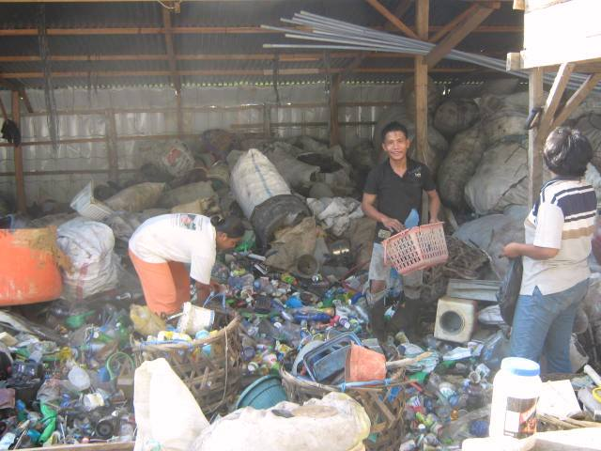
Plastic waste management at UD Damai Mandiri, currently has a semi recycling of waste to large-sized plastic seed types by hiring people who need jobs around the factory, plastic waste trash that has been processed nodes include the type of PE, PE color, A1 , HDT mambo, PP black, white HDT, Monty, pet and others. While several other types of waste that can not be processed due to limited capital equipment such as light plastic and paper, or plastic bag, paper, cardboard, or metal with a variety of types, if possible, then this business can only grow with the type of waste that others not yet processed, because many types of waste that we meet in different places and to date has not been processed is a waste of this type of leaf litter or plastic paper, the ingredients, ranging from various types of machines required, storage and drying floor to cost around 750 million Rupiahs , but if this can be realized, the benefits can be achieved, mainly from the reduction of waste and type of employment required shall the very large and have an effect on so many things, such as increased household economy, beauty and cleanliness of the environment, and the most important is the general manager of the organization independently of its effect on sustainable programs that can be implemented. Then the organization's role in enhancing self-reliance, independence and improved livelihoods can be achieved.

Objectives
1. Helped more of 100 poor families in finding jobs, so that their economy could be better
2. Encourage the creation of a clean and beautiful environment.
3. Encouraging people think the changing pattern of looking at waste as materials that are still valuable

Results to be achieved
1. More of 100 poor families get permanent jobs
2. Creation of a clean and healthy environment
3. Community can perform pattern - based reuse, sorting and recycling waste.

Organization structure Management and financial activities system
1. Program Organization structure.
Team Leader : Deputy Director
Field Manager : Fundraising Manager
Finance : Finance Manager
Workers Manager : Field Staff.

With responsibilities and duties of each are:

- Team Leader : Accountable for the program including the process of signing contracts, licensing, reporting, monitoring and evaluation, while in terms of finance, responsible for the program is responsible for the ratification process after the financial outlay requests submitted by program managers to be given to the financial manager.

- Executing program: accountable for any activity in the field / warehouse, manufacturing process of licensing, financial expenditure planning process, reporting process, the process of material purchase, production process, sales process, process monitoring, process evaluation, process of preparation needs of field staff, the process of withdrawal of financial and prepare all forms of requests and negotiating the sale price and purchase and prepare the field staff skill enhancement. And most importantly, implement the evaluation results to think about the process of improving the income of this fund raising activity.

- Financial managers: Prepare all forms of financial need after receiving a mandate from the party responsible for the program and then give it to field staff, prepare financial statements, financial expenditure plan by program managers, store all forms of financial transaction reports as well as monitoring and evaluation of financial conditions in the field.

- Field staff: Take full responsibility for the all workers, security field / warehouse, purchase and sale of materials, create a daily financial requests, make daily and weekly reports, organize the production process and make innovations required the approval of program managers for program progress.

2. Financial activities system.
All the process in the financial system that must be implemented in this program are as follows.

- Request for procurement of locations, making warehouse and the purchase of machinery and preparation of all forms of the initial process will be made by the responsible managers for submission to the charge of the program which is then forwarded to the finance manager for the money spent, which means the beginning of the process should start after the joint survey carried out and agreed by Deputy Director.

- Request daily needs for material purchases or other purposes related to business processes in the field conducted by field staff and then submitted to field manager then proceed to the charge of the program to be forwarded to the finance manager.

- Spending money daily by field staff in the process of purchasing materials based on the format that has been made ​​jointly to be a reference to money that spin can be more effective and solely for fund raising increased revenue.

- Wages will be paid by mutual consent or by regulations made by program managers in order to avoid unwanted problems.

Similarly, a plan was made to be a reference to the management of social business in AsoH_Meulaboh Organization. If there is a change or something that needs to be changed, it will be done in-depth discussion between the responsible person, manager and all staff involved in this program.

Budget Program
No | Budget Category | Unit Cost | Qty | Total Cost | US Dollars | From AJWS | Request from Another Donor or Global Giving
 |  |  |  | Local currency | US Dollars | From AJWS | Request from Another Donor or Global Giving
1 | Location and suppoting cost
1.1 | Land/warehouse rent | 5,000,000 | 5 | 25,000,000 | $2,840.91 | $2,840.91 | $0.00
1.2 | Land/warehouse service | 3,000,000 | 1 | 3,000,000 | $340.91 | $340.91 | $0.00
1.5 | Purchasing pedicap | 7,500,000 | 10 | 75,000,000 | $8,522.73 | $852.27 | $6,392.05
1.6 | Oil and pedicap maintenance | 100,000 | 60 | 6,000,000 | $681.82 | $2,130.68 | $511.36
Total |  |  |  | 28,000,000 | $3,181.82 | $4,034.09 | $0.00
2 | Destroyed hard palastic waste machine
2.1 | Destroy Mechine | 25,250,000 | 1 | 25,250,000 | $2,869.32 | $2,869.32 | $0.00
2.2 | Gear Box | 3,350,000 | 1 | 3,350,000 | $380.68 | $380.68 | $0.00
2.3 | Mover mechine | 11,700,000 | 1 | 11,700,000 | $1,329.55 | $1,329.55 | $0.00
2.4 | Bench mechine | 2,400,000 | 1 | 2,400,000 | $272.73 | $272.73 | $0.00
2.5 | Relocation basin | 1,250,000 | 1 | 1,250,000 | $142.05 | $142.05 | $0.00
2.6 | Destroyed knife | 1,350,000 | 1 | 1,350,000 | $153.41 | $153.41 | $0.00
2.7 | Travel cost | 2,000,000 | 1 | 2,000,000 | $227.27 | $227.27 | $0.00
2.8 | Instalation cost | 3,000,000 | 1 | 3,000,000 | $340.91 | $340.91 | $0.00
Total |  |  |  | 50,300,000 | $5,715.91 | $5,715.91 | $0.00
3 | Light plastic Machine
3.1 | Oven machine | 48,000,000 | 1 | 48,000,000 | $5,454.55 | $0.00 | $5,454.55
3.2 | Driyer machine | 10,000,000 | 1 | 10,000,000 | $1,136.36 | $0.00 | $1,136.36
3.3 | Destroyer | 80,000,000 | 1 | 80,000,000 | $9,090.91 | $0.00 | $9,090.91
3.4 | Press machine | 47,000,000 | 1 | 47,000,000 | $5,340.91 | $0.00 | $5,340.91
3.5 | Sending price | 10,000,000 | 1 | 10,000,000 | $1,136.36 | $0.00 | $1,136.36
3.6 | Install price | 12,500,000 | 1 | 12,500,000 | $1,420.45 | $0.00 | $1,420.45
Total |  |  |  | 207,500,000 | $23,579.55 | $0.00 | $23,579.55
4 | Medium of hard palstic mechine instalation
4.1 | Plate Wood 2x20x500cm | 50,000 | 35 | 1,750,000 | $198.86 | $198.86 | $0.00
4.2 | Pillar wood 10x10 x 500 cm | 60,000 | 9 | 540,000 | $61.36 | $61.36 | $0.00
4.3 | Pad wood 5x10x500cm | 45,000 | 20 | 900,000 | $102.27 | $102.27 | $0.00
4.4 | Zinc | 47,000 | 40 | 1,880,000 | $213.64 | $213.64 | $0.00
4.5 | Nail | 2,500 | 5 | 12,500 | $1.42 | $1.42 | $0.00
4.6 | Cement | 49,000 | 40 | 1,960,000 | $222.73 | $222.73 | $0.00
4.7 | Gravel | 200,000 | 2 | 400,000 | $45.45 | $45.45 | $0.00
4.8 | Sand | 250,000 | 2 | 500,000 | $56.82 | $56.82 | $0.00
4.9 | Salary for maker | 5,000,000 | 1 | 5,000,000 | $568.18 | $568.18 | $0.00
Total |  |  |  | 12,942,500 | $1,470.74 | $1,470.74 | $0.00
5 | Medium of Light plastic machine instalation
5.1 | Plate Wood 2x20x500cm | 50,000 | 350 | 17,500,000 | $1,988.64 | $0.00 | $1,988.64
5.2 | Pillar wood 10x10 x 500 cm | 60,000 | 90 | 5,400,000 | $613.64 | $0.00 | $613.64
5.3 | Pad wood 5x10x500cm | 45,000 | 200 | 9,000,000 | $1,022.73 | $0.00 | $1,022.73
5.4 | Zinc | 47,000 | 400 | 18,800,000 | $2,136.36 | $0.00 | $2,136.36
5.5 | Nail | 2,500 | 50 | 125,000 | $14.20 | $0.00 | $14.20
5.6 | Cement | 49,000 | 400 | 19,600,000 | $2,227.27 | $0.00 | $2,227.27
5.7 | Gravel | 200,000 | 20 | 4,000,000 | $454.55 | $0.00 | $454.55
5.8 | Sand | 250,000 | 20 | 5,000,000 | $568.18 | $0.00 | $568.18
5.9 | Salary for maker | 50,000,000 | 1 | 50,000,000 | $5,681.82 | $0.00 | $5,681.82
Total |  |  |  | 129,425,000 | $14,707.39 | $0.00 | $14,707.39
6 | Hard Plastic drier intalation
6.1 | Metal net | 9,500 | 100 | 950,000 | $107.95 | $107.95 | $0.00
6.2 | Frame of metal net | 120,000 | 10 | 1,200,000 | $136.36 | $136.36 | $0.00
6.3 | Drier field | 5,000,000 | 1 | 5,000,000 | $568.18 | $568.18 | $0.00
6.4 | Leveller | 25,000 | 5 | 125,000 | $14.20 | $14.20 | $0.00
6.5 | Tent plastic | 40,000 | 5 | 200,000 | $22.73 | $22.73 | $0.00
6.6 | Stock werehouse | 2,500,000 | 1 | 2,500,000 | $284.09 | $284.09 | $0.00
Total |  |  |  | 9,975,000 | $1,133.52 | $1,133.52 | $0.00
7 | Lightweight Plastic drier intalation
7.1 | Metal net | 9,500 | 500 | 4,750,000 | $539.77 | $0.00 | $539.77
7.2 | Frame of metal net | 120,000 | 50 | 6,000,000 | $681.82 | $0.00 | $681.82
7.3 | Drier field | 5,000,000 | 5 | 25,000,000 | $2,840.91 | $0.00 | $2,840.91
7.4 | Leveller | 25,000 | 50 | 1,250,000 | $142.05 | $0.00 | $142.05
7.5 | Tent plastic | 40,000 | 25 | 1,000,000 | $113.64 | $0.00 | $113.64
7.6 | Stock werehouse | 20,000,000 | 2 | 40,000,000 | $4,545.45 | $0.00 | $4,545.45
Total |  |  |  | 78,000,000 | $8,863.64 | $0.00 | $8,863.64
8 | Training for all staf and garbage collector
8.1 | Waste Management training for family | 2,500,000 | 1 | 2,500,000 | $284.09 | $0.00 | $0.00
8.2 | Composting Training | 2,500,000 | 1 | 2,500,000 | $284.09 | $0.00 | $0.00
8.3 | Waste handycraft training | 2,300,000 | 1 | 2,300,000 | $261.36 | $0.00 | $0.00
8.4 | Waste management factory training | 1,500,000 | 1 | 1,500,000 | $170.45 | $0.00 | $0.00
8.5 | Business managing training | 10,000,000 | 1 | 10,000,000 | $1,136.36 | $0.00 | $1,136.36
Total |  |  |  | 18,800,000 | $2,136.36 | $0.00 | $2,136.36
9 | Personal cost
9.1 | Program Coodinator | 2,000,000 | 12 | 24,000,000 | $2,608.70 | $0.00 | $1,826.09
9.2 | Field officer | 1,500,000 | 12 | 18,000,000 | $1,956.52 | $0.00 | $1,369.57
9.3 | Admint / account staf | 1,500,000 | 12 | 12,000,000 | $1,304.35 | $0.00 | $913.04
9.4 | Cashier | 1,500,000 | 12 | 12,000,000 | $1,304.35 | $0.00 | $913.04
9.5 | Machine operator | 1,500,000 | 36 | 12,000,000 | $1,304.35 | $0.00 | $913.04
9.6 | Employees of factory guards | 600,000 | 36 | 21,600,000 | $2,454.55 | $736.36 | $1,718.18
Total |  |  |  | 99,600,000 | $10,932.81 | $736.36 | $7,652.96
10 | Business capital
10 | Basic bussiness capital for Hard plastic | 50,000,000 | 1 | 50,000,000 | $5,681.82 | $2,840.91 | $0.00
10 | Basic bussiness capital for lightweight plastic | 200,000,000 | 1 | 200,000,000 | $22,727.27 | $0.00 | $19,318.18
10 | Mechine oil/ltr for Hard palstic machine | 4,500 | 88 | 396,000 | $45.00 | $45.00 | $0.00
10 | Hard plastic Mechine maintenance/day | 20,000 | 15 | 300,000 | $34.09 | $34.09 | $0.00
11 | Mechine oil/ltr for light palstic machine | 12,500 | 15 | 187,500 | $21.31 | $0.00 | $21.31
11 | Light plastic Mechine maintenance/day | 60,000 | 15 | 900,000 | $102.27 | $0.00 | $102.27
11 | Packing | 70,000 | 12 | 840,000 | $95.45 | $47.73 | $47.73
11 | Travel cost | 8,000,000 | 1 | 8,000,000 | $909.09 | $454.55 | $454.55
Total |  |  |  | 260,623,500 | $64,618.28 | $3,422.27 | $19,944.03
Total cost |  |  |  | 895,166,000 | $136,340.01 | $16,512.90 | $76,883.93
 | Overhead 5% |  |  | 44,758,300 | $6,817.00 | $825.64 | $3,844.20
 | Managemnt fee 20% |  |  | 179,033,200 | $27,268.00 | $3,302.58 | $15,376.79
Grand Total |  |  |  | 1,118,957,500 | $170,425.01 | $20,641.12 | $96,104.91
Remarks
1 | Destroy Mechine, gear box and mover mechine prize is per unit, no item inside.
2 | Thing or waste we want to make to be our bussiness is plastic waste
3 | Travel cost from Meulaboh to medan is 2 million Rupiahs, with capacity loading is 4,5 tons.
4 | After first send the thing, we continuing to buy use ASoH first fundraising budget, include the minimum for this budget request.

