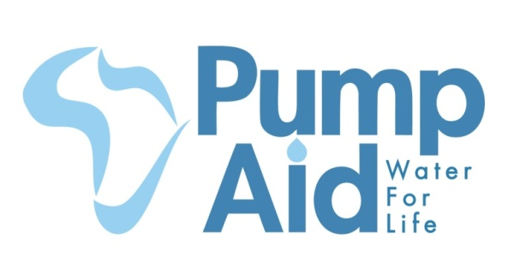
Project Completion Report
Clean water project for people in rural Malawi

The Elephant Pump Water Project in Chilowa village, Mchinji District, Malawi, generously supported by Individual Donors via Globalgiving.com
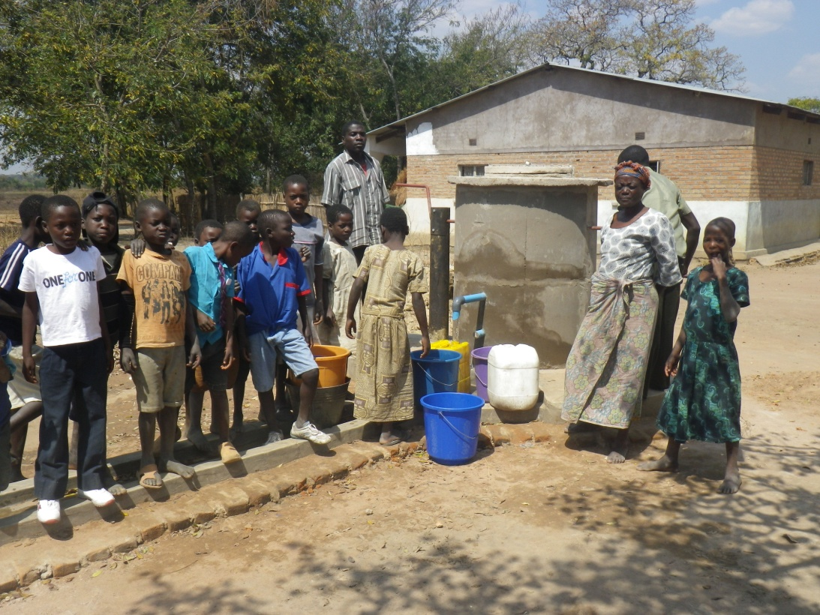
December 2012

The finished Elephant Pump in Chilowa Village with community members collecting safe and clean water thanks to your support.
The situation before the support of Pump Aid and Individual Donors from Global Giving
In Chilowa village the main water source was this hole in the ground. The water was dirty and caused illness throughout the village particularly affecting the most vulnerable people in the community, such as small children and the elderly. The hole often dried up, meaning the community would have to travel over a mile (1.5km) to the river, but this source was also dirty.
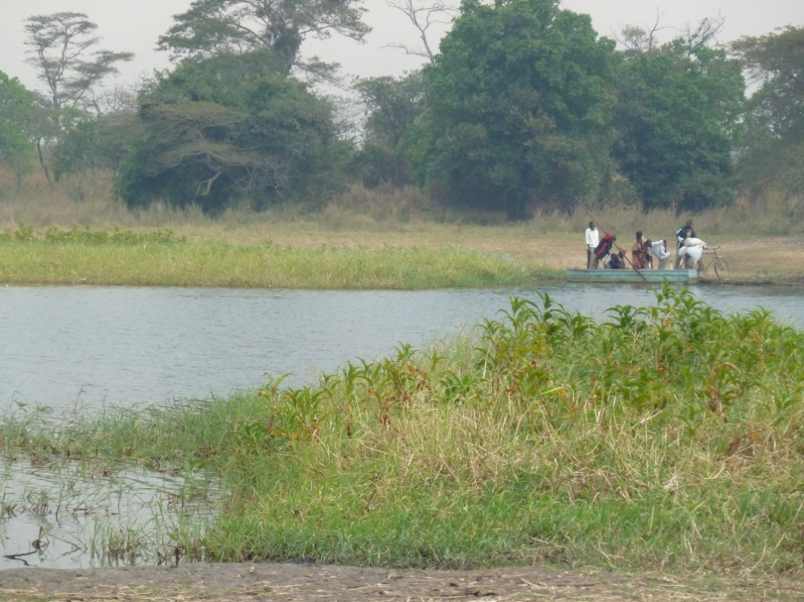
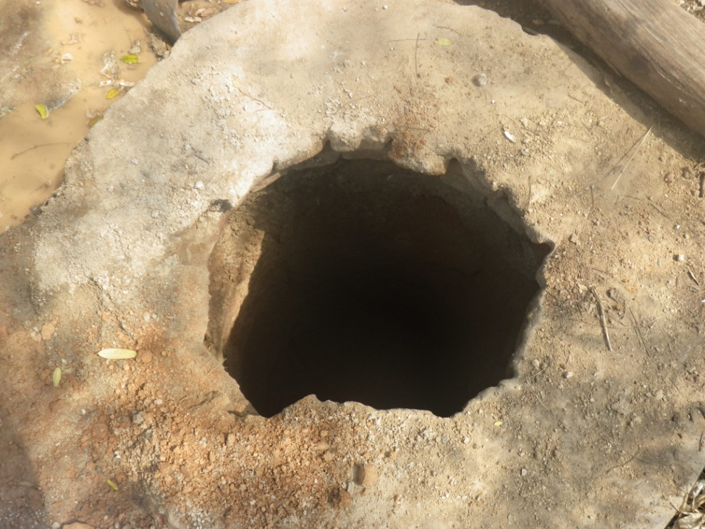

How we brought about a change
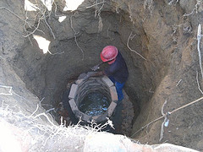
Before construction and instillation of an Elephant Pump community mobilisation meetings are held with the community. During these meetings open discussions are held regarding community needs and how Pump Aid can best meet these needs. Water was one of their high priorities. Pump Aid staff together with the community formulated a plan on how best they could contribute to the project with labour and simple materials.
Having identified this village as one with extreme need the Pump Aid team worked hand in hand with the community in well preparation and pump construction, to ensure that they would no longer have to drink dirty water that made the children in the village sick.
In Chilowa a hole for collecting water already existed. Pump Aid were able to deepen the hole, line it with bricks, seal it with concrete and install a pump, all of which transformed the hole producing dirty water into a well with an Elephant Pump producing clean water.
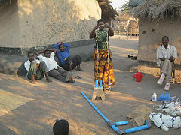
The Elephant pump is a simple solution for communities without safe and clean water. It is an improved rope pump designed to protect the water source from contamination, but also provide rural communities with a sustainable water supply that does not require high technical knowledge or large economic inputs for communities themselves to keep the pump working. To ensure that the community has the skills to complete any minor repairs necessary the team returned to the village to do training in August and September.
The situation now
The 35 households of Chilowa village now have access to safe and clean water. They no longer have to travel far distances to collect water that made their children sick. Because of the reduced distance travelled to collect water people can now collect even more water for simple domestic tasks that many people take for granted, such as washing clothes and household cleaning. At a cost of just £3070 the lives of the people of Chilowa village have been improved, demonstrated by the smiles on the faces of the community members below.
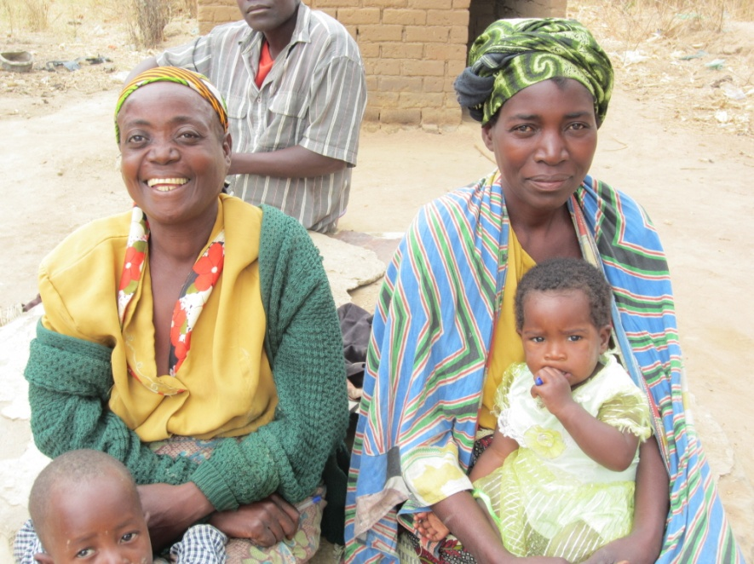
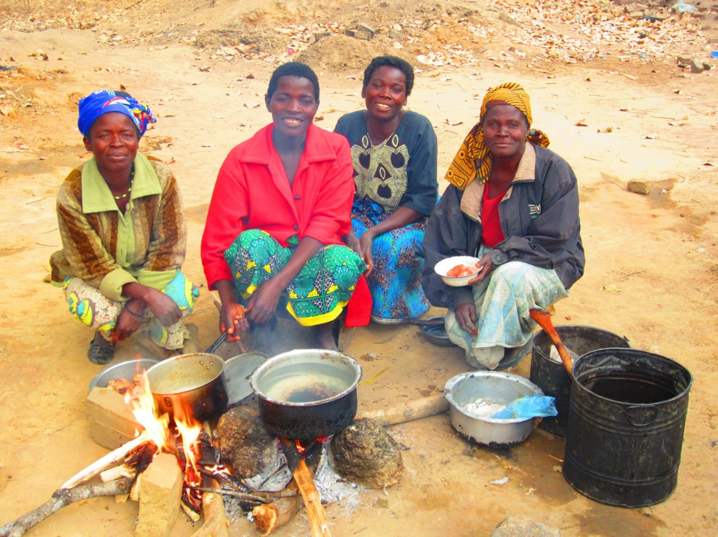

You can find Chilowa village on google maps (GPS, S (x): -13.43384, GPS, E (y): 33.15144);
Click here

Future
Currently 2.5 million people living in rural areas lack access to a safe water source (JMP Report 2012) but through this approach Pump Aid has already helped 300,000 people have access to clean and safe water. With the support of individual donors from Global Giving we will be able to continue helping villages in Malawi, such as Chilowa village, improving peoples’ lives through clean and safe water.
To find more information about how Pump Aid is changing people lives in Malawi please visit;
http:// pumpaid.org
www.facebook.com/pumpaid
http://www.globalgiving.co.uk/donate/1098/pump-aid/
follow us twitter: @PumpAid
or email us at; fundraising@pumpaid.org

