Abebu Engidaw, 18

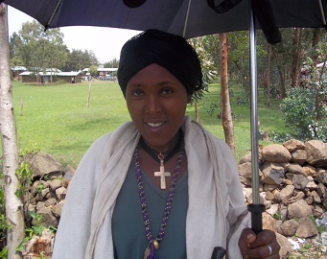
When Abebu got married four years ago, she was a fifth-grader at school. She was unaware of her marriage arrangement until the day of her wedding. At that time she was a shy girl, reluctant to ask about any reproductive health issues and unable to oppose her husband’s decision to have children. She got pregnant at the age of 15 and was forced to immediately drop out of school.

Abebu faced a long and difficult labor. She lost her baby during the delivery. Her husband wanted to try again. Abebu conceived and delivered a child at the age of 17. She asked her husband about using contraception, but he refused.

Around that time, CARE’s project started in her village and Abebu selected to be a group facilitator. She learned about family planning methods, and important life skills such as communication, negotiation, critical thinking and problem solving.

“I will never forget the training,” says Abebu. It opened my eyes and showed me how to lead my life.”

After leading a discussion with her group, Abebu decided to talk to her husband about sexual health and contraception. After their conversation and reading Abebu’s training, her husband’s attitude began to change. They agreed to use contraceptives and decide together when to have their next child. She said her husband encourages her to continue discussions with her peers and is even sharing some of the household chores with her.

