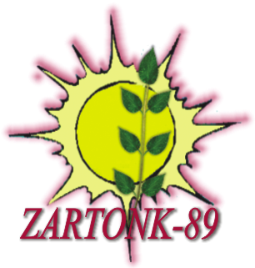 PROJECT PROPOSAL

The title of the project Online Olympiad
The implementing organization Zartonk-89 NGO
The implementation place Republic of Armenia
The aim of the project
To assist youth and teenagers from different countries in raising journalistic research skills in the sphere of education, right and culture by using information technology in the Republic of Armenia.
The objectives of the project
Online Olympiad will be held in the sphere of human rights, education and journalism.
Target group
500 young people at the age of 13-18 from Armenia and other countries.
Implementation schedule / calendar description
- Competitive tasks and website will be created and the tasks will be posted on the website, advertising trailer production for 4 weeks.
- Will be realized necessary advertisement, awareness and coverage with mass media (newspapers, radio, internet and so on) for a week.
- Organizing meetings, discussions and cultural dialogues (4 times)
- The participants will register, they will do their tasks in 30 days period and send them to the mentioned email for 3 weeks
- The works will be checked and assessed for 2 weeks
- The winners will be encouraged with prizes; their works will be posted on the Internet, results summary of the project and submission of final report for 2 weeks.

Description of the project
The main objective of the project is to create educational and cultural environment where the given chance of new media will be used for the benefit of the teenagers / young people where information technologies will be used as an active factor in the educational process, where by means of competition children will reveal applied inexhaustible opportunities of new media.
In the result of the project Journalistic Online Olympiad will be held on the sphere of human rights, education and journalism where can participate everyone at the age of 13-18 from Armenia. Topics will be suggested to the participants; they should fill in the tasks and send them by email in 30 days period. The tasks will be posted on the website of the project. The winners will be awarded with prizes. In the initial stage of the project information meeting – discussions on the human rights and journalism will be organized; the whole process and the results of the project will be widely highlighted in Press and Internet.
The expectations of the project
The project will help enhance the usage of new media in the sphere of education and culture, increase the number of teenagers using media resources, and assist in their free speech and thought, identification of other nations .It will encourage the beneficiaries to write themes on mentioned spheres, to make media materials, which will take a chance to learn how to use internet as a tool of education, culture and information spreading.

