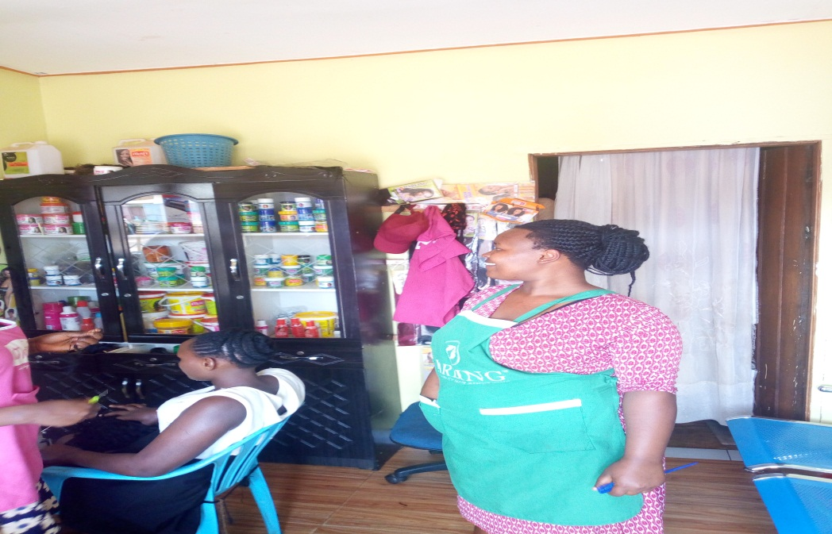
The picture above shows Orishaba at her saloon in Nansana.

