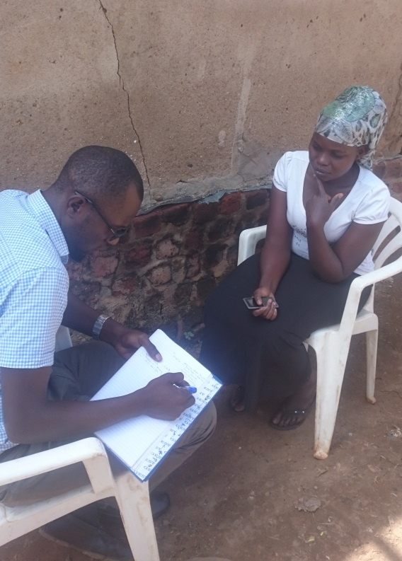 | 
Above is Shakira interacting with the M&E Associate during a monitoring visit in Kampala

