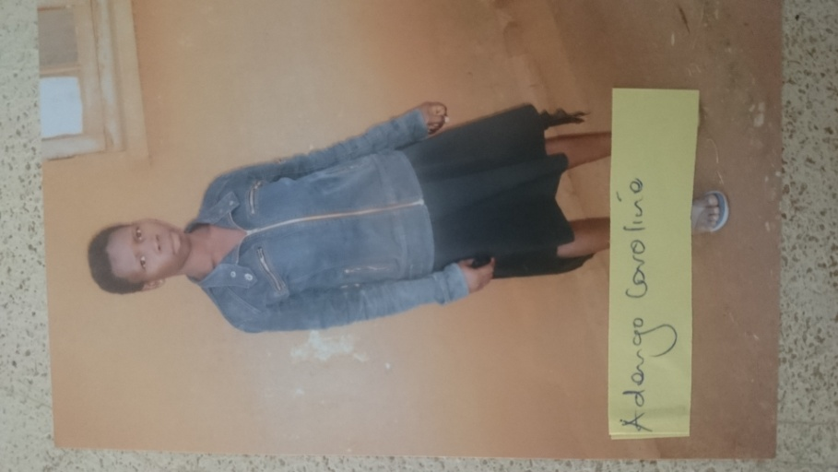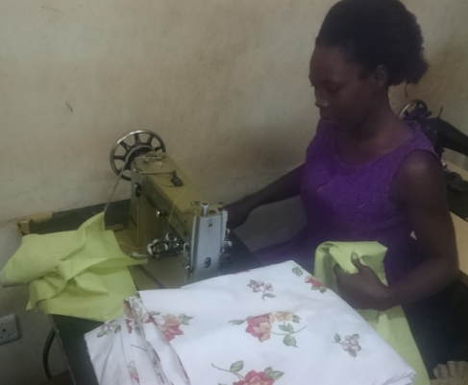
Above is Adengo as a domestic worker and on the right worrking in a tailoring shop in Kampala where she earns 150,000/= per month

