MUSENERO’S CASE STORY.
Musenoro is a 19 year old hair dresser working at a saloon in Kafunda, Sub County in Wakiso district. On a good day Musenero makes between 6000 Uganda shillings – 8000/= a day depending on the clients that come in at the saloon. She is very grateful to PLA for the great work that they did by enrolling her in school because her life completely changed, she shared with us that now I cannot go hungry, i pay for my rent and that of my brother and also save 1000/= per day in a saving group and I agreed to get her money when it accumulates. Musenoro plans on starting her own saloon after her savings accumulate and she believes that she can start small with the capital of 400,000shs.
Before Musenero was enrolled at Nile vocational Institute by PLA she was doing domestic work at home and also washing clothes for neighbors to earn a living. She used to stay with her father in Kawempe since the father separated with mother, however the mother also does not have a constant source of income; she is a substance farmer in the village. Musenero’s father had many children so he could hardly meet any of his children’s basic needs that’s why she dropped out of school in her primary seven (P.7) without completing it. So during mapping in Kawempe PLA identified her and later enrolled her in school at Nile vocational Institute in Ntinda for six months and later took her for internship in Ntinda for more two months.

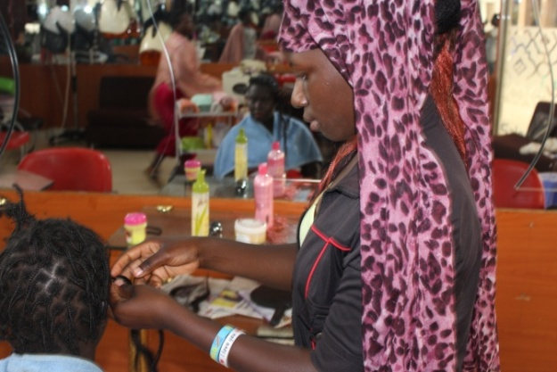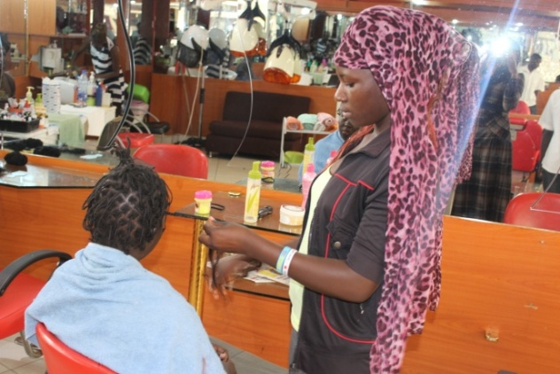
The above photos shows Ms. Masenero during her internship in Ntinda.

