REPORT: MAY-JUNE 2012
PROJECT: EMPOWER CHILD DOMESTIC WORKERS
Subject: 99 former child domestic empowered
Platform for Labour Action through the Global Giving donors has impacted on many youths’ lives in Uganda particularly in Kampala. PLA identified 99 (68 girls and 31 boys) CDWs in 2011 from Nsambya police barracks, Kabalagala, Katwe and Kibuye. Who were withdrawn, rehabilitated and placed at Nile Vocation Institute to take on six months courses in hair dressing, motor vehicle, catering and tailoring. During their stay at the institution, monitoring visits were carried out to check on their progress and provide psych social counseling as well as deliver requirements like soap, shoes, clothes, mosquito nets, sanitary towels, bed sheets, and blankets among others.
PLA through her partnerships with SCD Darling, a cosmetics company, visited PLA beneficiaries at NVI taking hair dressing and taught them how to make different hair styles, hair maintenance, colour selection, saloon maintenance and customer care. The company also provided aprons and posters showing different hair styles and t-shirts to the said beneficiaries. .
After six months, the said beneficiaries graduated and were resettled with their guardians. They are now involved in meaningful employment in saloons and garages. During follow-ups made,they were happy to be involved in work that does not exploit them

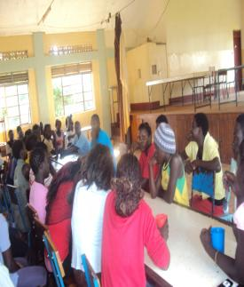
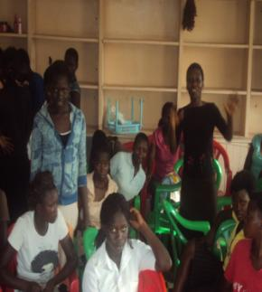

(These are the PLA beneficiaries being counseled (This is a photo of PLA beneficiaries in the by PLA staff, Ben and Nicole. hair dressing class conducted by SCD Darling)

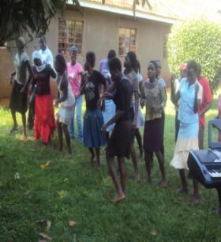
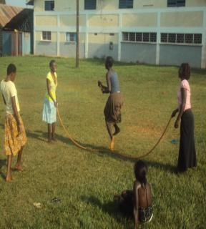

Above: Beneficiaries playing at their school administration compound.

