48 Hair Dressing children benefit from a private company

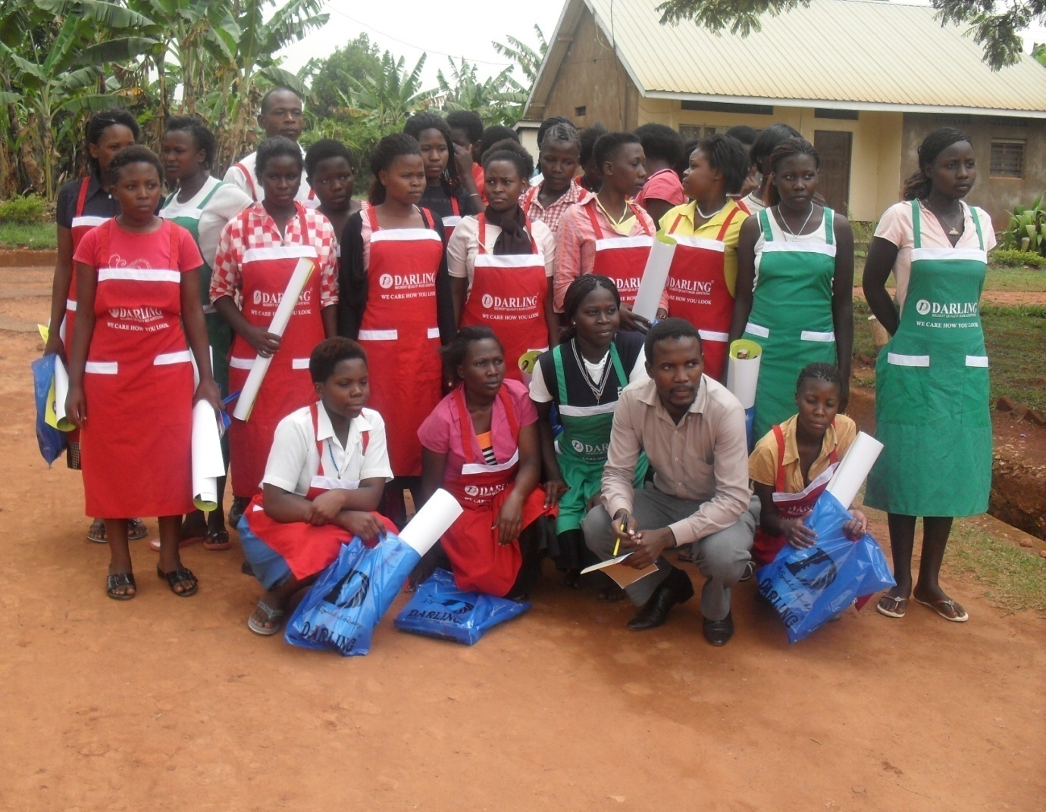

SCD-Darling Ltd is a company that manufactures Beauty products in Uganda specializing in Hair products. During the January to March 2012 they visited the former child domestic workers in Nile Vocational Institute. During the visit they conducted training on how to use the hair products – hair extensions and a variety of creams and shapoo. Theywere trained on hair dressing by the Darling hair technicians.

Peter Mukabire, sales executive of SCD-Darling Uganda said, “As a company we have done this to carry out our corporate social responsibility to help improve on the standard of living of children. We do these by taking our hair specialists to train vulnerable girls like the beneficiaries of PLA on how to use our products.” This helps them to understand how to use the beauty products for better results on their future clients.

In addition to the training the 48 girls were offered aprons by SCD darling. In appreciation of the support, one beneficiary, Atuhairwe Winnie, thanked PLA for the session because it’s one way of showing beneficiaries that they care about them. In her remarks she said that, ‘I had always heard about Darling company on radio but didn’t know that I was using their products, thank you Darling company for teaching us, thank you so much my sponsors may God bless you people’.

The aprons donated are worth USD 155.

We are planning to engage more companies like SCD-Darling in Uganda to support our cause. These children have completed their training at the Nile Vocational Institute. We intend to follow them up and see how the skills they have acquired better their lives.

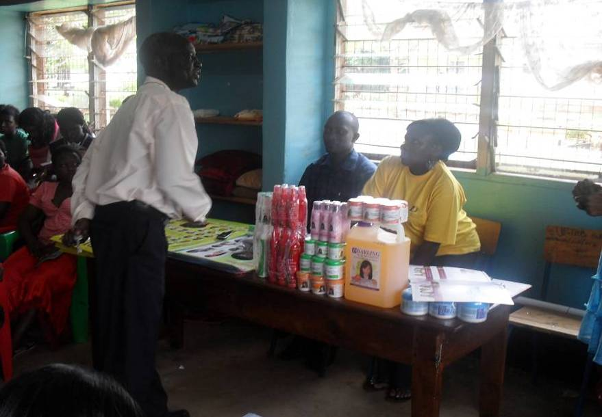
Dean of students introducing the team to hair dressing class

Left, Nsubuga Mary- Hair technician facilitating the seminar. Right beneficiaries during the seminar


