ADENGO

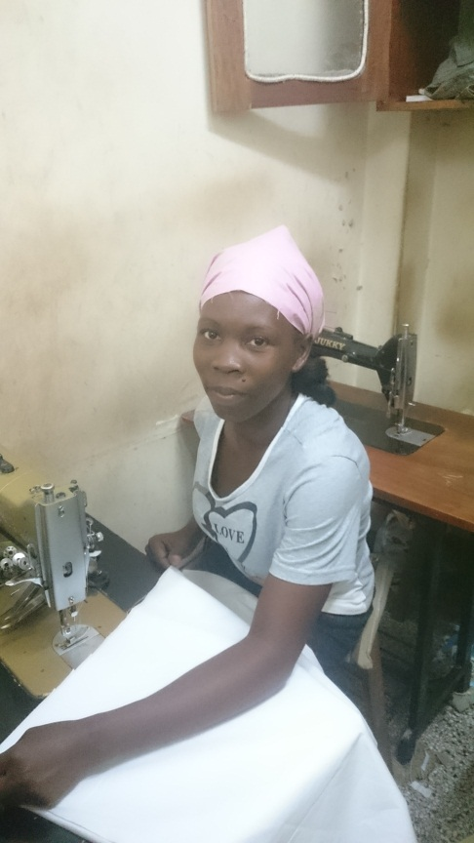
Adengo making a bed sheet at her work place at Copper Complex in Kampala.

