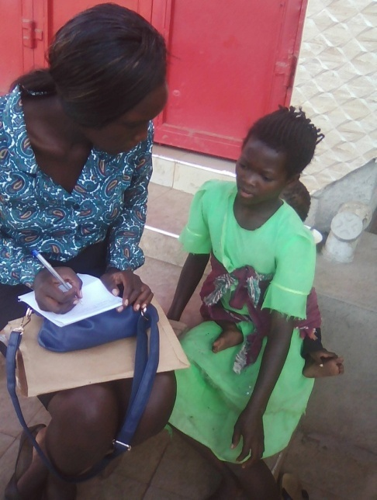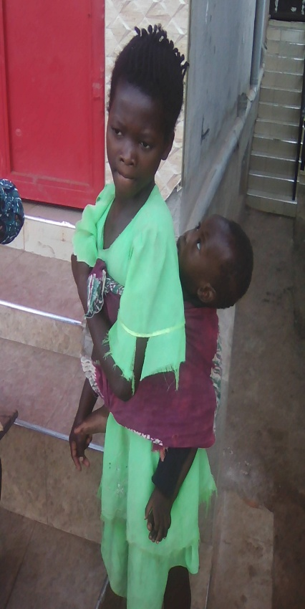
Above: Extreme left, the program assistant capturing Aberuchan’s case story and on the right Aberuchan carrying the employer’s baby on her back
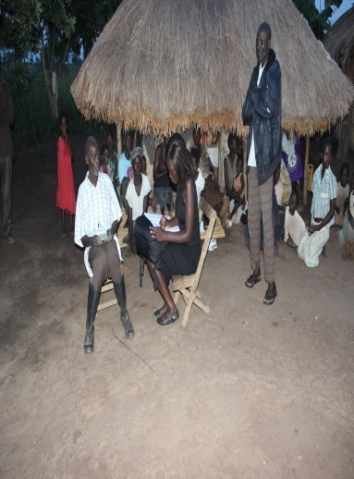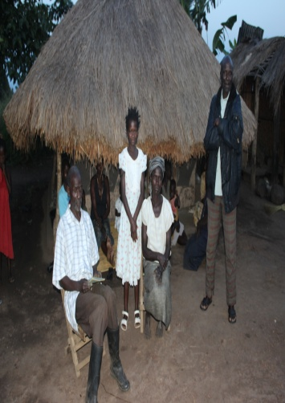

Above: Aberuchan Aberuchan during her reunion with her parents in Masindi District in Bokwe village

