Elegantly Embellished

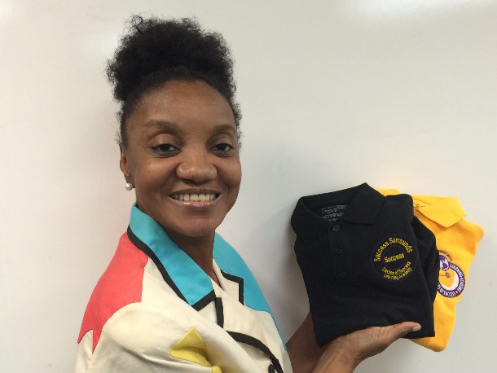

Ms. Cheryl, a food service worker at the VA Medical Center, is always eager to learn new things. She found out about RISE through a flyer that was mailed to her home and decided to register for the next Save Up program orientation session. Cheryl was thrilled when she found out that she had been accepted into the program. Initially, she came into the program with the goal of purchasing a vehicle, because at the time, she was having transportation problems. It was evident the minute she came to the first Save Up workshop that she was about to go through a transformation.
That night, the facilitator led a discussion about using your talents as a financial resource. Everyone was asked to share a talent or hobby that they possessed that could be used as a money-making venture. When it was Cheryl’s turn to speak, she shared with the group how much she enjoyed machine embroidery. As a single mother of three, Cheryl learned how to do machine embroidery to inexpensively personalize her children’s clothes and had become quite good at it. Friends and relatives saw her work and started asking her to personalize their items too. She happened to have a sample of her work with her and showed it to the group. You could feel the excitement in the room as the participants passed around the tote bag, embroidered with her initials. Finally, someone spoke up, “you should start your own business!” Her Save Up classmates encouraged her to think about stitching as her asset goal to micro-enterprise and the rest is history.
Cheryl enrolled in a partner agency’s micro-enterprise training, and wrote her business plan. Once she reached her savings goal with RISE, she obtained her business license and purchased her equipment to officially start her business, Elegantly Embellished.

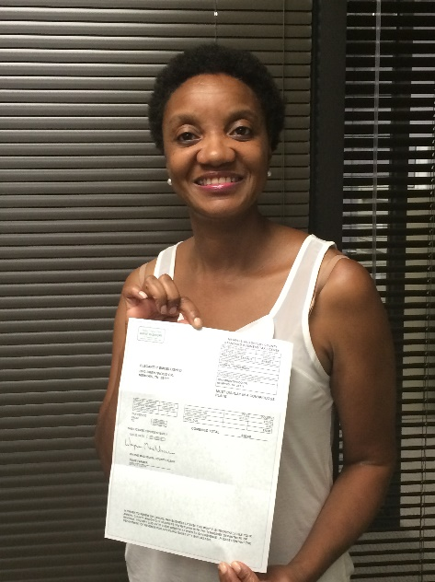
She stated “I had always dreamed of becoming a business owner and never thought that I would have the resources to make that dream a reality. RISE has shown me that if you acquire the knowledge, put your knowledge into action, and be persistent, your dreams and aspirations can come true. I had never been a saver before becoming a Save Up participant. The staff never let me give up. They stayed in contact with me, I attended RISE events and it kept me motivated. I felt that someone cared about me.” Cheryl recently completed a large order embroidering logos for school uniform shirts.
Even though she has completed the program, Cheryl plans to keep her savings account and make monthly deposits for a “rainy day” fund.

