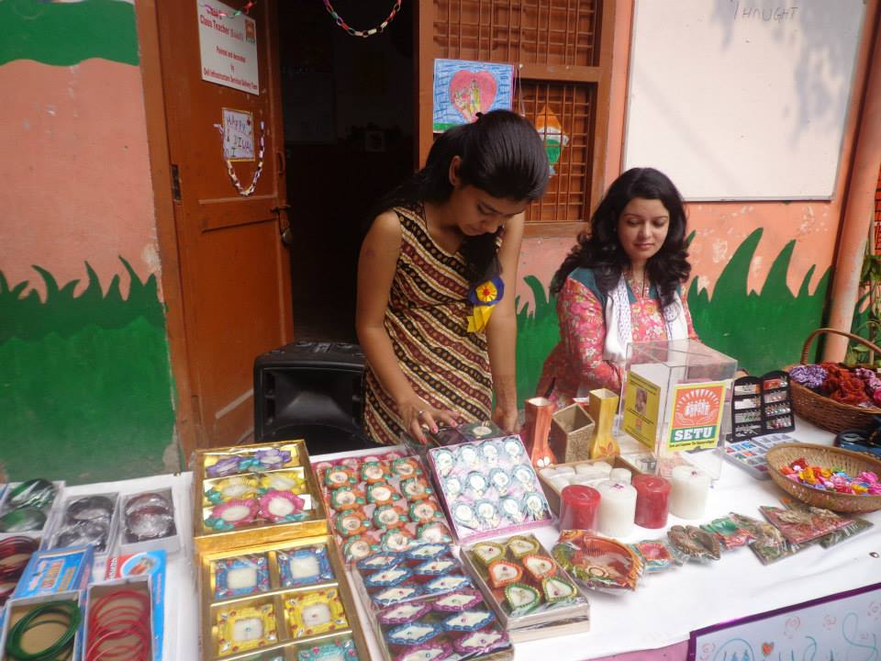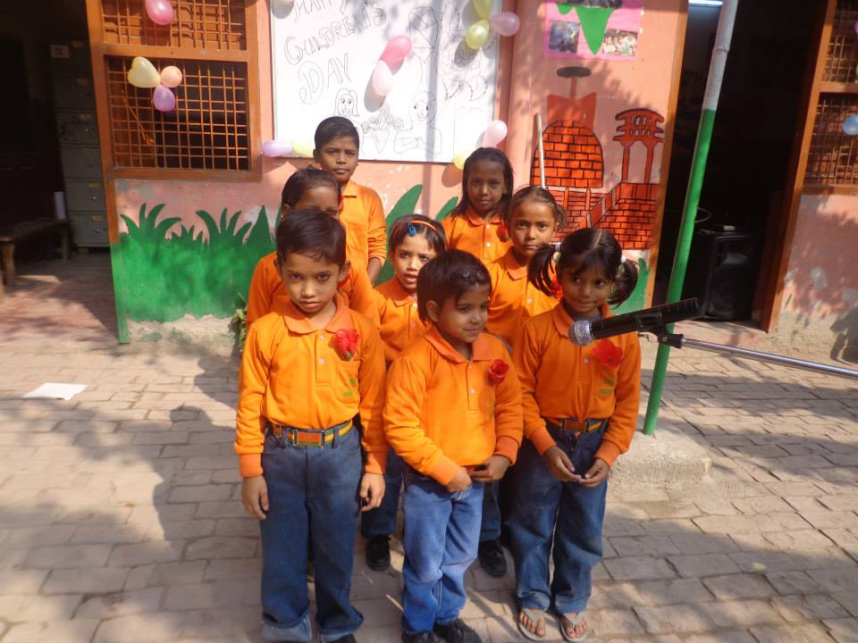

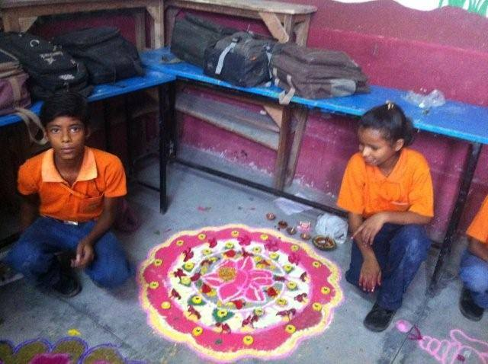

Colourful Rangoli made by our students

Diwali Mela at SETU

Tiny Tots at Children's Day

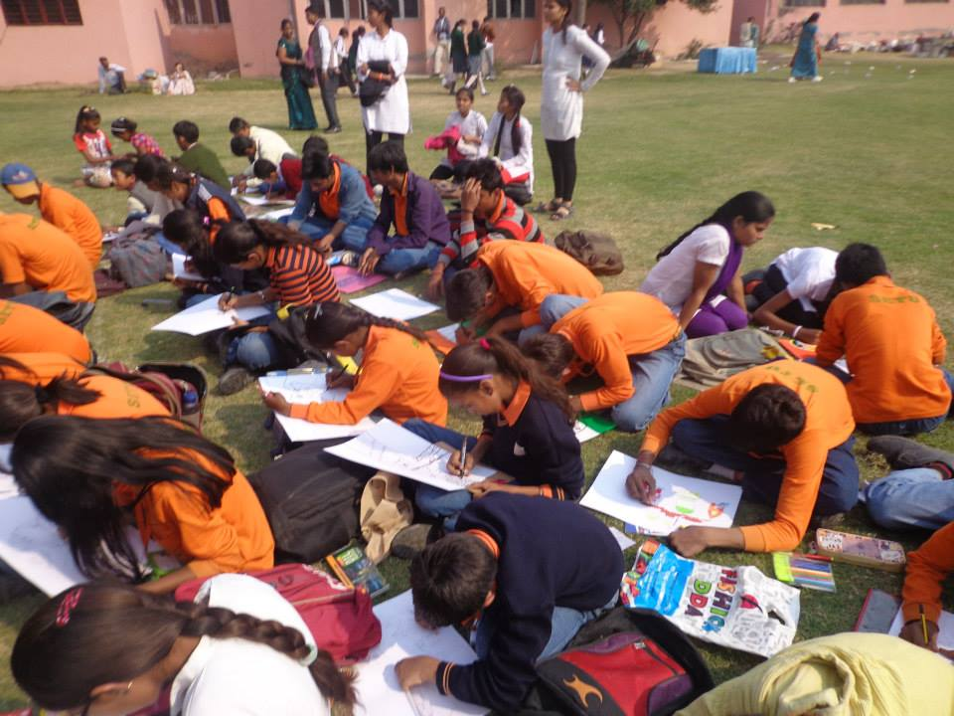

Setu Students at Bal Diwas Mela organised by Lioness club