A Project of: - Give a Smile to 3000 Slum Children to attend School
Implemented by: - Ruchika Social Service Organization
A Project of :- Give a Smile to 3000 Slum Children to Attend School
Implemented by:- Ruchika Social Service Organization

We are happy to present the 3000 Slum children to attend school project before the donor agency and all other well-wishers. This was the most difficult one and we had to take a lot of difficulties to cross this quarter of intervention due to unexpected outbreak of Corona pandemic in India in March 2020.
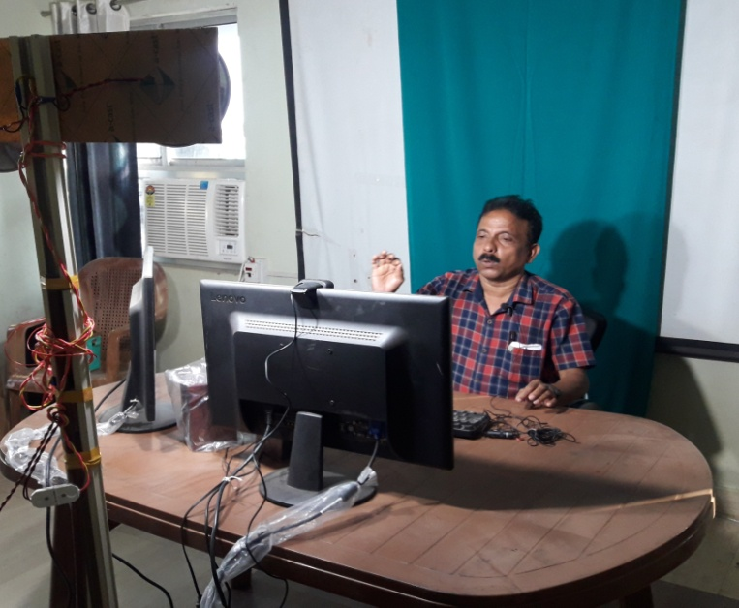
Corona virus outbreak impacted Remedial education
The COVID-19 has resulted in schools shut all across the country. Attending online classes everyday has become the new normal for students during this lockdown. As schools are shut because of the lockdown to contain the spread of corona virus, online class have taken centre stage in student’s life now.During this pandemic situation our Remedial children are out of the classroom. It affects strongly the children of slums as they do not access e-learning facilities. A number of children do not access a smart phone for the purpose. However with a well-built effort, we are able to reach out the remedial children living in the slums with e-learning processes.Everything is running online to ensure appropriate learning for their children and engage them in curricular activities. Parents and Basti Education committee members are being well guided by the teachers to manage the situation and talk about the corona virus with their children. Remedial teachers and cluster educators are working on the issues and reaching to remedial children. The objective is to enhance their academic proficiency at par with their peers in the school. Now our cluster educators are making in every subject lesson videos and uploading videos in YouTube. This YouTube link is sharing to our slum children to continue their education.

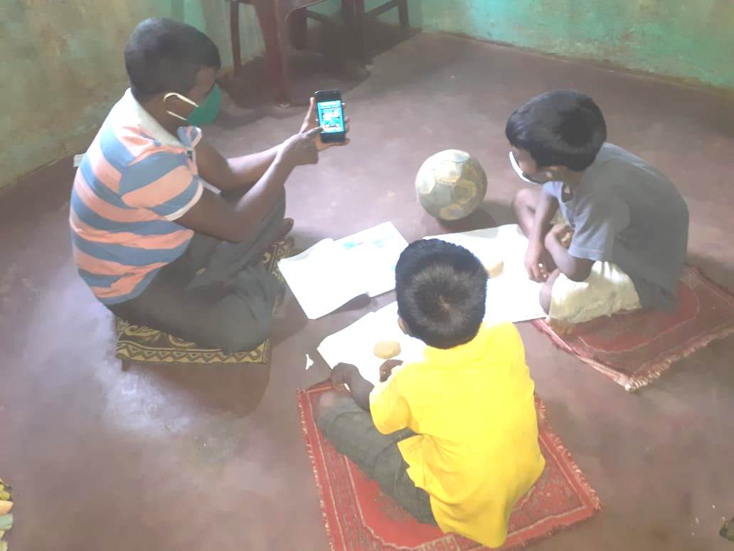
Online classes during COVID-19:-
The Corona Pandemic has resulted in the closure of schools across the country. Education has changed dramatically over the last 10 months, with a considerable rise of e-learning, whereby teaching is executed and on digital platforms. The situation has forced the schools to shut down and enforced students to stay at home. In the mean time children as well as parents feel emotionally and psychologically drained. The knowledge component is more natural to deliver in online mode. In view of the gravity of the situation, Ruchika started E-learning for remedial children soon after the lockdown was imposed. All the children were tried to be linked to the mobiles and a suitable timing was identified for each centre for e-learning. Supervisory team designed course contents in YouTube and sending the YouTube link to children and parents. The teachers also tried to do follow up to know whether all the students are studying or not. Online classes have been conducted by teachers to ensure smooth running of academic activities. We have conducted half yearly assessment for the children to continuous and comprehensive evaluation.

Activities with Govt School Teachers during COVID-19: -
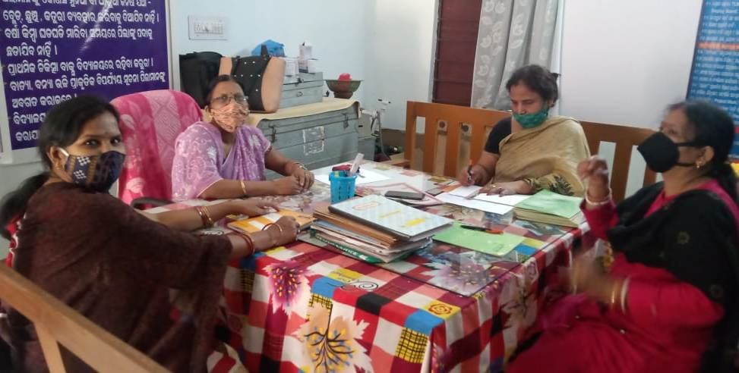
The Covid-19 pandemic has created the largest disruption of education system all over world. Children’s are out of school due to school closure in response to COVID-19. The sudden closures of the schools have disrupted the flow of learning of the students and the existing method of imparting knowledge of the educational institutes across the world. Our Remedial teachers have been visiting Govt Schools to make good rapport with Govt school teachers. Simultaneously they are discussing about the online classes and its evaluation through online. This mutual cooperation during COVID-19 have built good rapport with government school teachers. Remedial teachers have also guiding and counselling parents to continue the online education regularly.

Social distancing is being exercised through e-learning
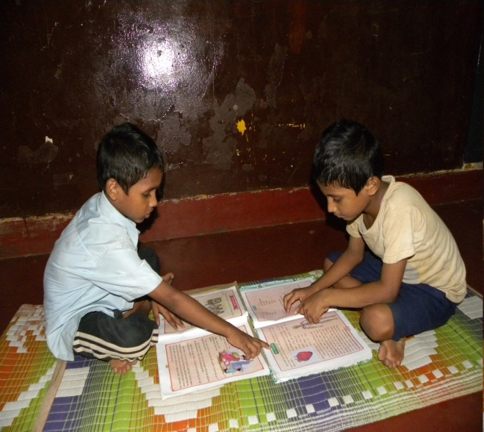
Corona virus is a highly infectious caused severe acute respiratory syndrome. It mostly spread among individuals during close contact now resulting in millions of death. COVID-19 is referred as pandemic due to its severity and also as the greatest global health crisis.Amidst the regulations of social distancing and self isolation, the students if allowed to attend schools may not be able to exercise the safety precautions in an effective manner. It would be very touch to control the students from playing or touching each other which might make the situation of virus spread out of control. Online classes are providing the same quality of education in the comfort of their homes thereby helping in securing their future and also in controlling the virus spread.

Teaching children preventive measures from COVID-19
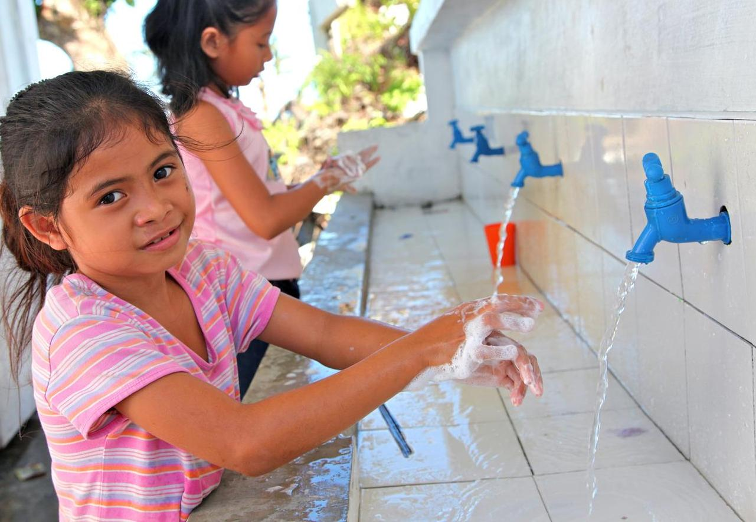
Corona virus infection is a global emergency. Over the few months there is a rapid increase in the number of cases and deaths due to Corona virus infection. It is very important to minimizing this risk of infection for which we need to adopt appropriate prevention measuresas there is no specific treatment and immunization available to date to address this serious issue. It has been found that prevention is the best option for controlling the rapidly spreading infection of Corona virus.Children were trained and educated about the basic hygiene like hand wash, maintain social distance, stay at home and so on. We not only teach them what to do, we also teach them how to do it and explain the children why to do this.

Provision of Psycho-social support to Remedial Children

In the current context of lock down and restriction of movements, children have constrained access to socialization, play, and even physical contact, critical for their psychosocial wellbeing and development. School closures are preventing children from access to learning and limiting their interactions with peers. Children sometimes feel confused and at loss with the current situation, leading to frustration and anxiety, which increase with the overexposure to mass and social media, especially among adolescents. Some adults may struggle to find ways to explain and communicate with children about the current situation in a way that is understandable by this age group, which add frustration and disquietude.
A manual has been developed by Childline India Foundation to support CHILDLINE supporting children affected by the COVID-19 pandemic. The manual is activity-based and so minimal supervision or guidance is needed. There are activities for two age groups – age’s six to ten and 11 to 19. By use of these activities we continue to support the children living in slums to ventilate their anxiety and stress. We have translated the Manual into Odia. Our Odia Translation Manual has been distributed to all Child Care institutions of Odisha by Child Line India Foundation and govt. of Odisha.

Community Sensitization during COVID-19 lockdown: -
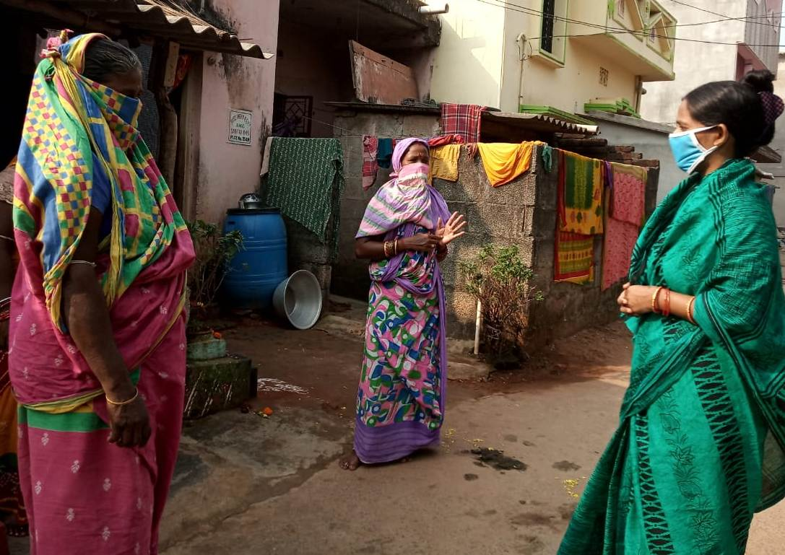
COVID-19 continues to constitute a public health emergency in Odisha. So, with this emergency Ruchika trained Remedial teachers, BEC members and Adolescent groups to spread awareness in the community on use of mask, hand washing with proper procedure, maintain social distance, avoid touching nose and mouth, follow lockdown guidelines etc. Since the outbreak of the COVID -19 pandemic in Odisha, Ruchika have helped the communities to cope with the effects of the pandemic, sensitized community people as well as distributed Masks, Soaps, provided rations to the needy ones and teach hand wash procedure to remedial children. In this situation our BEC members and Balika Mandal members played an important role. They not only educated the community, they also prepared masks by themselves and distributed to the people in order to save them from the Corona virus infection.

Empowering Adolescent girls in the time of Covid-19:-
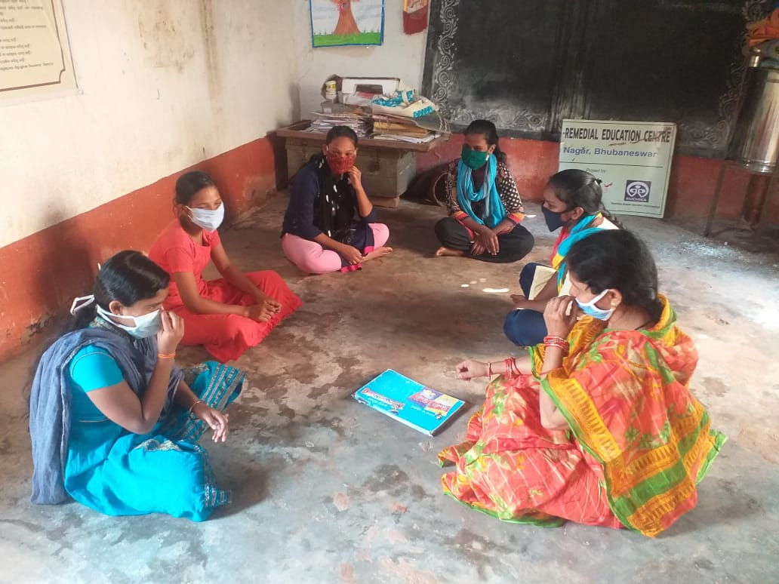
Balika Mandal Members are playing vital roles to educate community in the context of Covid-19. They are encouraged and trained to meet the crisis as their participation is playing vital role. Balika Mandal members are stitching masks and distributing to community people as well as to our remedial children. In the same time, they are educating to their community people on wearing of mask, proper handwash, maintain social distance, and follow all Covid-19 guidelines.

Engagement of parents and BEC in e-learning
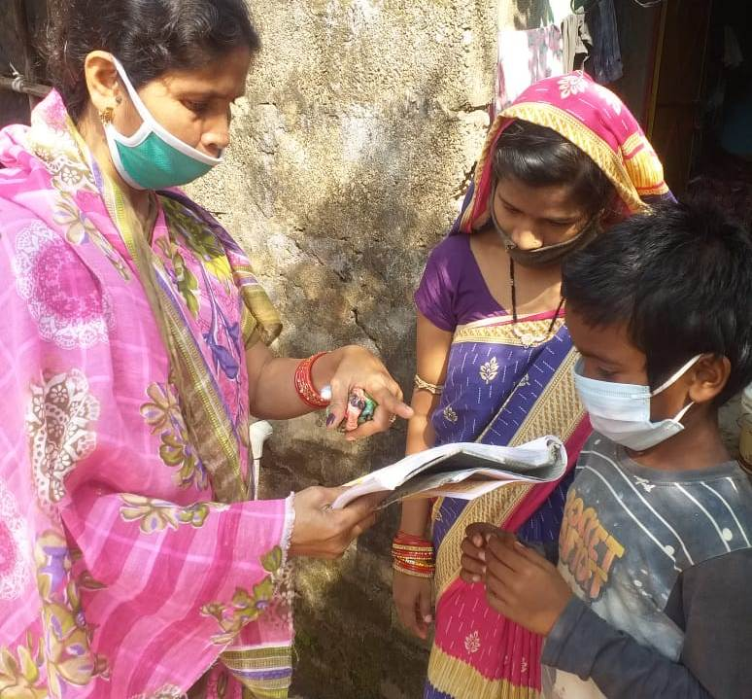
Covid-19 is an unfortunate situation that has upturned each sector around the globe. The education sector is the one that is facing the greast impact. Online education is a very important part of education. Parents are the first and foremost teachers of every students. In case of online learning, now parents are supporting to their children in their studies. In our remedial teaching teachers and supervisory staffs are uploading videos of learning sessions on You Tube which parents are watching and teaching their children accordingly. In the same way our BEC members are trained to lookover the studies of our remedial children. Those parents are having no Smartphone for e-learning we have connected them with BEC and Balika Mandal Members to continue their studies. This is a group effort to achieve the objective of e-learning.

