A Project of: - Give a Smile to 3000 Slum Children to Attend School
Implemented by:- Ruchika Social Service Organization
A Project of :- Give a Smile to 3000 Slum Children to Attend School
Implemented by:- Ruchika Social Service Organization

We are happy to present the 3000 Slum children to attend school project before the donor agency and all other well-wishers. This quarter was the most difficult one and we had to take a lot of difficulties to cross this quarter of intervention due to unexpected outbreak of Corona pandemic in India in March 2020.
Impact of Corornavirus on the slum children :
There are more than 436 slum settlements in Bhubaneswar across the railway lines and other vacate lands which contain almost 35 % total population of Bhubaneswar city. As we all know that there are a multitude of factors that escalate the susceptibility of these informal settlements to Covid-19 infection. The dearth of clean and unshared drinking water and sanitation facilities, inadequate attention to personal hygiene, poor living conditions, food and income insecurity, and lack of access to quality healthcare expose residents in urban slums to significant risk because they ensconce fundamental environmental conditions which foment the contraction and transmission of the disease.
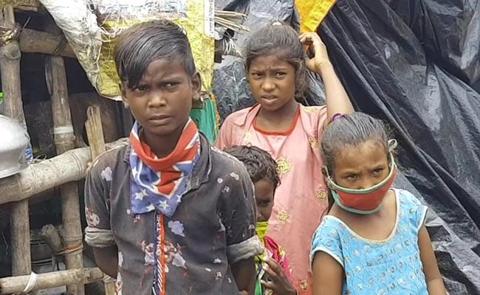
To add fuel to the fire, overcrowding in slums makes social distancing and self-quarantine quixotic, and place the slum dwellers at an increased risk of contracting an infection. As countries across the world now feel that living with the Coronavirus might become a way of life, it is imperative to account for these limitations before any policy action is formulated for tackling Covid-19 in such settlements.
Widespread job, income loss and economic insecurity among families are likely to increase rates of child labor, sexual exploitation, teenage pregnancy, child marriage, trafficking of children and forced begging. As the national death toll from COVID-19 increases, large numbers of children will be found orphaned and vulnerable to exploitation and abuse.
Added family stresses related to the COVID-19 crisis – including job loss, isolation, excessive confinement, and anxieties over health and finances – heighten the risk of violence in the home, including both between partners and by caregivers against children. The United Nations secretary-general has reported a “horrifying” global surge in domestic-based violence linked to COVID-19, and calls to help lines in some countries have reportedly doubled. Child abuse is less likely to be detected during the COVID-19 crisis, as child protection agencies have reduced monitoring to avoid spreading the virus, and teachers are less able to detect signs of ill treatment with schools closed.
Covid-19 has impacted nearly 300 million kids studying in 1.4 million schools in India due to lockdown and closure of schools. The impact is more severe for disadvantaged children and their families especially those living in slums, causing serious interrupted learning, compromised nutrition, childcare problems, and consequent economic cost to families who could not work.

Corona virus outbreak impacted Remedial education
The COVID-19 has resulted in schools shut all across the country. Remedial children are out of the classroom. It affects strongly the children of slums as they do not access e-learning facilities. Because most of them are first generation learners and a number of children do not access a smart phone for the purpose. However with a well-built effort, we are able to reach out the remedial children living in the slums with e-learning processes. Everything is running online to ensure appropriate learning for their children and engage them in curricular activities. Parents are being guided by the teachers to manage the situation and talk about the corona virus with their children. Remedial teachers and cluster educators are working on the issues and reaching to remedial children. The objective is to enhance their academic proficiency at par with their peers in the school
Expected serious implications of Corona pandemic in future
The disadvantages are disproportionate for under-privileged learners like slum children who tend to have fewer educational opportunities beyond school and they are first generation learners. When schools close, parents who are almost illiterate are often asked to facilitate the learning of children at home. Hence it is expected that the prolonged lockdown will result serious implications over the slum children as enlisted below.
- Student drop-out rates tend to increase as an effect of school closures due to the challenge of ensuring all students return to school. Disadvantaged, children of single parents are more likely not to return to school after the closures are ended, and the effect will often be a life-long disadvantage from lost opportunities.
- The academic proficiency of slum children will drop down dramatically as nobody is there in their family to academically support them during lockdown. Hence when schools open cannot adjust with their peers (non-slum children) having higher proficiency, thus may tends to drop out from the school.
- The parents will be compelled to focus on restoring their livelihood after lockdown and will further neglect the children’s education.
- The economic crisis of families due to a strong bang on livelihood due to prolonged lockdown may compel the slum parents to push their children into labour sector and permanently close their doors to school.

Hence it is imperative to immediately start an effective technology based solutions in the field of education to bring the slum children back to the proficiency level at par with their peers in the school along with a strong community mobilization initiative to prevent post lockdown dropout and to close the doorway for children to enter into labour force.
Online education during COVID-19 lockdown
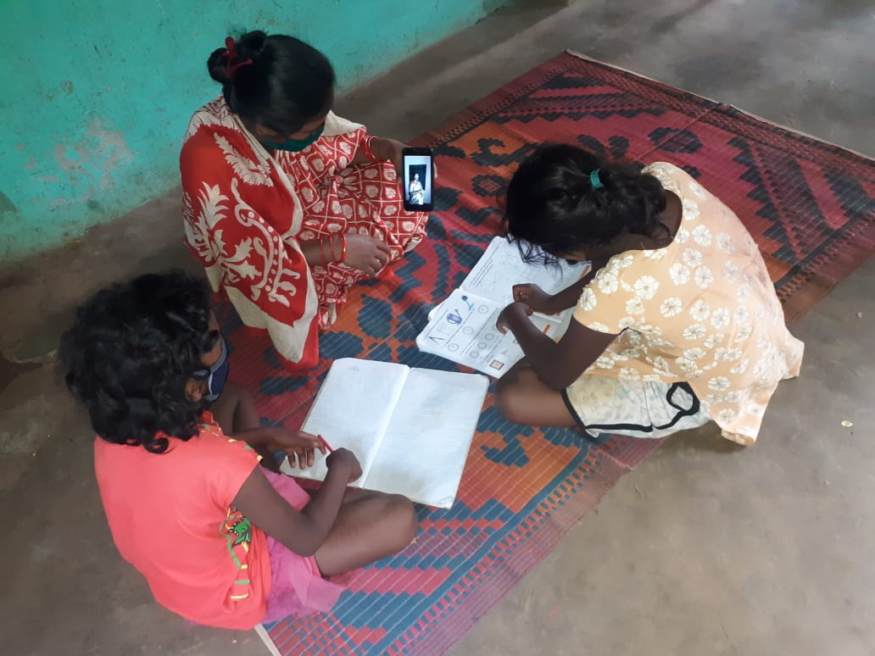
The Corona Pandemic has made a global impact in the past weeks and continues to hit most of the sectors, with education being one of the most affected ones. Students are losing valuable time in their education during the lockdown. The situation has forced the schools to shut down and enforced students to stay at home. In the mean time children as well as parents feel emotionally and psychologically drained. In view of the gravity of the situation, Ruchika started E-learning for remedial children soon after the lockdown was imposed. All the children were tried to be linked to the mobiles and a suitable timing was identified for each centre for e-learning. Teachers and supervisory team designed course contents with voice messages, video messages, charts, assessment sheets and instructions to the students and parents. The complete syllabus was divided into sets and stored in different whatsApp groups. Each teacher formed a student’s group and started sending the course contents. The teachers also tried to do follow up to know whether all the students are studying or not. Online classes have been conducted by teachers to ensure smooth running of academic activities.

Assessment was carried out through the assessment sheets after completion of each topic, thus confirmed continuous and comprehensive evaluation. Teachers and parents are connected on Whatsapp group. Smart phones are helping teachers to prepare short videos and to conduct e-learning classes. Teachers are making the most use of technology like YouTube and other social media platforms to make the students updated and engaged. In the new order of social distancing, homes are the new classrooms. Whatsapp and You Tube are now helping teachers to connect with students and conduct classes during the lockdown.

Co-curricular Activities during lockdown

Co-curricular activities are very important part undertaken in the Remedial Education program to develop the student’s personality as well as to strengthen classroom learning. During the lockdown it was mandatory for all to stay at home. In this situation our remedial teachers have prepared new TLM for classroom teaching and encouraged children to prepare the TLM at home. This was only possible through WhatsApp group and online teaching. Because we know learning never stops.

Participation of remedial children in Bande Utkal Janani Programme
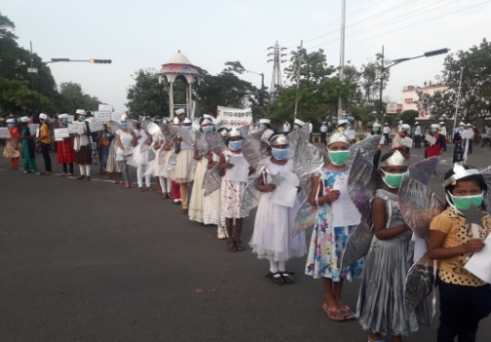
Odisha Chief Minister Naveen Patnaik had on May 28, 2020 issued a clarion call to all people connected to the soil of Odisha to come together and sing “BandeUtkal Janani” at 5.30 pm on May 30, 2020 to motivate the efforts of COVID warriors, who have played a major role in keeping the life of people safe from the infection of corona virus and who have been working day and night, with sacrifice and co mmitment.
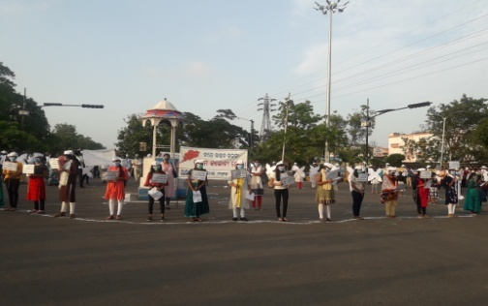
Thousands of people sang the song “Bande Utkal Janani” on May 30th to encourage frontline warriors battling against COVID-19 pandemic. The song was sang by people of Odisha with standing position in every public places like railway station, traffic square, and every Govt. and Private office and at Home. Bhubaneswar Commissionarate Police invited Ruchika remedial children to participate in this grand occasion. Therefore our remedial children along with Ruchika team participated with prepared placards, banners and Gandhi Caps to encourage frontline Corona warriors. The children participated at A.G traffic Square, Bhubaneswar with police. In this program, DCP, Police Sri Anoop Sahu, traffic DCP Ms. Sagarika Nath, Social Activist Mrs. Namrata Chadha and many other police officers and traffic police participated and sang Bande Utkal Janani together with our children. All of them have appreciated to our children for their participation and their massage to frontline Covid Warriors.

Teaching children preventive measures from COVID-19

Corona virus infection is a global emergency. Over the few months there is a rapid increase in the number of cases and deaths due to Corona virus infection. It is very important to minimizing this risk of infection for which we need to adopt appropriate prevention measures as there is no specific treatment and immunization available to date to address this serious issue.

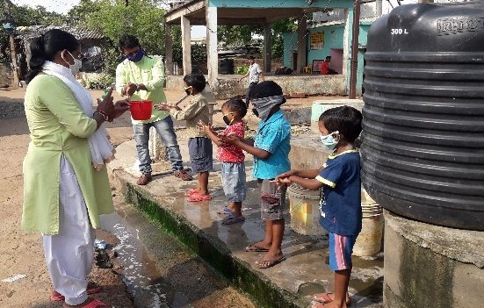
We know it is possible for people of any age to be infected with the virus but so far there have been relatively less number of cases of Covid-19 reported among children. The protection of children is particularly important. Precautions are necessary to prevent the potential spread of Covid-19. In this serious situation Remedial teachers have been teaching about the basic concept diseases prevention and control. While Covid-19 continues to spread it is important to teach the prevent measures to children as well as whole community for further transmission, reduce the impacts of the outbreak and support control measures.

It has been found that prevention is the best option for controlling the rapidly spreading infection of Corona virus. Children were trained and educated about the basic hygiene like hand wash, maintain social distance, stay at home and so on. Following are some of the preventive measures taught to the children during the pandemic.
- Clean your hands at least 10 times a day using soap and water. Follow all 08 steps of hand washing processes for 30 seconds.
- Maintain a safe distance from every one (at least for 2 metres).
- Don’t touch your eyes, nose or mouth.
- Cover your nose and mouth with your bent elbow or a tissue when you cough or sneeze.
- Stay home and do not go out.
- Use mask when you go out in emergency.
- If you have a fever, cough and difficulty breathing, seek medical attention immediately.

We not only teach them what to do, we also teach them how to do it and explain the children why to do this.

Support most needy people with rations

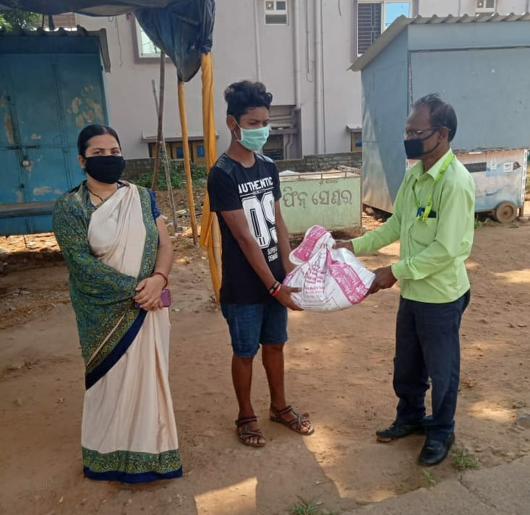
Since the lockdown was imposed, the slum dwellers lost their source of income and faced a shortage of food. Such population including daily laborer’s, petty businessman, shop assistants, factory workers and rickshaw pullers are become economically inactive during this time. It is our responsibility to help the needy people amongst us in their time of crisis. Ruchika has so far reached out to slum children and 200 slum community people with rations during the lockdown to address the food crisis and other crisis during Covid-19. Ruchika also have been provided with masks and soaps with health advice to the children in 15 slums of Bhubaneswar. In addition, fruits have been distributed to children. Ruchika have resolved to continue distribution of rations to the needy during the lockdown.

Distribution of sanitary materials:-

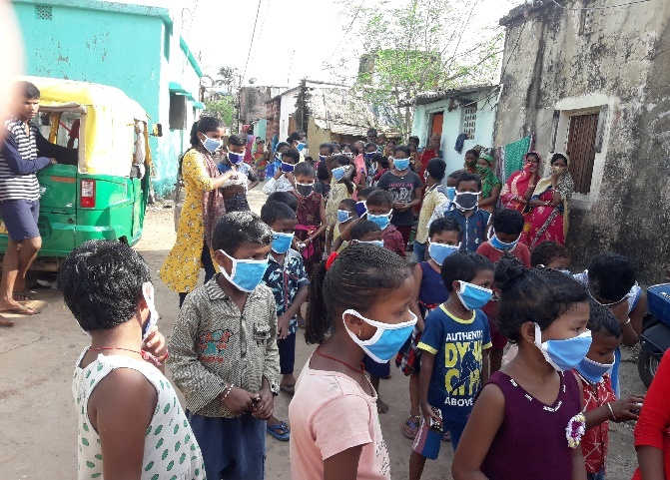
Sanitation and hygienic is essential to protecting human health from Covid-19 outbreak. Hand washing with clean water and soap is one of the most basic and effective measures to prevent the spread of Corona virus. It requires access to clean water, soap and hand wash knowledge and practices. Ruchika has distributed personal hygienic kit like- Soap, and face masks to the slum dwellers especially to the children in our intervention area. Ruchika has been teaching slum people and children on the regular hand wash process, maintain social distance, follow lockdown rules, stay at home etc. This could help the people to maintain personal hygienic to prevent Corona outbreak.

Support disabled children in the intervention community:-

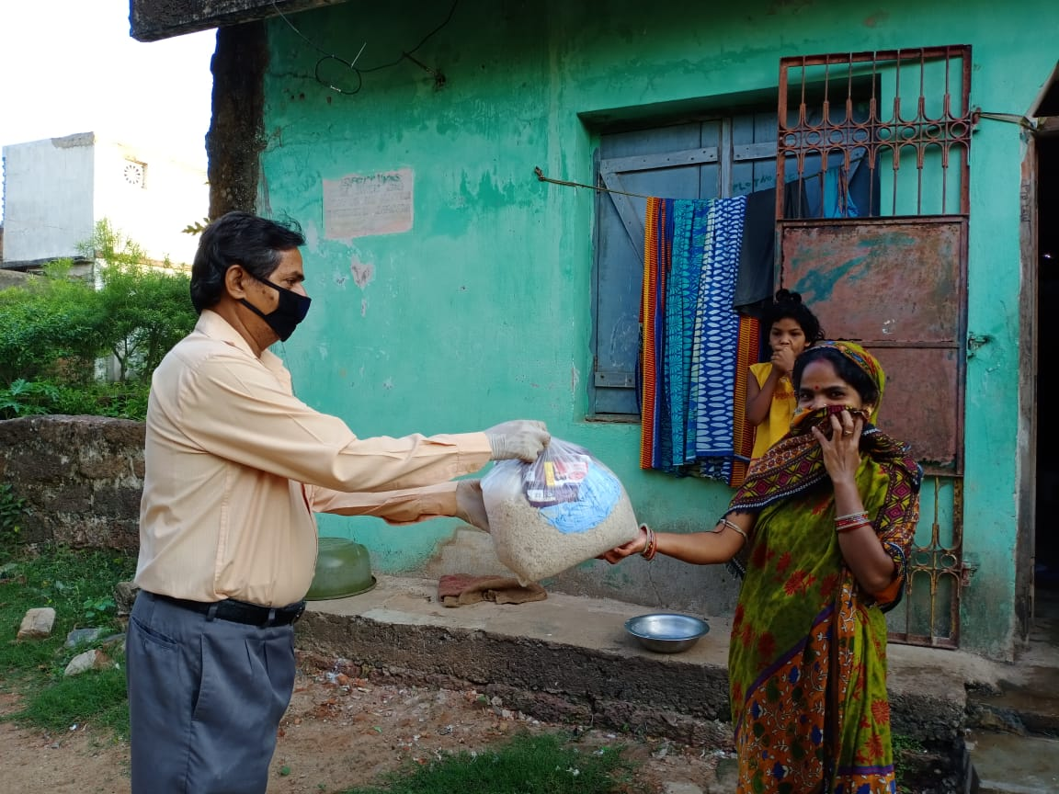
The Covid-19 pandemic has thrown some of the most unique challenges at children with disabilities. Covid-19 has been disruptive to all families but the efforts of school closures, medical equipment shortages and social distancing are further amplified for families of children with disabilities. With continued lockdown, clinical, therapeutic and other services for children with disability have been disrupted all over the world. We identified 120 families of children with disabilities in our intervention slums and they were provided with ration and hygiene and sanitary materials.

Provision of Psycho-social support to Children

In the current context of lock down and restriction of movements, children have constrained access to socialization, play, and even physical contact, critical for their psychosocial wellbeing and development. School closures are preventing children from access to learning and limiting their interactions with peers. Children sometimes feel confused and at loss with the current situation, leading to frustration and anxiety, which increase with the overexposure to mass and social media, especially among adolescents. Some adults may struggle to find ways to explain and communicate with children about the current situation in a way that is understandable by this age group, which add frustration and disquietude.
A manual has been developed by Childline India Foundation to support CHILDLINE supporting children affected by the COVID-19 pandemic. The manual is activity-based and so minimal supervision or guidance is needed. There are activities for two age groups – age’s six to ten and 11 to 19. By use of these activities we continue to support the children living in slums to ventilate their anxiety and stress. We have translated the Manual into Odia. Our Odia Translation Manual has been distributed to all Child Care institutions of Odisha by Child Line India Foundation and govt. of Odisha.

Activities with Govt School Teachers during COVID-19: -

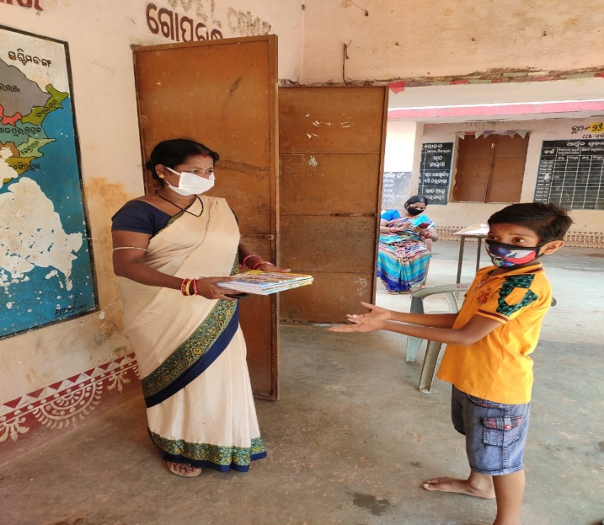
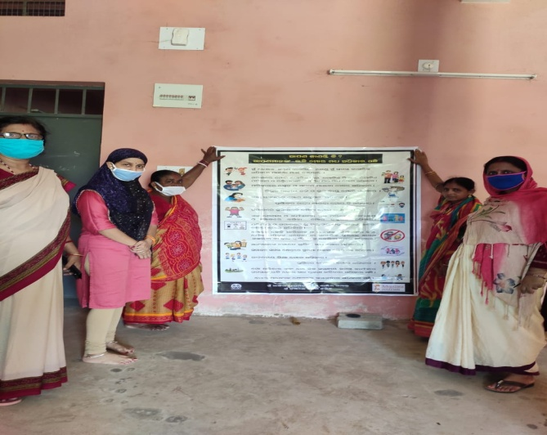
Children’s are out of school due to school closure in response to COVID-19. The sudden closures of the schools have disrupted the flow of learning of the students and the existing method of imparting knowledge of the educational institutes across the world. In the given condition Odisha Govt. has been conducting e-learning and Books have distributed among the students. In the mean time our remedial teachers have helped govt school teachers in distributing textbooks at their door steps. The children are also distributed with mid day meal token. Remedial teacher helped in the process of enrolment of children in Govt. school. Child protection policy posters have been pasted in the Govt Schools. This mutual cooperation during COVID-19 have built good rapport with government school teachers.

Community Sensitization during COVID-19 lockdown: -

COVID-19 continues to constitute a public health emergency in Odisha. So, with this emergency Ruchika trained Remedial teachers, BEC members and Adolescent groups to spread awareness in the community on use of mask, hand washing with proper procedure, maintain social distance, avoid touching nose and mouth, follow lockdown guidelines etc. Since the outbreak of the COVID -19 pandemic in Odisha, Ruchika have helped the communities to cope with the effects of the pandemic, sensitized community people as well as distributed Masks, Soaps, provided rations to the needy ones and teach hand wash procedure to remedial children. In this situation our BEC members and Balika Mandal members played an important role. They not only educated the community, they also prepared masks by themselves and distributed to the people in order to save them from the Corona virus infection.

Staff Capacity Build Up Training:-
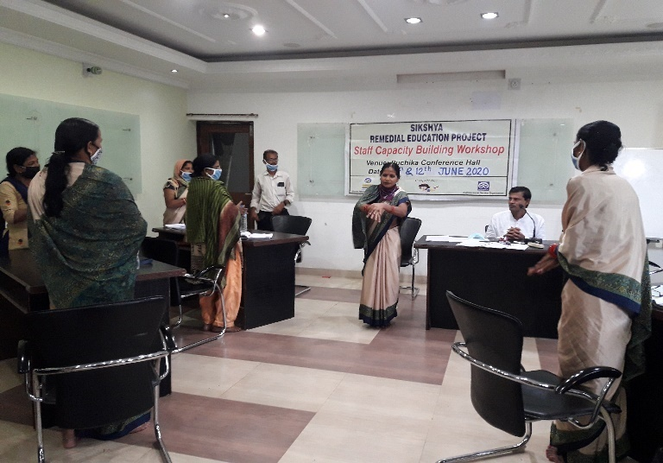
Two days Staff Capacity building program were organized in the premises of Ruchika Resource Centre on 11^{h}& 12thJune 2020. The training program was planned for two days to maintain social distance. 50% remedial teachers attended in the 1st day training where as rest 50% remedial teachers attended the second day training. This two days training was conducted by maintaining social distance. All staffs were sanitized, screened and used masks. All remedial teachers were educated on COVID-19 so that they can teach the community and the children about social distancing, hand washing techniques, use of mask and COVID precautions. Remedial teachers were taught how to be digitalised and enhance digital learning for slum children. They were also trained to provide counselling service to the children through mobile. They were taught on Mathematics and preparation of new TLM to conduct classes in remedial centre.

Remedial teacher as COVID Warrior: -

The outbreak of COVID-19 has left the country shut its doors to contain the spread of the corona virus leading to disruption in the lives of people. There is a large number of Corona Warriors going the extra mile to battle the pandemic. They all deserve our thanks and respect.

The country is immensely proud of the teaching community. Our Remedial teachers have been incredible as they leapt with zeal, commitment and creativity into this new way of online teaching. Teachers have been producing online curricula, all while dealing with their own families. During the lockdown they have confronted with ever-increasing obligatory meetings and training sessions by maintaining social distance. During this challenging time all remedial teacher have been reporting to their concern supervisors regarding their community status. Remedial teachers have helped to health workers in collection of health status data of every household.

