Project Report on:Give a Smile to 3000 Slum Children to attend School
Implemented by: - Ruchika Social Service Organization

We are happy to present the 3000 Slum children to attend school project before the donor agency and all other well-wishers. This was the most difficult one and we had to take a lot of difficulties to cross this quarter of intervention due to unexpected outbreak of Corona pandemic in India in March 2020.
Education is a fundamental right of all children in India. Yet many children those who living in the slum do not have adequate access to government school. Primary Education in India suffers from many deficiencies. In order to impart quality education to these marginalized slum children Ruchika started its first initiative in the form of Platform school in the year 1985 in Bhubaneswar. In addition, Ruchika is running Remedial Education centre in slums of Bhubaneswar and providing remedial coaching to marginalized slum children.
Goal and Objectives of the Project:
The Programme Objective was to reach out to all the slum children of Bhubaneswar to increase academic proficiency and targeting a significant reduction of drop-out in the schools as well as ensuring Right to Education Act, in its true spirit in the target area.

Specifically, the programme focused on improving the lives of the marginalized slum children through a three-pronged approach:
- Provision of Specialized Remedial Education to enhance academic proficiency. The approach identifies children with low proficiency and designs appropriate before or after school remedial support including competency building, counselingparents and children, family visits, etc.
- Community mobilization to raise awareness on quality education and greater involvement of the parents and community at large in the education system
- Specific activities with school authorities, district level authorities and the Education Department (Government of Odisha) to ensure quality of education as well as realization of maximum provisions of Right to Education Act 2009 (RTE).
The programme aimed at directly benefiting slum children through remedialeducation centres and school going children through activities implemented in slums and in neighbourhood schools.

Ruchika’s Intervention:
Ruchika intervenes in 65 most vulnerable slums of Bhubaneswar for last 10 years. The objective of the program is to bring a sustainable and right based change in the community by using Remedial Education as a platform. It targets children in the age group of 6 to 11 years with remedial coaching, 12 to 18 years of girls and boys with learning life skills including Reproductive Health Rights, Community with education and awareness on child rights and other human rights.
Changing the attitude of people and making them role models, making universal schooling a people’s movement and upgrading the academic skill and proficiencies of all children at par with the non-slum children studying in the school, training them to demand their rights, and creating a conducive environment in the slums to ensure all rights and putting all children into the safety net are some of the huge tasks the organization has planned in these slums. It needs time to educate and strengthen the care givers and duty bearers and to enable them to fulfill their obligations towards children. This urges the organization to continue intervention at least for two more years in the same slums. During the forthcoming two years, the organization plans to strategically focus on developing strength of the children as well as the community, care givers and duty bears to be the role models and protagonists of Child Rights activism.
Remedial Education during Covid-19 Pandemic:
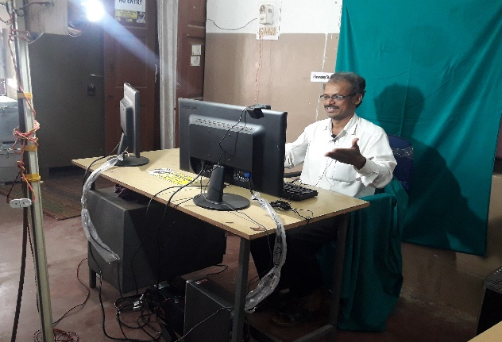
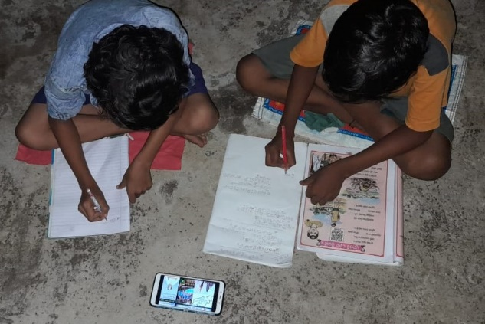
The COVID-19 pandemic has created the largest disruption of education systems in all over the world. The COVID-19 has resulted in schools shut all across the country. This has brought far-reaching changes in all aspects of our lives. Social distancing and restrictive movement policies have significantly disturbed traditional educational practices. Attending online classes everyday has become the new normal for students during this lockdown. As schools are shut because of the lockdown to contain the spread of corona virus, online class have taken centre stage in student’s life now. During this pandemic situation our Remedial children are out of the classroom. It affects strongly the children of slums as they do not access e-learning facilities. A number of children do not access a smart phone for the purpose. However, with a well-built effort, we are able to reach out the remedial children living in the slums with e-learning processes.Everything is running online to ensure appropriate learning for their children and engage them in curricular activities. Parents and Basti Education committee members are being well guided by the teachers to manage the situation and talk about the corona virus with their children. Remedial teachers and cluster educators are working on the issues and reaching to remedial children. The objective is to enhance their academic proficiency at par with their peers in the school.All the cluster educators have prepared the lesson videos and uploaded in You-tube for better access to children as well as parents in all over Odisha.

A Group effort to achieve the objective of e-learning:

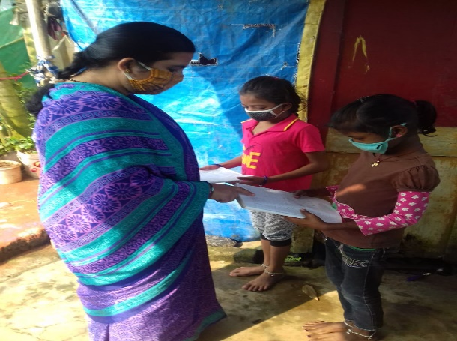
E-learning classes have played a crucial role during this pandemic, helping schools and student learning during the closure of school. While adapting to the new changes, students are needs to be gauged and supported accordingly. During this pandemic our teachers and cluster educators have prepared videos and uploaded in You-tube. As it is new for all students as well as parents so all our Cluster educators and remedial teachers are taking follow-up of the class and conducting assessment to evaluate the academic progress. The teachers identified academic proficiency among the children getting ready to appear the annual evaluation and were helped strategically to overcome the academic difficulties.
Parents are the first and foremost teachers of every students. In case of online learning, now parents are supporting to their children in their studies. Our Basti Education Committee members and Balika Mondal members are also guided and taking follow up of the classes. In the same way our BEC members are trained to look over the studies of our remedial children. The remedial teachers also visited the home and guided to children. The Cluster Educators were focused on the academic’s issues of the children. The low performers of children, late starters and no starters as well as slow learning capacities of children were given importance in the process.Those parents are having no Smartphone for e-learning we have connected them with BEC and Balika Mandal Members to continue their studies.

Covid-19 pandemic impacted health, psychosocial well-being of children:

The outbreak of the Covid-19 pandemic had a profound impact on the health and psychosocial well-being of the children.Closure of schools prevented children from gaining access to learning and limited interaction with their peers. The pandemic also brought stress on parents to their capacity of providing care and engaging with their children.
Slum children are at risk of suffering from a range of child protection, exploitation, and health impacts, such as being forced into early marriage, begging, child labour, and dropping out of school, as well as hunger, emotional, and psychosocial harm.At the time of this emergency Ruchika continues to help children and provides psychosocial support to children and families become better prepared to cope with emergencies.
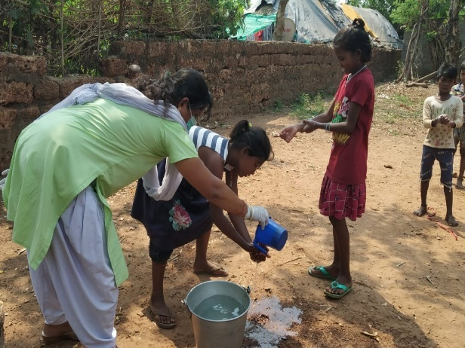
Our efforts for slum children during the pandemic:
During this pandemic, Ruchika has continued the team effort to continue the education of children through e-learning. We worked with communities to identify the most marginalized, so we can help family and children survive and thrive. Our team has identified dropout children and all children living in the slum and facilitate their movement into schools through enrolment drives. Our team has provided psychosocial support to the children and their families become better prepared to cope with emergencies. At the same time, we have teach to slum children on proper handwashing, use of mask an maintaining social distance.

