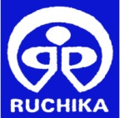

IMPLEMENTED BY:RUCHIKA SOCIAL SERVICE ORGANISATION N
(1stjan-2020 to 30thMar-2020)

It is our proud privilege to present the First Quarterly Report (January-2020 to March2020) for the first phase of remedial education project before the donor agency and all other well-wishers.During this first intervention the project has crossed several milestones and hurdles but eventually it completed almost the project target being achieved. As we all are aware about COVID-19 which has been spread all over world. On this world emergency Ruchika has taken major initiatives by teaching Remedial teachers on COVID-19 and aware community people on use of mask and handwash. Ruchika also trained to Balika Mandal members and BEC members to work together for community awareness on COVID-19. In the passage of time Ruchika also learnt a lot from the intervention and have prepared itself to fight against all odds and take up all challenges for the best interest of children, the greatest assets of mankind.
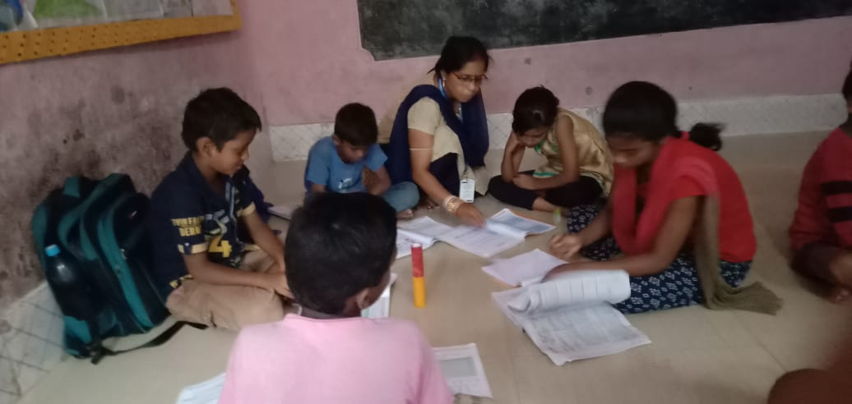
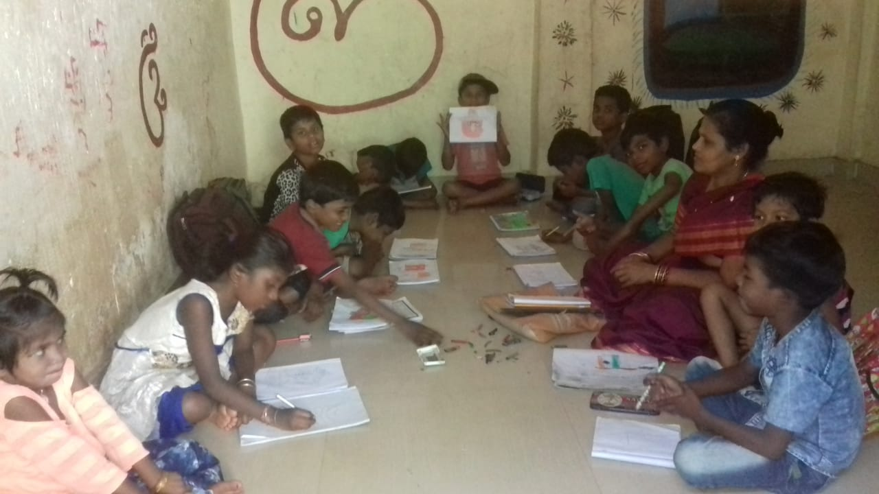

Ruchika Social Service Organization started its program in April 1985 for children with the ideology and overwhelming credo "if the child cannot come to school then the school must go to the child". Since the enforcement of Right to Education Act 2009, Ruchika has built strong focus and expertise in improving quality of education through remedial education programin the slums across Bhubaneswar.

The intervention aims to review and improve the learning competencies in three core subjects – English, Odia and Maths. The teachers assist the children to identify actual academic issues/ deficiency and find a remedy to enhance proficiency. They also help their friends in learn the competencies, by forming pairs and groups as necessary. This process has enabled not only in learning but also in reviewing and planning their school tasks and preparing for school assignments. Over and above the project aims to achieve universal enrolment, retention, reducing rate of dropouts and ensuring provisions of RTE in school. This year an additional component has been added to empower the adolescent girls to become change makers. Hence at the ultimately the Rights of the Children to Free and Compulsory Education will be achieved in its true sense in our target intervention area and a successful model will be in place for all the concerns.

Remedial Education:

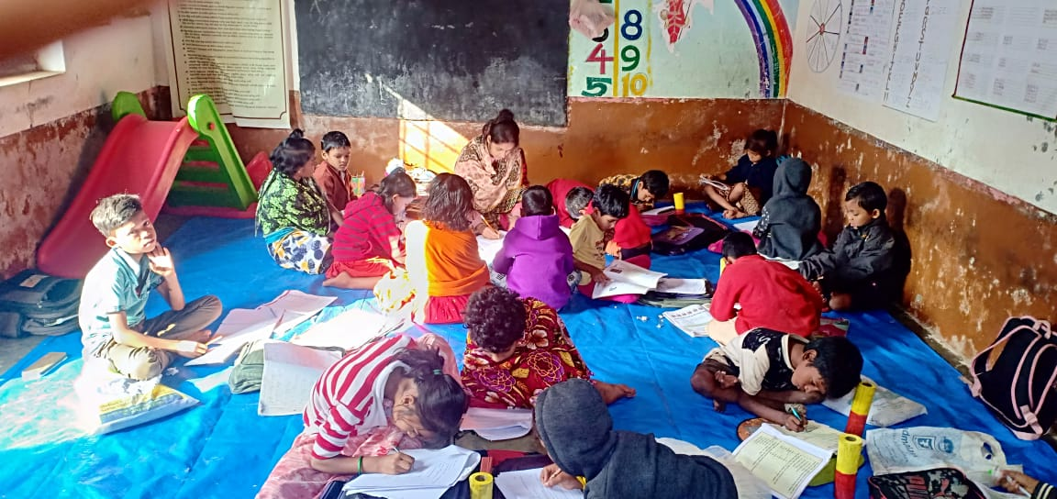
Remedial Education programme has been running regularly in 40 slums of Bhubaneswar. The students who are found lagging behind, in the course of action are treated with special remedial coaching with individual attention on every Saturdays. The Remedial teachers followed competency-based coaching and friendship approach while teaching the students in the remedial center. Attention was given to make the classroom interesting andinteractive. Remedial teachers are using different teaching learning material (TLM) in the classroom. Child participation in the education process was given first priority.On every Saturday nature observation was conducted by teachers in which the children visit different beautiful places and observe the nature.All Supervisory Staffs are doing effective monitoring to Remedial center in regular basis and supporting to Remedial teachers for smoothfunctioning of the center. Simultaneously Basti Education Committee members were also monitoring and actively participating in the overall management process of Remedial center. Community mobilization was also given priority before and after coaching hours by our remedial teachers to build up good rapport with parents as well as make them aware about Education Rights of children.

Co-curricular Activities:
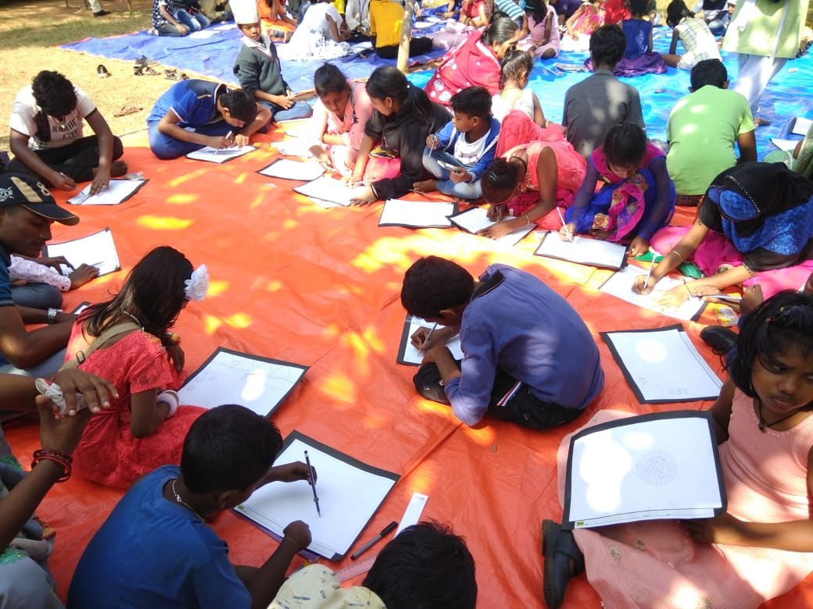
Co-curricular activities are those activities which are undertaken along with academic studies. For the development of a child, curriculum is not only the single criteria. The holistic development of the child, classroom teaching should be supplemented with co-curricular activities which enhance the child’s individual emotional,social
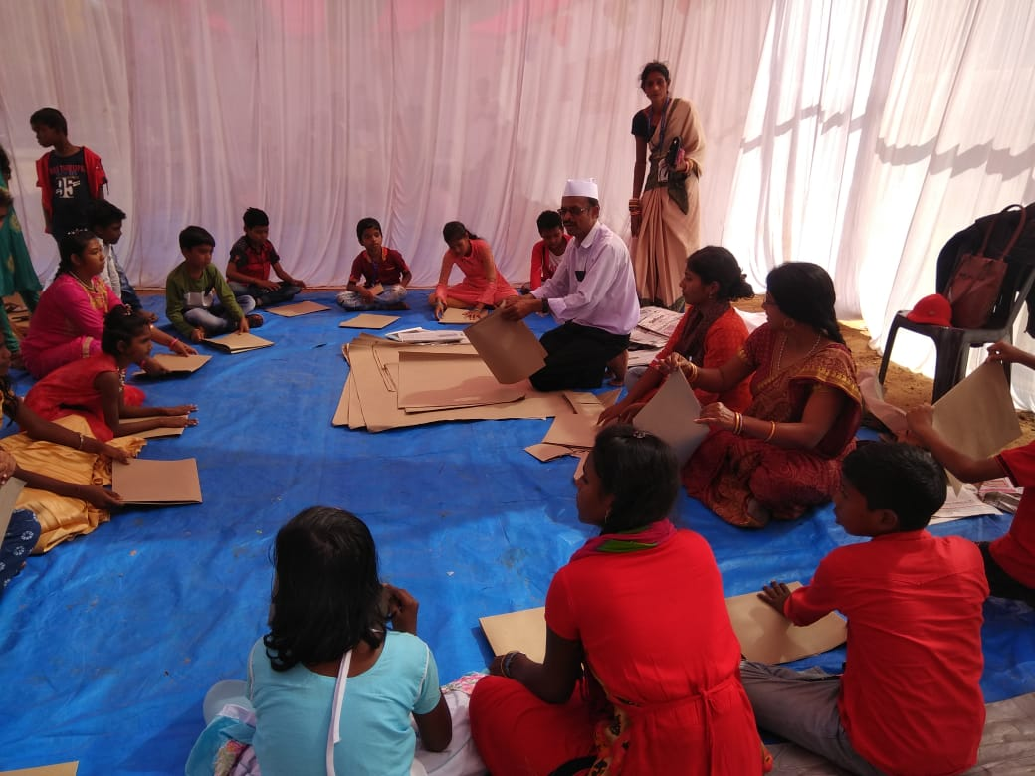
and spiritual growth. Co-curricular activities are very important part and parcel of educational institutes to develop the student’s personality as well as to strengthen classroom learning. In this regard, our remedial teachers have been conductinginteresting, joyful and creative activities in the remedial centres to attract the children to participate in the teaching learning process. During this quarter drawing competition and origami work have been conducted.

Science on Wheel:

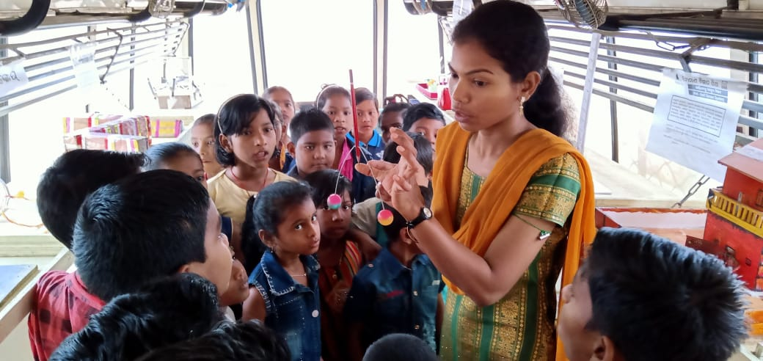
Science on wheels is a bus with science models which visits the remedial education centres regularly. It also visits government schools in our intervention area. The objective of the model is to create interest among the children on science and technology. It helps to enhance immensely the limits of their curiosity. During this quarter the bus has covered total 20 remedial centres and 20 Govt. Schools in the intervention area. Students observed the science models in details and put many questions about the preparation, functioning and utilities ofthe models in social life. In the previous fourth quarter Ruchika was organized two days Science Exhibition Program i.eLittle Scientist VII on 30thdec 2019 to 31thdec2019. On this exhibition Mr. Himanshu SekharSatapathy, Senior Scientist,Regional Science Centre,was invited as Guest of Honour . During the interaction with our little Scientist, he found out the best interest of our remedial children towards the Science. So, he gave one proposal to Ruchika for the exposure visit of Remedial Children to the Regional Science centre.

Exposure Visit to Regional Science Centre:-

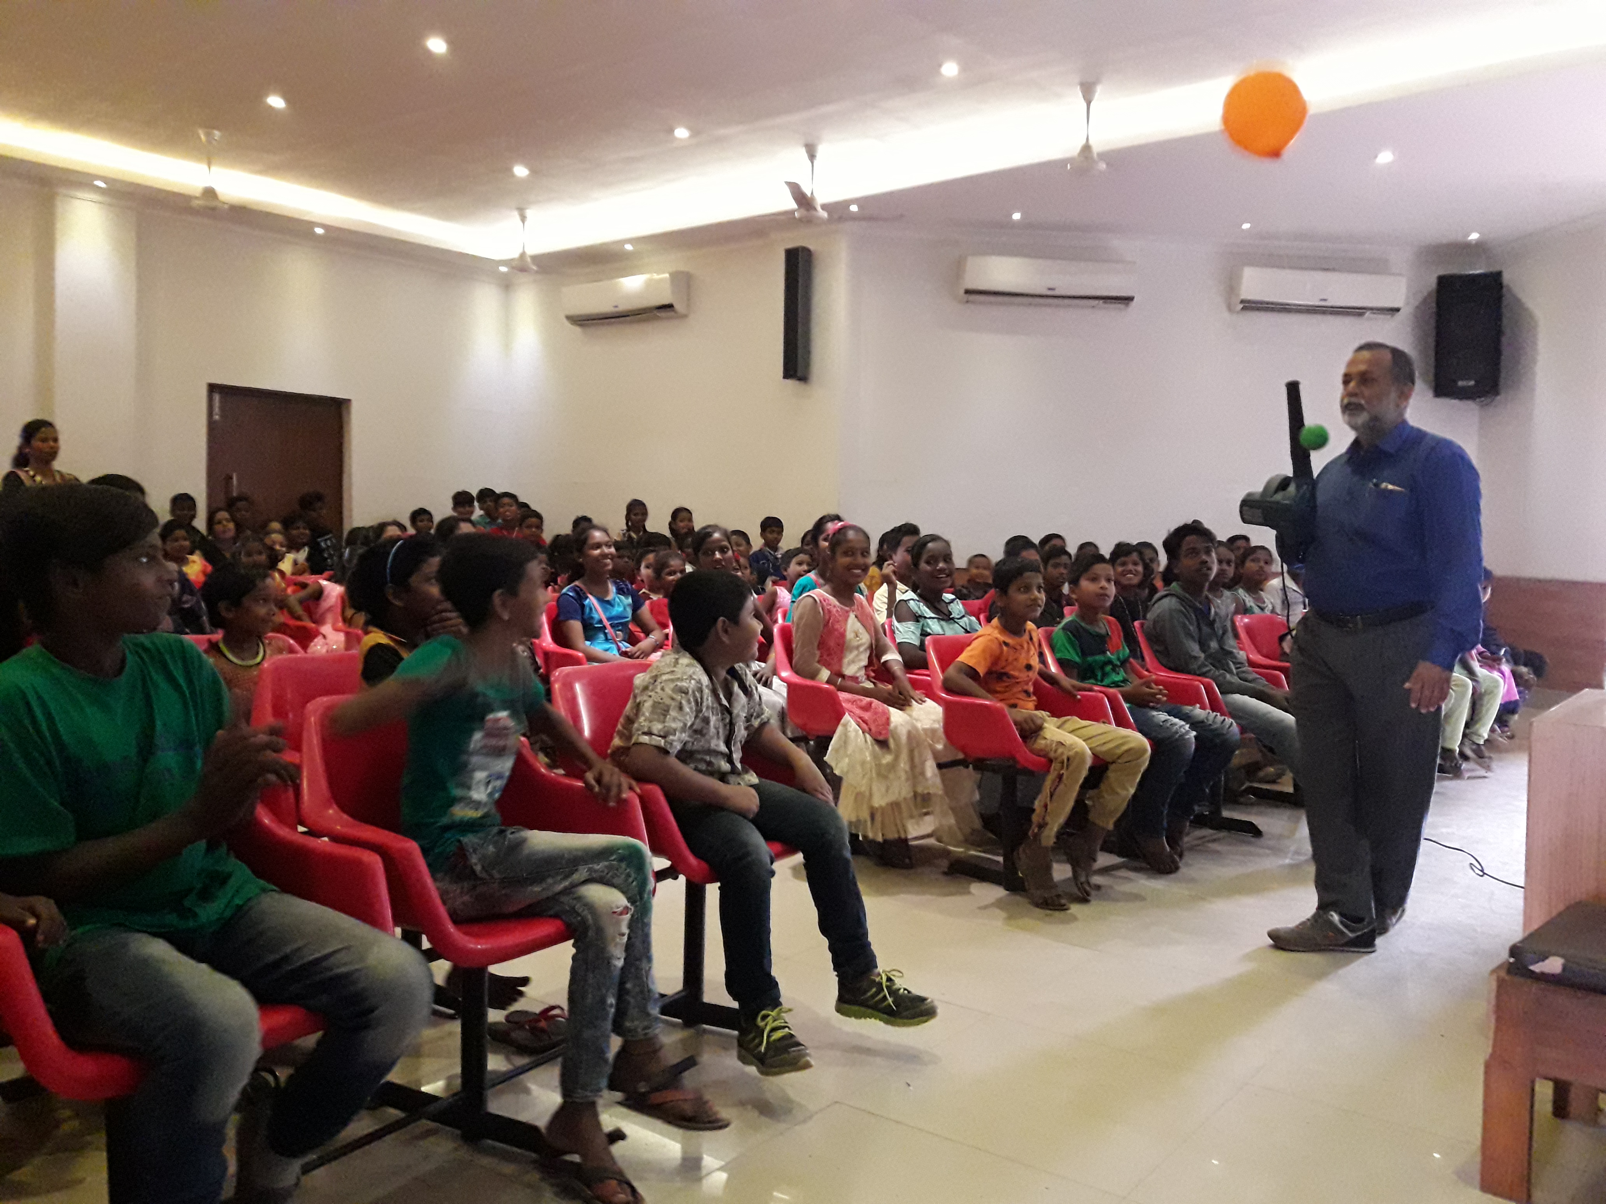
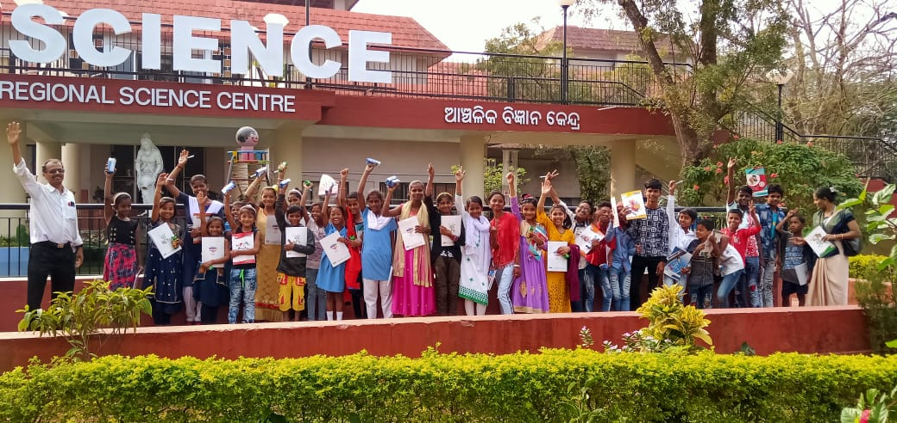
In order to provide Science Education to our Remedial Children Ruchika has conducted exposure visits to Regional Science Centre, Bhubaneswar. The objective was to grow scientific interest and temperament among the children. 1293 Nos of Remedial children along with Balika Mandal Membersand all supervisory staff visited the centre. Ruchika has covered 40 remedial centres Children were shown various experiments at the centre like the Mirror house, the infinite well,infinite train, and many more. A team of experts from Science centre demonstrated various scientific experiments before the children which increases the Scientific knowledge among the children. The children were also amazed to experiment with the set up in the science park that amplified sound. They observed how sound travels through metals and had fun time with the playing materials avail in the park.

Nature Observation

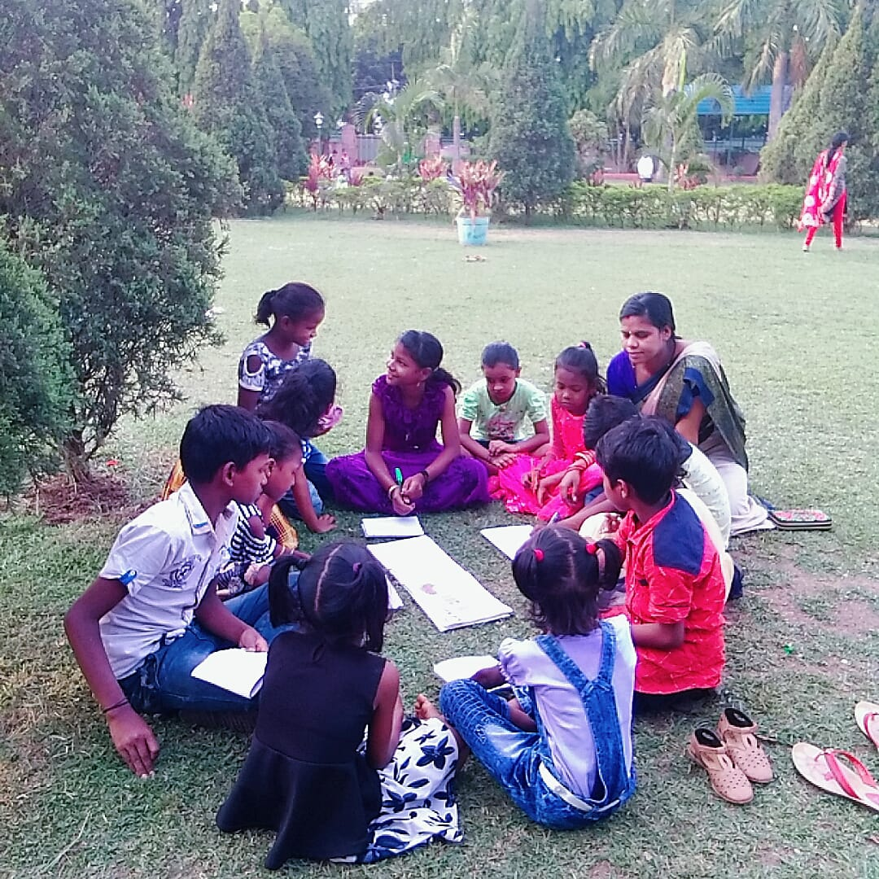
Nature observation is a process of interaction with natural environment. Its purpose is to educate the children in terms of environment. It allows children to learn by doing and experiment with ideas.Itis a part of our regular curriculum. On every Saturday the children visit different beautiful places and observe the nature. In open environment children are able to observe the natural environment around their school, home or community. All the students had given a nature study note book in whichthey are free torecord their observations with words, drawings and also write the poems. This activity made them to love the nature and learn from the nature. This activity provides countless opportunities for discovery, creativity and problem-solving ideas among the children.

Activities in Government School:

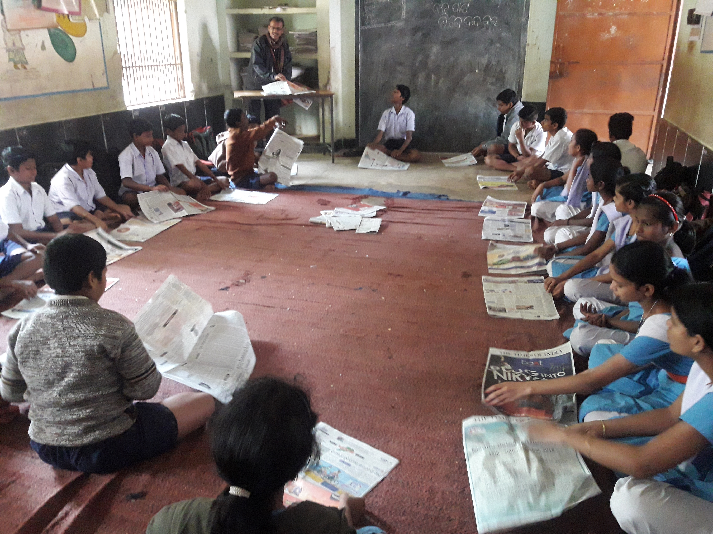
The remedial teachers and the supervising staff regularly visited the government school in the intervention area.This time RTE posters have been pasted in Govt School andteachers have been trained on RTE and its proper implementation to reduce dropout. The Supervisory team also conducted co-curricular activities i.e is Origami, Painting and Art exhibition, joyful games etc.The school teachers helped the supervisory staffand also learned from the process.

Monitoring &Evaluation:

An intensive monitoring was done during this quarter. The Program Manager, Head Educator, as well as Cluster Educators, all have visited the field and tried to run the program in full spirit during this quarter. The Community issues at different pockets were resolved. All most every day the monitoring team visited their target area as per plan.

An effective MIS was prepared to monitor the activities of the program. The Basti Education Committees were trained and given responsibilities to monitor the program. The members of BEC have been taking responsibilities and helping resolving the community level issues.

Activities with BEC Members:

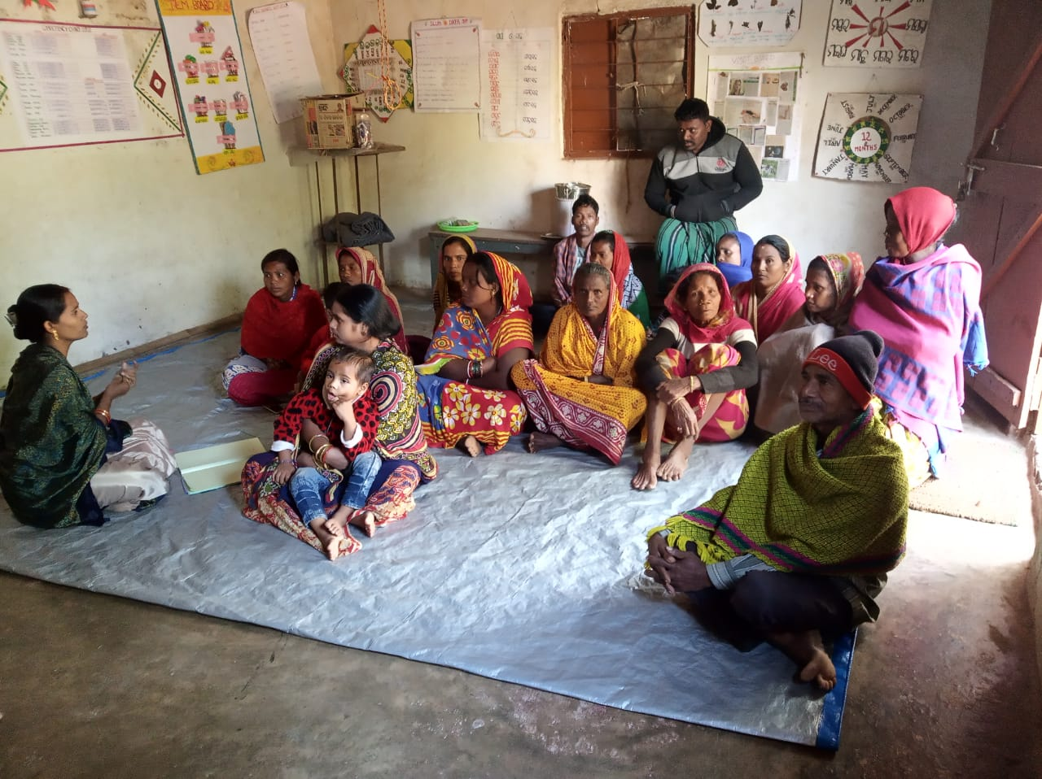
Basti Education Committee Meetings have conducting once in a week by our Remedial teacher in their individual remedial center. In this meeting BEC Members participation is given top priority.The discussion was given on the relationship between the school and community in implementing RTE, role of the members of Basti Education Committee to bring a change in the education scenario of slum areas, identification of dropout and

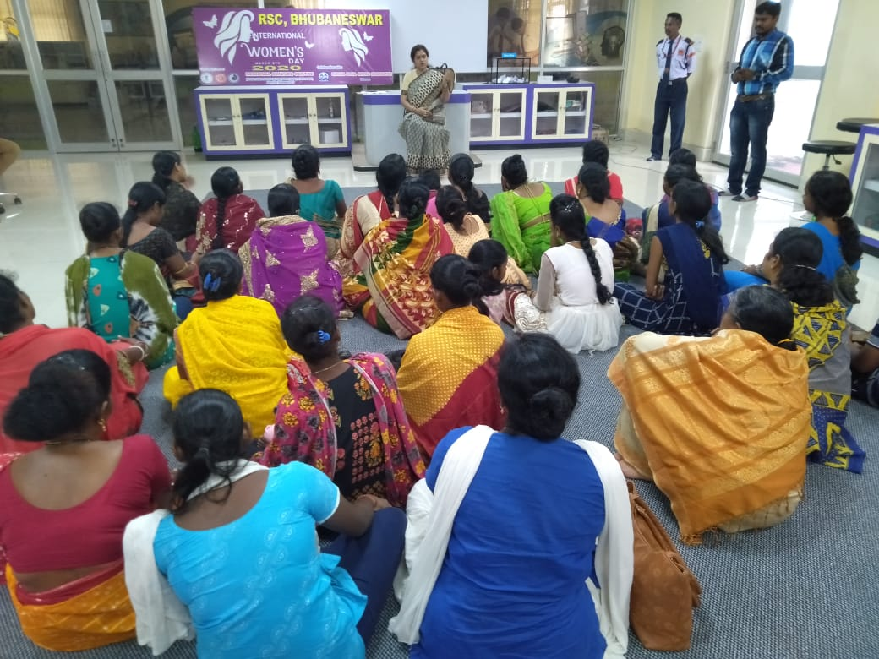
enrollment of dropouts in Govt School. In this quarter on 8th March, 2020 Ruchika celebrated “International Women’s Day” with some of ourWomen BEC Members in collaboration with Regional Science Center. For the event, chief guest was Mrs. Jharana Dash, Social Activists. The discussion was held on Women’s Right and Equality in the Society. All the Members have encouraged by the chief guest and well aware about their social, Economic and political rights.

Staff Capacity Build up Training:

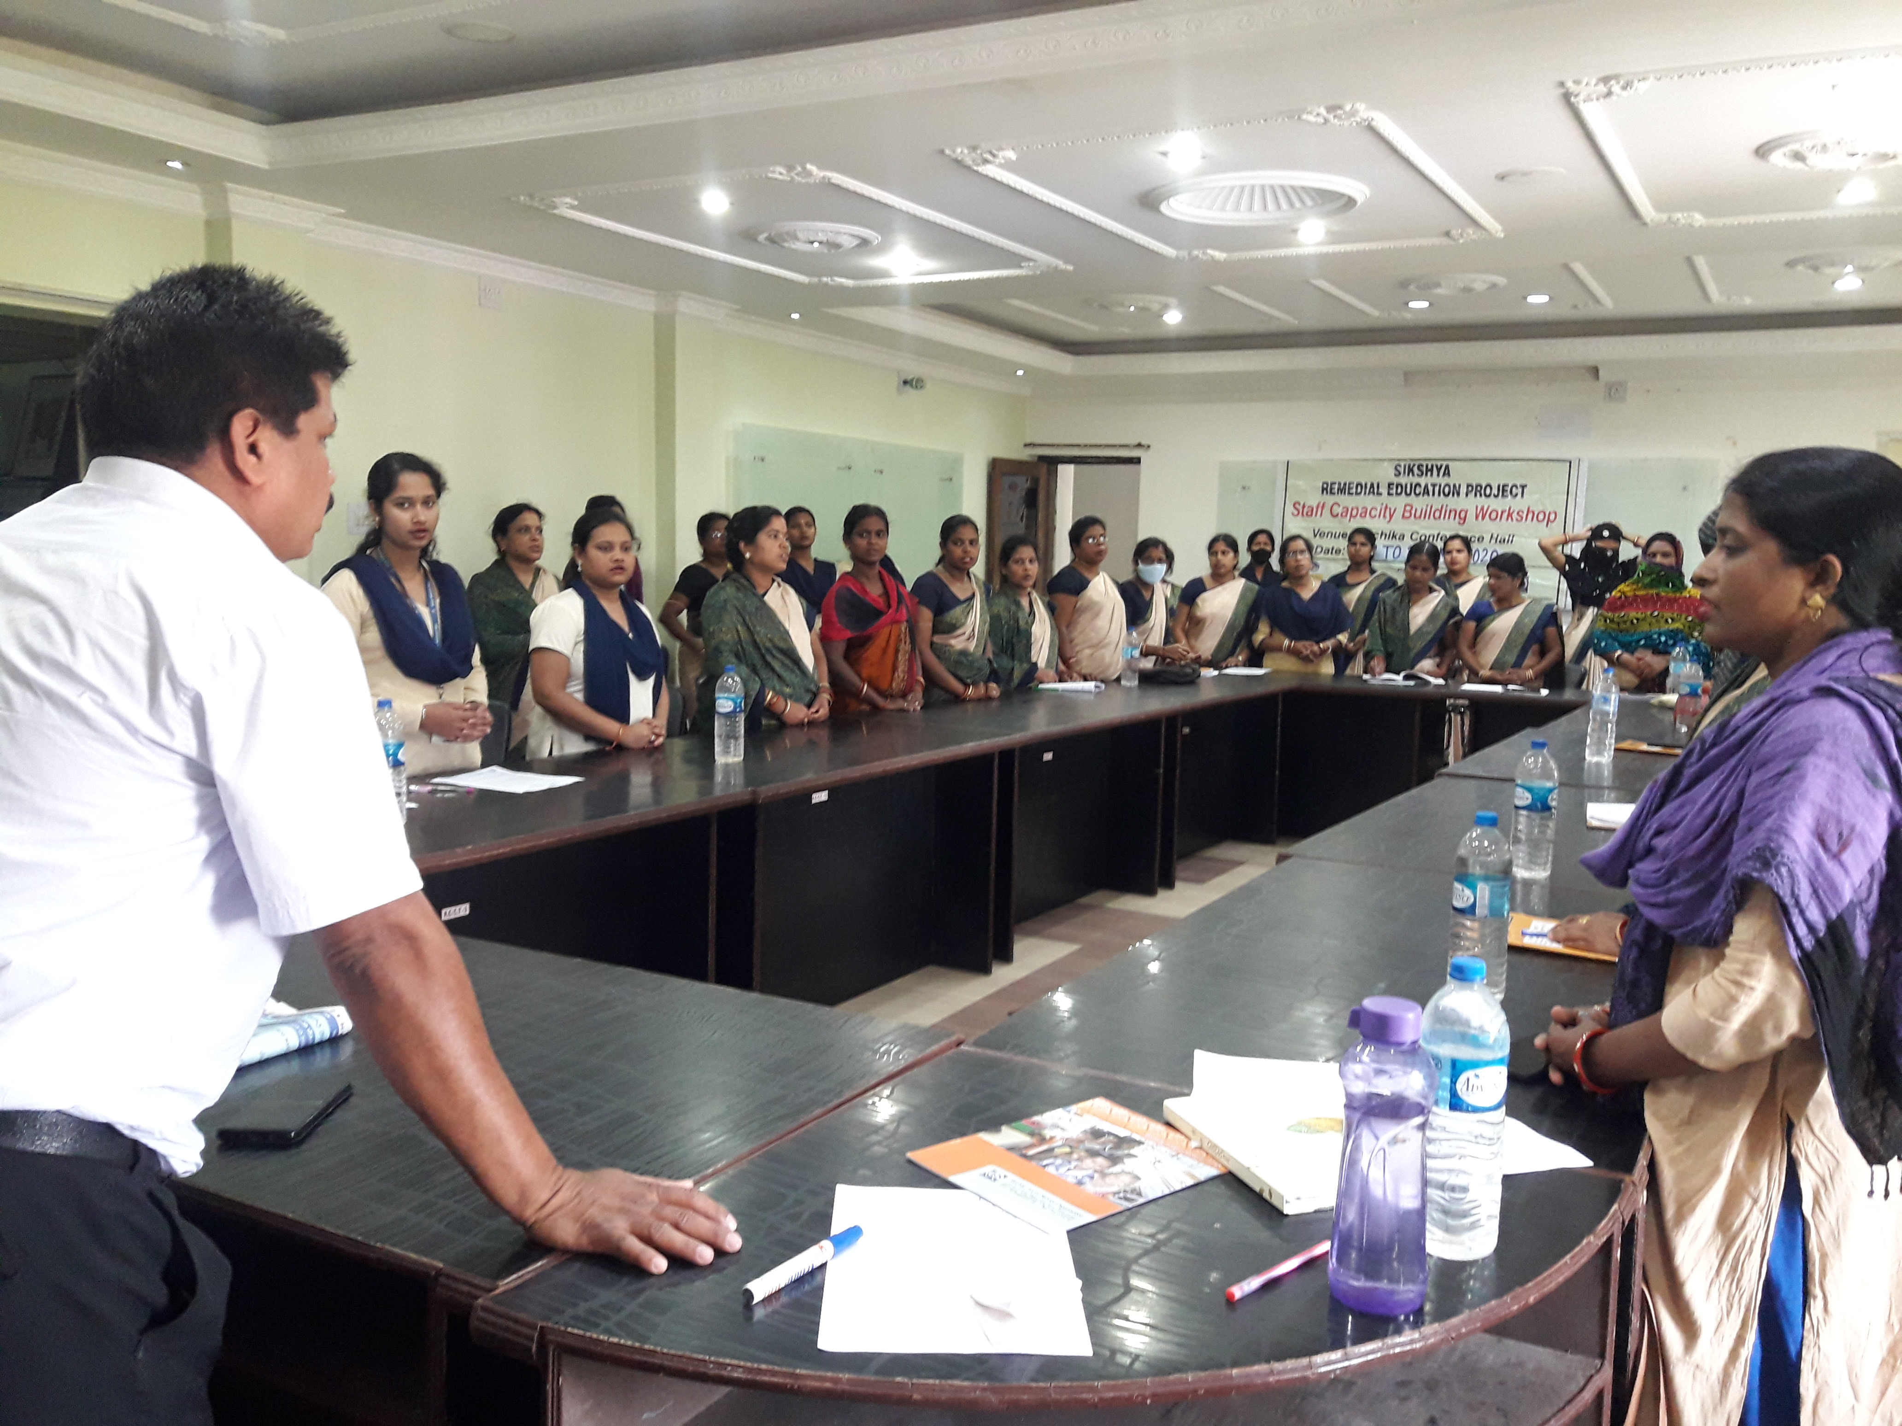
Two days Staff Capacity build up training program were organized in the premises of Ruchika Resource Centre on 19th&20thMarch 2020.In this training program classroom management and Preparation of Innovative TLM was discussed.Allremedial teachers brought their old TLM from their individual centre and shared with others in purpose to exchange their ideas and to prepare the new TLM. All remedial teachers were also trained on community awareness on COVID-19 and how to make people more aware on use of mask, handwash as well as maintain social distance.

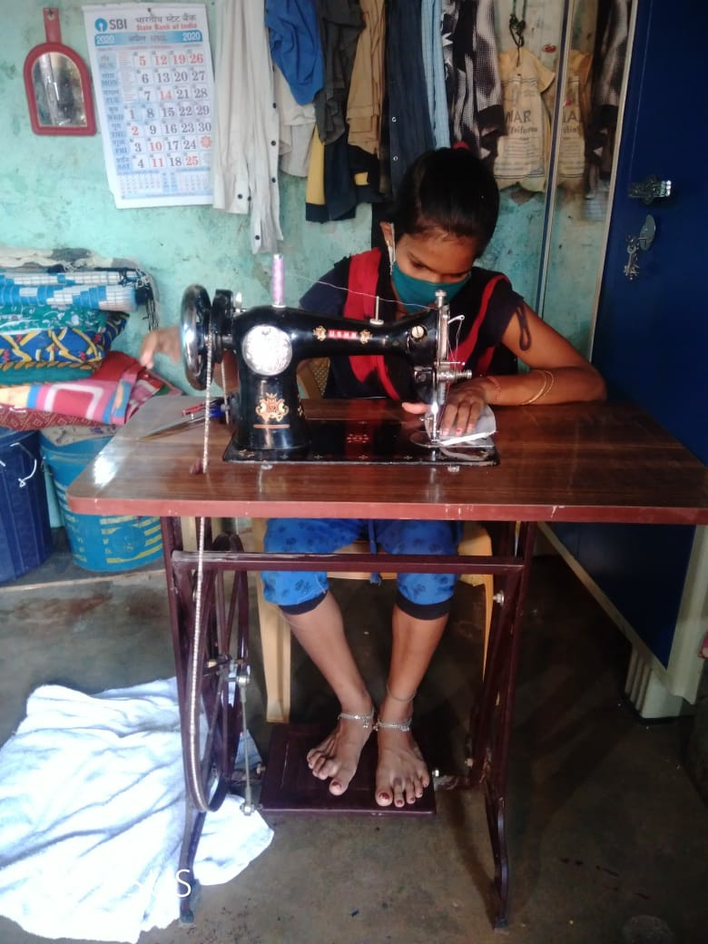
Community Sensitization on COVID-19:-

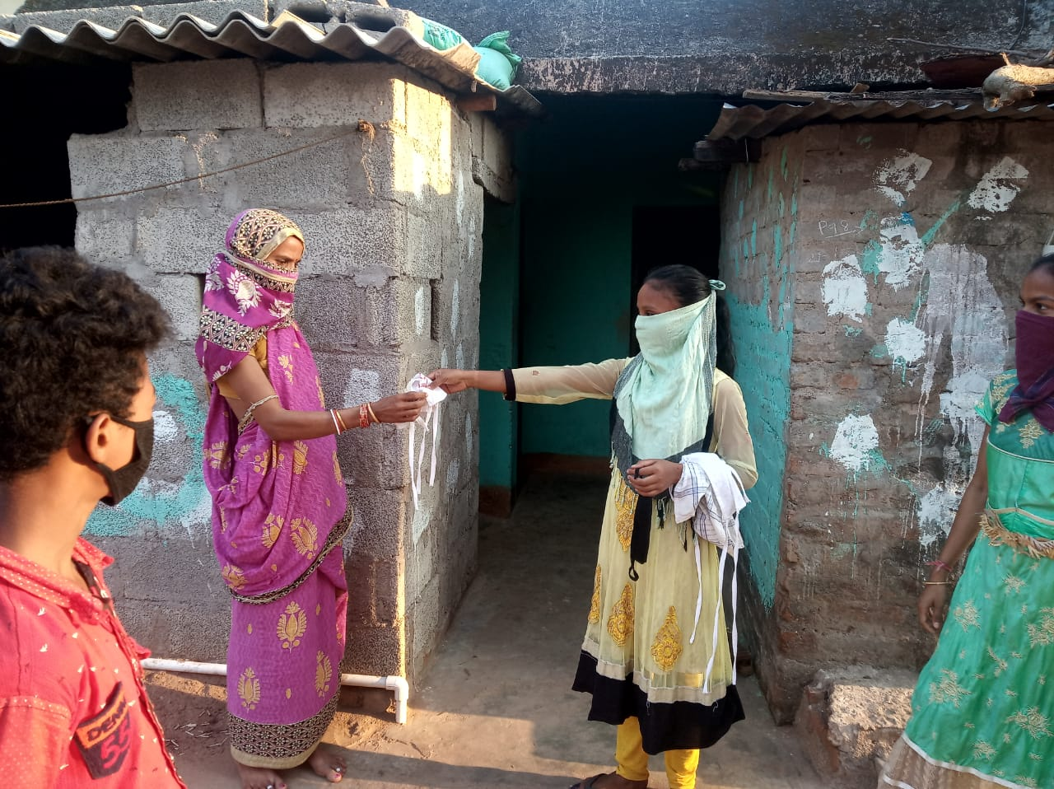
COVID-19 continues to constitute a public health emergency of International concern. So, with this emergency Ruchika has been trained to Remedial teachers to spread awareness among the community people on use of mask, continuous handwash, and maintain social distance. In this situation our BEC members and Balika Mandal members also has taken major responsibility as an active leader in their community. They have aware community people on the same as well as some of the members have stitched mask by self and distributed to community people.

