
Low Cost Shelter for Flood Victims of Pakistan
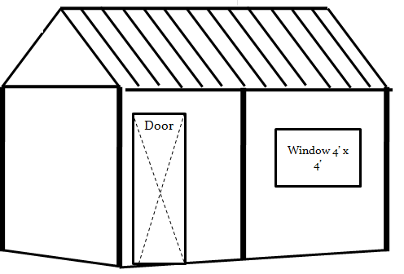
Low Cost Housing
for 1500 families

Objective:
The main objective of the project is to protect 1500 affected families of Uc Dubi & Khorwah of Taluka Shaheed Fazal Rahoo, Badin District & UC Tando Ghulam Hyder of Taluka & District Tando Mohamed Khan by providing them low cost housing 1500 families to bring them back to normal life as before floods.
Beneficiaries:
- Target Families: 1500
- Total: 9,500 Children: 4,000 Women: 2,800 Families: 3,805

Target Area:
- District Badin
  - UC Dubi and UC Khorwah, Taluka Shaheed Fazil Rahoo, District Badin
  - District Tando Muhammad Khan
  - UC Tando G. Hyder, District Tando M. Khan

Complete Design of Low Cost House
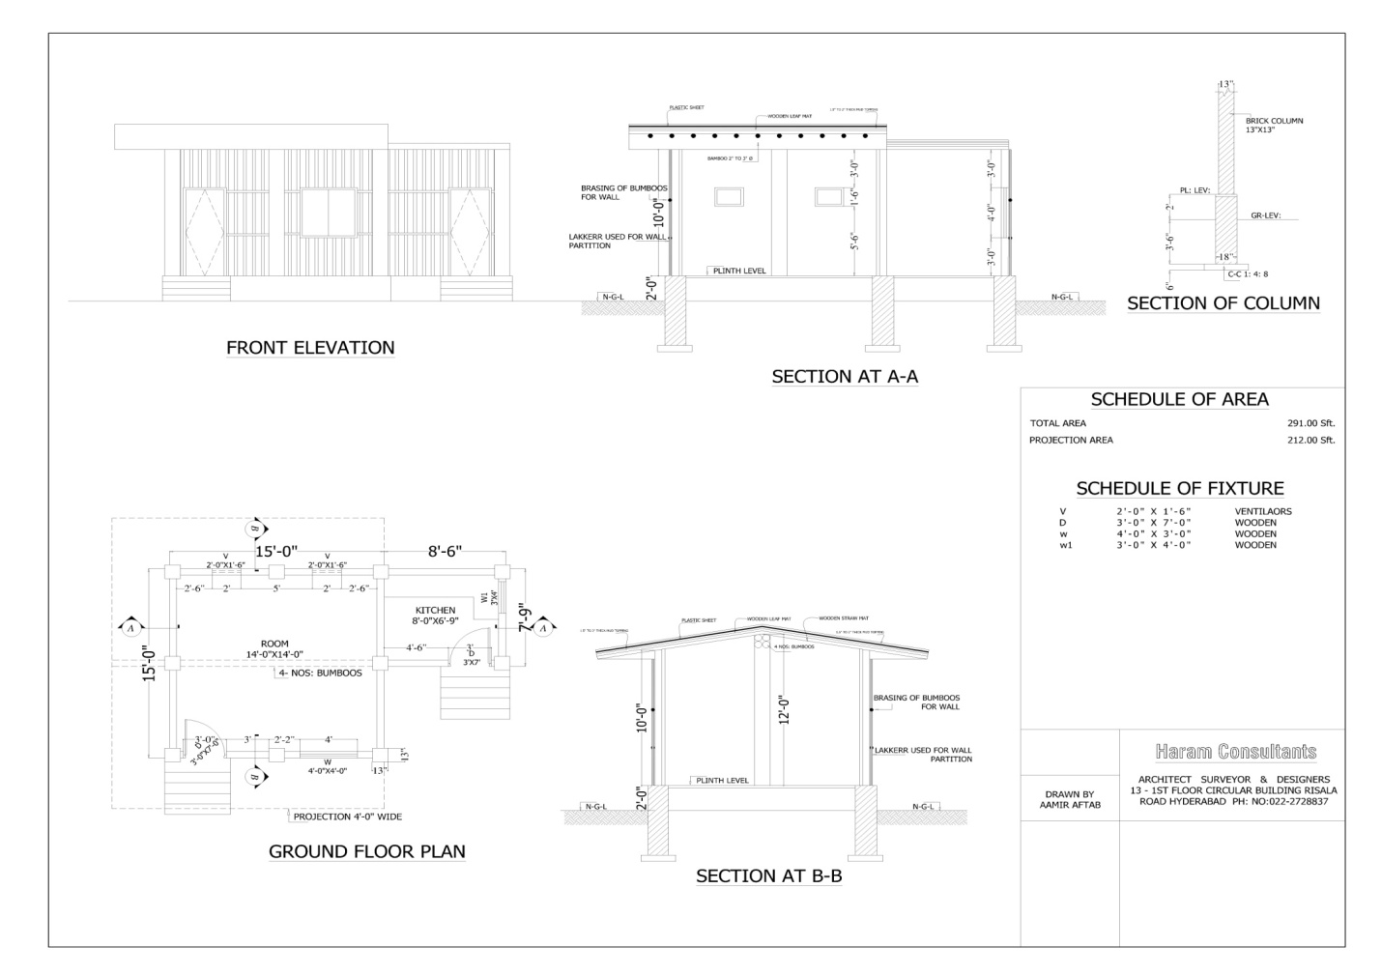

Budget
Project Budget:
Direct Material Cost | 562,500
Direct labor Cost | 29,800
Indirect cost, Admin | 38,400
Per house cost | 375 US $
Note: Admin Cost: 6%
Project Staff:
1 | Project manager | 1
2 | Program officer male | 1
3 | Program officer female | 1
4 | Social mobilizers 4 (2male & e female) | 4
5 | Field workers | 2
6 | Civil engineer | 1
7 | Driver & supporting staff | 3
 | Total | 13

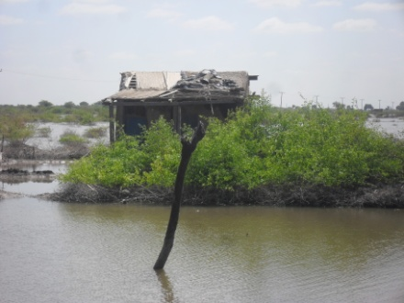
Material for Low Cost shelter

Material & Services provided to Households

1 | Bricks | 1500
2 | Cement | 08
3 | Bamboos | 34
4 | Sand | 200 (CFT)
5 | Guarder | 03
6 | Kani Pakha | 02
7 | Chaka Pakha | 02
8 | Door | 01
9 | Window | 01

Work & Services will be done by skilled team for households
- Bricks masonry of peelers.
- Fixing Guarders on peelers.
- Fixing of Bamboos on top.
- Fixing of Kani Pakha.
- Fixing of Chaka Pakha.
- Fixing of Door and Window

Low Cost Design for Badin District
- SCOPE OF WORK
- Beneficiaries Contribution
- Excavation for foundation or peelers.
- Back filling and inside 2’Ft Filling of Dirt with compaction.
- (Hand trolley will be provided to beneficiaries for Filling)
- Arrangement of walls material (local wood Lakers & bushes) will be beneficiaries’ responsibility.
- (Locally bushes plants material every where available in huge Quantity.)
- Wall’s work completely done by house hold.
- (Lakers fixing mud plastering inside and outside)
- Roof Top and Flooring mud plaster mixing and applying house hold responsibility.
NOTE: Above said material is available and nearby villages, No cost pay again that material it’s for burning in stove and making walls for shelter. These all above mention material are available in surrounding villages and it’s all free of cost because these all are maturely product.

Project Activities:
- 1. Orientation workshops and Quick survey of 1500 families, selection of most poor and deserving
- 2. Procurement committees visits, purchasing of quality items
- 3. Transportation of item to the site office and with the help of volunteers etc.
- 4. Mobilization and formation of village groups
- 5. Finalization of the list of 1500 families
- 6. Procurement of the construction material for 1500 houses & 1500 local Kitchen for 1000 in Badin and 500 in Tando M. Khan districts
- 7. Program manager and social mobilizers will coordinate with NGOs/CBOs/Govt. departments and DDMA offices and program manager will make sure to attend all shelter cluster meetings in district
- 9. Submission of monthly and weekly project staff meetings and reports submission to office on regular basis
- 10. Monitoring visits to be conducted by AHD monitoring officer and check the activities are done and future plans.
- 11. Training on low cost housing models and safe building practices
- 12. Trainings on Disaster Risk Reduction Techniques for target families in target areas
- 13. Construction of low cost latrines by local support and WASH partners collaboration
Low Cost House Budget in Pak Rs.
1- Guarders 6” x 6” x 15’– 0 01 x 3000 = 3000
Guarders 4” x 6” x 15’– 0 02 x 2000 = 4000
2- Bamboos 8’ – 2” x 34 = 277 RFT 277 x 18 = 5000
(Both Panels)
3- Door 7’ x 3’ 01 x 3000 = 3000
4- Window 4’ x 4’ 01 x 3000 = 3000
5- Kani Pakha 8’ x 16” 02 x 1600 = 3200
6- Chaka Pakha 8’ x 16” 02 x 1500 = 3000
7- Bricks 1500 1500 x 06 = 9000
8- Cement 08 Bags 08 x 420 = 3360
9- Sand 200 CFT 200 x 30 = 6000
10- Masson 03 Days 03 x 700 = 2100
11- Labors 06 06 x 400 = 2400
Total Amount in US $ 500 Pak Rs. = 43,700

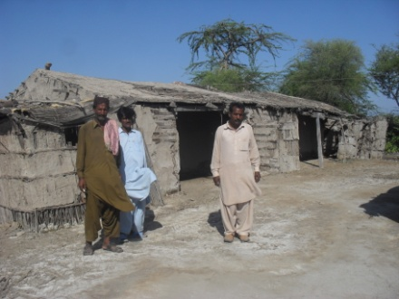
Shelter Coordinator discuss the structural gaps for damages

