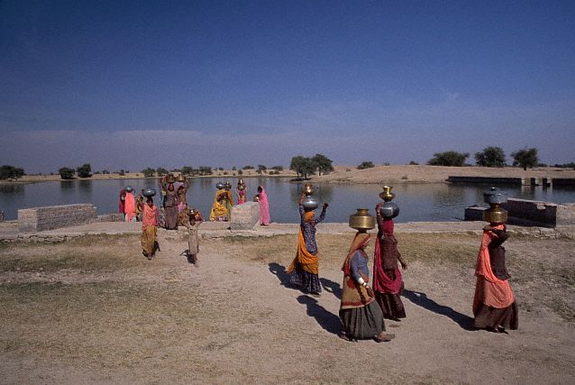
India
Water Quality Facts
2003 Population: 1.1 Billion
Urban Population: 30%
Rural Population: 70%
Annual Growth rate: 1.6%
Surface Water Issues:
India has the world’s most densely populated river basins, leading to high levels of bacterial contamination in surface water supplies. 80% of this pollution is from disease bearing human waste¹.

¹ Planning Commission (2002) "Tenth Five Year Plan" Government of India.
² Statistical Abstract of India, 1998.
³“Strategic overview of the drinking and industrial water use sector”, AP Water Vision Position paper 2, 2003.
⁴ Andhra Pradesh Pollution Control Board. 2001. State of environment of Andhra Pradesh. Hyderabad, Andhra Pradesh: APPCB.
⁵ Brandon C., and Homman K. 1995. "The cost of inaction: Valuing the Economy-Wide Cost of Environmental Degradation in India" Asia Environment Division, World Bank.
Women carrying drinking water*
While India is currently meeting UN Millennium Development Goals in providing access to improved water sources, access to safe drinking water remains urgent, as 30% of urban and 90% of rural households still depend on completely untreated surface or ground water.²
Water and Sanitation-related Disease in India
Inadequate access to safe drinking water causes infant mortality and intestinal diseases. The most common water-borne diseases in India are :
-Diarrhea-Hepatitis
-Trachoma -Intestinal worms

These diseases affect, 37.7 million Indians annually, and over ¾ of the afflicted are children under five3.

In 1999, diarrhea alone killed over 700,000 Indians4.

^{T}he World Bank has estimated that the annual health costs of water and sanitation diseases in India are between 3.1 to 8.3 billion US$5.
Groundwater Issues:
Currently it is estimated that 80% of domestic needs in rural areas and 50% of domestic needs in urban areas are met by groundwater supplies, which are rapidly shrinking due to excessive depletion.

Over two hundred thousand habitations have serious chemical problems with drinking water quality, primarily caused by groundwater:

-Arsenic (Ganges Delta)-Fluoride (17 states)
-Salinity (Coastal areas)-Iron (Country-wide)
-Nitrate (Agriculture and sewage)

Pre-Tsunami
Water and Sanitation-related Disease in Tamil Nadu
Tamil Nadu is endemic for Acute Diarrhoeal Diseases with sporadic outbreak of cholera in most of the districts throughout the year, and in epidemic proportions during the rainy seasons and peak summer periods. The following table shows that water-borne disease was a serious health and development threat in Tamil Nadu well before the tsunami.
2
1,390
0.14
101
69,807
2004(Jan-Nov)
0.26
1
3,90
0.11
66
58,784
2003
0.19
3
1,591
0.28
199
69,889
2002
0.09
1
1,110
0.27
159
59,511
2001
0.05
1
1,328
0.30
195
64,130
2000
0.06
1
1,807
0.36
266
74,583
1999
0.00
0
1,807
0.47
368
77,677
1998
0.09
2
2,261
0.67
520
78,025
1997
Fatal rate
Deaths
Cases
Fatal rate
Deaths
Cases
Cholera
Acute Diarrhoeal Diseases
Year
Tamil Nadu Overview
2001 Population: 62.5 Million
- Urban Population: 44%
- Rural Population: 56%
Source: Health & Family Welfare Department, Government of Tamil Nadu

