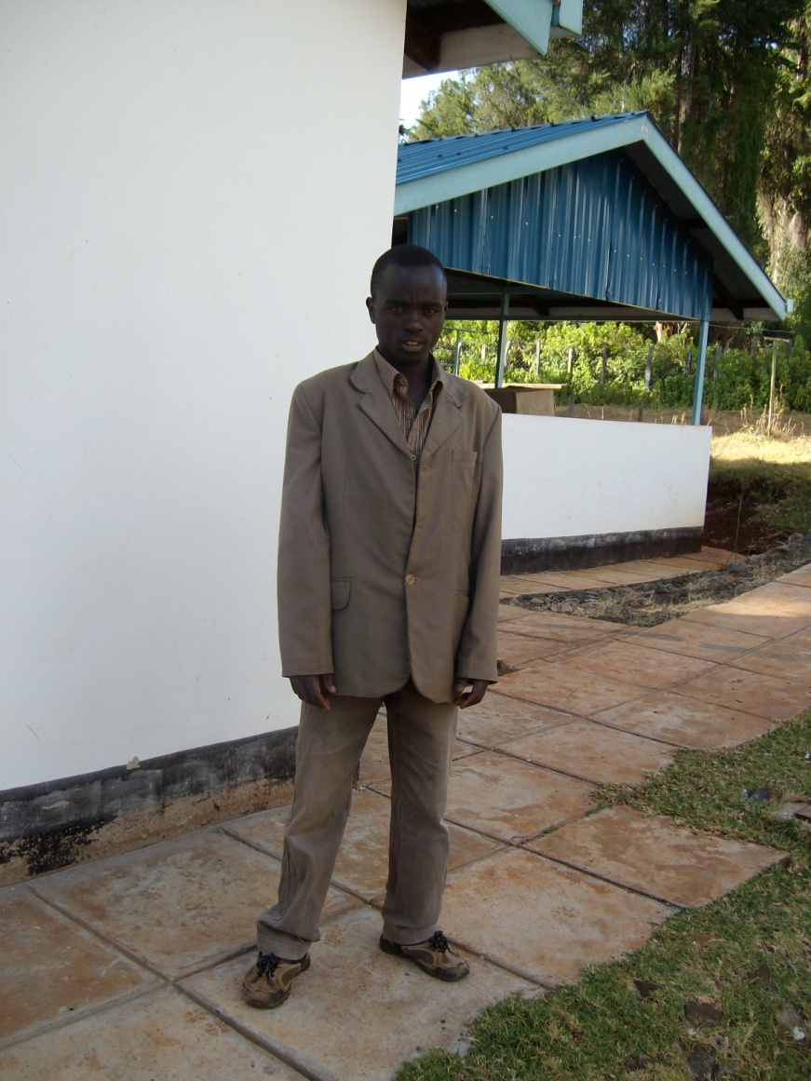
TARUS ELIA JULIUS- COMMUNITY HEALTH WORKER CHEBIEMIT NERKWO UNIT -KAPTOMUT VILLAGE
MARAKWET DISTRICT.

