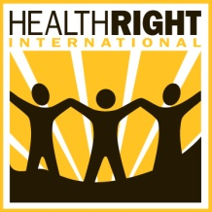

Reducing Malaria Deaths in Kenyan Children
Report for February 2012

Tarus Elia Julius
CHW Chebiemit Nerkwo Unit
Kaptomut village

I got the opportunity to be trained as one of the community health workers to serve in the Kaptomut village of Chebiemit sub location in the Chebiemit Nerkwo unit. I have been carrying out household visits and ensuring that my households members are sleeping under [mosquito nets] every night especially those who are most vulnerable to Malaria. I have also been advocating for behavior change among them. I have been able to refer pregnant mothers for antenatal care, refer children under five years for treatment and immunizations, provide health education to the household members on malaria prevention especially through the consistent use of [mosquito nets] which are issued free of charge at the health facilities. Every month, I attend CHW monthly meetings where I get more training and mentoring from the HealthRight international staff. Currently I am also able to monitor the utilization of the [mosquito nets] at the household level and mobilizing them against misuse which has been a challenge in the past as some community members used them for decorations, fencing kitchen gardens and others used them to safeguard their poultry. I’m now confident that my household members have developed a positive care seeking behavior and wish that someday malaria will be a disease of the past. As a community health worker I have had a title and respect from the community who always consult for opinions and clarifications on health issues that the community suffers from. I’m also appreciated during community events and given the opportunity to address them on simple health matters affecting the community. I could not have achieved all these in my households without the support from this program.

- Tarus Elia Julius

