DRYLANDS NATURAL RESOURCES CENTER (DNRC) PROGRESSIVE REPORT, Sept-Nov.2015 pictures
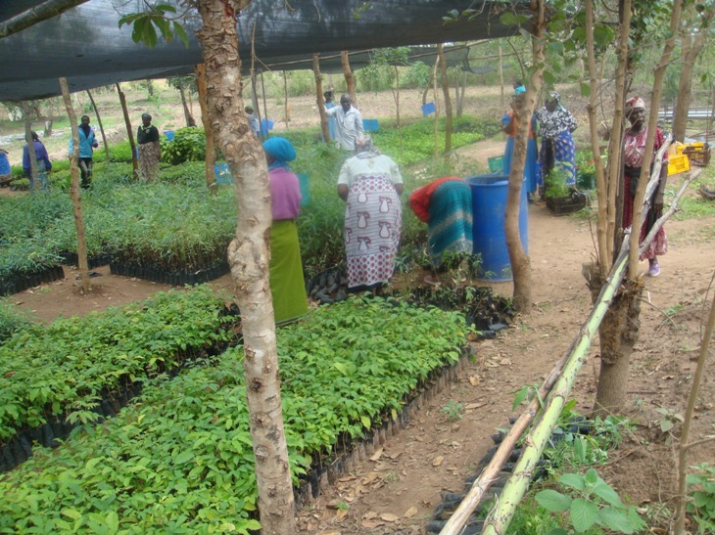
Farmers getting their tree seedlings from our tree nursery

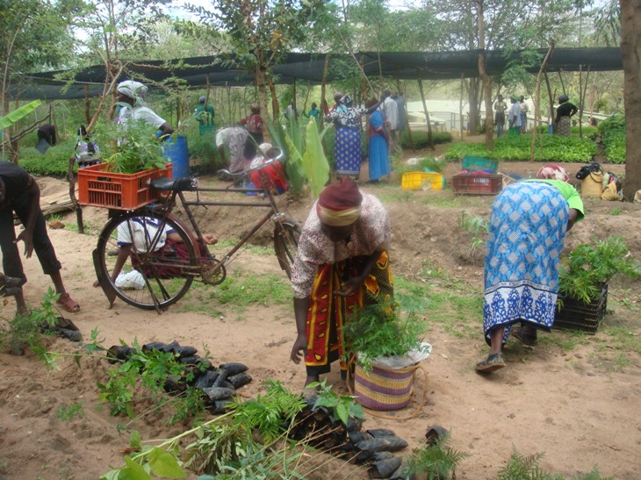
Farmers confirming and carrying the issued tree seedlings
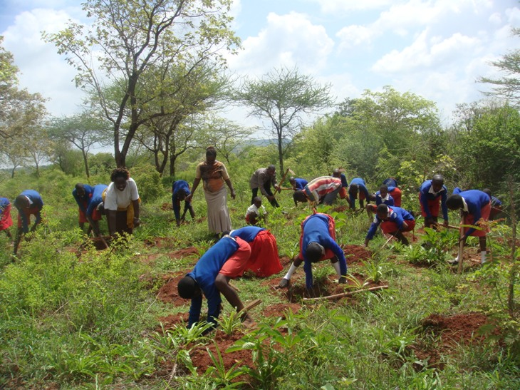
Kyooni primary school preparing their food forest.
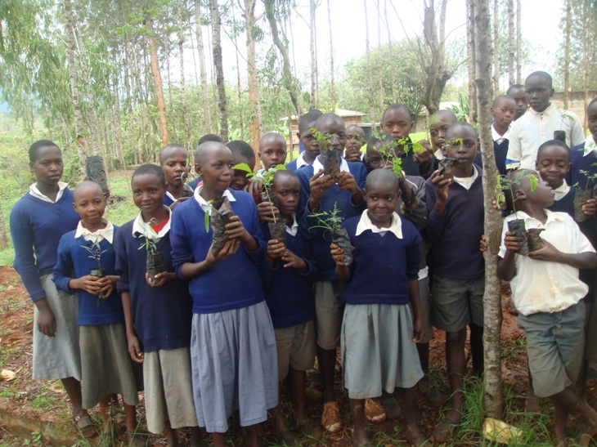
Kimandi primary pupils holding issued seedlings ready to plant

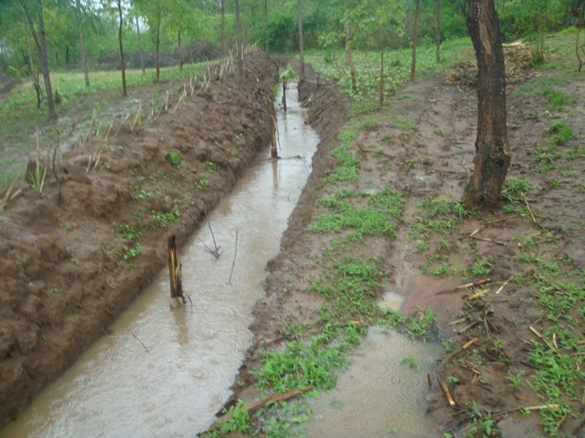
Swale at DNRC site stopping, spreading and sinking water for planted bananas and napier grass on the balm.

