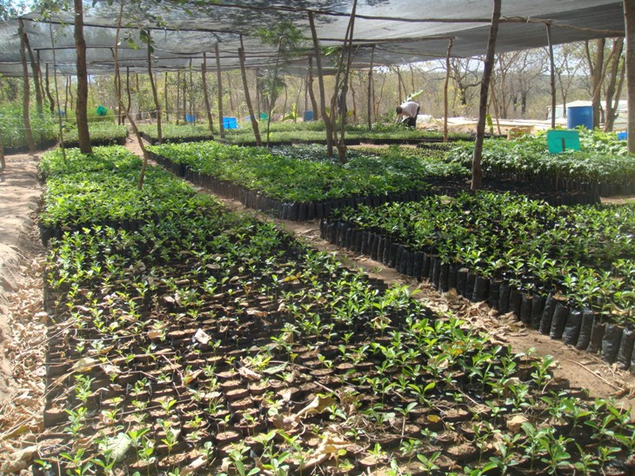
DNRC tree nursery

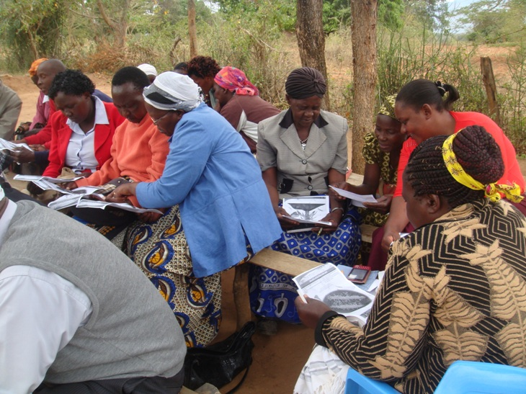
A group of farmers in a training session.

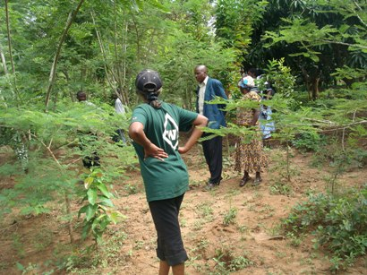
An example of food forests/woodlots farmers are trained to establish

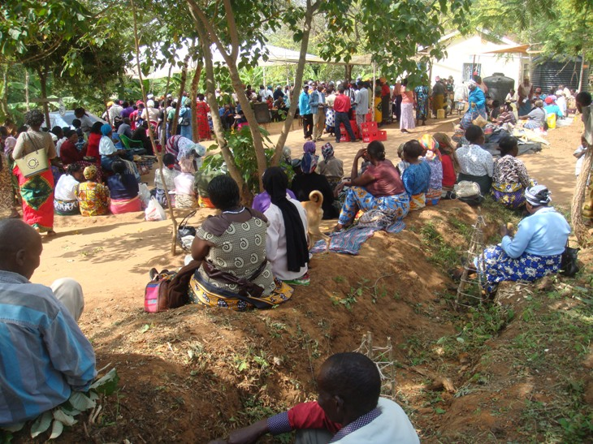
DNRC farmers attending the Bi-annual get-together

