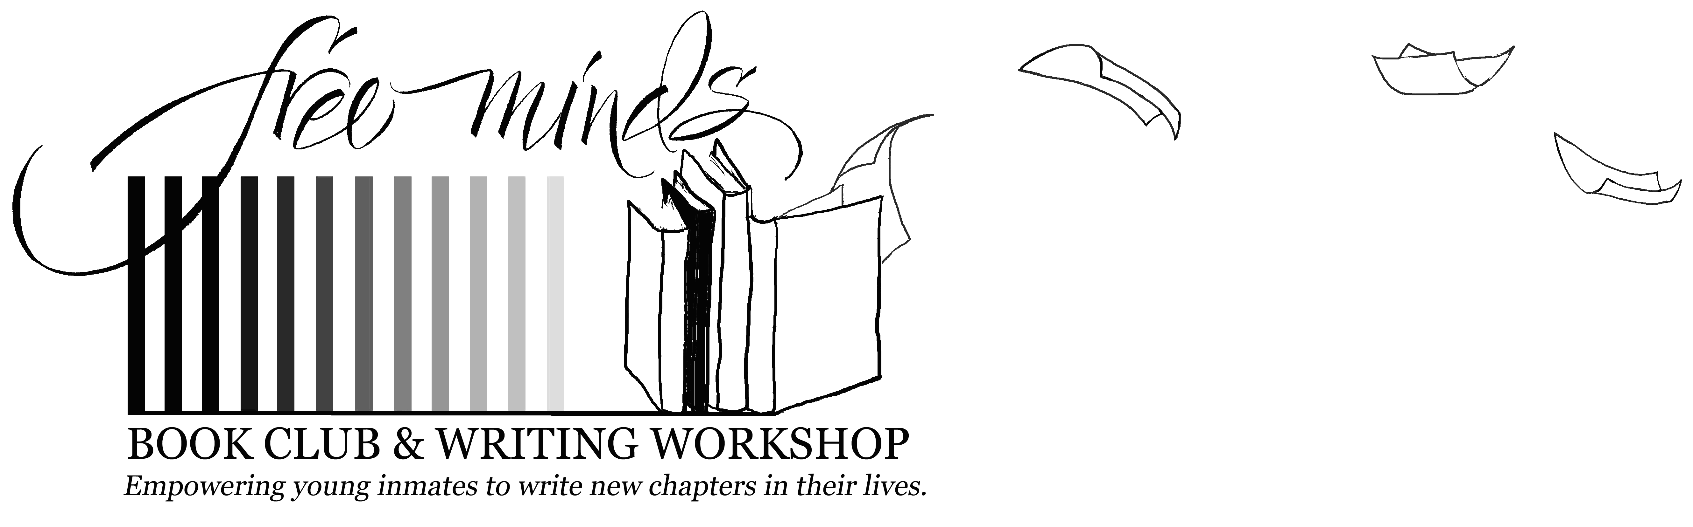

INITIATIVE – Free Minds Book Club – Books Across the Miles (BAM)
Need and Urgency of Project – Maintaining the momentum and excitement about books that is developed through the Book Club is difficult, yet crucial after youths are transferred to federal prison. Free Minds strongly believes that books and creative writing have the incredible power to teach, build community, inspire individuals and change lives. The BAM initiative will allow us to harness and build upon this potential. Without Free Minds coordinators visiting them weekly while in the DC Jail to encourage them, some youths’ enthusiasm and hope can begin to wane. Through BAM though, we will develop and formalize a curriculum based upon the book club model that will allow us to reach these youths in an organized and consistent manner not currently possible due to limited resources. BAM will ensure that we maintain and strengthen our bonds with youths, and their bonds with books, even after they have been dispersed throughout prison facilities across the nation to serve their sentences.
In 2010, more than 100 juvenile males, ages 16 and 17 years old were charged as adults for felony crimes and incarcerated at the DC Jail. Most had already dropped out of, or disengaged from school. Without education, many will see criminal activity as their only viable source of livelihood after they go home. Juveniles incarcerated as adults are at extremely high risk for future criminal activity. Because Washington, DC does not have its own state prison facility, DC Jail’s inmates are transferred to federal prisons as far away as North Dakota and Wisconsin. The DC Department of Corrections does not serve or track them after they are transferred. Free Minds is the only organization that addresses the unique needs of juveniles incarcerated as adults at the DC Jail, by mentoring and serving them throughout their entire incarceration, into reentry and beyond.
It is vital that we create a strong and enduring connection with youths at this critical juncture to excite them about learning and motivate them to pursue positive new futures. Nationwide statistics show that up to 90% of juvenile offenders incarcerated as adults will reoffend within one year after release. For youths served by Free Minds, this figure is just 24%. The success of so many who have achieved their GED, high school diploma, enrolled in college or vocational training and obtained stable employment demonstrates that with the appropriate support these youths can positively redirect their lives. We believe that BAM will not only greatly strengthen our programming, but will result in more of our youths remaining actively engaged with Free Minds throughout their incarceration and successfully returning to the community.
Planned Activities/Timeline – BAM will utilize Free Minds’ proven book club model to continue cultivating a strong love for the reading among young inmates after they turn 18 and are transferred to federal prison. Free Minds already sends books to youths in our Continuing Support phase, but because they are dispersed to various facilities across the country, the powerful impact of sharing impressions of a common book in a book club setting with others who are reading it is lost. BAM will provide four additional books to each youth annually, and allow them to continue to interact and discuss what they are reading with each other in a way that increases their understanding and appreciation of the book. It will reinforce the idea of reading as an experience rather than an academic assignment, contributing to a lifelong love for reading.
Upon notification of funding, Free Minds will distribute copies of the first BAM title (via order on Amazon.com) to all youths currently participating in the Continuing Support phase of our program (approximately 100 youths who have been sentenced and transferred to federal prison). Additionally, each youth will receive a letter in the mail describing the BAM initiative and a curriculum including a list of discussion questions (identical to those that would be used during an in-person book club session), an essay question, and a poetry prompt related to the book with instructions to respond within one month. (Note: Once developed, this curriculum can be reused in successive years of the project). Over the ensuing three months, their discussion question answers, essays and poems will be published and disseminated in The Free Minds Connect newsletter creating a “virtual” Book Club for the entire group by allowing a discussion despite their incarceration in facilities separated by hundreds of miles. Through this medium, youths will recreate the dynamic interaction that occurred in the Book Club. For example, a young inmate at a federal prison in Maryland will be able to share his impressions of the book with a young inmate at a facility in Ohio. After reading the newsletter, one might disagree with the other and be inspired to respond in the next issue creating an ongoing dialogue. The author of each book read will also be contacted and invited to participate by corresponding with the youths through The Free Minds Connect (Note: We have already discussed and confirmed participation with noted young adult fiction author Walter Dean Myers). Finally, more than 20 volunteer pen pals will buy their own copies of the book to read and correspond through letters with the young men about it. Each quarter, this process will be repeated with a new title for a total of four books, and 12 issues of The Free Minds Connect over the year.
By nurturing the new-found love of reading first established in the Book Club at the DC Jail, BAM will encourage youths now in federal prisons continue to pursue their education. BAM will keep newly hooked readers engaged, continue to encourage critical reading and thinking skills and reinforce the sense of bonding and community through education that is first forged among Book Club members at the DC Jail. This bond is a strong factor in Free Minds participants remaining connected and seeking the organization’s assistance after release from prison to successfully transition to a productive life in American society.
Benefit to the Community – The ultimate goal of Free Minds’ program is to use books and creative writing to empower incarcerated teenaged boys to pursue positive new paths in their lives. When youths return home from prison with a passionate desire for education rather than the street life, everyone in the community benefits.
By partnering with nearly 50 volunteers, including more than 20 who donate time as pen pals and mentors to our incarcerated youths, Free Minds encourages a strong and direct investment by the community in these youths’ success. BAM will build upon this investment by inviting pen pals as well as authors to engage more deeply and directly with the youths using the book club format.
After they return home, Free Minds members regularly volunteer with the organization. They spend hours in the Free Minds office answering phones, coordinating mailings, typing up the writing of those who are still incarcerated, and organizing and leading workshops for other youths. By giving them the opportunity to contribute and give back, Free Minds instills within our youths, the desire and skills to serve their community.

D.C. Department of Corrections
Strom, K. (2000). Profile of State Prisoners Under Age 18, 1985-97. Washington, DC: Bureau of Justice Statistics.

