We are proud to celebrate our 10th Anniversary this year. We continue working to provide hearing health and hearing solutions to those who need it most.
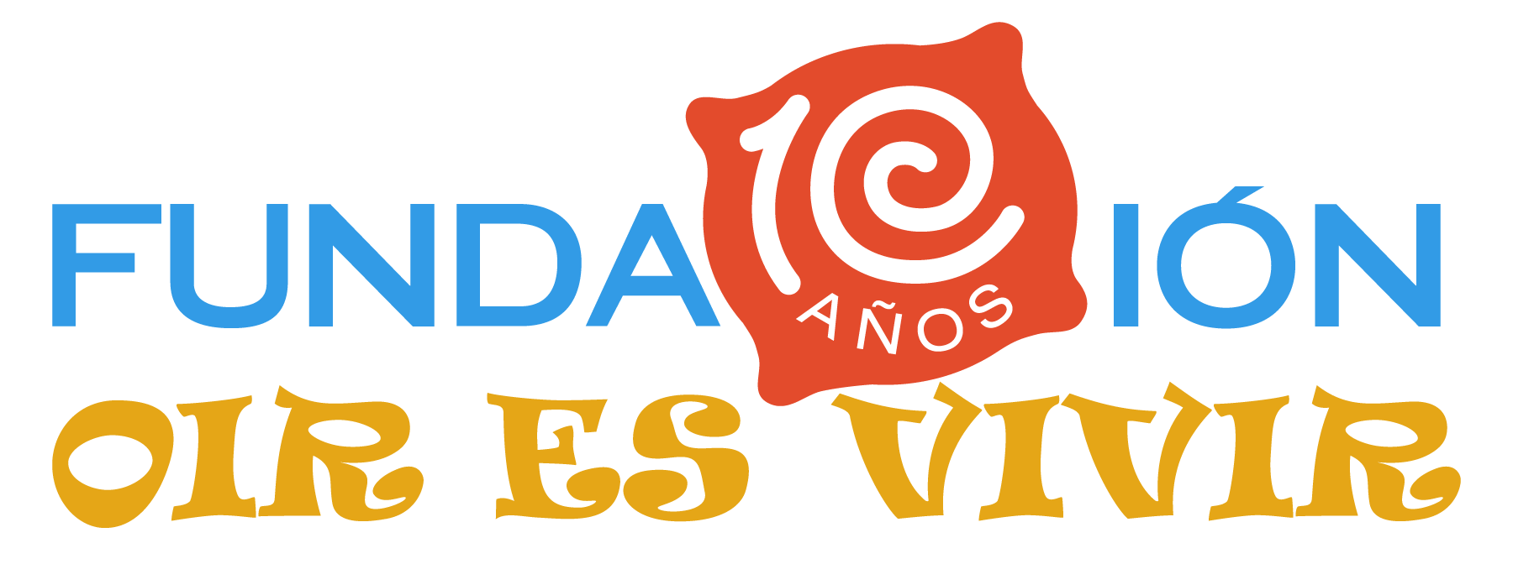
Meet some of our achievements:

More than 17,000 patients attended

More than 80 adapted hearing aids

Free exams for children in 78 public schools, 54 private schools and 35 friendly
foundations.

8 Tours of auditory health in indigenous and rural communities

34 Free Educational Sessions

Edition of the first educational story "Knowing Lorenzo"

Award Winning Foundation "Panama in Positive 2017", category NGOs.

Hearing Aids for Children and Adults ... because Hearing is Living
Under the donation program of hearing aids we have with MIDES, we adapt hearing aids to adults and children. It is a pleasure to support them so that they can hear.
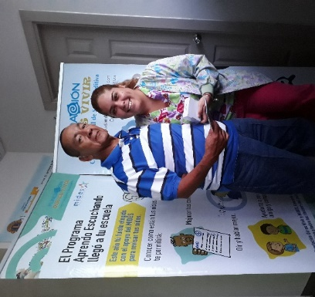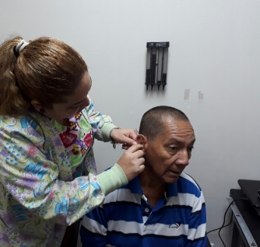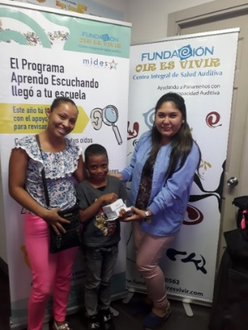

The care of the hearing aids includes us all ... that's why Mr. Gierhat's wife helps and learns about their use. It is important that when you receive your hearing aids, whether you are big or small, you are accompanied by a family member who provides support.

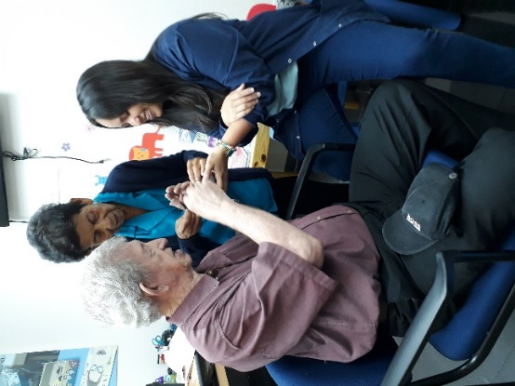
We offer Language Tests and Language Therapies for Children.
Our team of speech therapists is ready to offer your children language tests and therapies that help them improve the performance of their language. We offer these services also on Saturdays until noon.

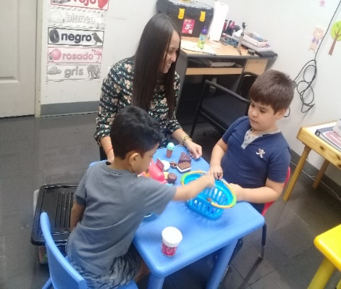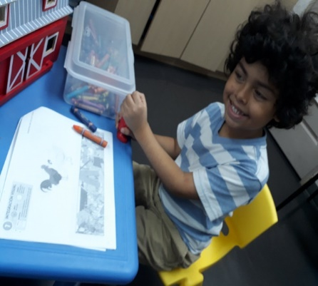
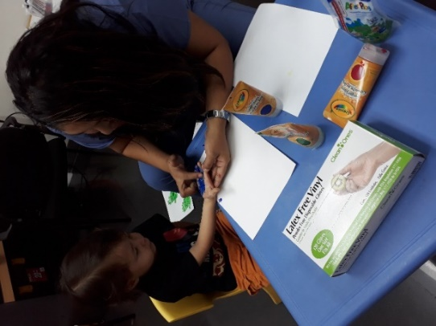
¡Todos los exámenes bajo un mismo techo!
Remember that in our clinic located in Vía Fernández de Córdoba, Plaza Córdoba, Floor 1, Office 8, we offer you not only the Auditory Screening, but all the auditory tests in one place.

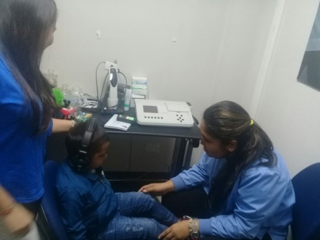
Impedance test
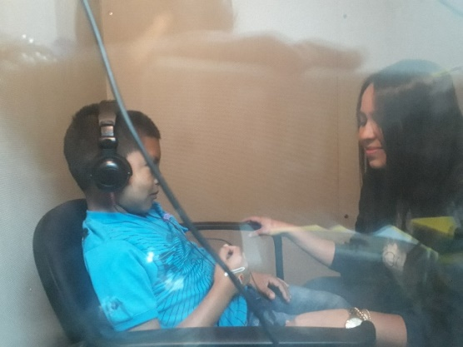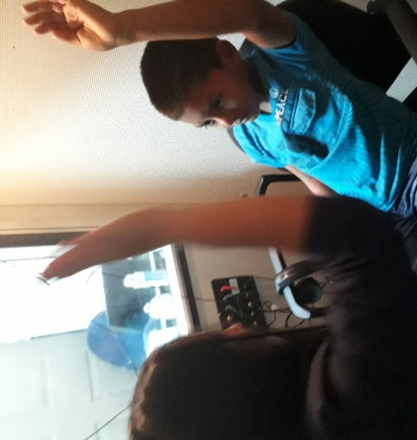
Audiometry test

Story "Knowing Lorenzo" comes to Libraries in the country.

Thanks to the National Library we can deliver our Storybook "Knowing Lorenzo" through the Public Libraries throughout the country. In this way we contribute so that more Panamanian families have access to information and education on the topic of deafness and hearing loss.

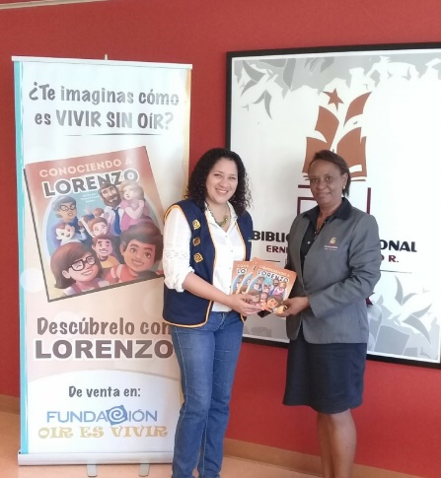

Baby Fair 2018
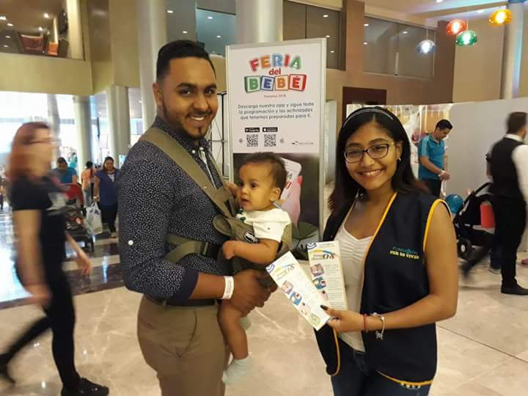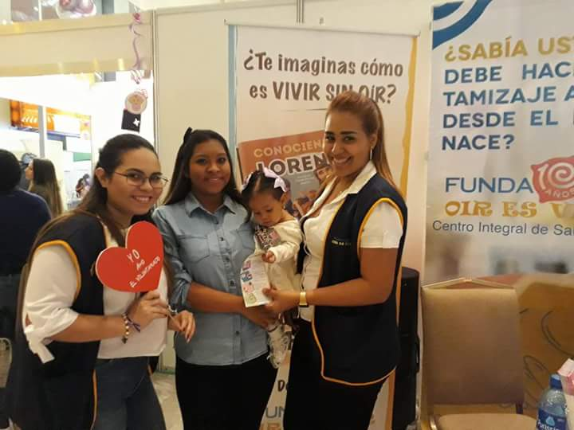

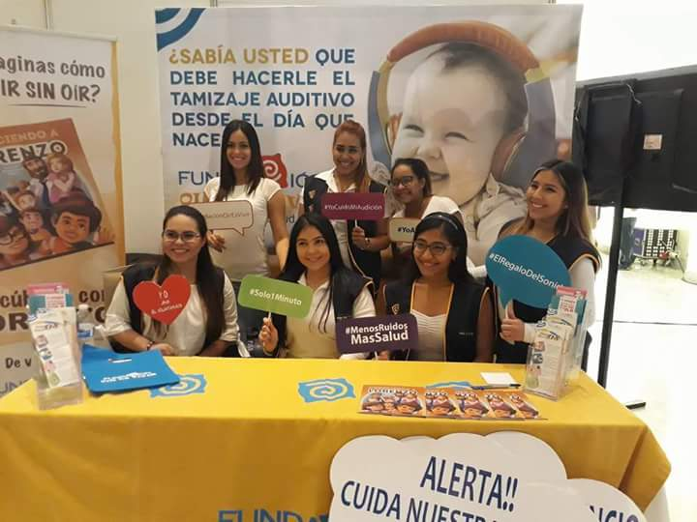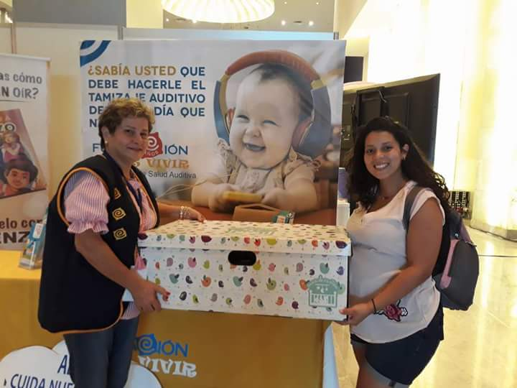

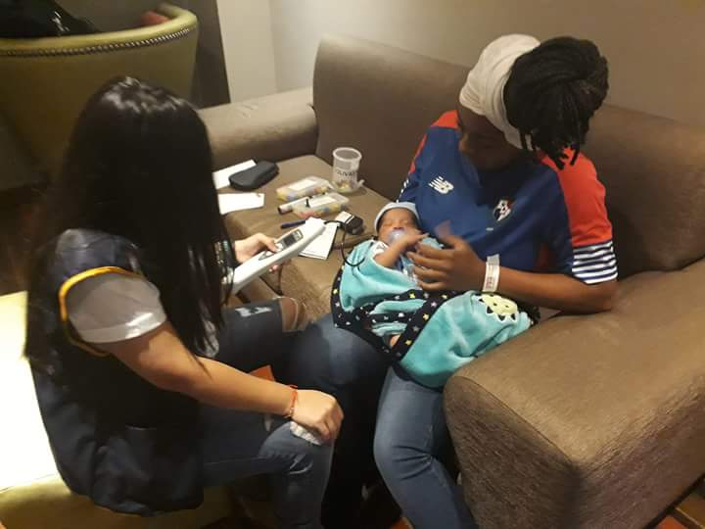

Hearing Aids for Children and Adults ... because Hearing is Living
During the month of March we had a donation day of hearing aids in conjunction with MIDES where we were able to return the gift of sound to many people.

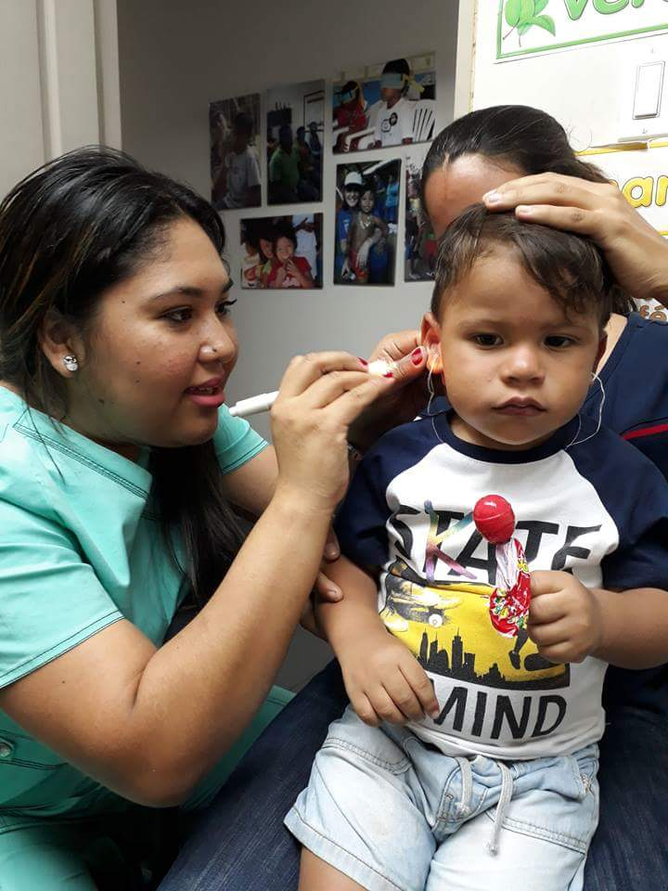

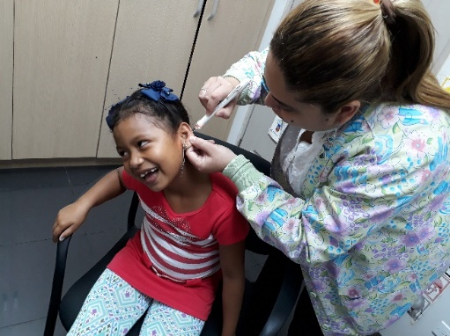
During this day we could benefit both children and adults, here we can see the molds taking which took 30 days to be ready to start the last phase of this day that was the hearing aid fitting.

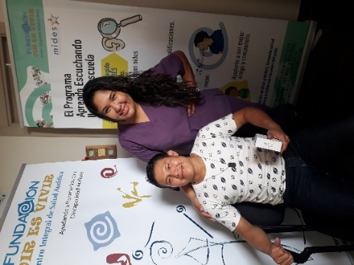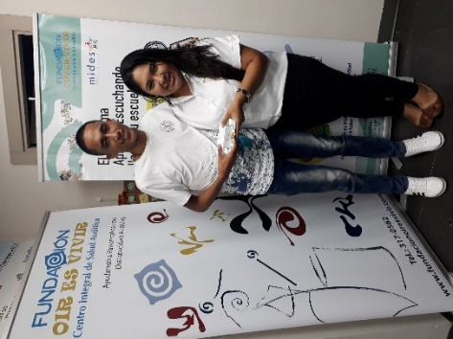
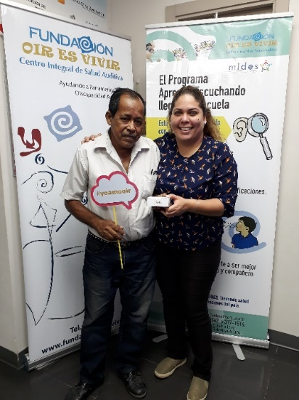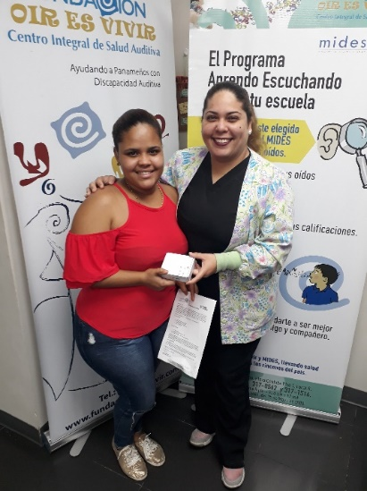
Delivery and adaptation of hearing aids to the people benefited by the donation day of hearing aids in conjunction with the MIDES.
.

Conference of hearing aids with EMPRESAS MELO

Empresas Melo supports us every year and this time supported us with the donation of 10 hearing aids in which several people could benefit.

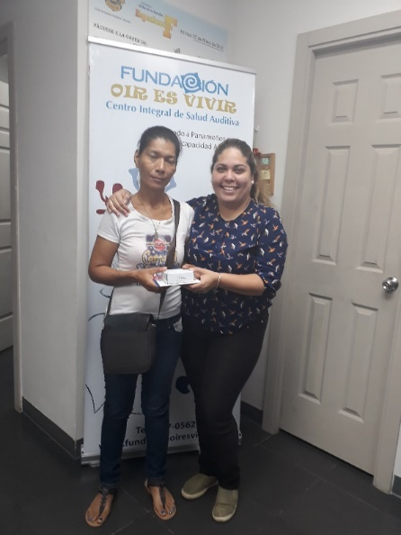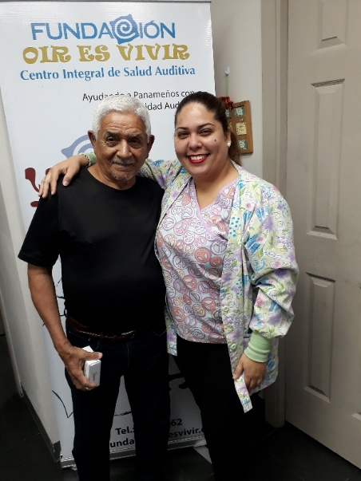
Delivery and adaptation of hearing aids to the people benefited by the donation day of hearing aids in conjunction with Empresas MELO.

Mobile program for hearing loss detection.
Our team of speech therapists is prepared to offer audiences both young and old, which is why with our mobile program we go to Corporación La Prensa which, year after year, supports us with this program.
.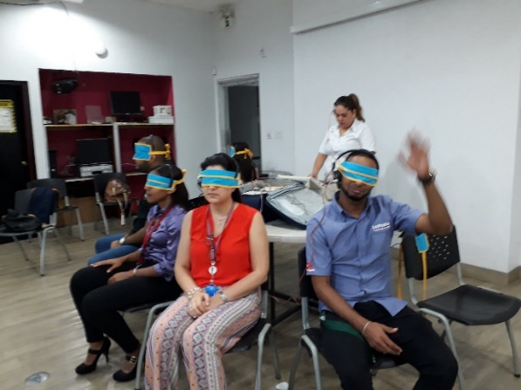 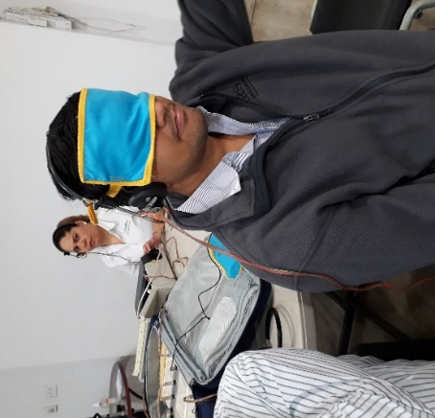
WE ALSO HAD THE OPPORTUNITY TO CARRY OUT THE HEARING TESTS TO THE COLLABORATORS OF THE MINISTRY OF AGRICULTURAL DEVELOPMENT.

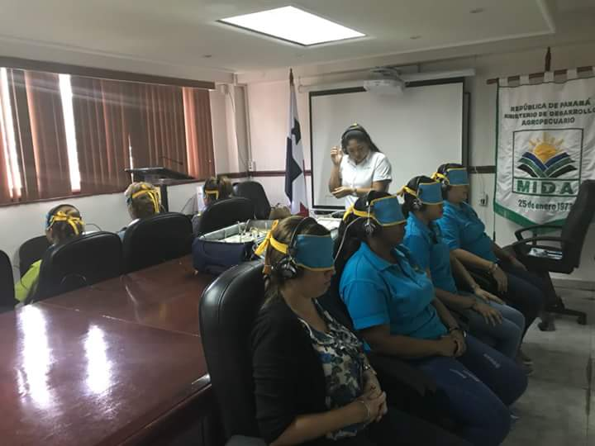

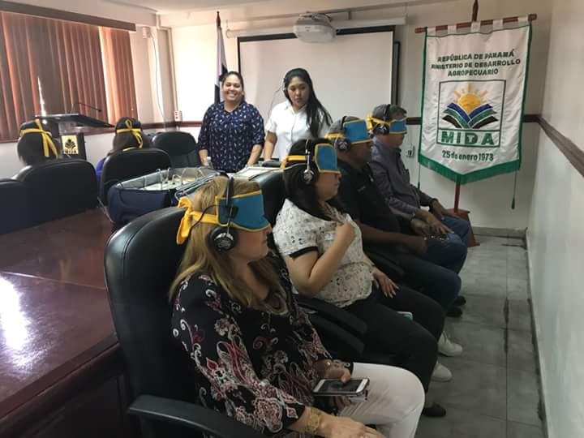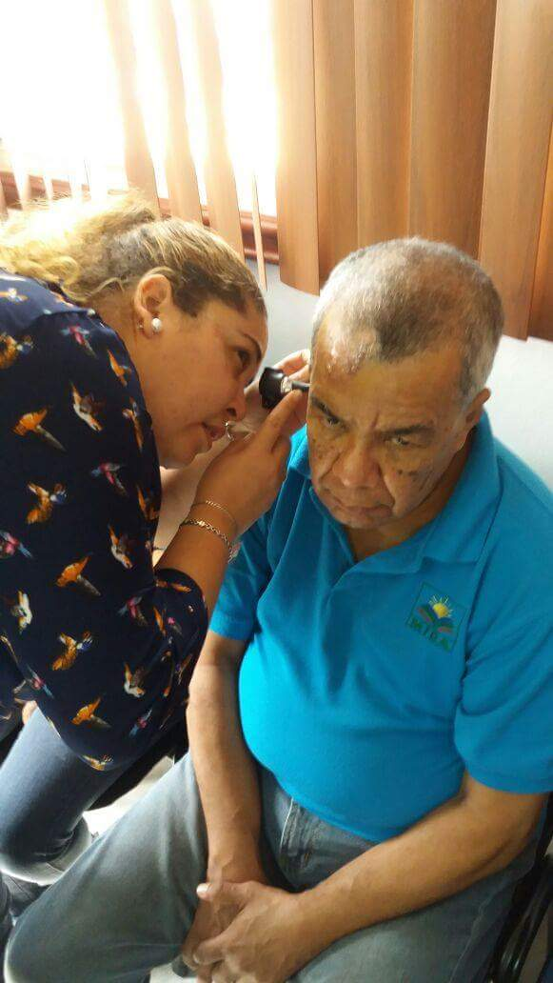
Program I learn by listening

One year more than the Kids and Family Center school takes us into account to take care of the auditory health of its students and we go to make tests to the little ones. Thank you for trusting in our Work.

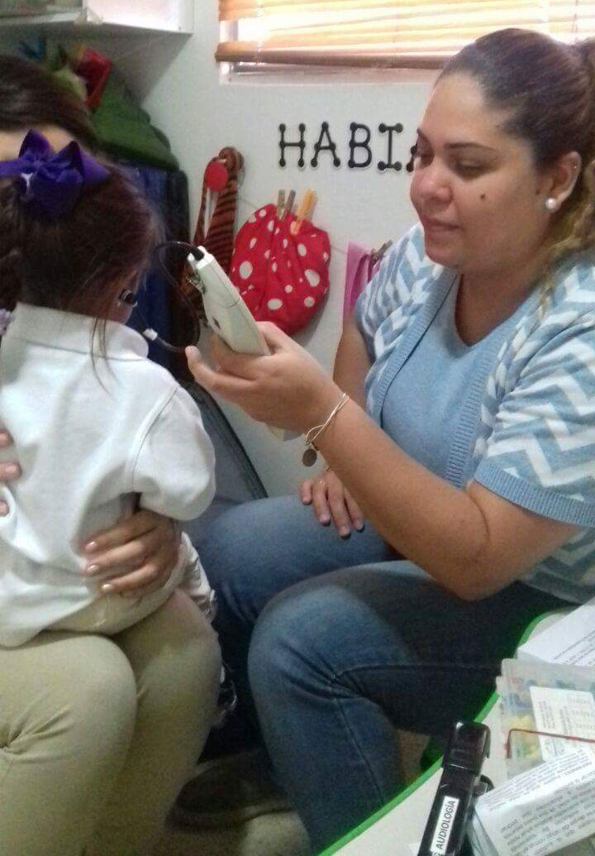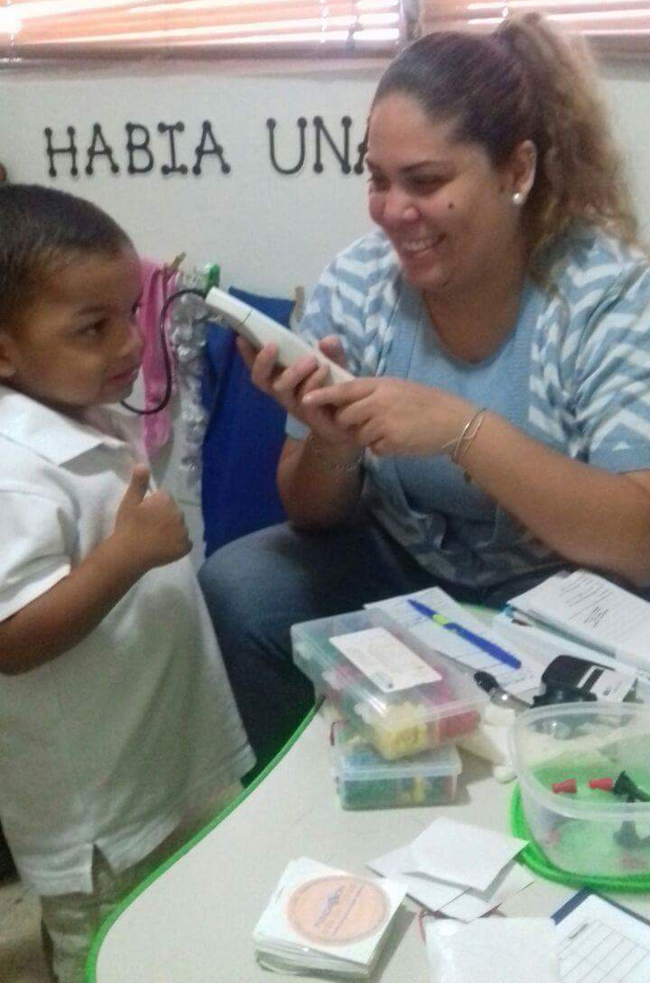

Launching Campaign “When you use the horn you hurt me” in conjunction with the Rotary Club Panama Sur.

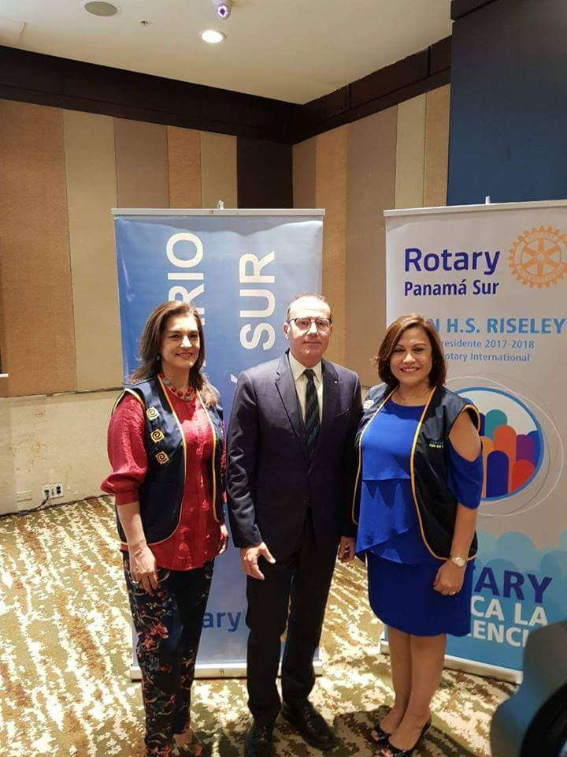
Mr. Alberto Botarelli, President of the Rotary Club Panama Sur, in the company of the ladies Giovanna Troncoso, President of Fundación Oir es Vivir and Analida Pitty Ceballos, Vice President of the Foundation.

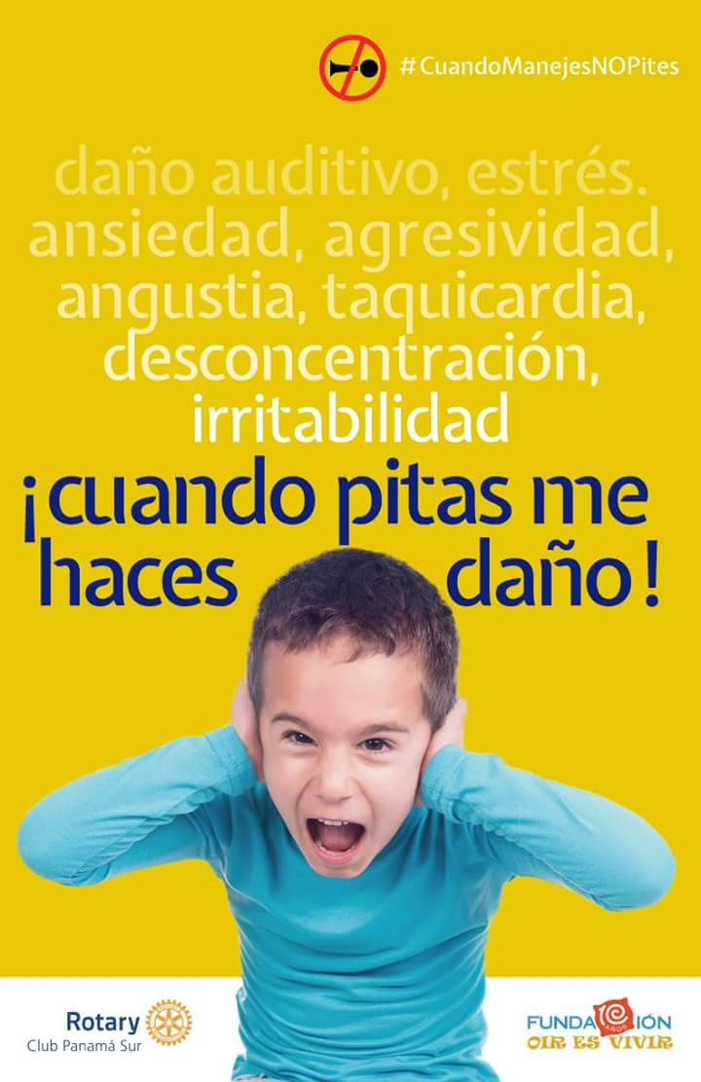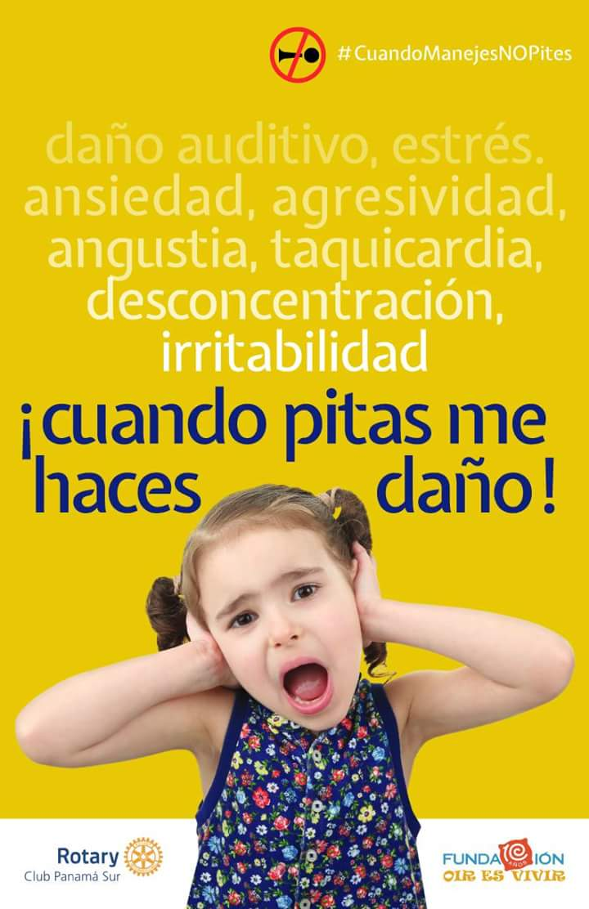
Thanks to the media, who are supporting this important campaign about the damage that noise makes to our health.

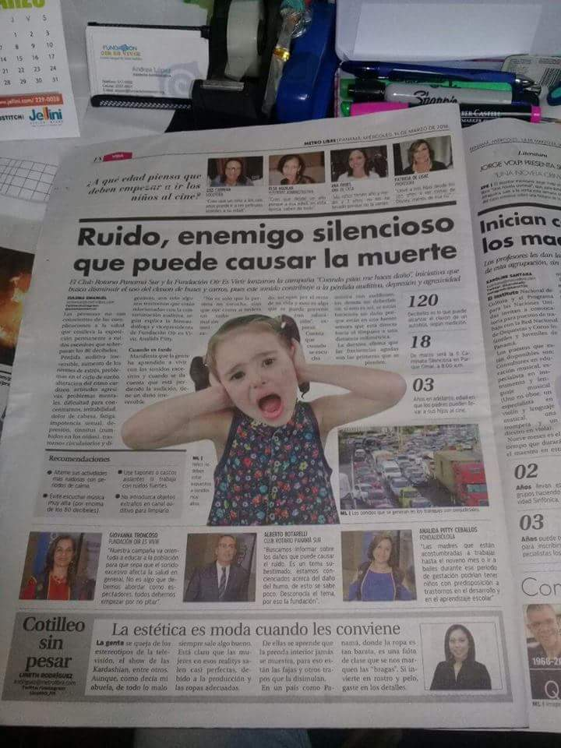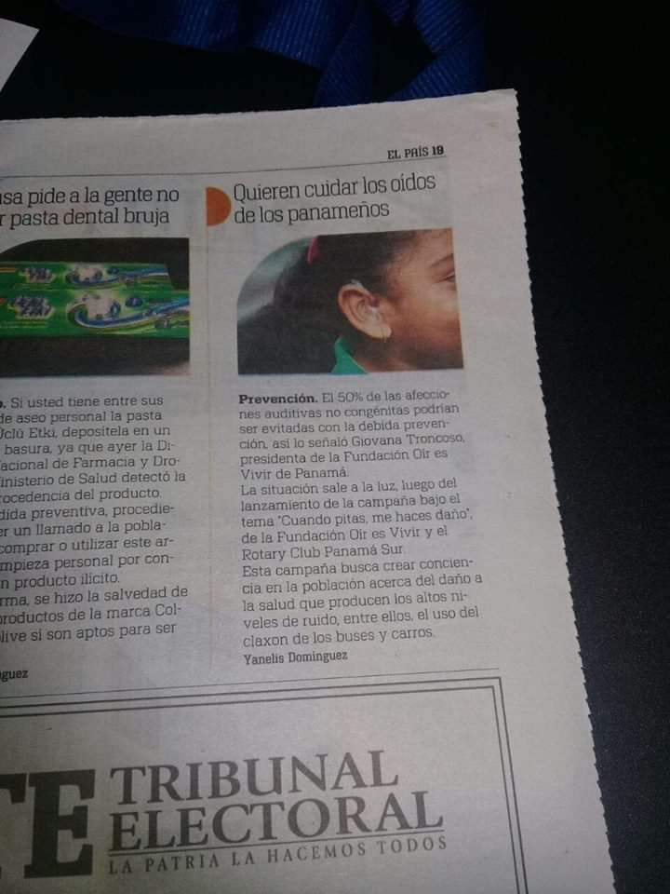
Newspaper: Metro Libre Newspaper: Día a Día
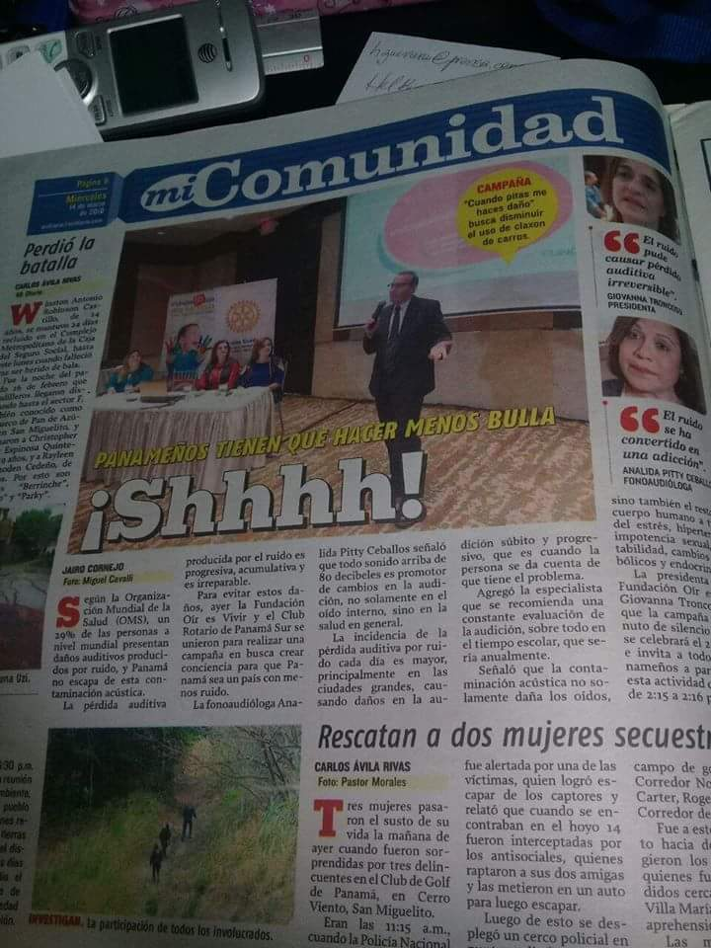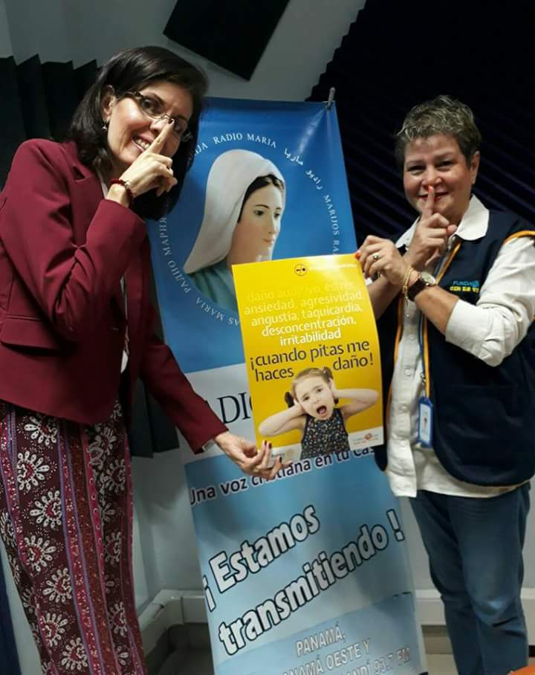
Newspaper: Mi Diario Radial Program Let's Talk about Home at Radio Maria with Mrs. Jacqueline De Los Rios.

II Silent Walk - Parque Omar
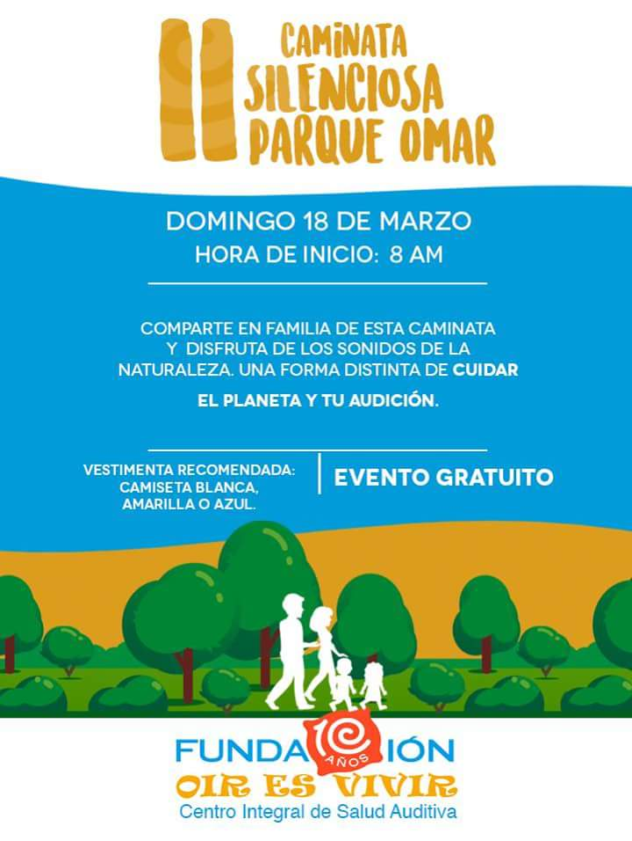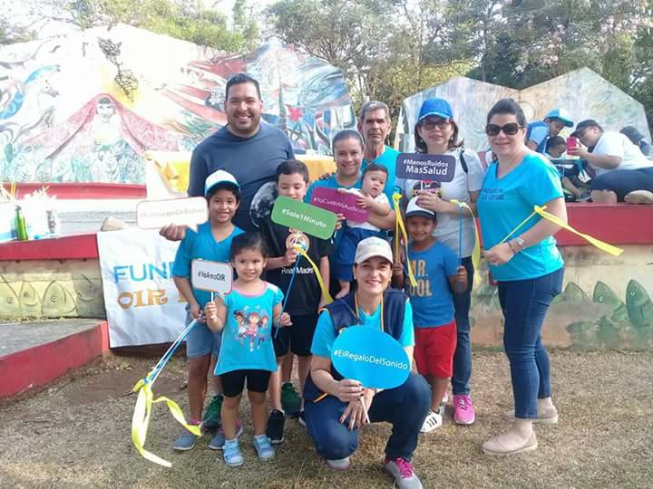
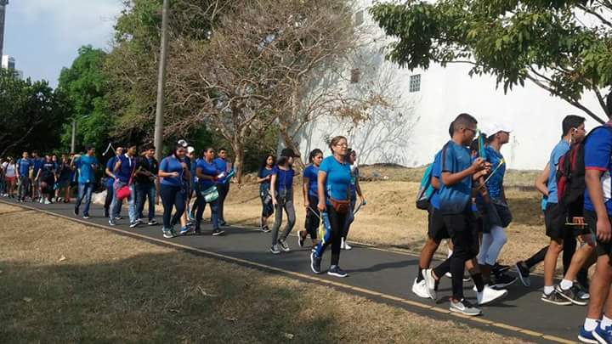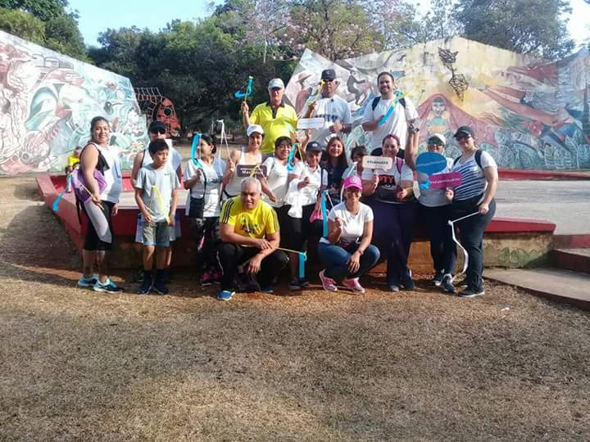

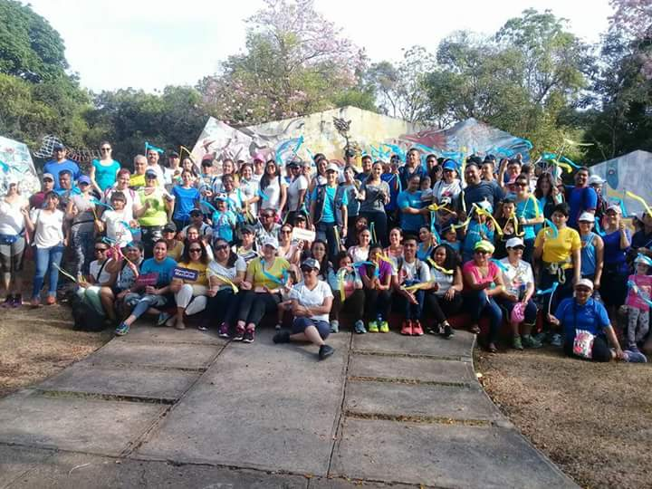

Conference given by our Vice President, Analida Pitty Ceballos, speech therapist, to more than 100 special education teachers from the Ministry of Education of the Panama Metro Regional Office.

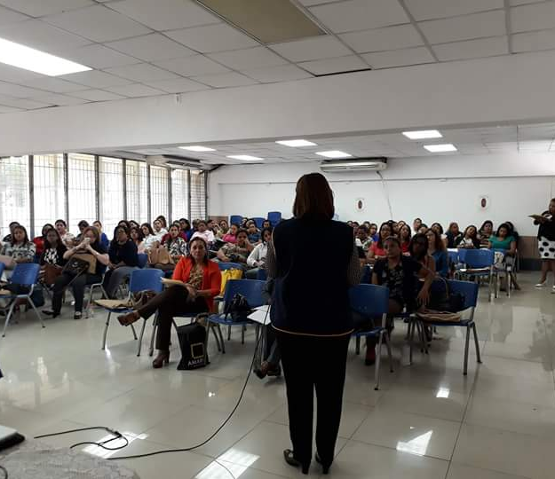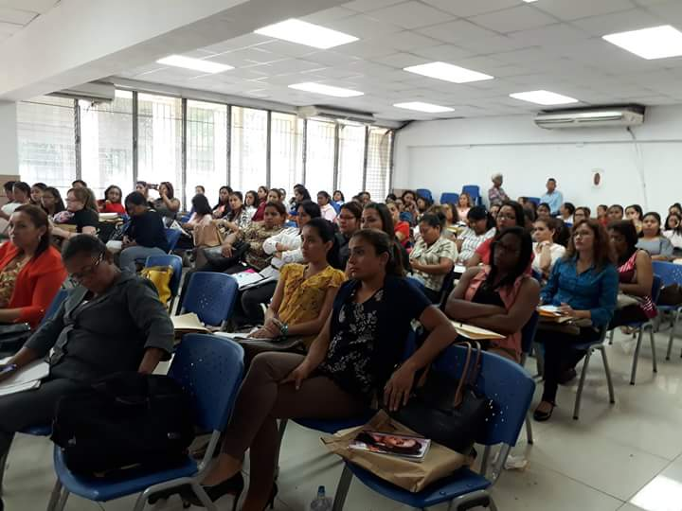
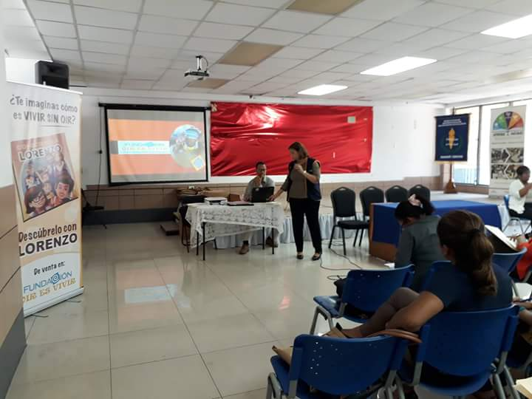

Promotional Talks of our Story "Knowing Lorenzo"

We were able to attend three meetings of the Educational Support Service Team of the Ministry of Education which is made up of special education teachers, phonoaudiologists and other specialists. We teach them how our story is a useful tool in the classroom.

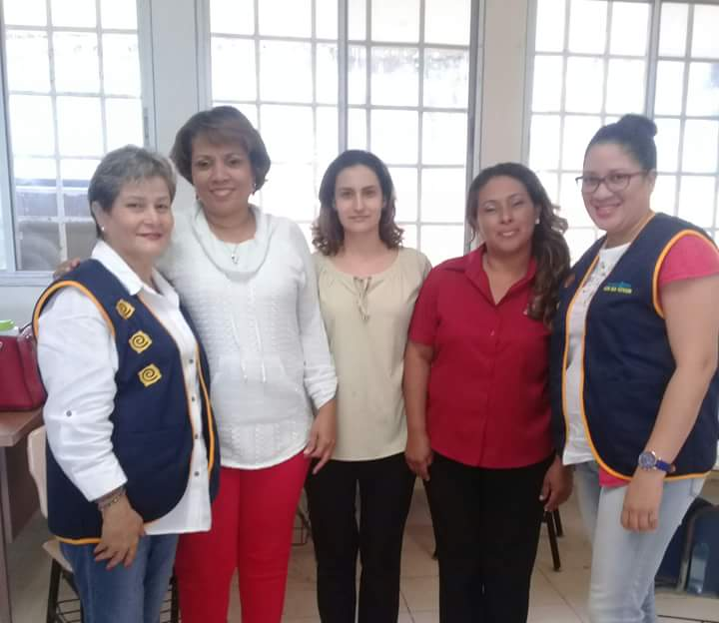
Talk given at José Artiaga´s School in Calzada Larga

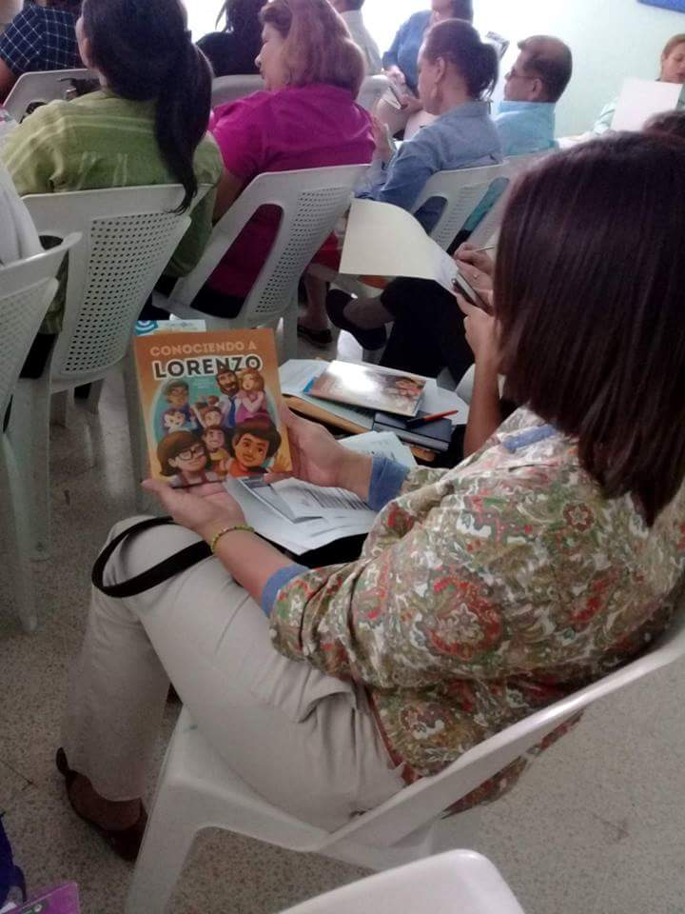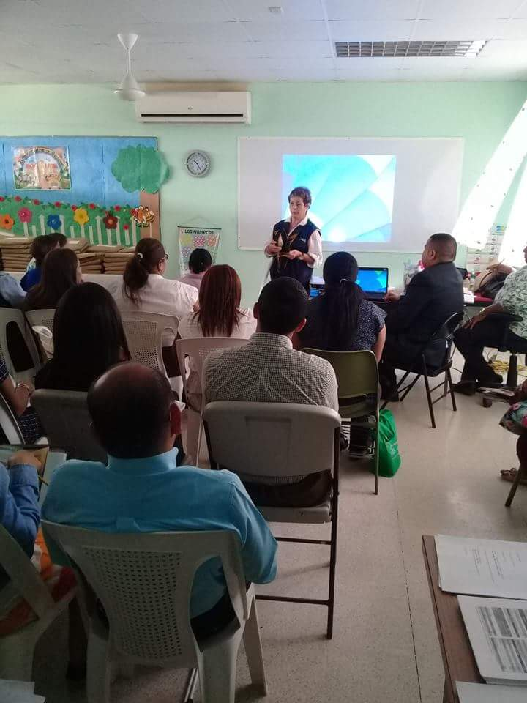
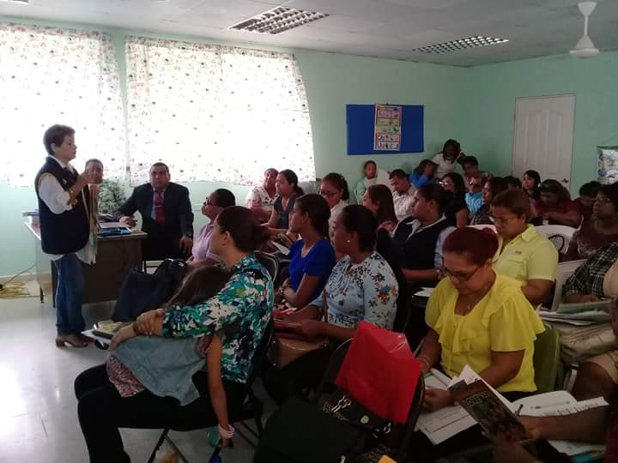
Talk given at Los Andes No.2 School at San Miguelito .

We are proud to celebrate our 10th Anniversary this year. We continue working to provide hearing health and hearing solutions to those who need it most.
Meet some of our achievements:

More than 17,000 patients attended

More than 80 adapted hearing aids

Free exams for children in 78 public schools, 54 private schools and 35 friendly
foundations.

8 Tours of auditory health in indigenous and rural communities

34 Free Educational Sessions

Edition of the first educational story "Knowing Lorenzo"

Award Winning Foundation "Panama in Positive 2017", category NGOs.

Hearing Aids for Children and Adults ... because Hearing is Living
Under the donation program of hearing aids we have with MIDES, we adapt hearing aids to adults and children. It is a pleasure to support them so that they can hear.

The care of the hearing aids includes us all ... that's why Mr. Gierhat's wife helps and learns about their use. It is important that when you receive your hearing aids, whether you are big or small, you are accompanied by a family member who provides support.
We offer Language Tests and Language Therapies for Children.
Our team of speech therapists is ready to offer your children language tests and therapies that help them improve the performance of their language. We offer these services also on Saturdays until noon.

¡Todos los exámenes bajo un mismo techo!
Remember that in our clinic located in Vía Fernández de Córdoba, Plaza Córdoba, Floor 1, Office 8, we offer you not only the Auditory Screening, but all the auditory tests in one place.
Impedance test

Audiometry test

Story "Knowing Lorenzo" comes to Libraries in the country.

Thanks to the National Library we can deliver our Storybook "Knowing Lorenzo" through the Public Libraries throughout the country. In this way we contribute so that more Panamanian families have access to information and education on the topic of deafness and hearing loss.
Baby Fair 2018
Hearing Aids for Children and Adults ... because Hearing is Living
During the month of March we had a donation day of hearing aids in conjunction with MIDES where we were able to return the gift of sound to many people.

During this day we could benefit both children and adults, here we can see the molds taking which took 30 days to be ready to start the last phase of this day that was the hearing aid fitting.

Delivery and adaptation of hearing aids to the people benefited by the donation day of hearing aids in conjunction with the MIDES.
.
Conference of hearing aids with EMPRESAS MELO

Empresas Melo supports us every year and this time supported us with the donation of 10 hearing aids in which several people could benefit.
Delivery and adaptation of hearing aids to the people benefited by the donation day of hearing aids in conjunction with Empresas MELO.

Mobile program for hearing loss detection.
Our team of speech therapists is prepared to offer audiences both young and old, which is why with our mobile program we go to Corporación La Prensa which, year after year, supports us with this program.
.
WE ALSO HAD THE OPPORTUNITY TO CARRY OUT THE HEARING TESTS TO THE COLLABORATORS OF THE MINISTRY OF AGRICULTURAL DEVELOPMENT.

Program I learn by listening

One year more than the Kids and Family Center school takes us into account to take care of the auditory health of its students and we go to make tests to the little ones. Thank you for trusting in our Work.

Launching Campaign “When you use the horn you hurt me” in conjunction with the Rotary Club Panama Sur.

Mr. Alberto Botarelli, President of the Rotary Club Panama Sur, in the company of the ladies Giovanna Troncoso, President of Fundación Oir es Vivir and Analida Pitty Ceballos, Vice President of the Foundation.

Thanks to the media, who are supporting this important campaign about the damage that noise makes to our health.

Newspaper: Metro Libre Newspaper: Día a Día

Newspaper: Mi Diario Radial Program Let's Talk about Home at Radio Maria with Mrs. Jacqueline De Los Rios.

II Silent Walk - Parque Omar

Conference given by our Vice President, Analida Pitty Ceballos, speech therapist, to more than 100 special education teachers from the Ministry of Education of the Panama Metro Regional Office.

Promotional Talks of our Story "Knowing Lorenzo"

We were able to attend three meetings of the Educational Support Service Team of the Ministry of Education which is made up of special education teachers, phonoaudiologists and other specialists. We teach them how our story is a useful tool in the classroom.

Talk given at José Artiaga´s School in Calzada Larga

Talk given at Los Andes No.2 School at San Miguelito .

