FUNDACION OIR ES VIVIR

ACHIEVEMENTS BEFORE ENDING 2018

"Tony Fergo’s Awards"

Two of our educational campaigns, Fundación Oír es Vivir were awarded!! The delivery was made within the framework of the Recognition of Remarkable Citizens 2018 event of the National Commission for Civic and Moral Values.

Winning 2 of 4 awards is an honor and reaffirms the need to work with passion for a better world. Each of us contributing and being part of the changes we want to see in the world.

Award for the best Digital Campaign with # Solo1Minuto de Silencio and Prize for the best Printed Campaign with our educational story Knowing Lorenzo!

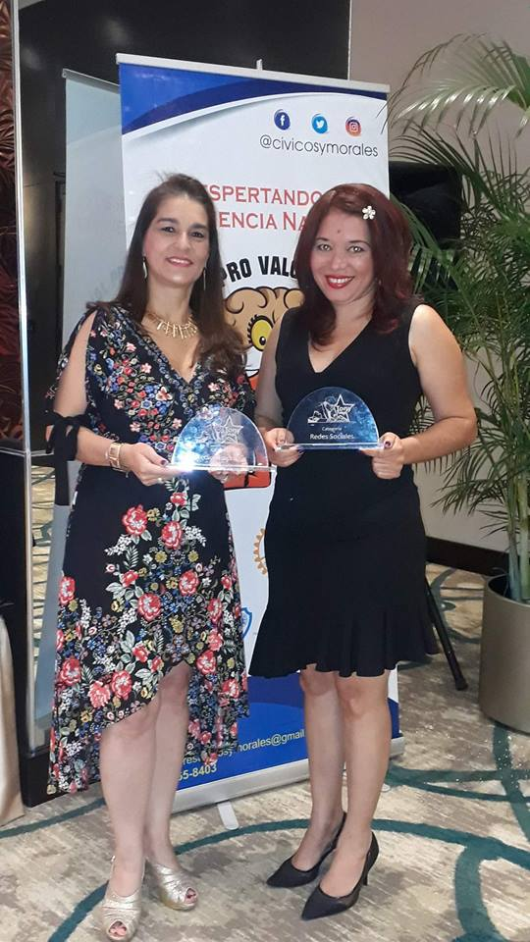

With the program "APRENDO ESCUCHANDO” (I learn by listening)
SAN JOSE DE MALAMBO ORPHANAGE
We are happy to have taken free hearing screening tests to the children of the San José de Malambo Orphanage. The care was provided to 30 children between newborns and 4 years old. We take advantage of our visit to give them our educational story Knowing Lorenzo

In this way we ensure that detecting a hearing loss early we can treat it to give the child the best chance to develop their language on time.

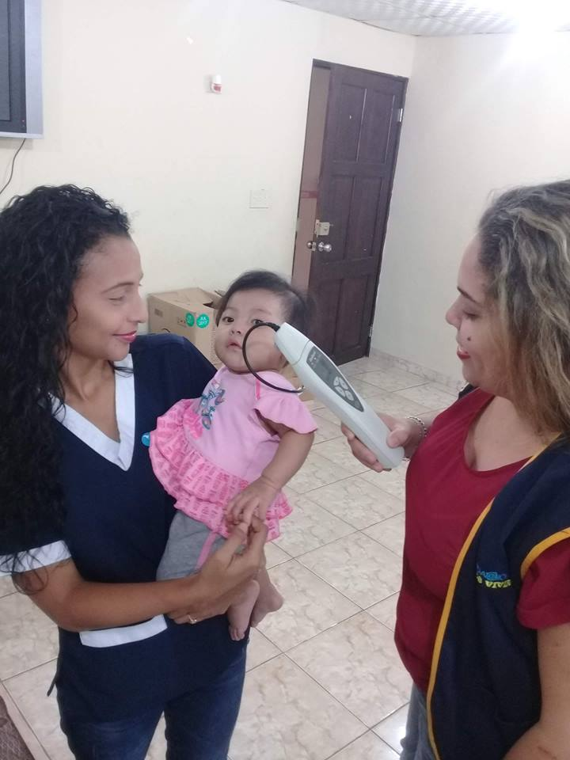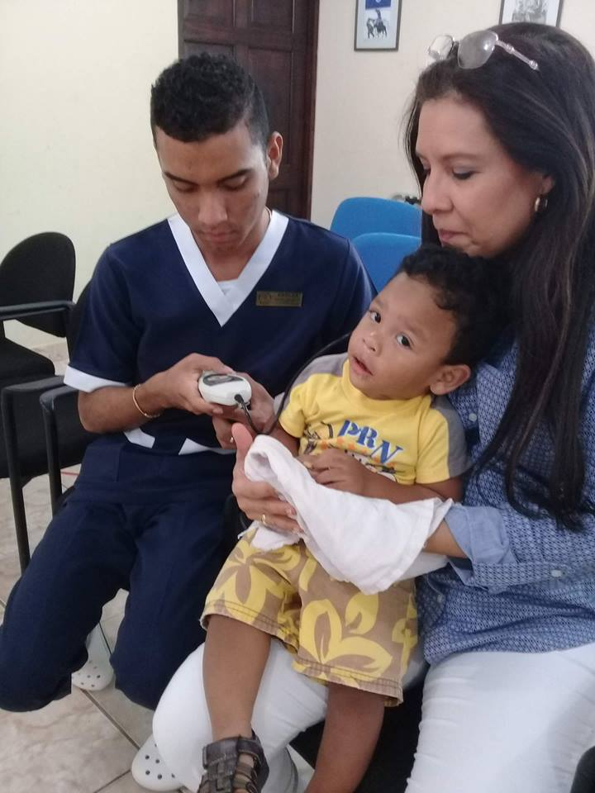

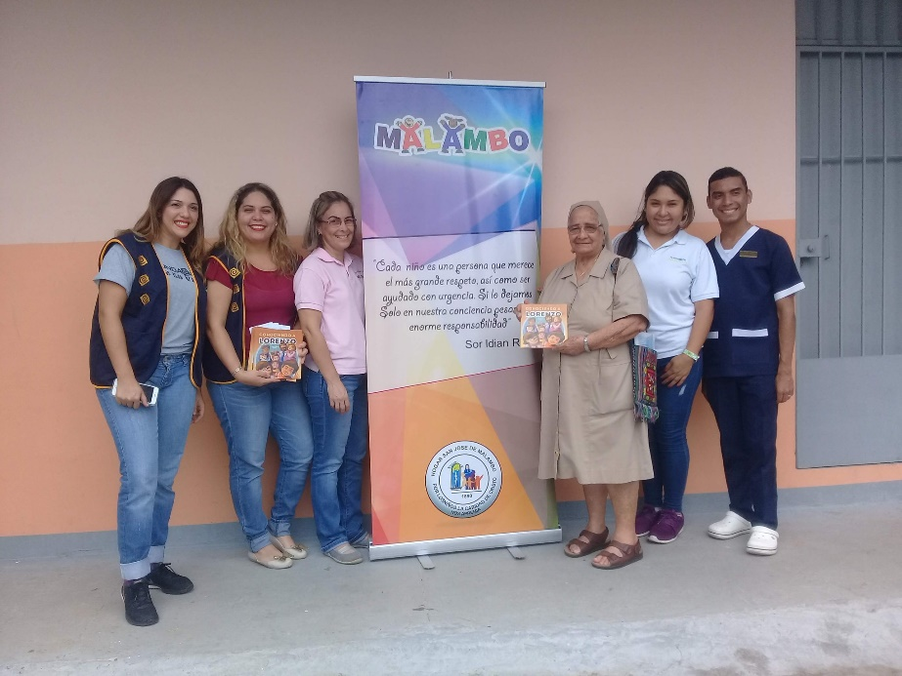

ABC n ME SCHOOL

The ABC n Me School every year show us their support by granting us a donation product of their “Bake Sale”. Infinite thanks for seeing value in our work and supporting it. The delivery was made by the school director: Marianela Pitty and received by Aminta Miranda, member of the board of directors of the foundation and Gabriela Mejía administrative director.
.
This donation allows us to continue taking Auditory Screening tests for public school children who also need the test.

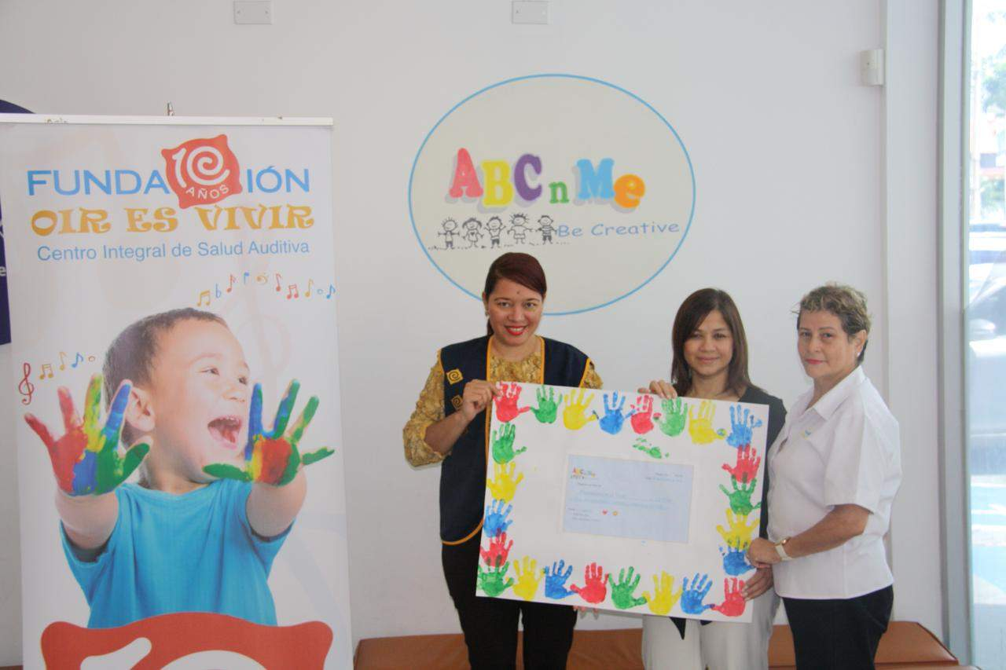
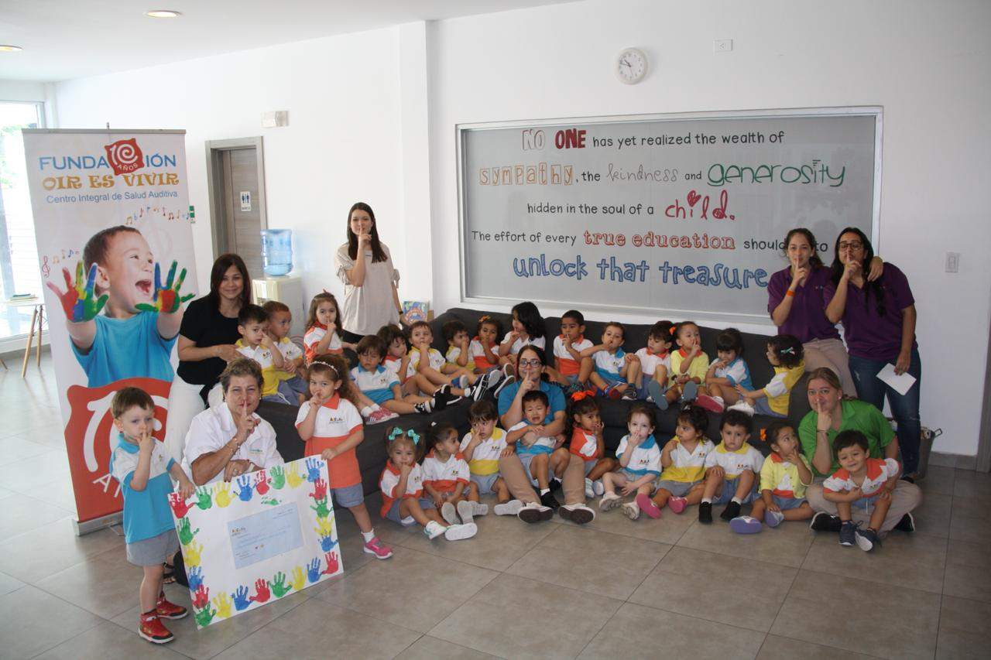

FIRST START CENTER
Thanks to the First Start Center for trust placed in order to be able to perform the hearing and language tests for their students.

Why is it important to do it? Because at first sight neither parents nor teachers can know if a child hears well.

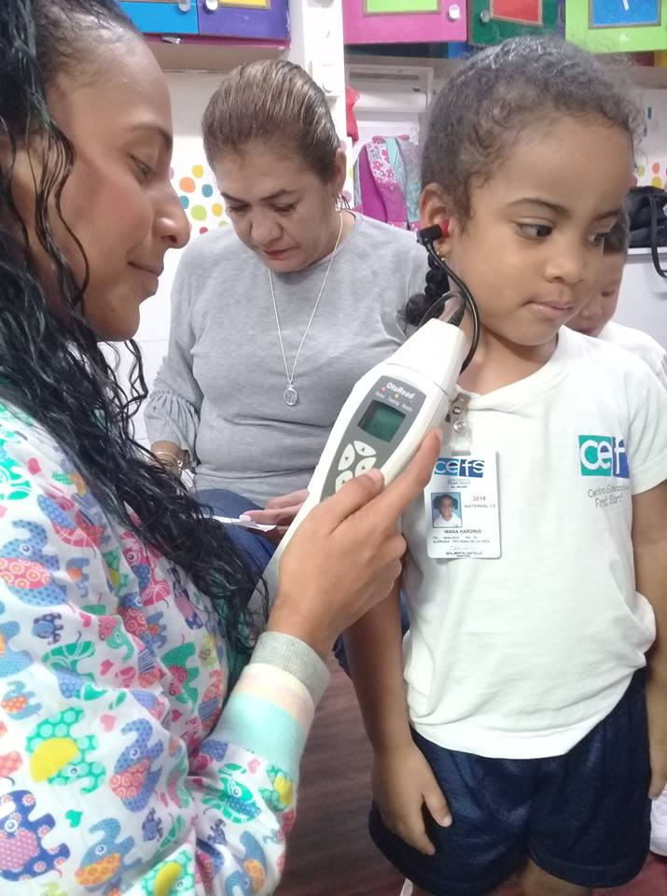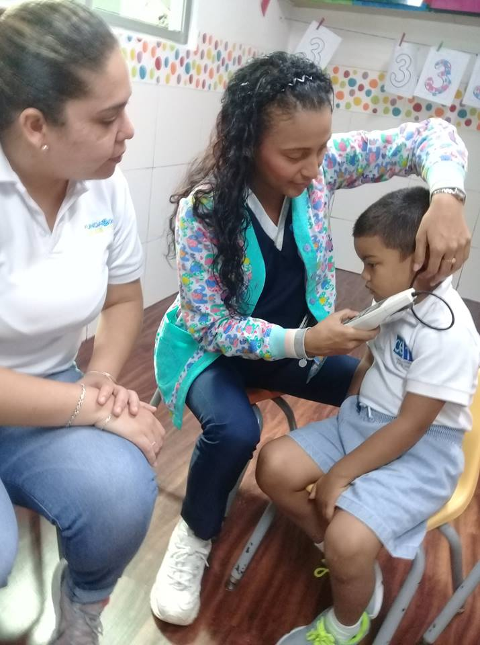
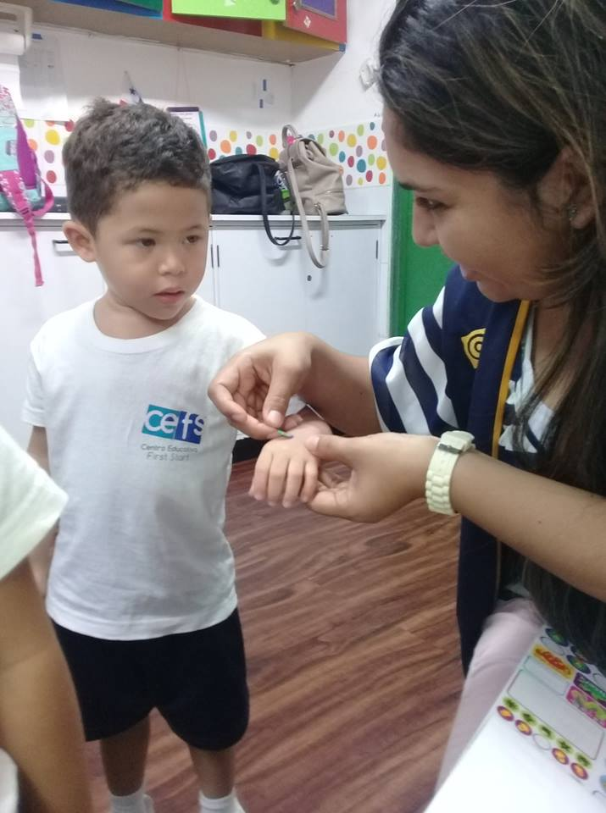
KNIGHTSBRIDGE INTERNATIONAL SCHOOL PANAMA
KNIGHTSBRIDGE INTERNATIONAL SCHOOL PANAMA at Panamá Pacífico, conducting auditory tests for its students.
Ensuring that children are hearing well is important for their school performance and development of other psychomotor and social skills.

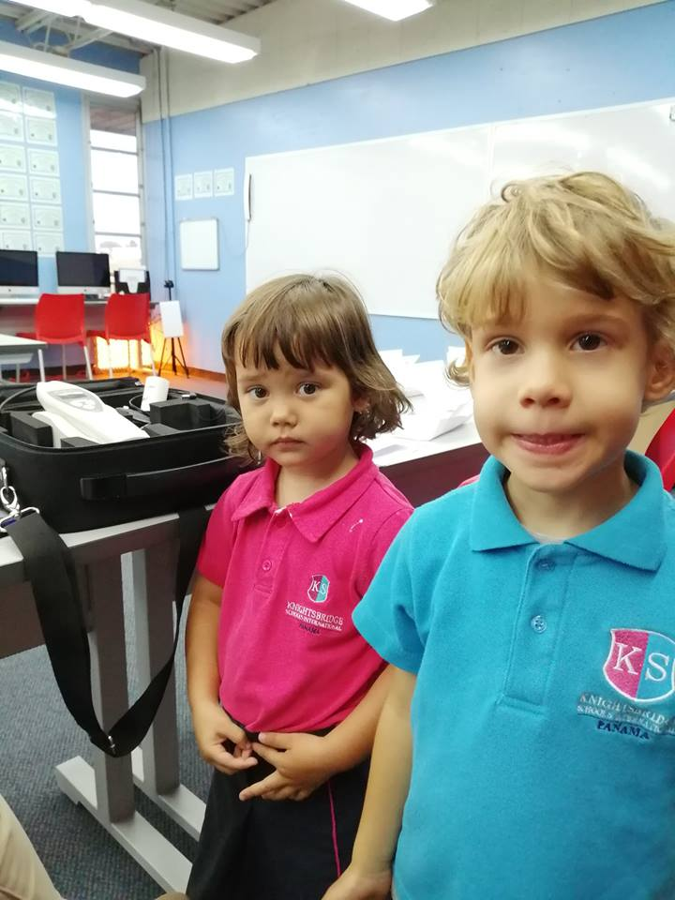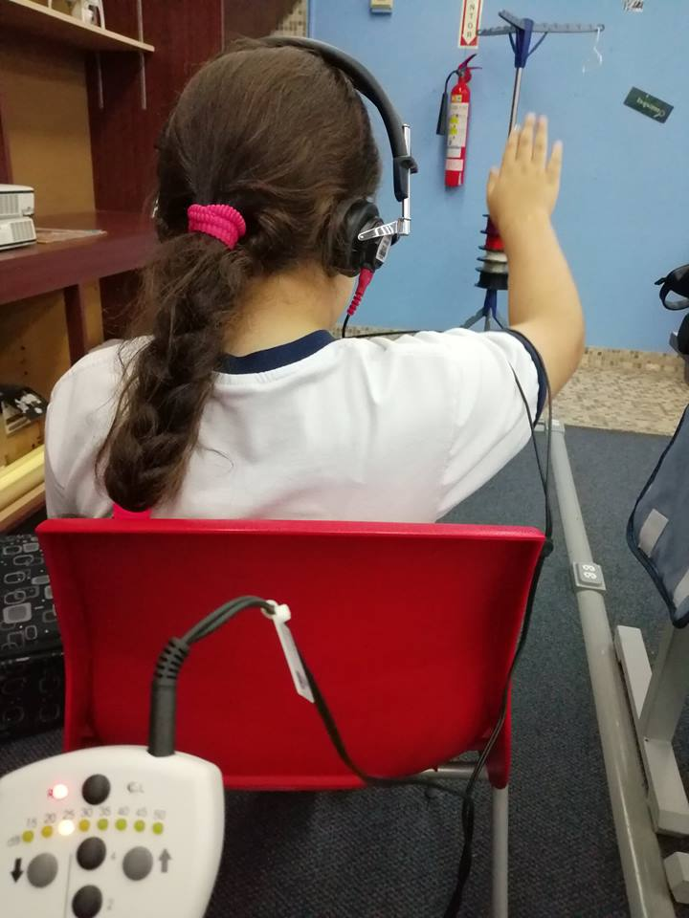
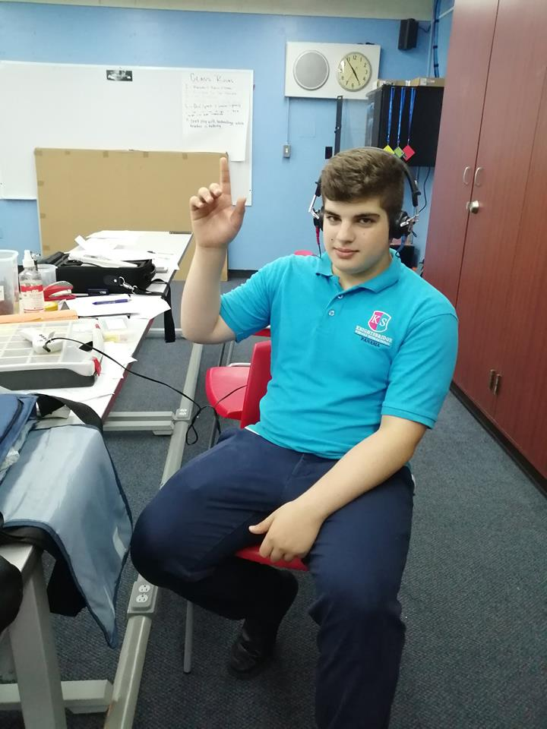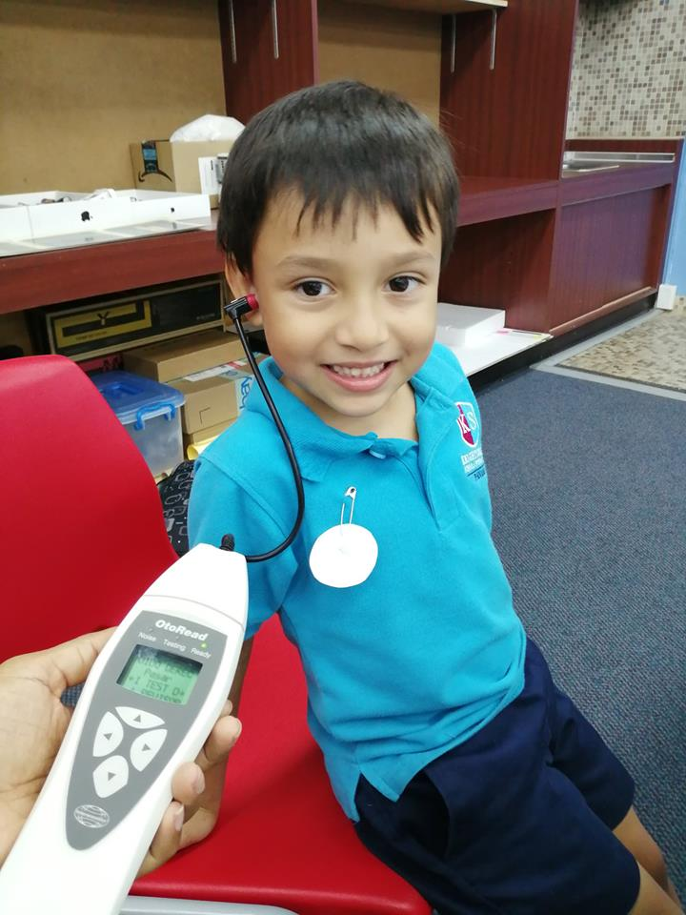

Doing hearing tests at Libian School
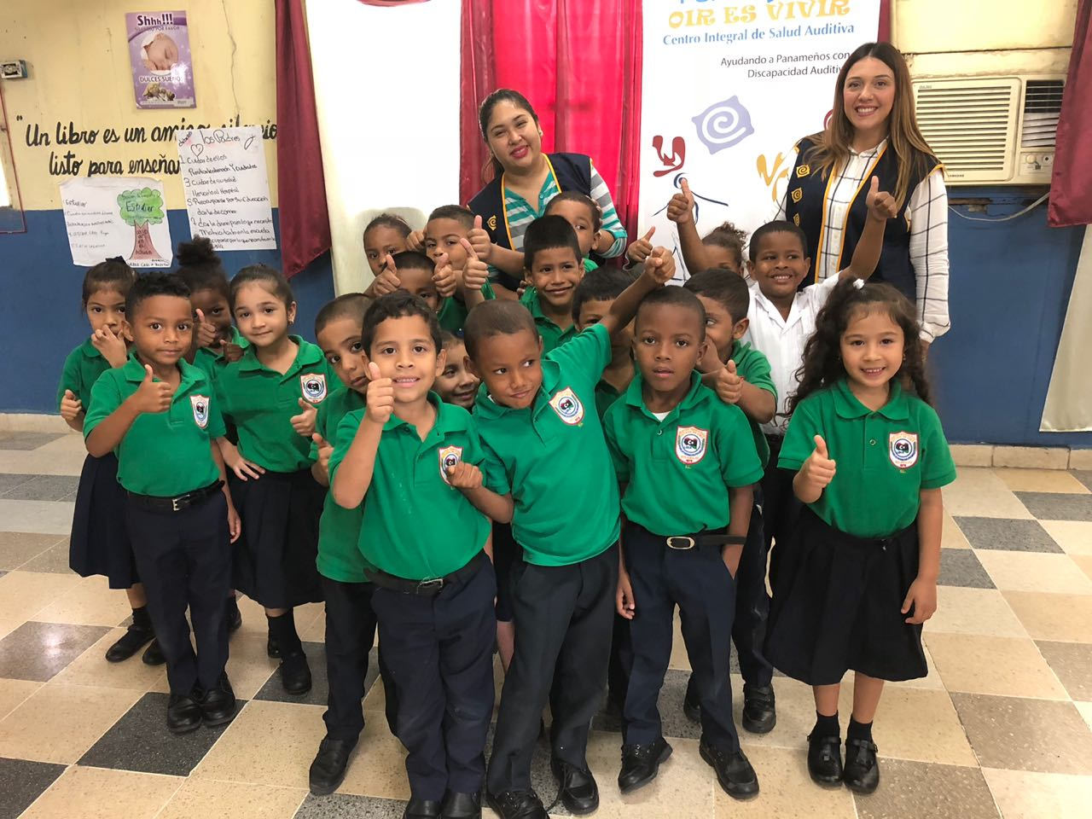
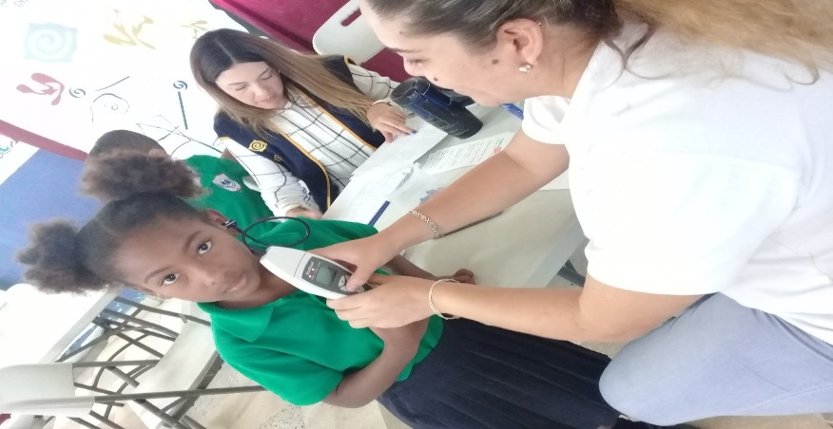

HEARING TESTS at ACADEMIA INTERAMERICANA DE PANAMA - Cerro Viento
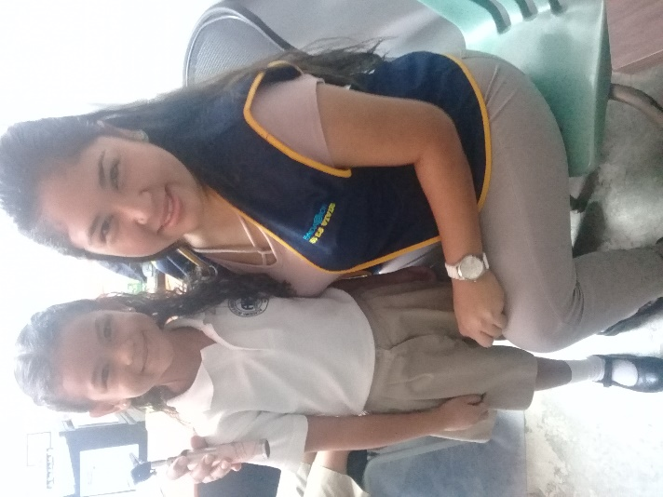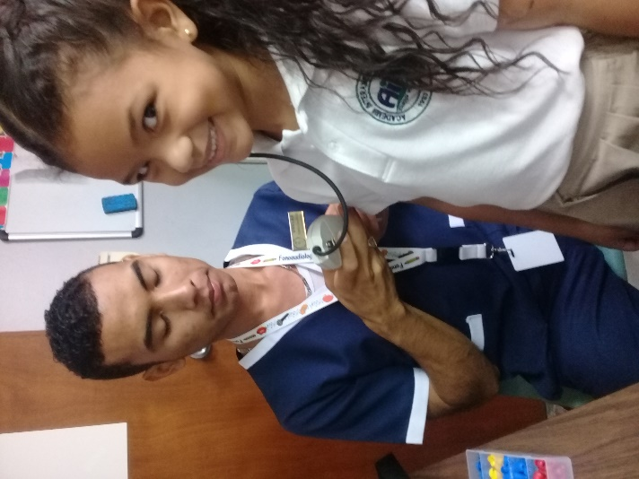
For students as a requirement for school reentry.

LIONS CLUBS NATIONAL ASSOCIATION
We assist LIONS CLUBS NATIONAL ASSOCIATION, in their tour conducted at the Ricardo J. Alfaro School at Tocumen community. Our collaboration was with the attention of around 140 children between 5 and 12 years old performing collective audiometry

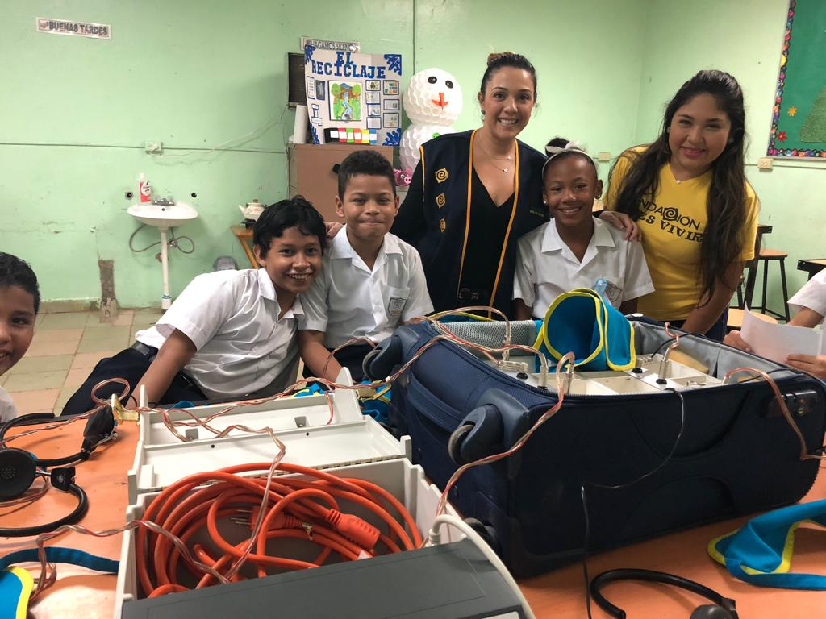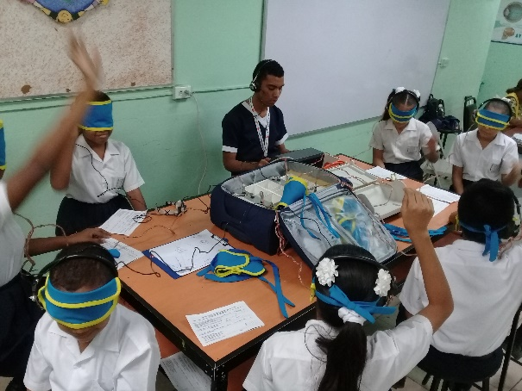

SERVING OTHER FOUNDATIONS IS ALSO PART OF WHAT WE DO.
We offered free hearing tests - collective audiometries and hearing screening for more than 50 children and young people from the SOS Children's Villages. In this way we contribute to a better Panama for all.

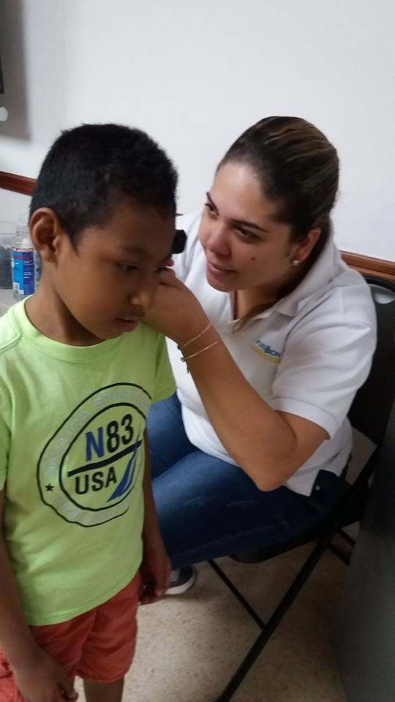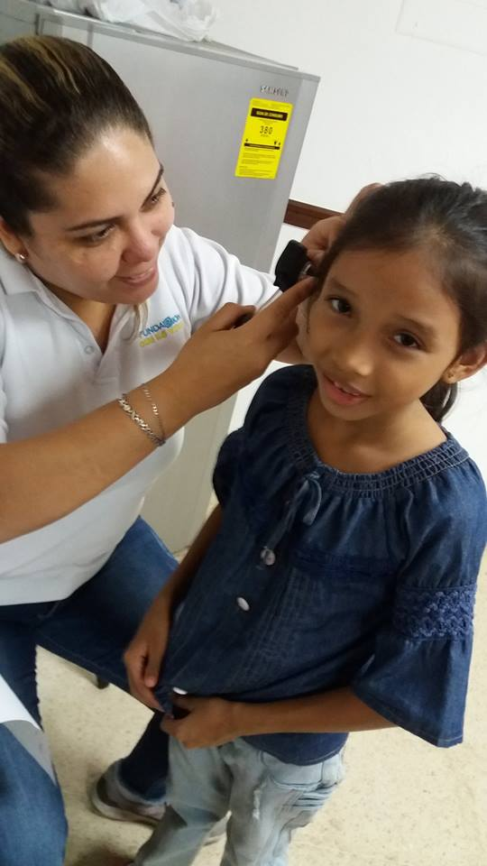
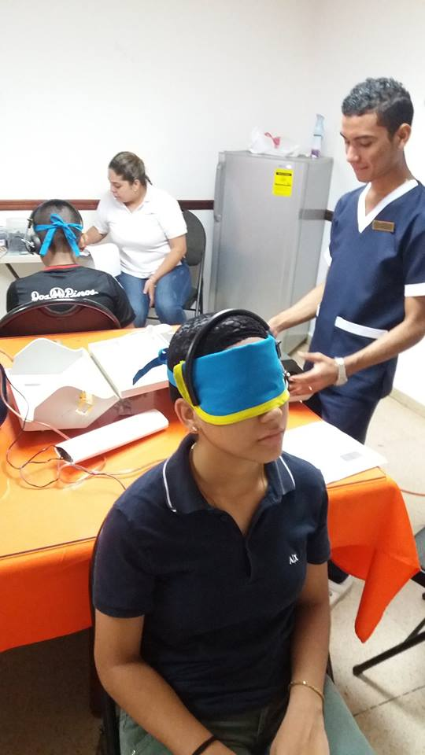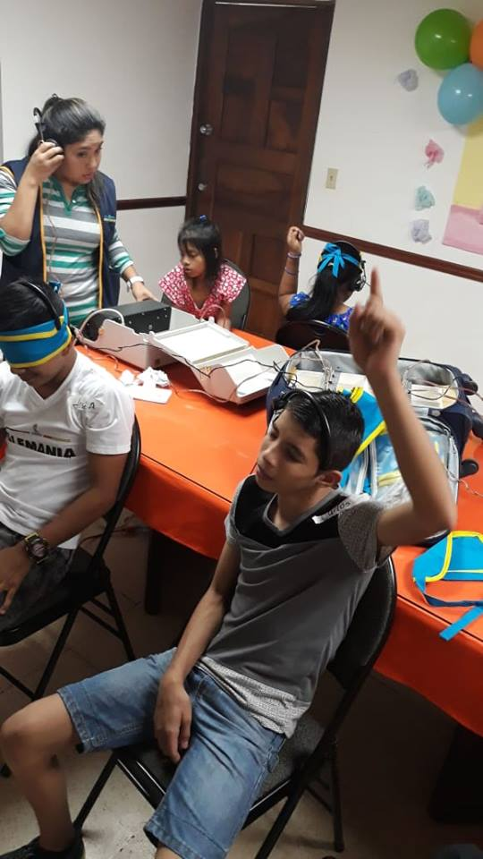

Thanks!!!!!!

We thank EMPRESAS MELO who on October 12, 2018 gave tribute to Panamanian talent and energy, recognizing the work and dedication of 10 Panamanian altruists among those who told FUNDACION OIR ES VIVIR.

Distinguishes us with this significant trophy for our work in favor of early detection of hearing loss and our management to support those who suffer from them by offering solutions that allow them to lead a full and productive life.

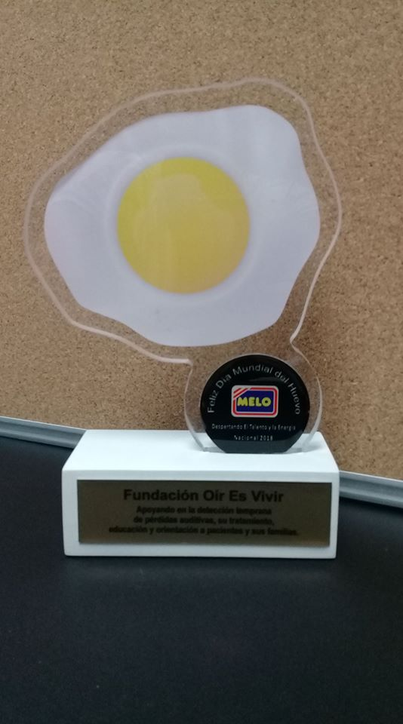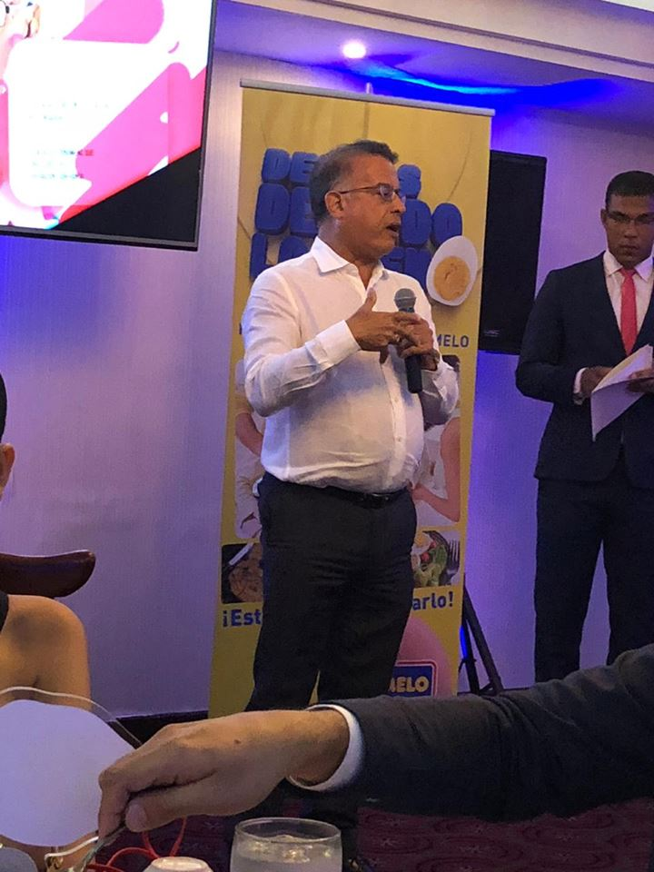

UPDATE SEMINAR

SEMINAR DICTATED BY LICDA. ANALIDA PITTY, with the topic: “Disorders of the Central Auditory Processes”

This teaching was very interesting because it brings new knowledge and nourishes us with questions in some patients whose lives are affected by this type of pathologies.

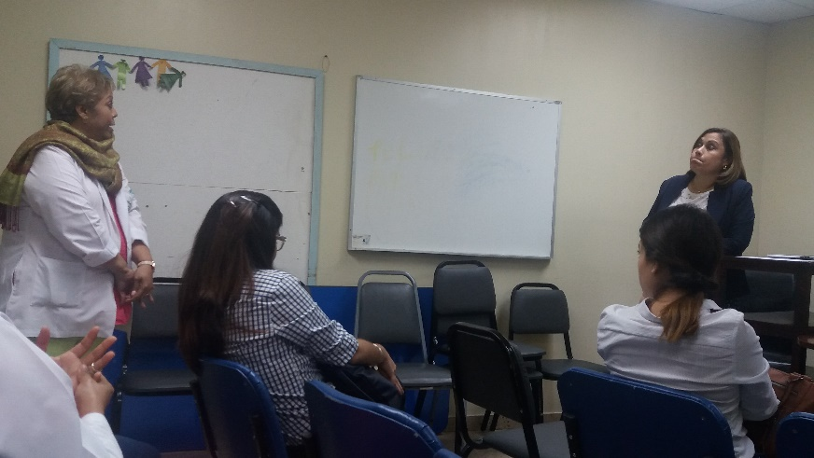

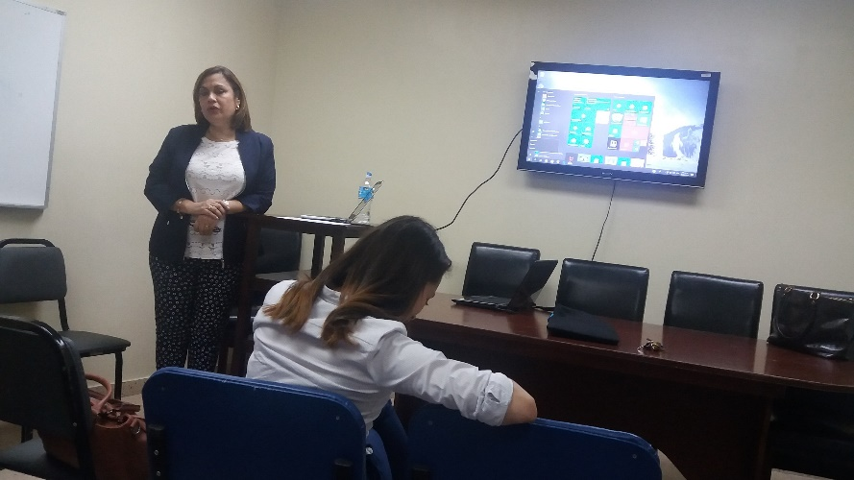

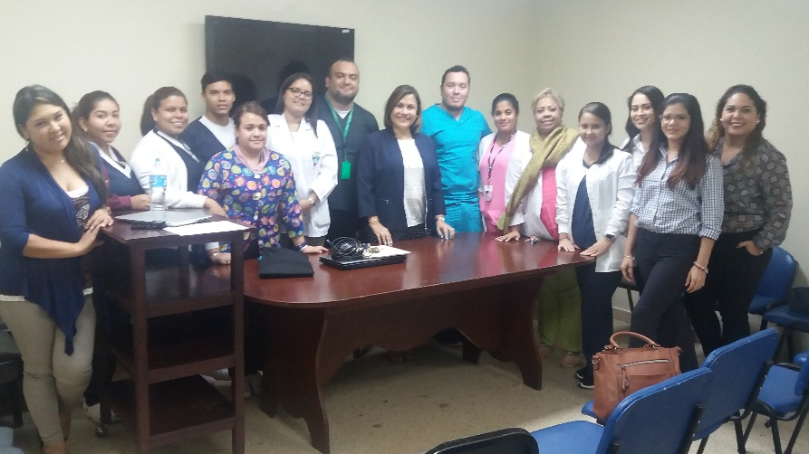

The most rewarding work is that which is done with love!

Photos of our third hearing health tour to the community of Las Guías in Coclé where we assist more than 150 children from this community with their first hearing test!

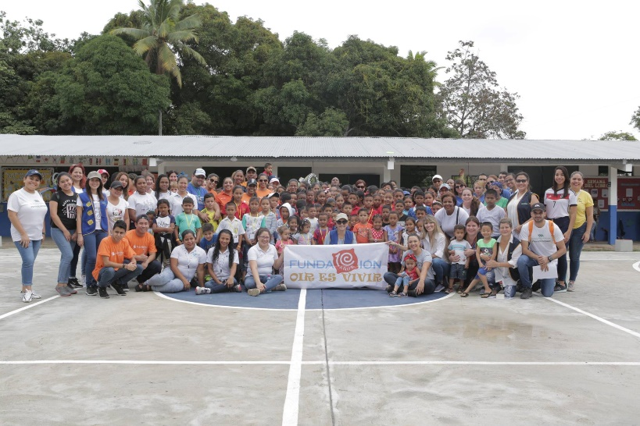
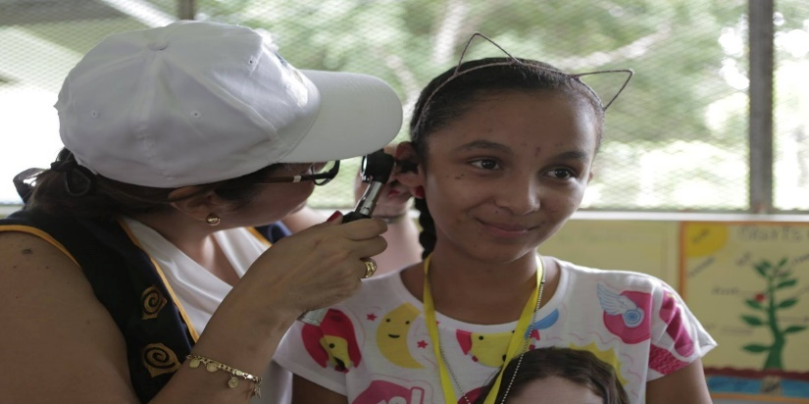
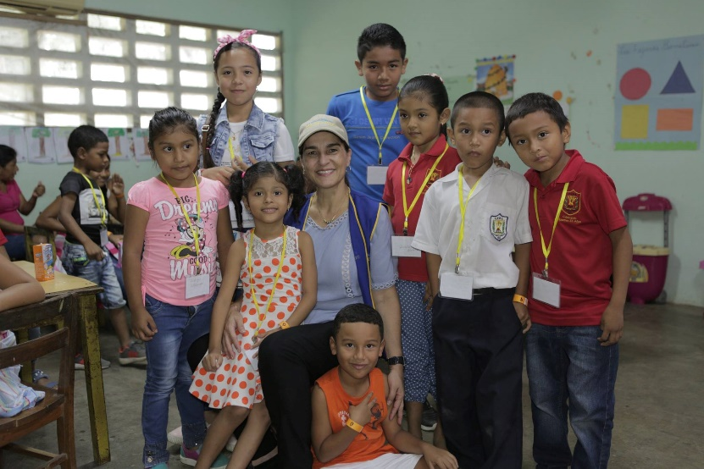
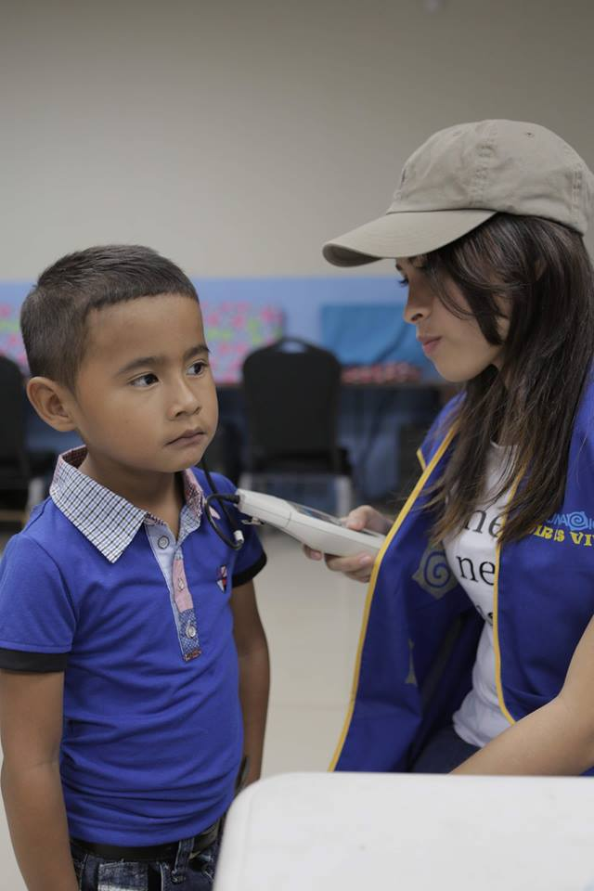
DONATION OF HEARING AIDS BY STARKEY FOUNDATION
We collaborated in the day of donation of hearing aids by the Starkey Foundation, held at the facilities of the IPHE of Betania. Through this donation, around 200 people of all ages who needed hearing aids were able to benefit, among whom there were around 35 patients referred by our Foundation!

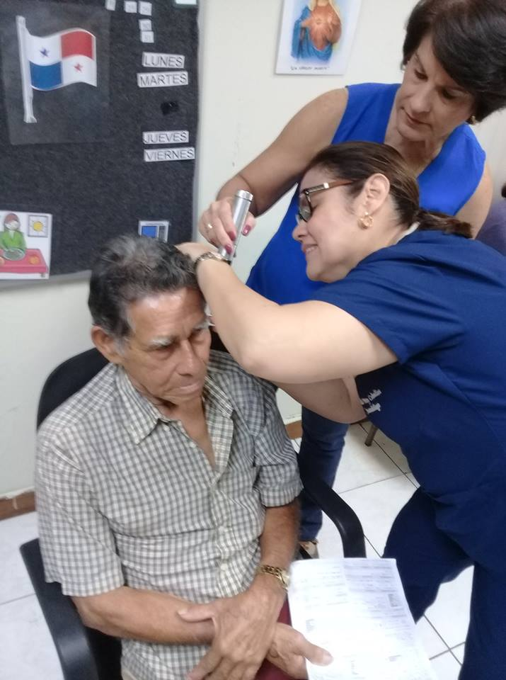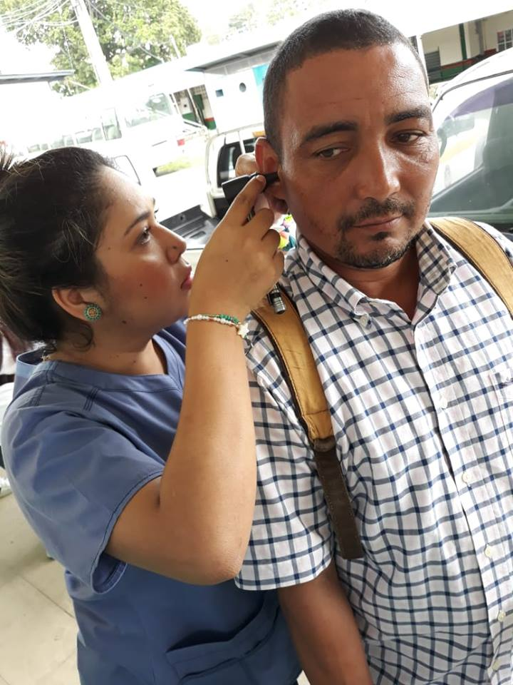
Remember that we have a complete clinic at your service.
Donation of hearing aids.

For those adult candidates and children who qualify.
Hearing loss can happen at any age!

We were able to adapt his hearing aids to Mario, 51 years old.

Marta María was adapted with her hearing aid that guarantees the Gift of Sound

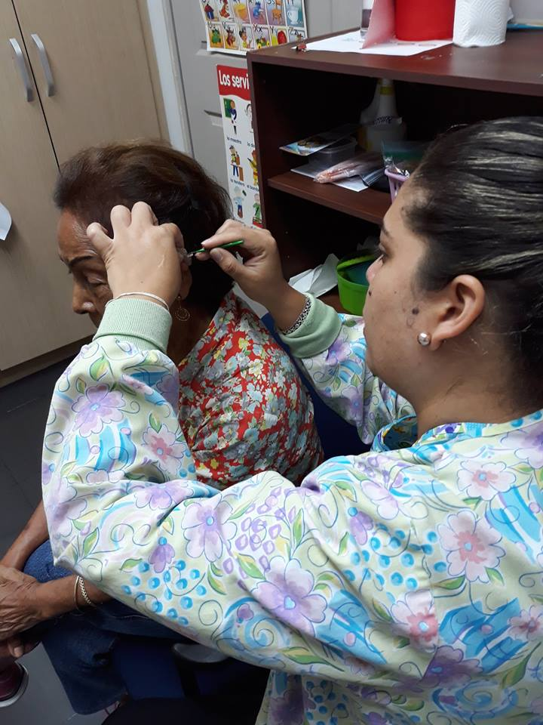

We work so they can hear!
This is our greatest satisfaction!

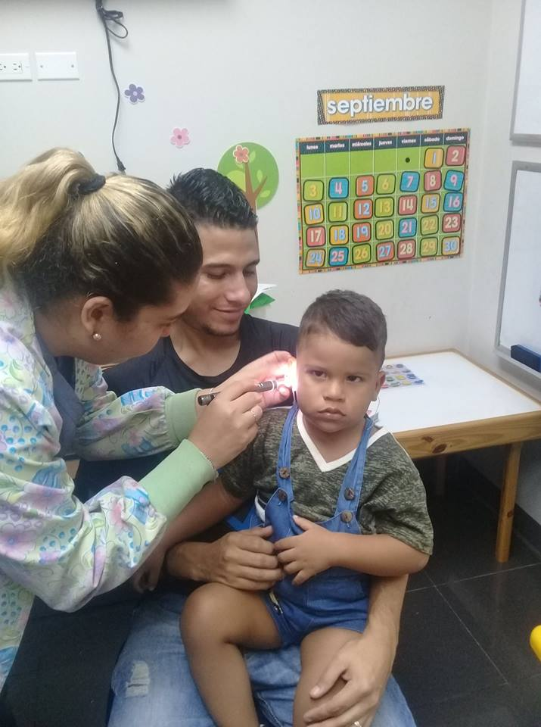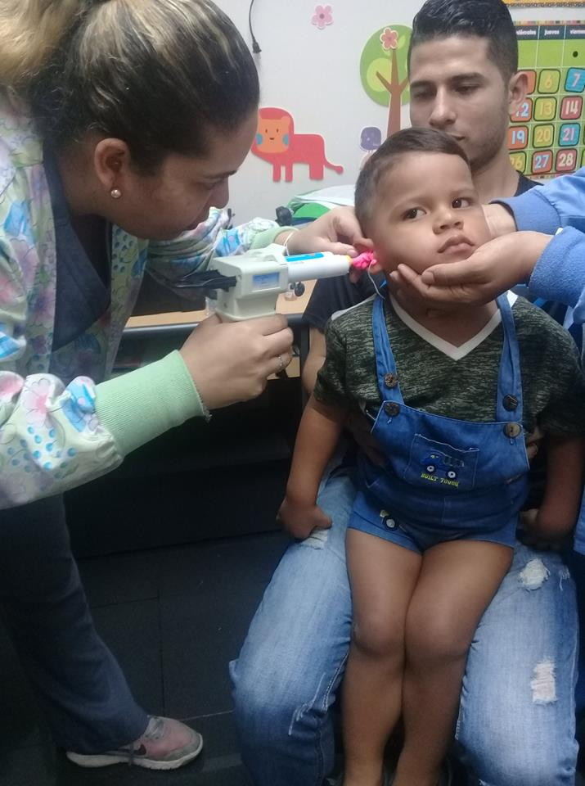
David taking his molds to be able to adapt his hearing aids.

Language therapy for children.

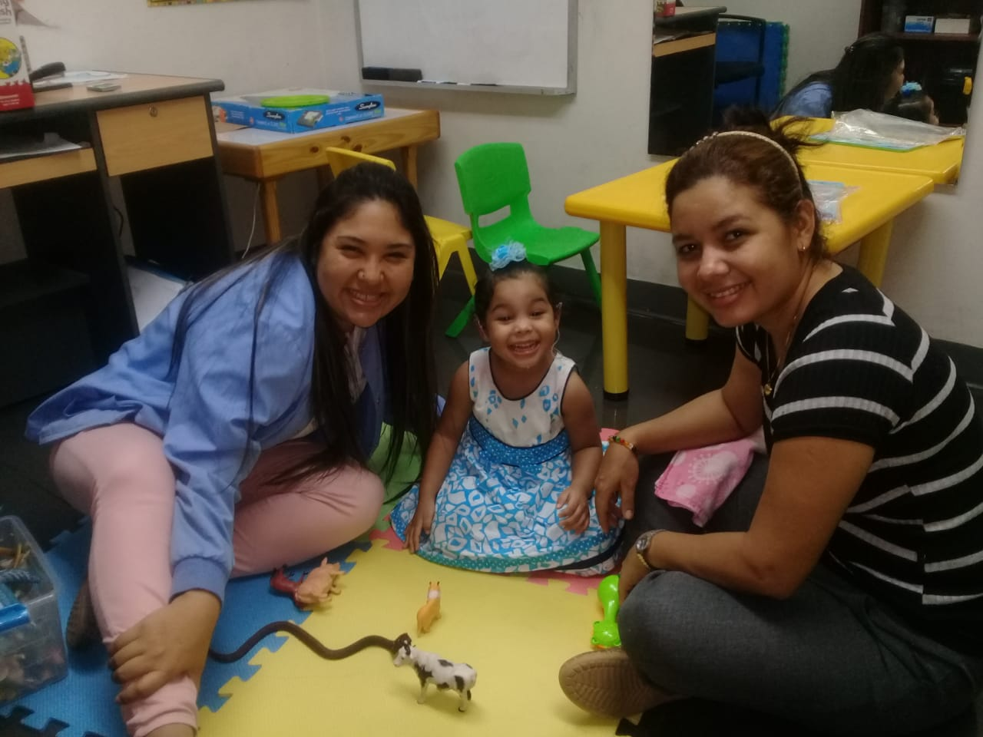
Britney with her mother and Emilia during her language therapy.
HEARING AIDS ADAPTATIONS
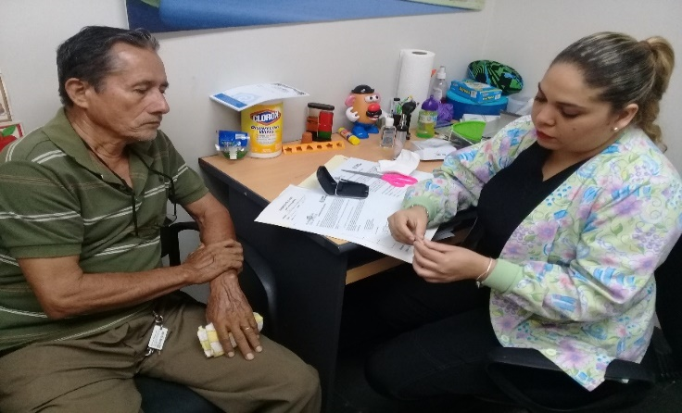
Lorenzo having care instructions.

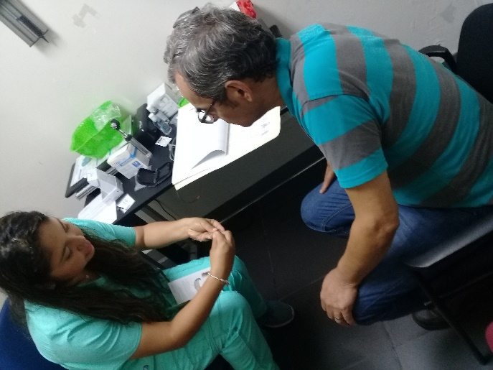
Francisco having care instructions.
.
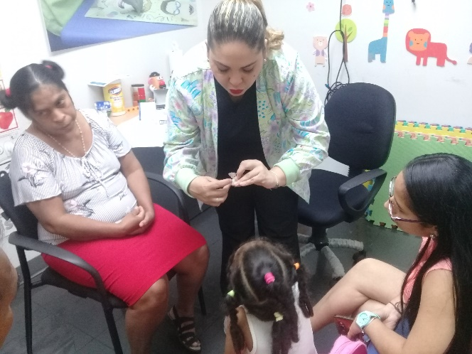
Also, Olga having care instructions.
.

MEDIA TOURS – ANNOUNCING OUR 10TH ANNIVERSARY
Interviews in different radio stations of our country, taking valuable information, everything we are offering to the Panamanian family for the care of their hearing and to support those who suffer hearing loss.
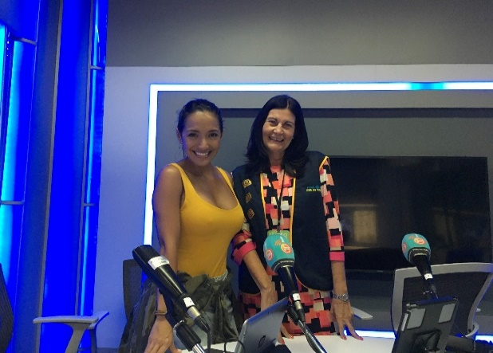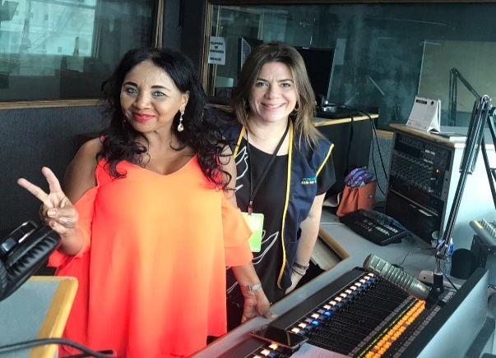
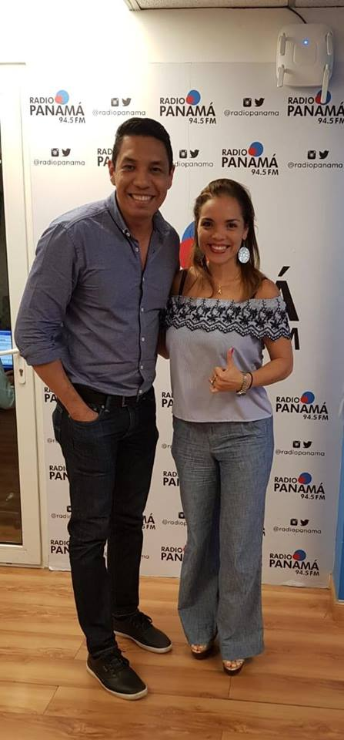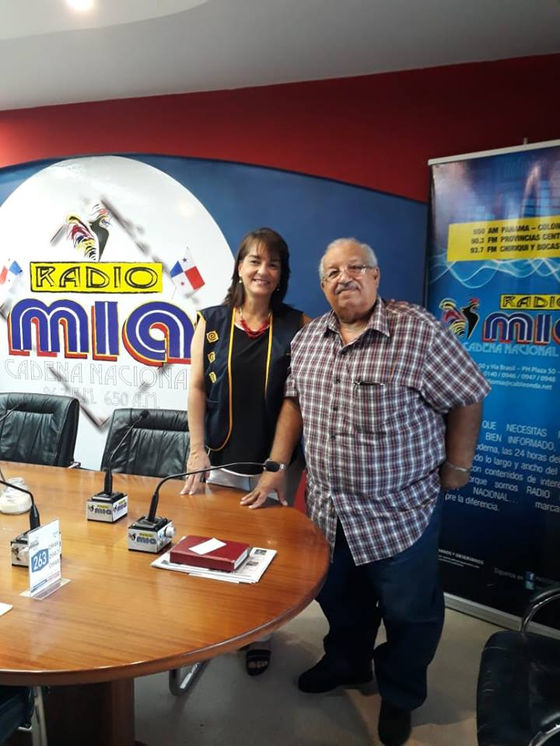
Regional Conference of the GOOD DEEDS DAY of Good Actions for Latin America.
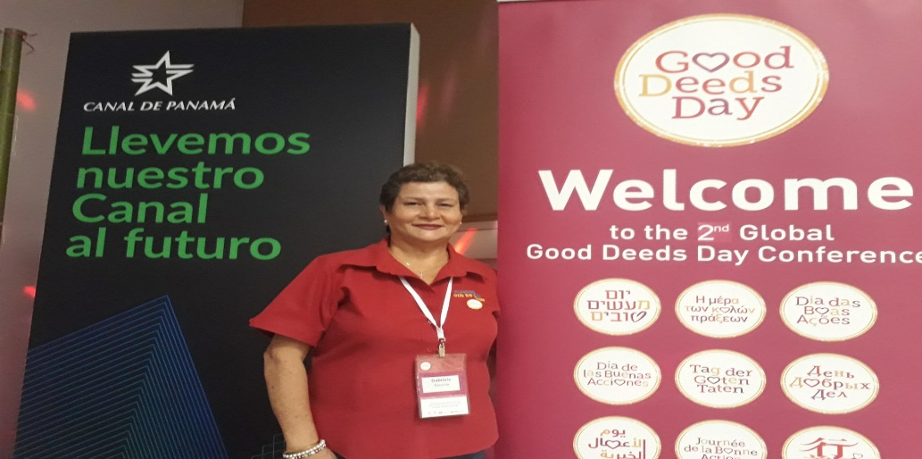

CELEBRATING OUR 10TH ANNIVERSARY!
Surrounded by friends, family, volunteers, institutions and donor companies, suppliers, artists, allied parents who have made possible the great achievements of these first 10 years. To all of them our eternal gratitude for having helped us bring the Gift of Sound to those who do not have it.

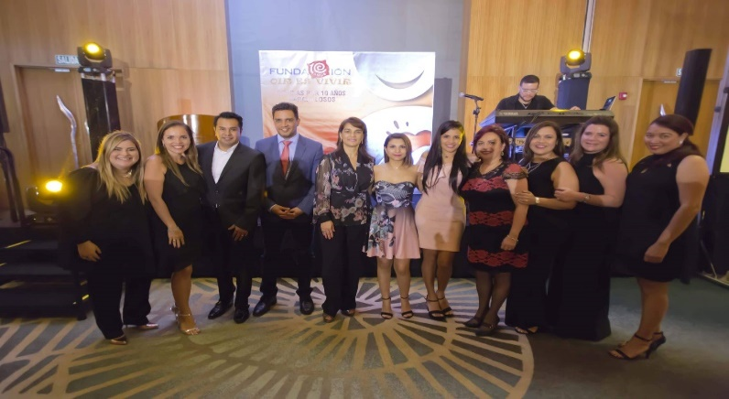
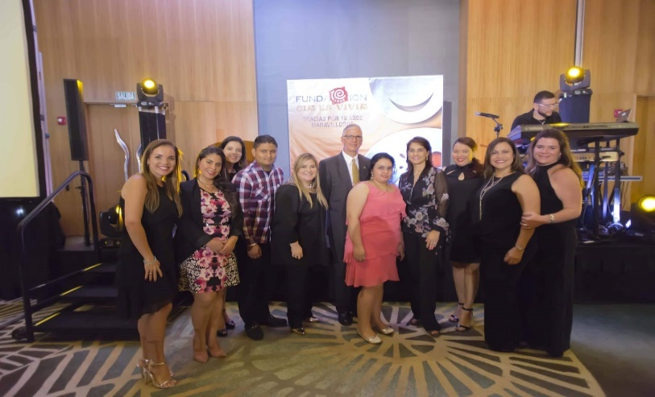
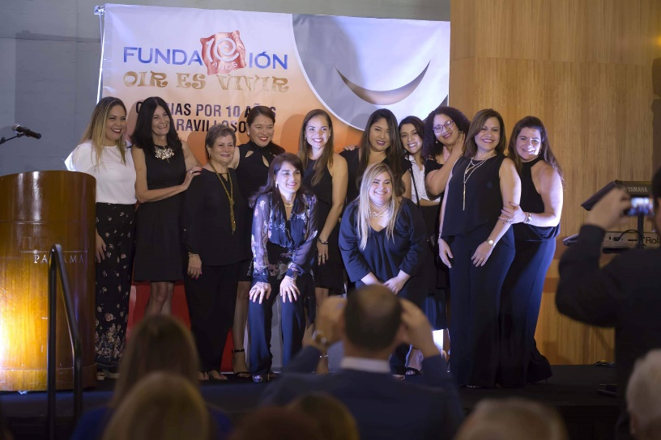
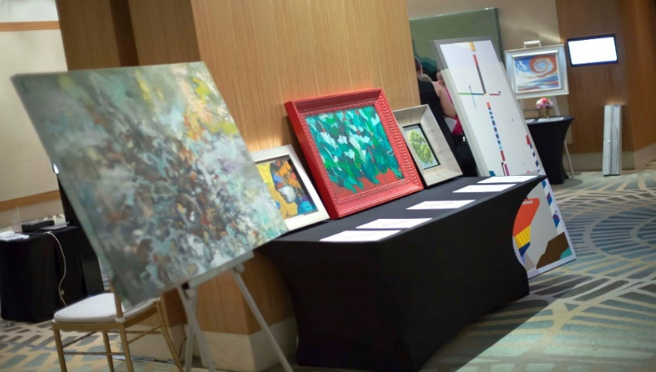

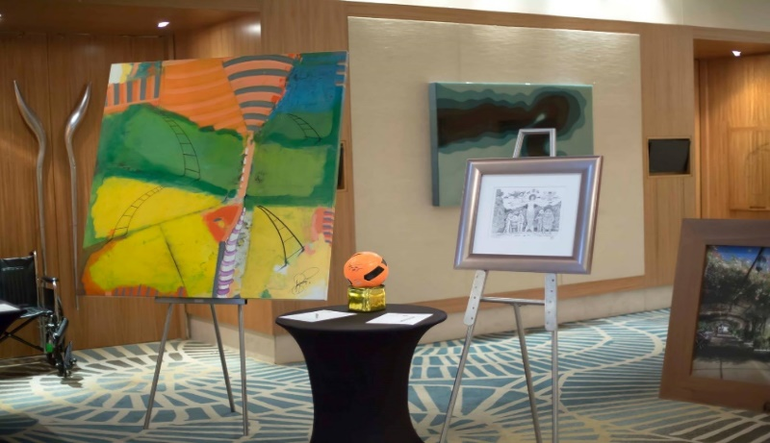
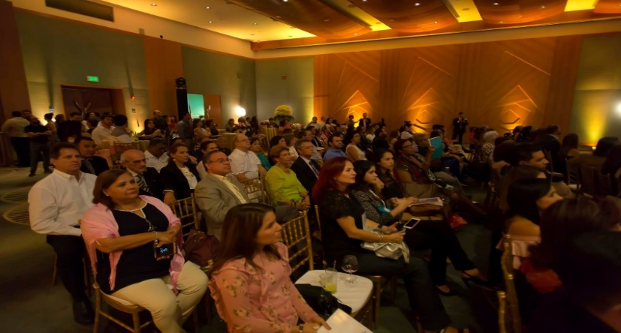

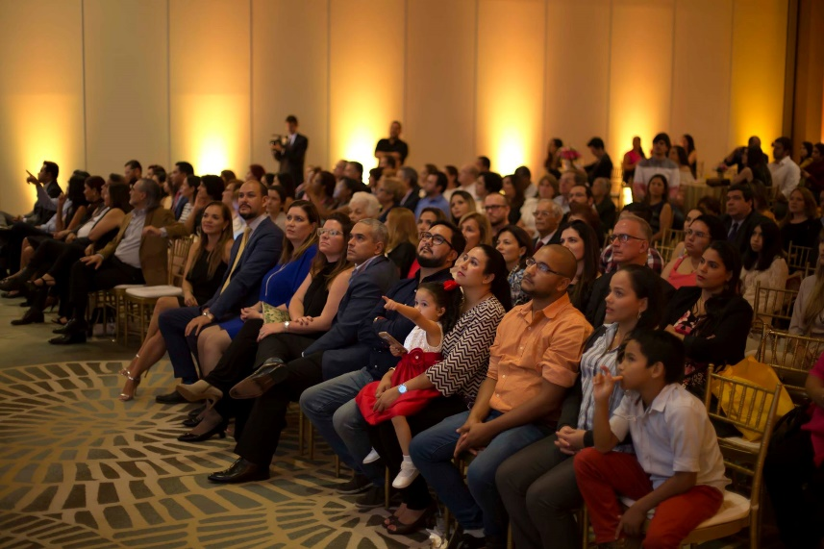
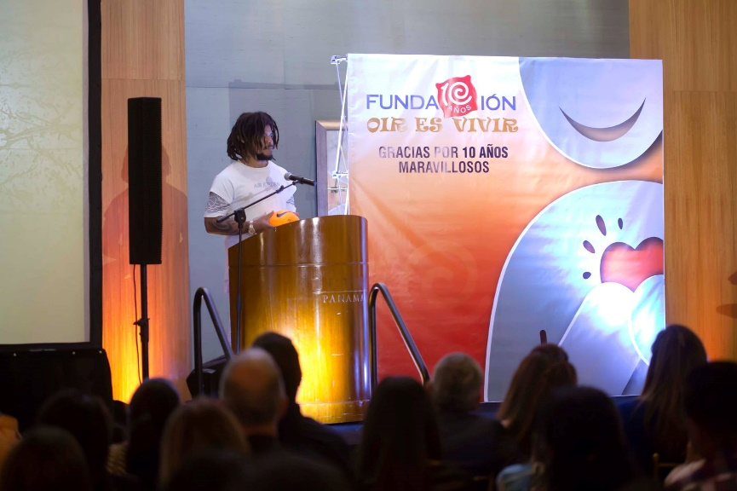
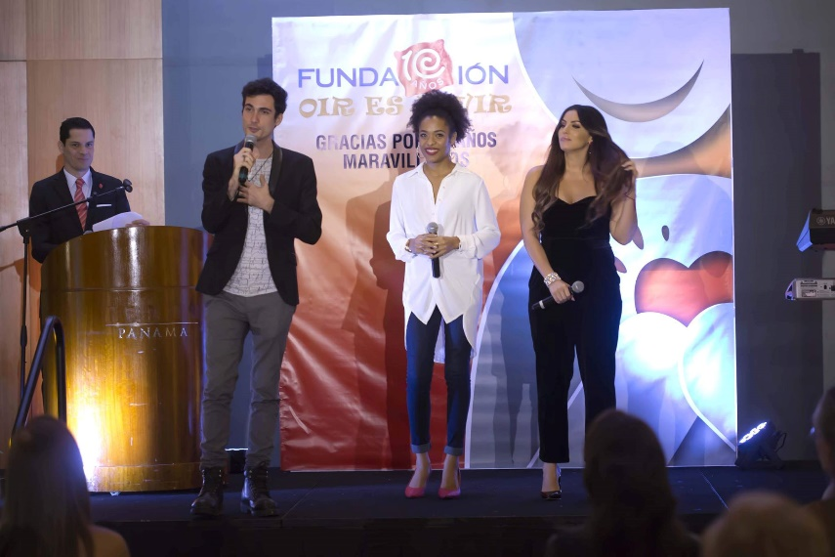

Second stage of the attentions done in our health tour at Ciri Arriba de Capira.
Children from Cirí Arriba came to our clinic.

We carried out the second phase of exams for the children of the tour from Cirí Arriba. That they did not pass the test and required specialized additional attention. Remember that sometimes a single test is not enough!

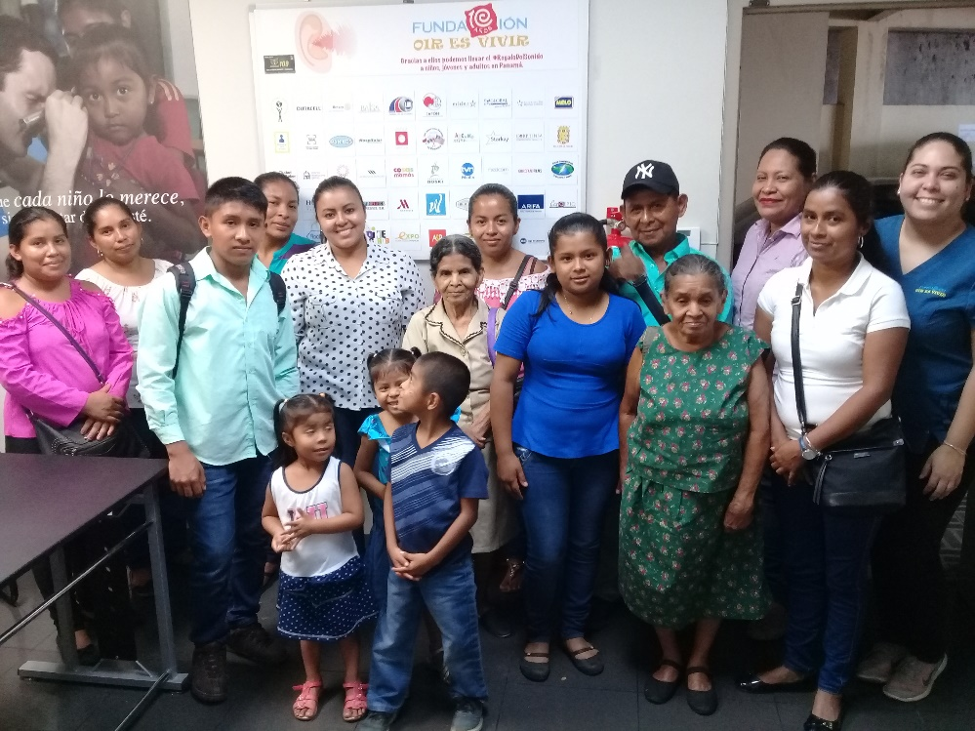

Second stage of the attentions done in our health tour at Las Guias, Coclé.
Children from Las Guias came to our clinic.

We carried out the second phase of exams for the children of the tour from Las Guias. That they did not pass the test and required specialized additional attention. Remember that sometimes a single test is not enough!

