FUNDACION OIR ES VIVIR – NOVEMBER & DECEMBER 2017

GRATITUDE IS THE MEMORY OF THE HEART

We were happy to thank you during our Recognition Act, donors, volunteers, patients, friends and staff, all support to make it possible for more and more Panamanian children and adults to hear and enjoy hearing health.

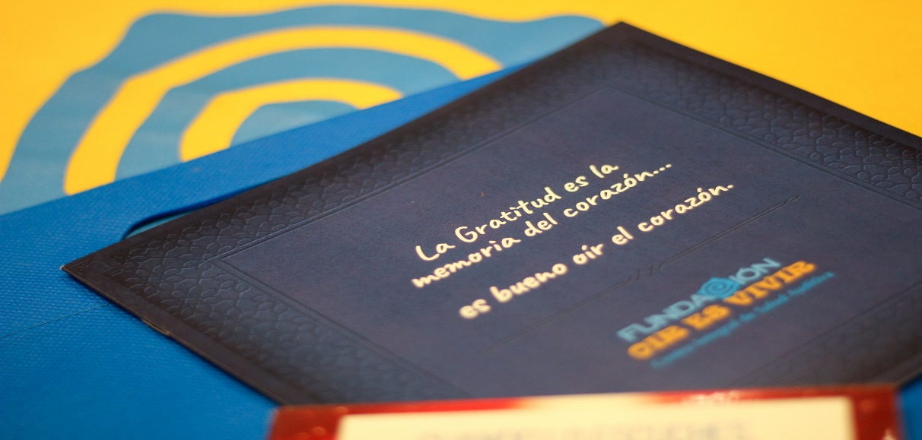

In 2018 we will celebrate 10 years of service and we will be celebrating it working for those who need it most!

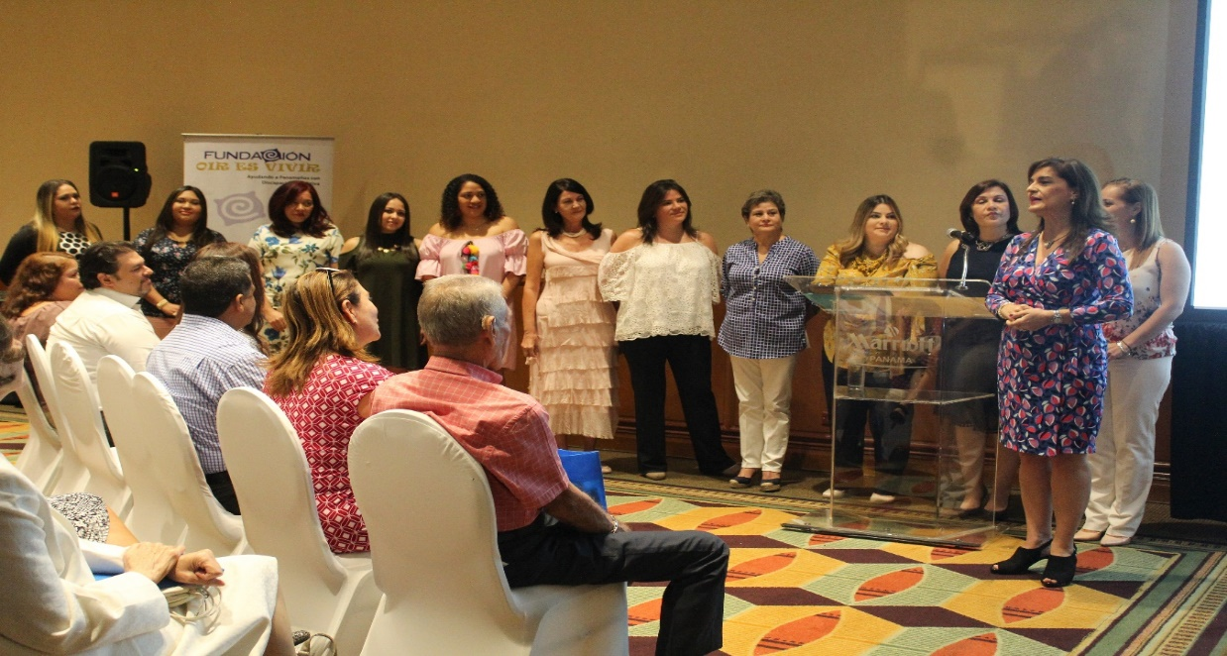

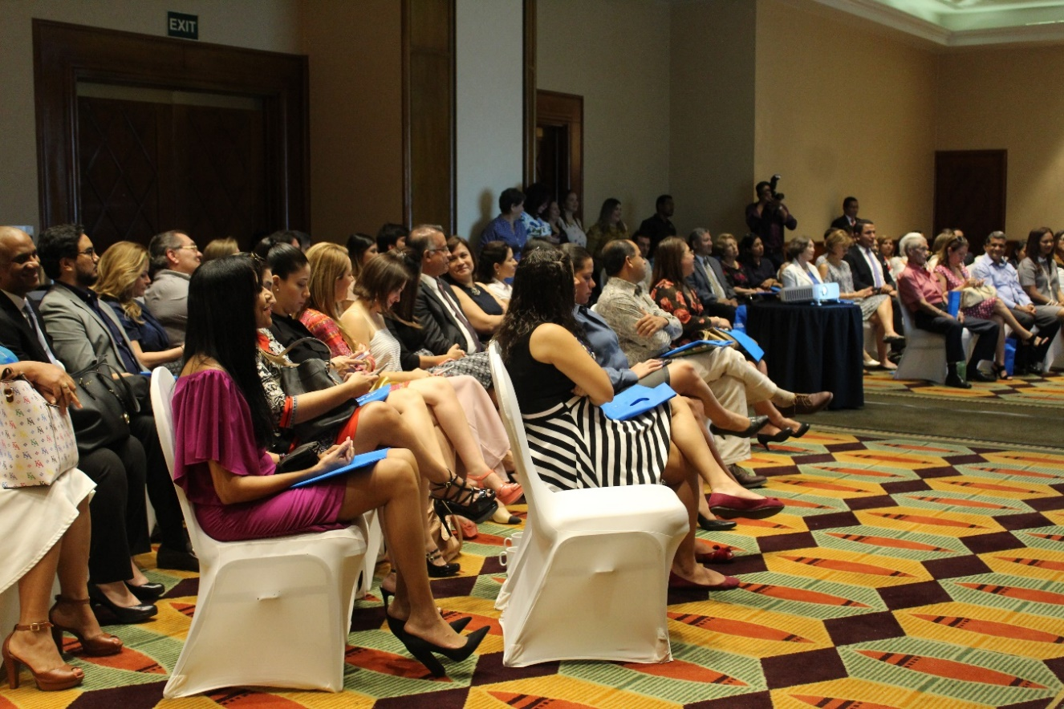

We introduce you the staff of Fundación Oír es Vivir

They are the ones that make the gift of sound possible to panamanians. Wonderful women who work and provide the best of themselves.

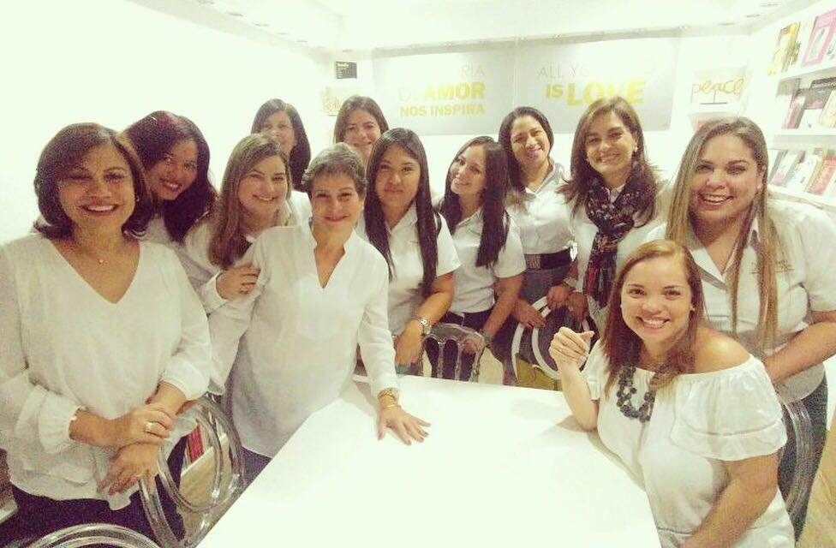

With the program "APRENDO ESCUCHANDO” (I learn by listening)

It continues to benefit more children of school age.

We went to Kids and Family Center, where about 10 attentions were made to children between 2 and 3 years old.

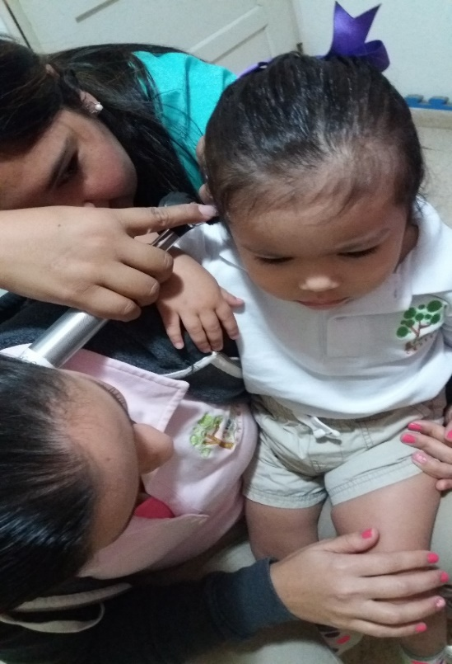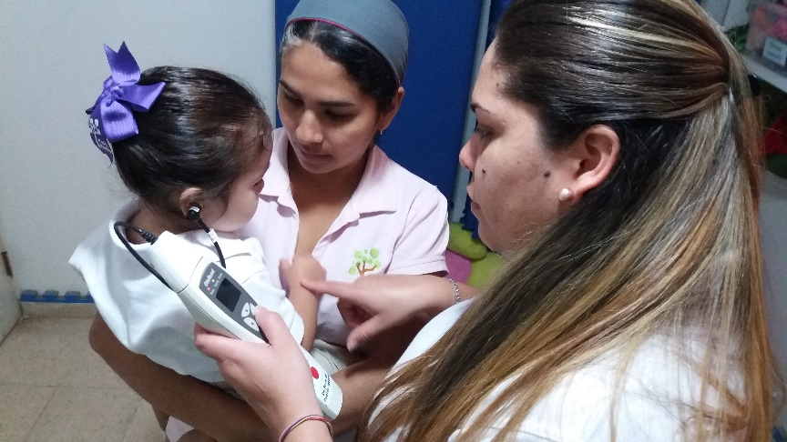

We celebrate the day of Thanksgiving.

The American Society of Panama, invited us to share their traditional Thanksgiving lunch, where they were also invited Juan and Johan, children with hearing loss captured on the tour to La Pintada and who already enjoy the gift of sound through the donation of headphones and was possible thanks to this sponsor. Thank you American Society for your repeated support.

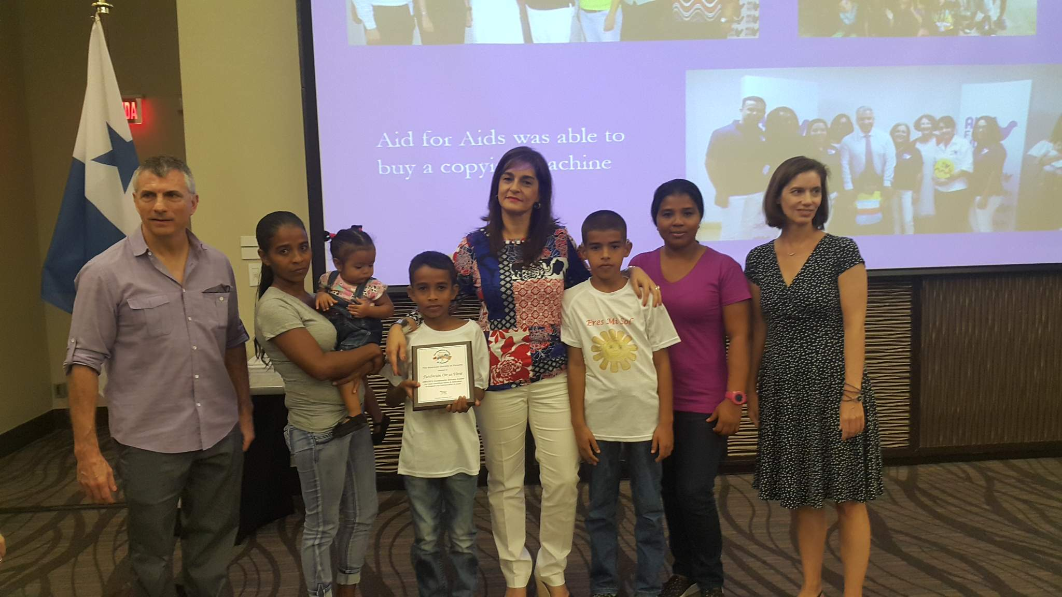

Remember that we have a complete clinic at your service.

Donation of hearing aids.

For those adult candidates and children who qualify. Remember adults start to lose some hearing approximately from 40 years.

Initial process for the request of hearing aids, interview by the speech therapist who receives documents and verifies the necessary requirements to apply with the hearing instruments that are then sent to the board of directors.

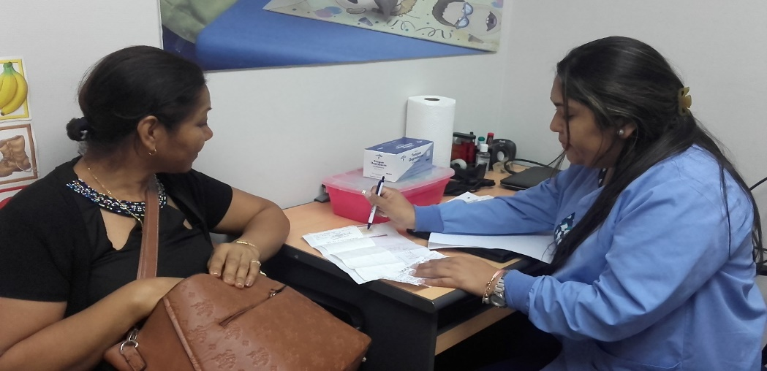
Ms. Ana received the gift of sound by receiving her new hearing aids here photos of the adaptation of it.

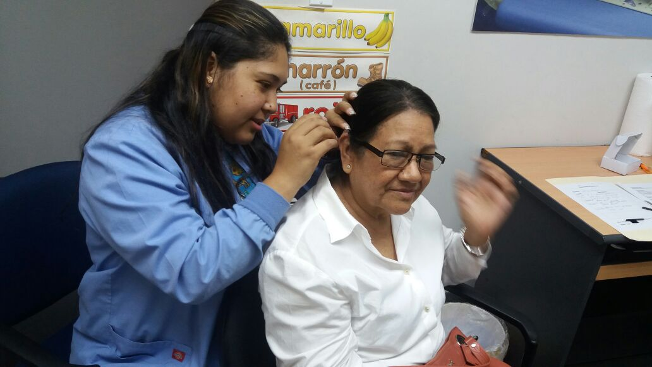

Audiometry tests

For students as a requirement for school reentry and for children and adults who require them.

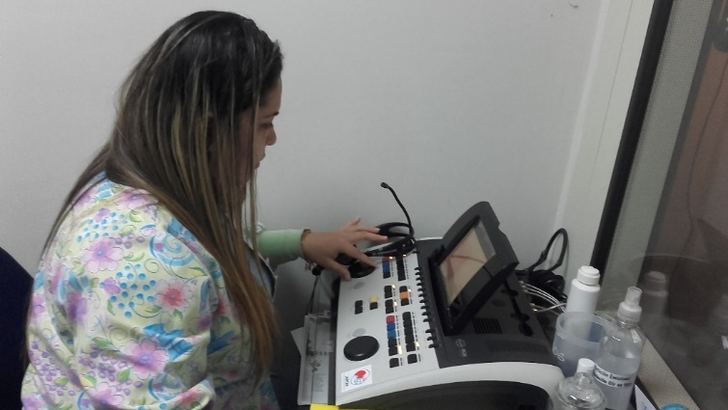

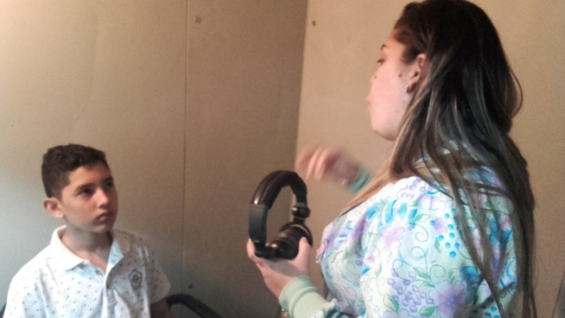

Language therapy for children.

The support in the adquisition of language on time is vital for an adequate school performance.

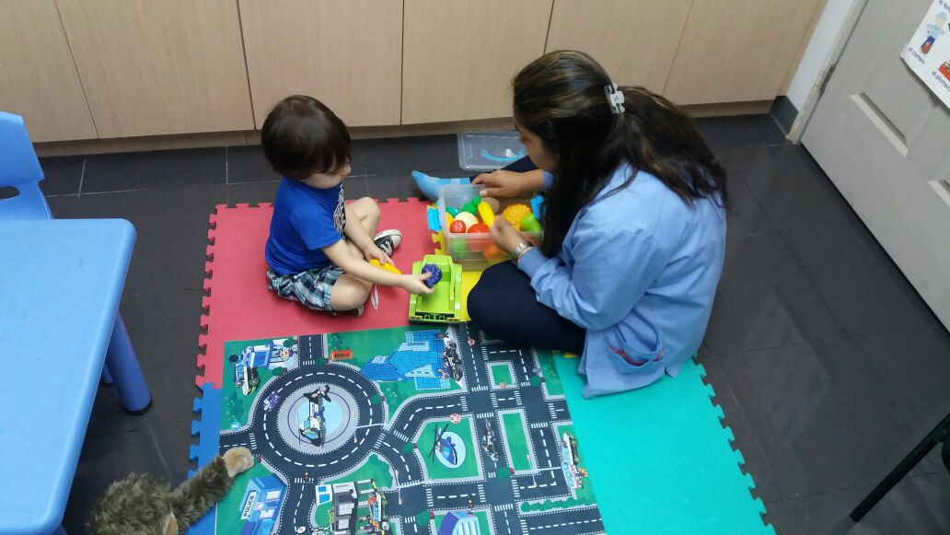

Children from Cerro Azul came to our clinic.

We carried out the second phase of exams for the children of the tour from Cerro Azul. That they did not pass the test and required specialized additional attention. Remember that sometimes a single test is not enough! Thanks to Empresas Melo for making this possible.

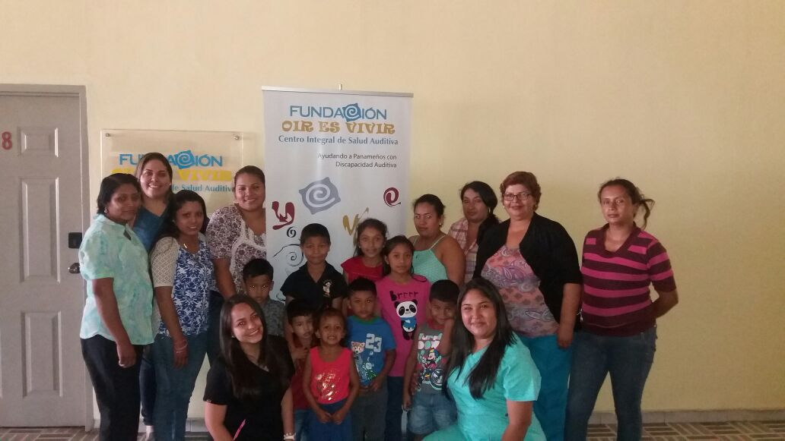

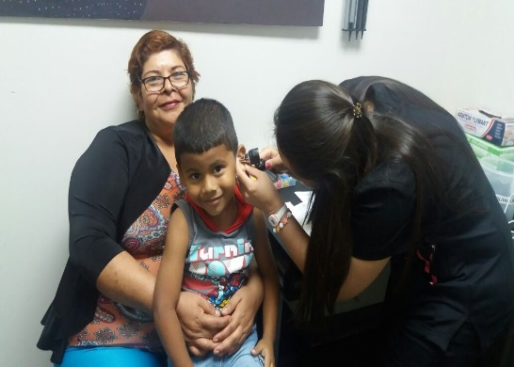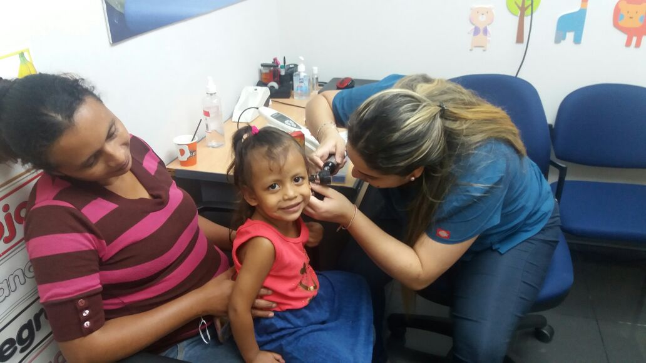

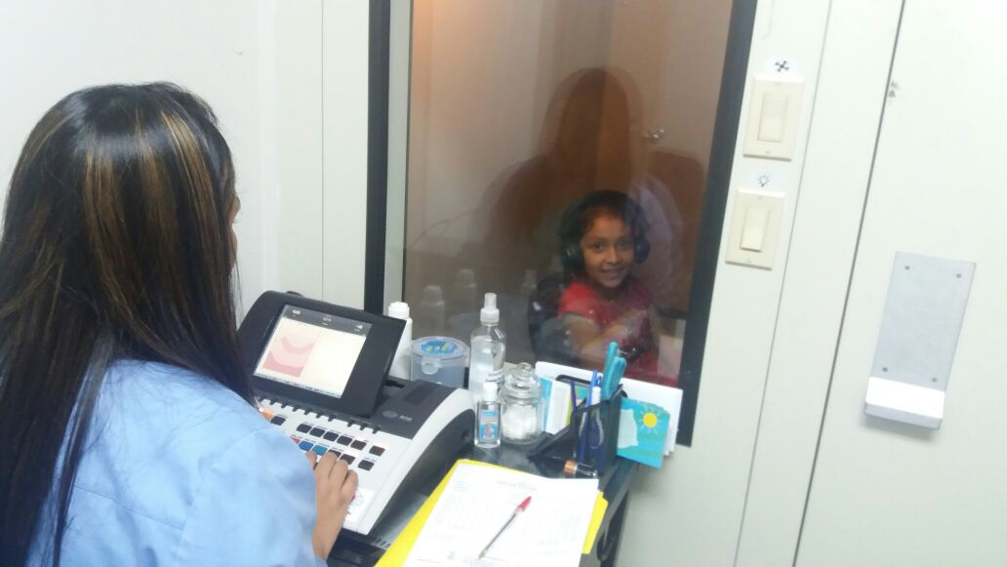

YOU ALREADY MEET LORENZO.

Learn with him, what role your children and you play in the world of children with hearing loss.

