TEN YEARS!!!!!!! FUNDACION OIR ES VIVIR….. doing GREAT!!!!!
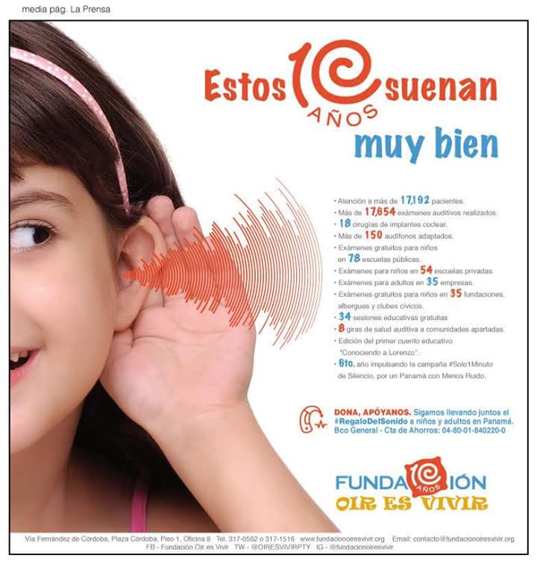
Giving the "Gift of Sound" to those who can not listen, was what in 2008 motivated Dr. Cynthia Guy to start the operations of Fundación Oír es Vivir en Panamá. Motivated by a family affection, the doctor lives deafness first hand and decides to undertake the work to help others.

In the first three years of operation, 18 patients were implanted, between children and adults; and they are supported by language therapies. This solution, however, is very expensive, so new strategies are sought to continue providing more accessible support.

Since 2011, the Foundation makes a turn to benefit a greater number of patients and that is when the Comprehensive Center for Hearing Health (CISA) is formed, a complete facility that offers all audiological services under one roof, thus facilitating to patients and their families, greater possibilities of accessing solutions that are within their reach.

Today and under the direction of its President Giovanna Troncoso, mother who lives through two of her children's hearing loss, we provide services both at the Center and through a mobile program that reaches schools, companies, shelters, foundations, rural and indigenous communities in our country.

HEALTH DAY AT THE SANTO TOMAS HOSPITAL, SUPPORTING THE PANAMA LIONS CLUB.

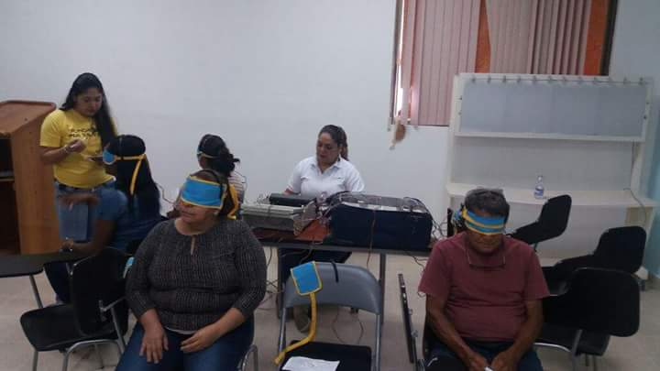

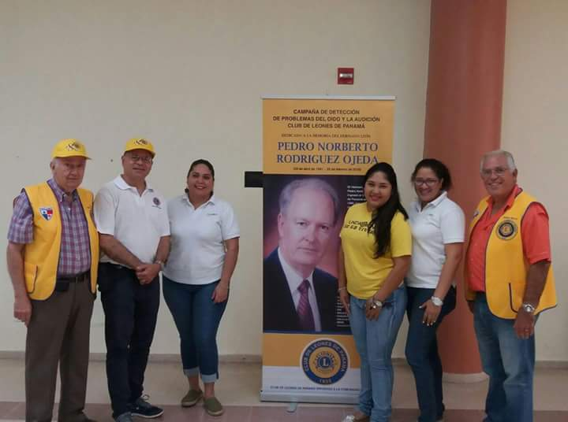

We continue to encourage companies to continue carrying our program and be able to audition their employees. Thanks ARIAS, FABREGA & FABREGA.

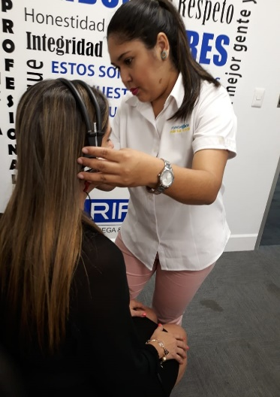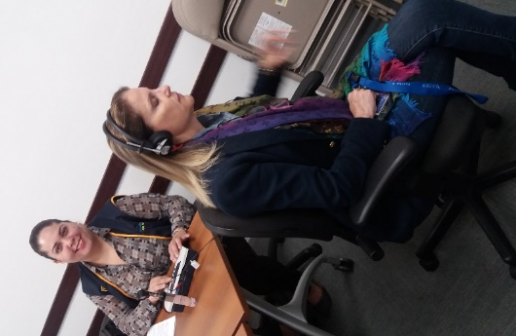

Also, we did tests to the students of the Interamerican Academy of Panama under the LEARNING LISTENING PROGRAM.

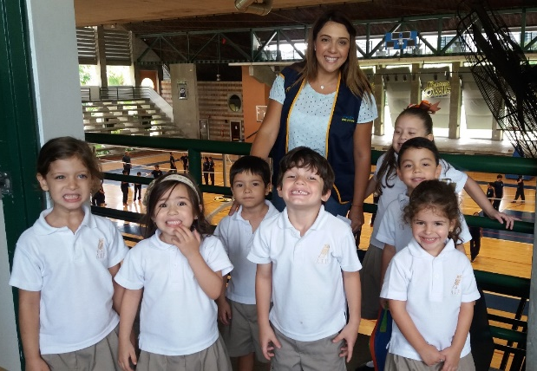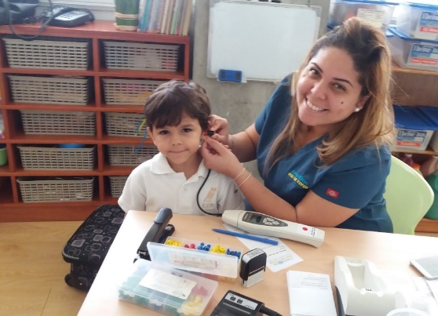

Panamanian Arab International Academy located at the sector of Margarita, Colón.

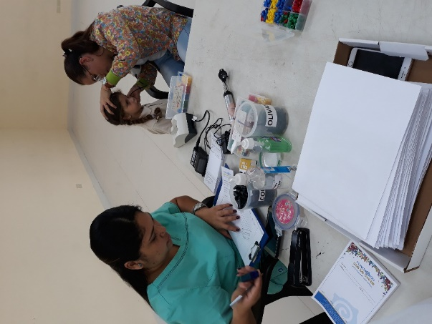

Thomas Jefferson School, between the ages of 3 and 16, these attentions were given with the collaboration of UDELAS seventh-semester students.

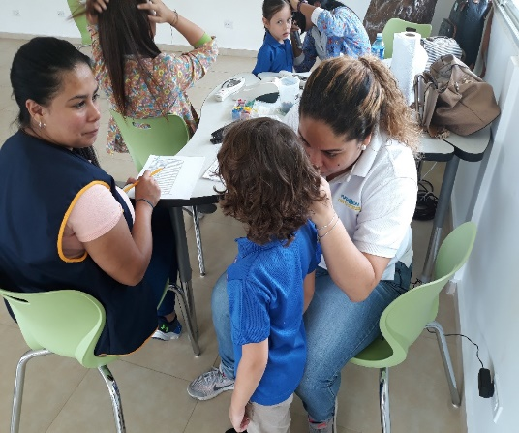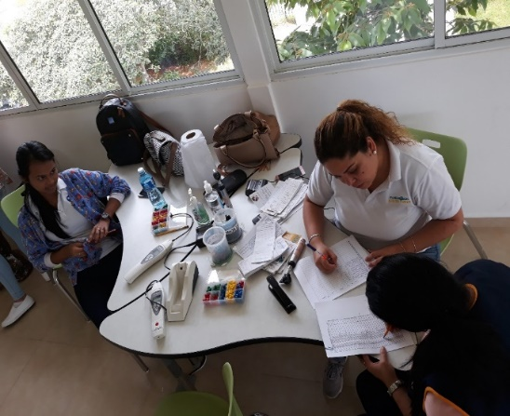
We did test to the children of the Soccer Academy "Roman Torres" where we will instruct parents and children about the care of the ears.
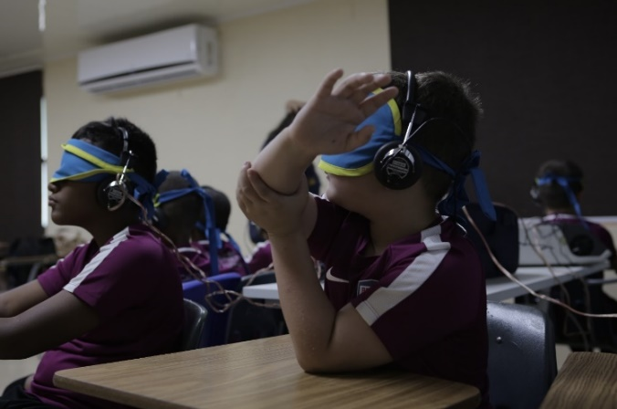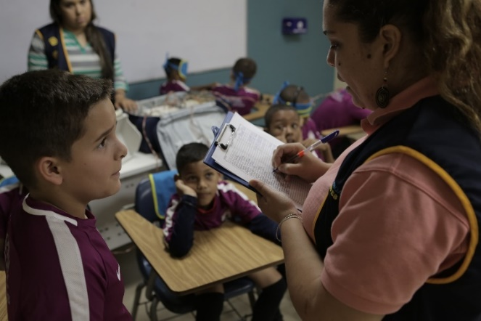
Taking molds for hearing aids.

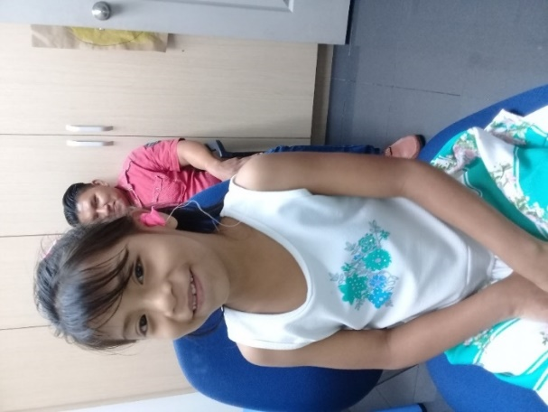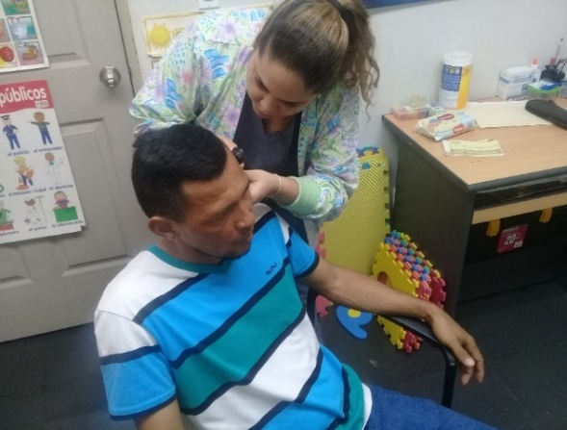
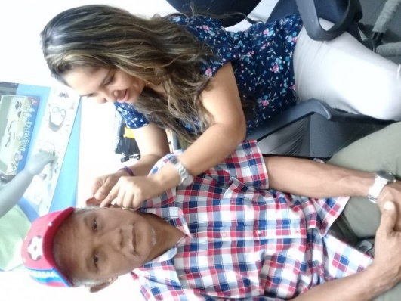
FOLLOW UP - Milagros came to her follow-up after a month of having had her hearing aid fitting.

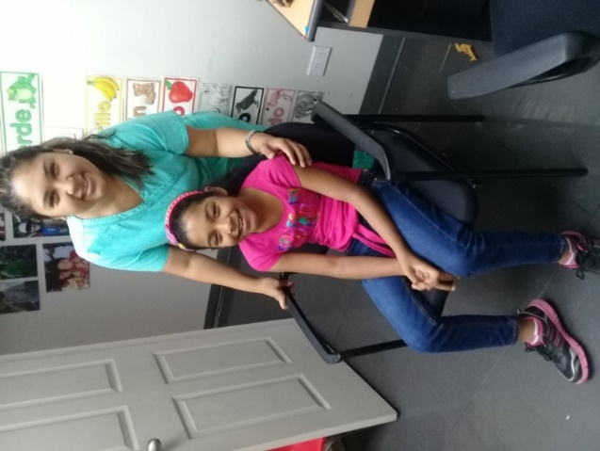
LANGUAGE THERAPY - Dorindo having his language therapy after been adapted with his hearing aids. Thanks to MIDES

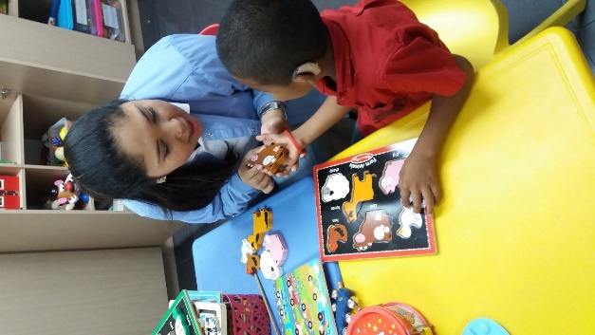
Our little friend Brittny, who comes every Saturday for her speech therapies.

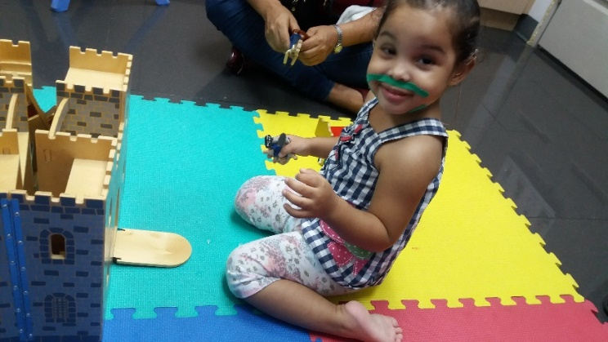
NEONATAL HEARING SCREENING

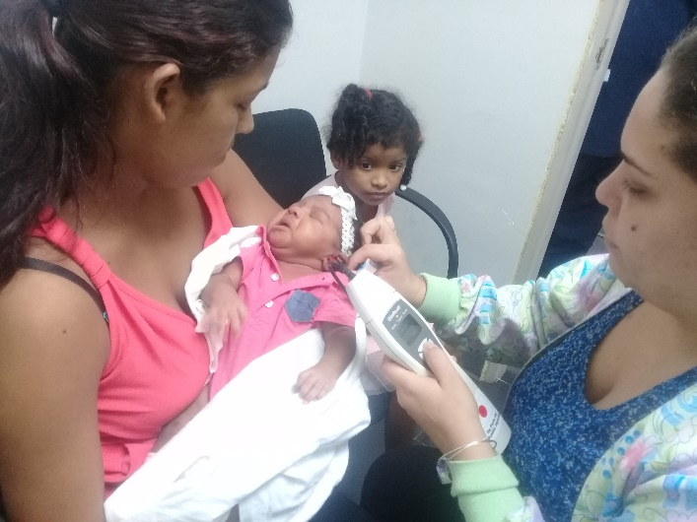

Thanks, MIDES for having the opportunity to continue hearing.
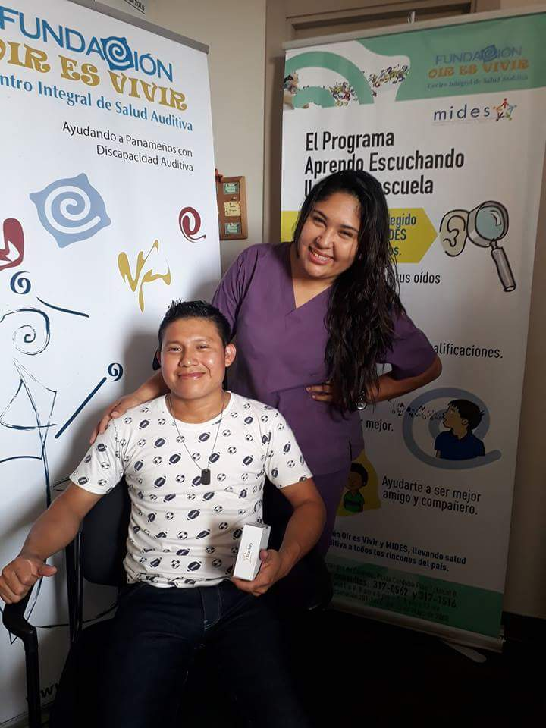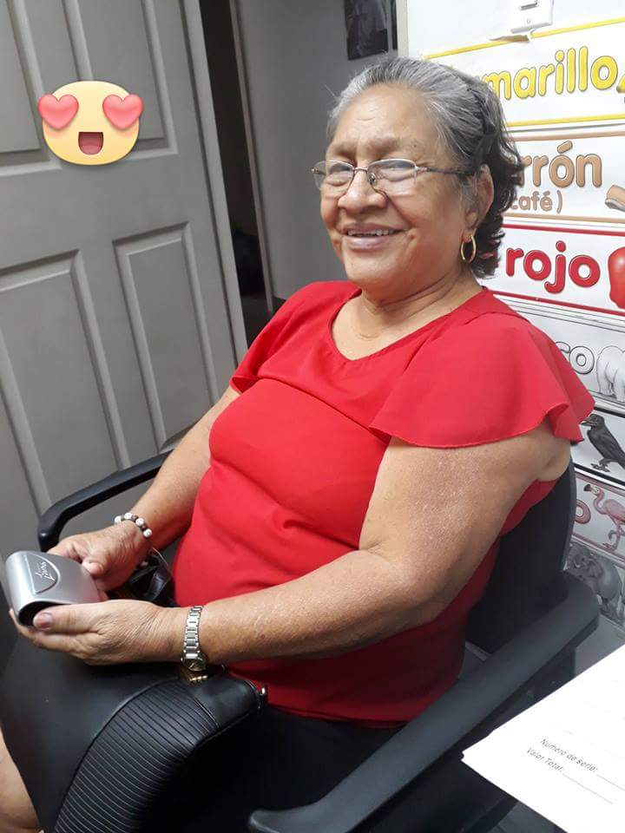
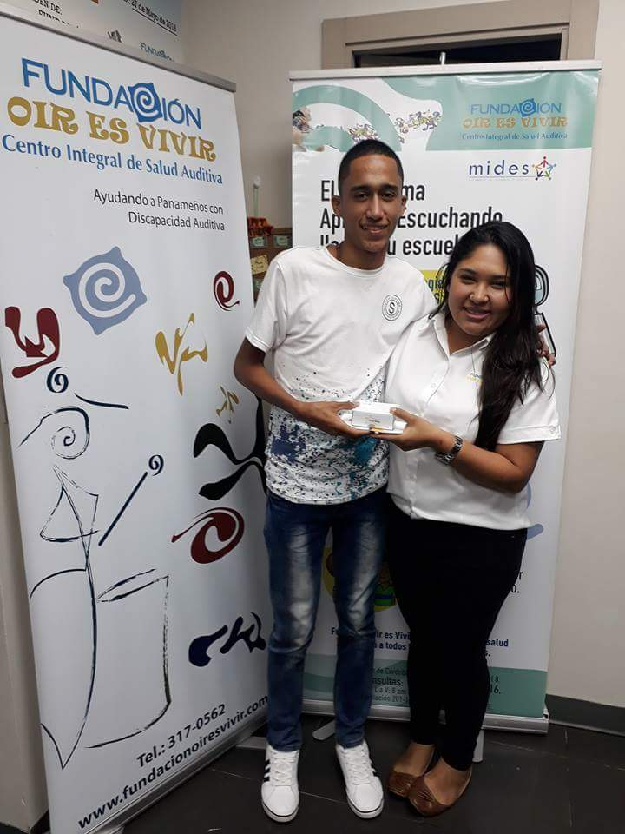
The Association Colombo-Panameñas Ladies made an activity where they gave away books “Knowing Lorenzo’’. Thanks for making us participate in this activity.
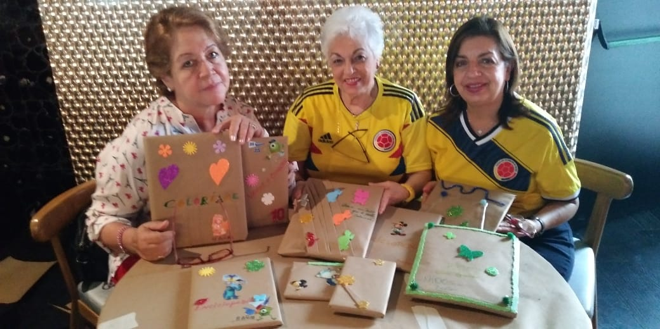

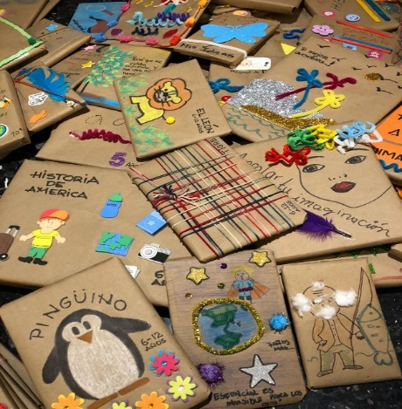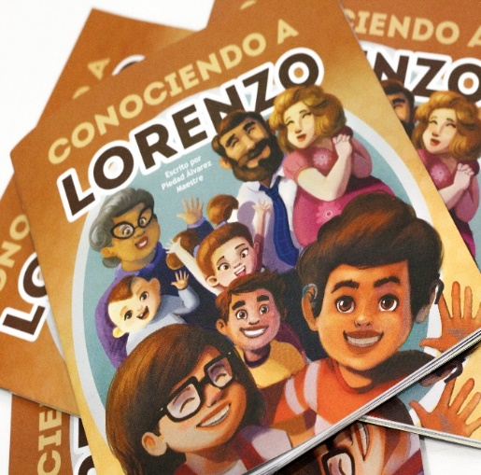
We received a visit from the staff of the Embassy of China and donated 3 computers.
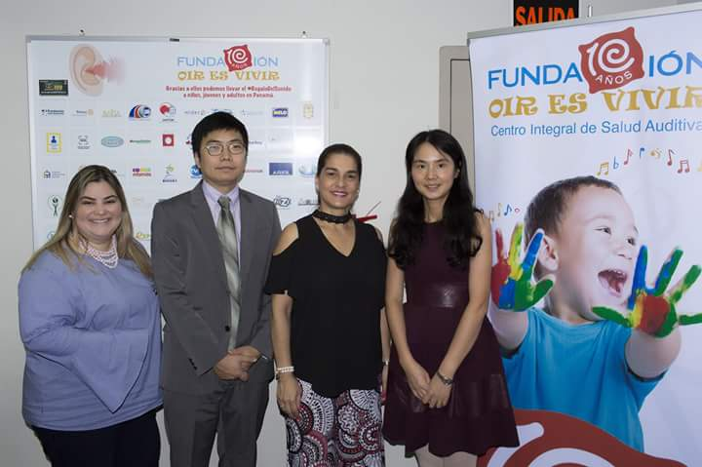

We visited Instituto Sun Yat Sen and did tests to the students under the LEARNING LISTENING PROGRAM.
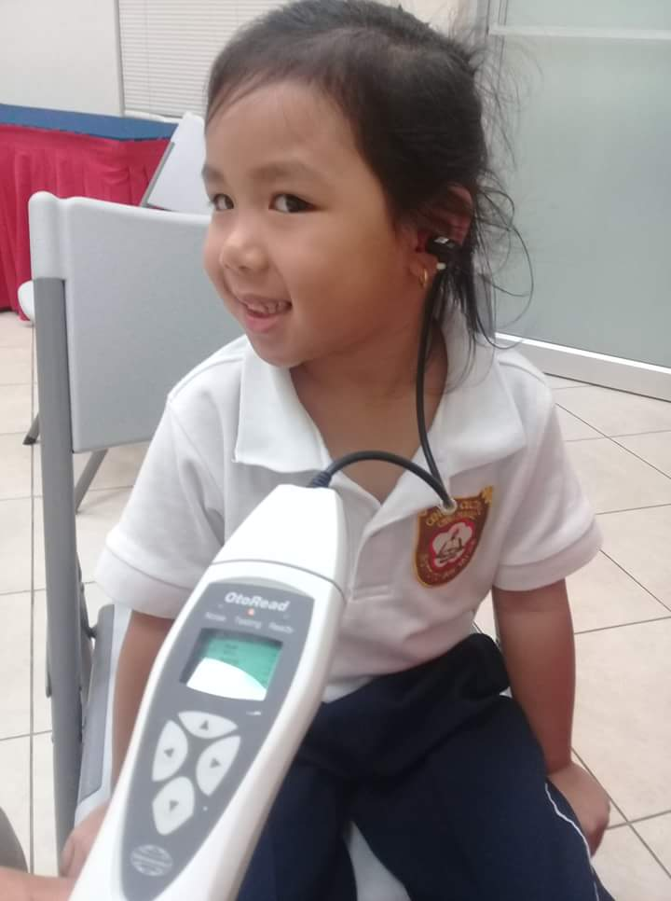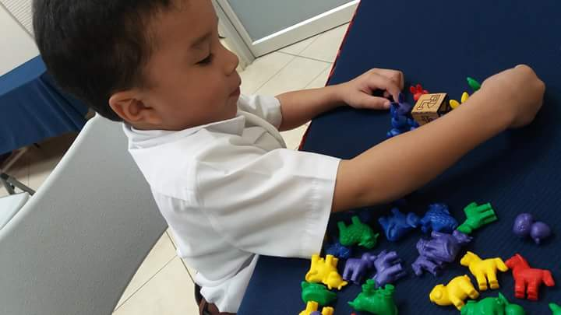

Continue doing earing test at TU GUIA PRE-SCHOOL .
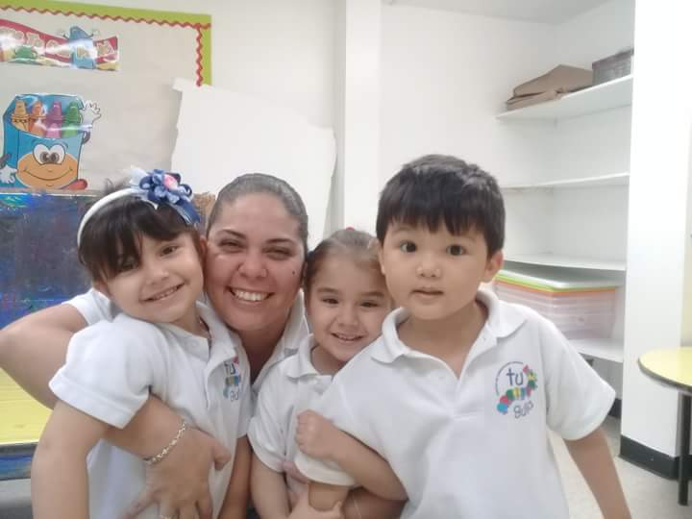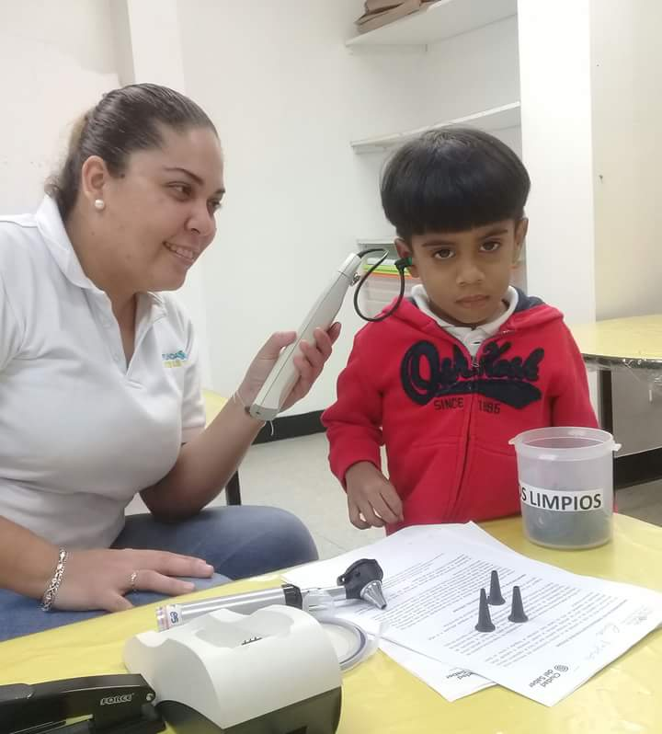

Session for parents and teachers –

On this occasion, three important talks were given to both the parents and teachers who participated in it and where they could also obtain more information regarding the importance of performing the hearing tests.

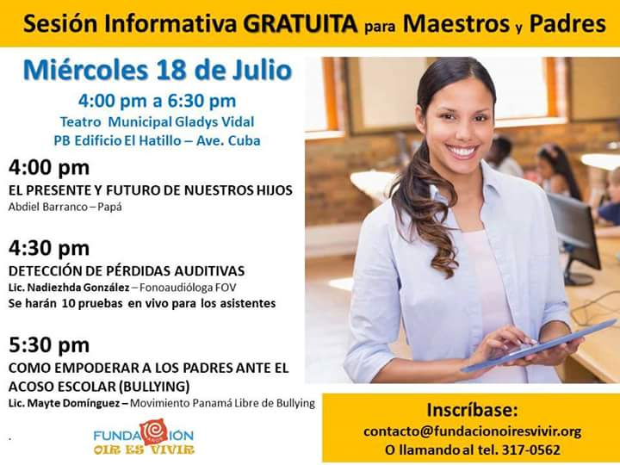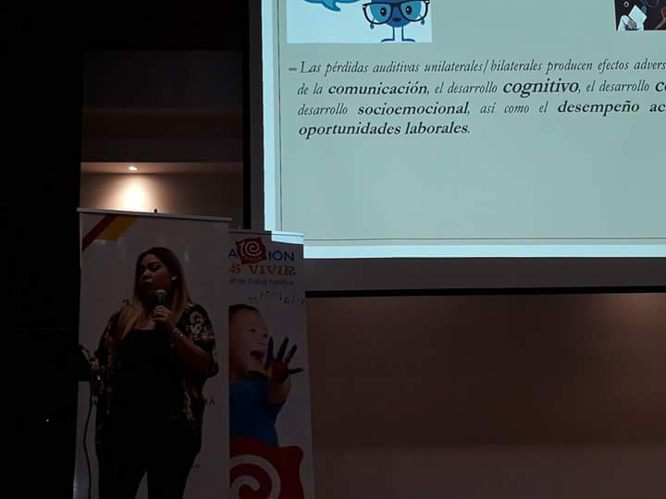
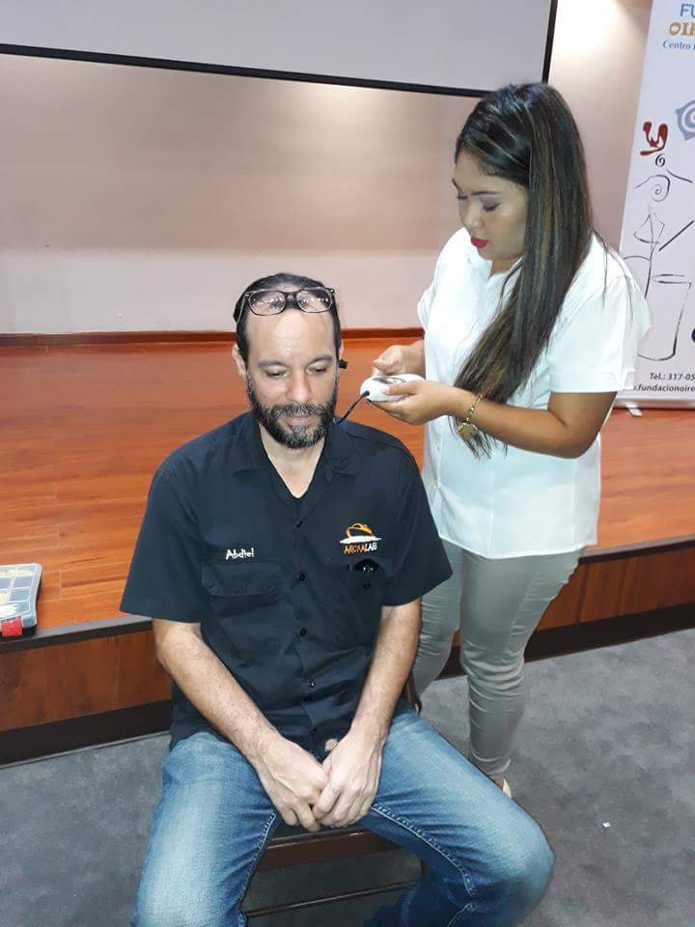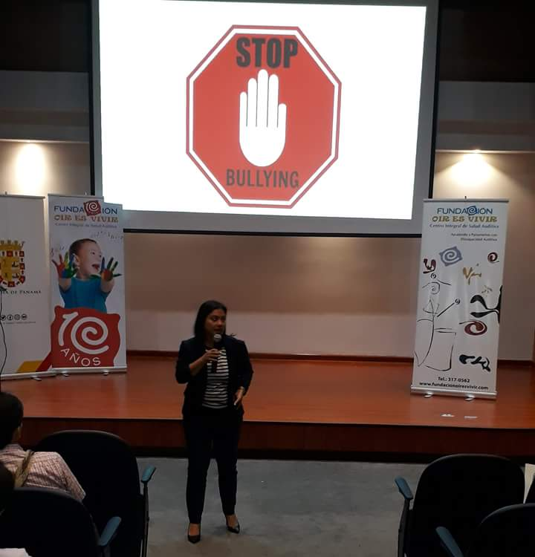
Follow-up to La Pintada children, Juan and Johan equipped with hearing aids, Thanks to American Society.
