Launch of our first book of educational story “Conociendo a Lorenzo” and participation in the International Book Fair 2017

Mrs. Piedad Álvarez Maestre, writer of our story “Conociendo a Lorenzo”, signing autographs to those who supported us that day during the book fair.

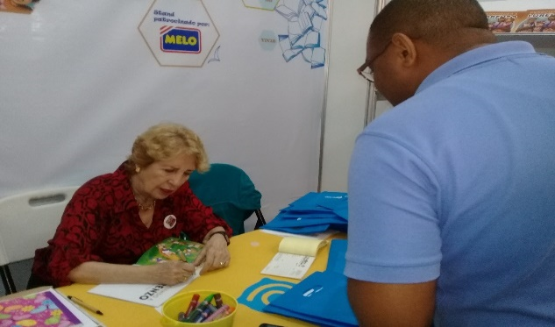
Our participation in the Book Fair was a success, we had stories, painted faces and visited many children.

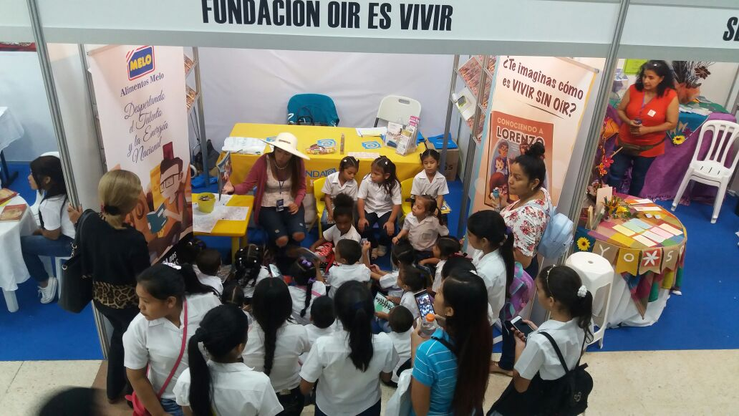

In our clinic located at Vía Fernández de Córdoba, a lot of good news!

- Language therapy with our friends Alexander and Joshua, both have a cochlear implant and are receiving therapies to improve their language

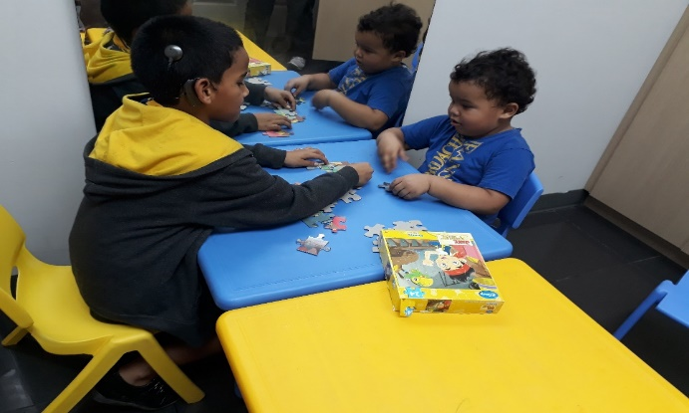
- The adaptation of headphones to the girl Ninoshka was made thanks to the sponsorship of Mr. Ricardo Tribaldos.

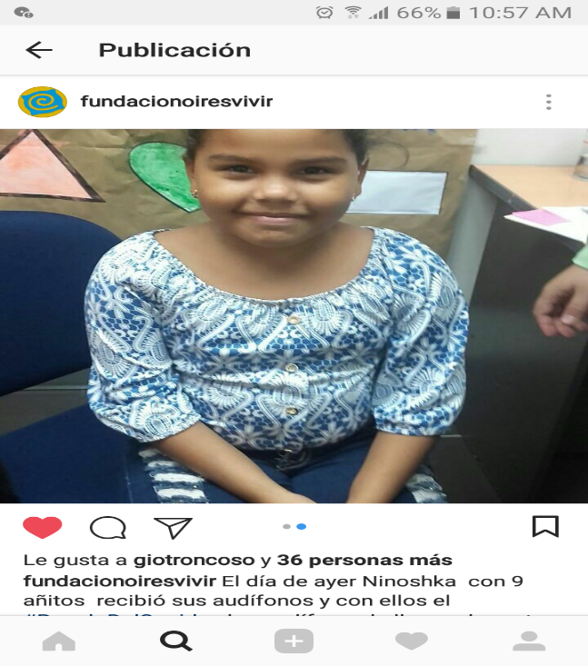

Our mobile exam program continues to benefit hundreds of children!

On this occasion we went to the CEDI of Mayor Diaz in which our speech therapists went to test more than 30 children between 3 and 5 years old. Thanks to the support of the Municipality of Panama.

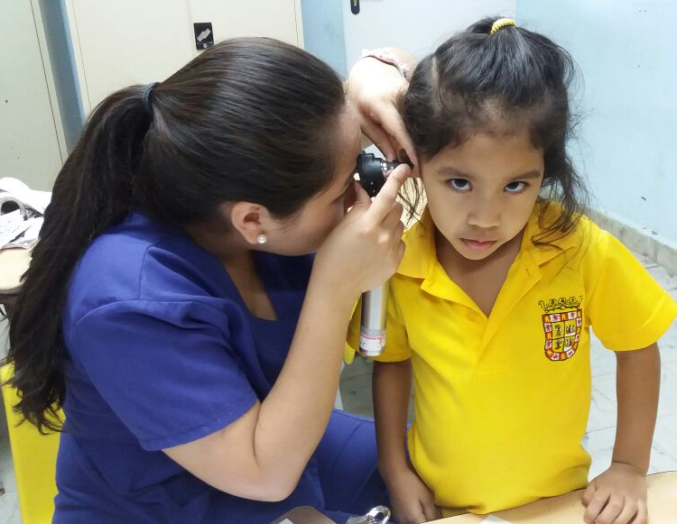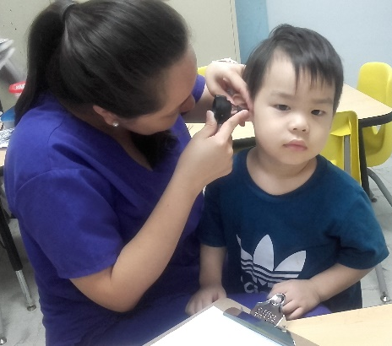
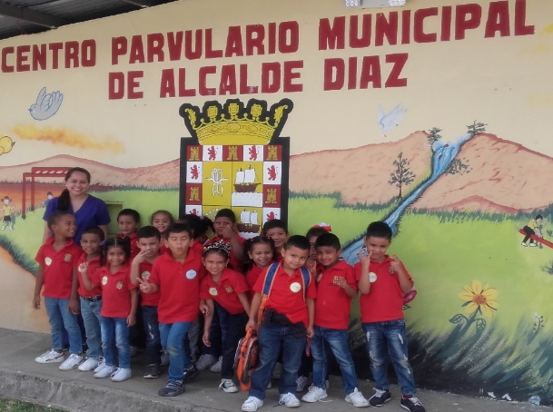

We also performed hearing tests at the CEDI in Santa Ana, where babies were nursed up to 5 years old, there were more than 80 children attended. Bravo!

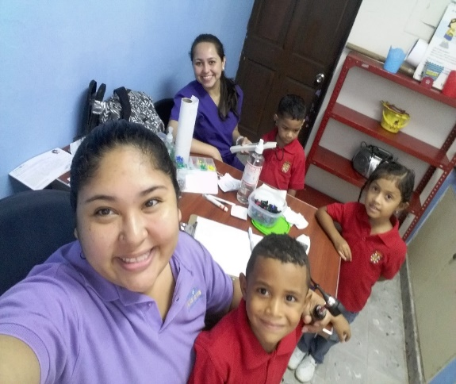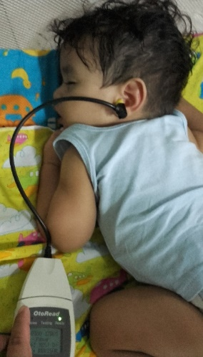
With our “Aprendo Escuchando” program, we went to the Royal College of Panama, where auditions test were performed on around 20 children.
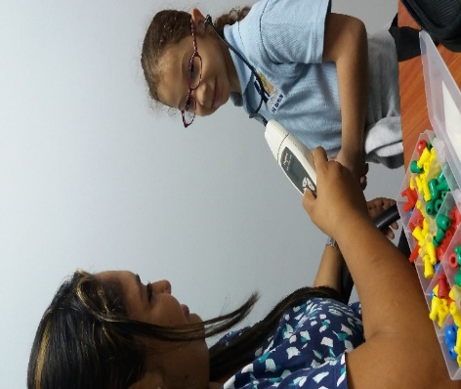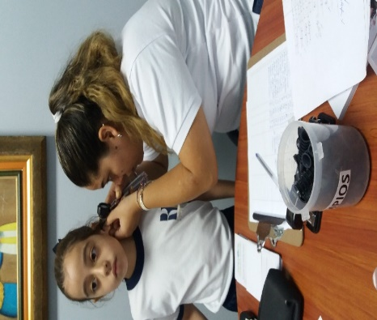

We also went to the Chino-Panameño School where language tests and authentic exams were given to elementary school children.
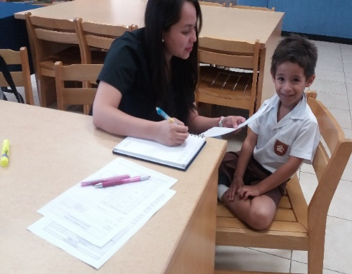

Hearing Health Tour - Community of Cerro Azul

We carried auditive exams to more than 100 children during our tour of the Cerro Azul community at the Juan E Jiménez school. Thanks to the friends of Melo SA, Intelligo Group, Hope Worldwide Panama, National Border Service, Frizz Waters, Portraits for People and all the volunteers who accompanied us on this successful tour.

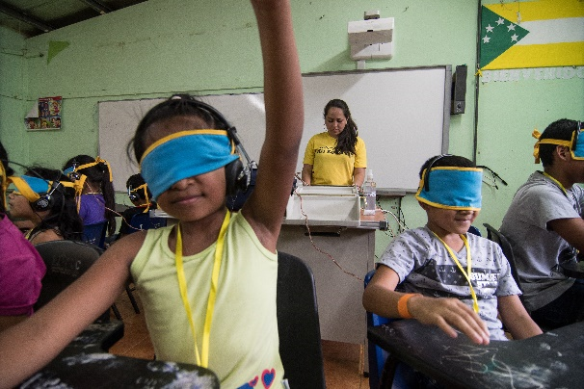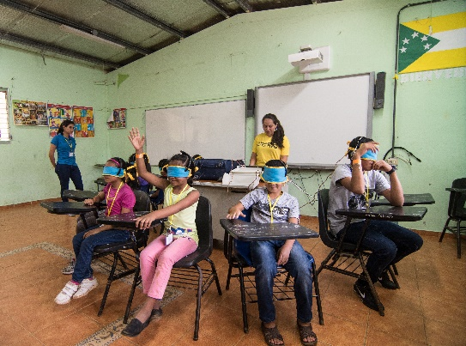
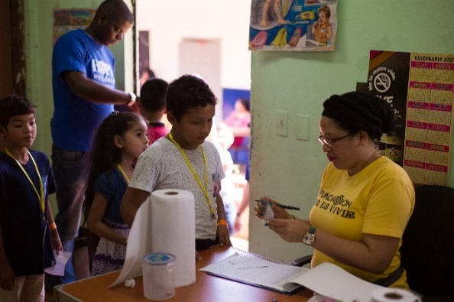
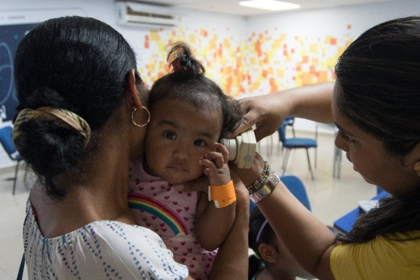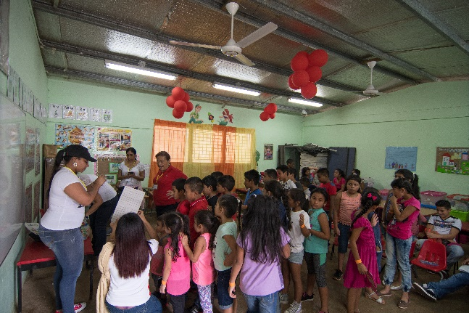

Happy to have started our alliance with “Olimpiadas Especiales Panama”, we became the center of attention to care for the health of the athletes. It will be a pleasure to serve you.

We participated in the Expo Mama 2017 at Albrook Mall, a weekend full of information for future moms, we were orienting about the auditory screening which is done at the birth of their baby.

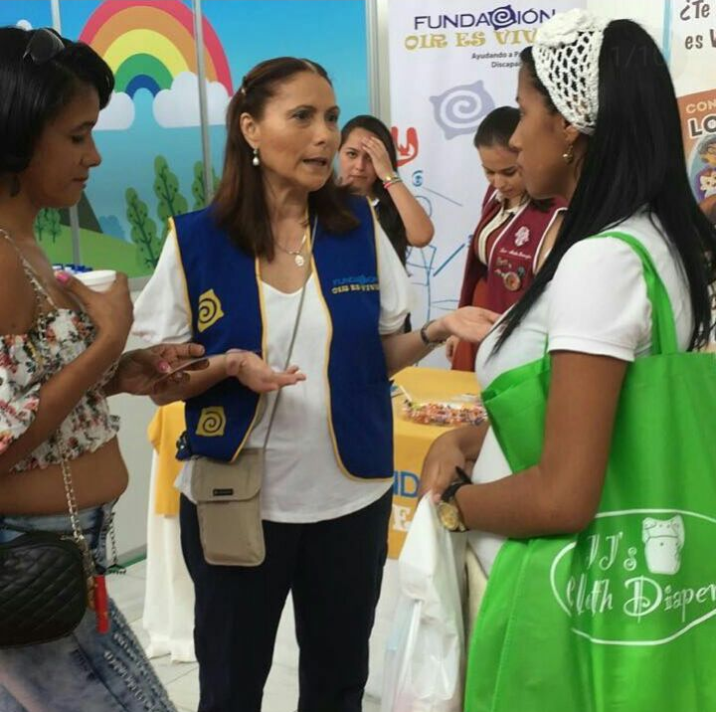

Thanks to the Sam Kardonski Foundation, we managed to carry out auditory exams for 47 young people aged 15 and 18 who participated in the activity carried out by the Rotary Club.

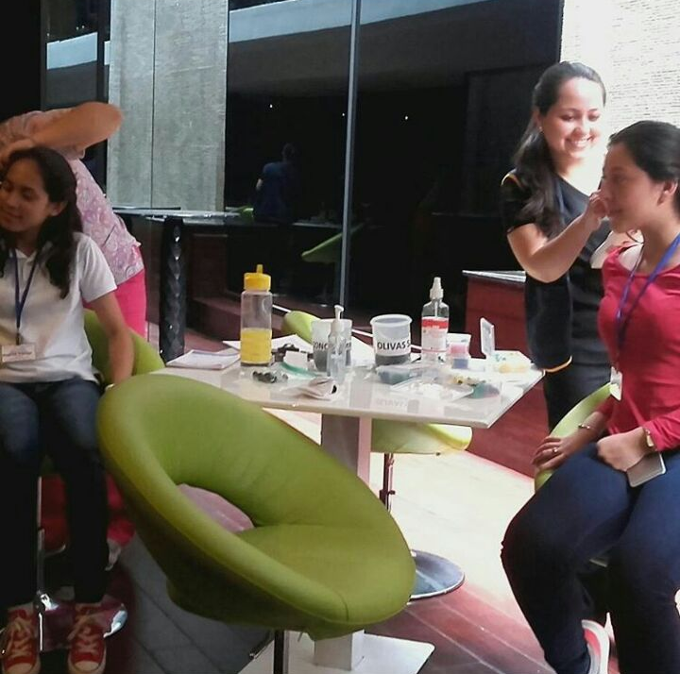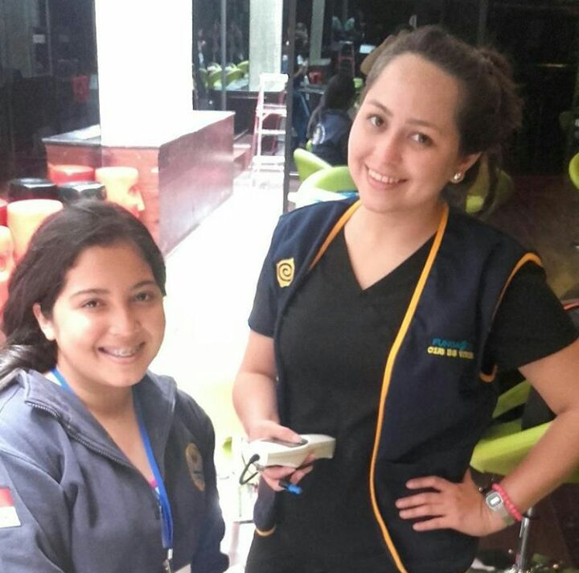

Our mobile exam program continues to benefit hundreds of children!

Thanks to Dell Panama, we were able to perform a hearing test on 100 children from Vista Bella School located in Arraijan.

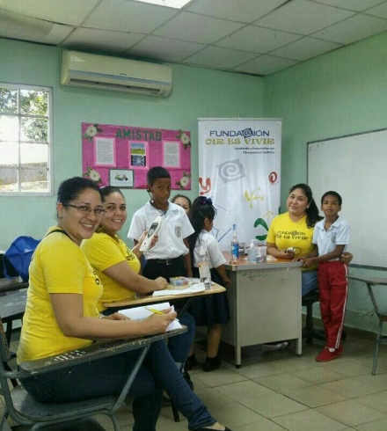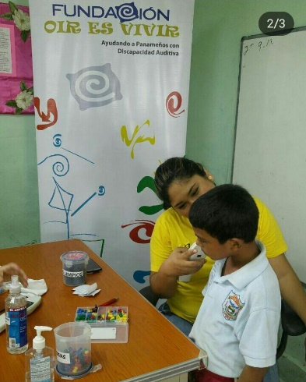
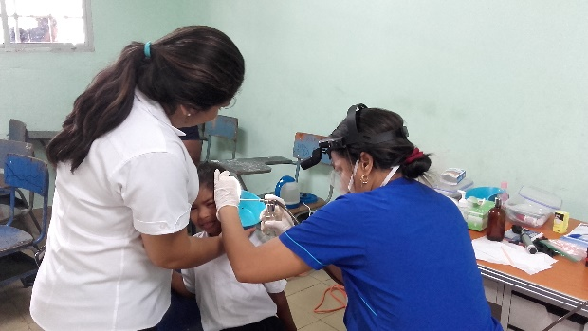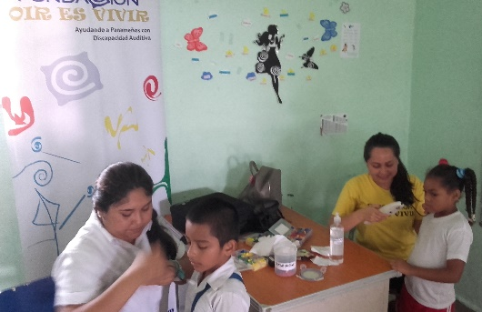

In our clinic located at Vía Fernández de Córdoba!
- Language therapy with our little friend Marianna

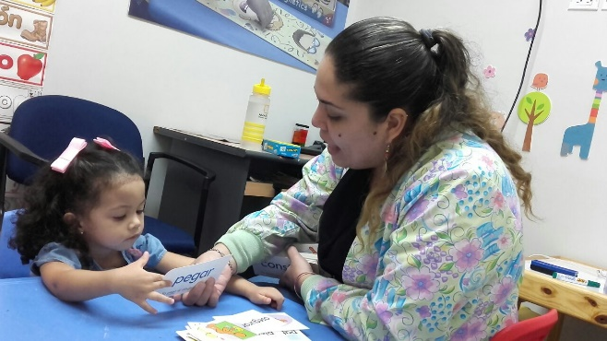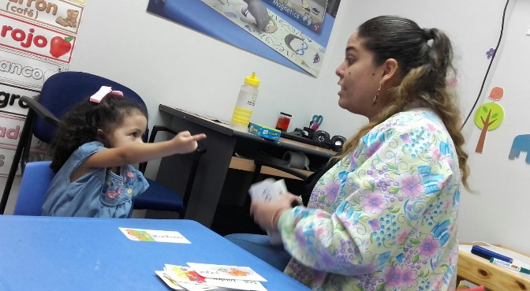
- Otoacoustic Emissions Tests were conducted on our little friend Danneth

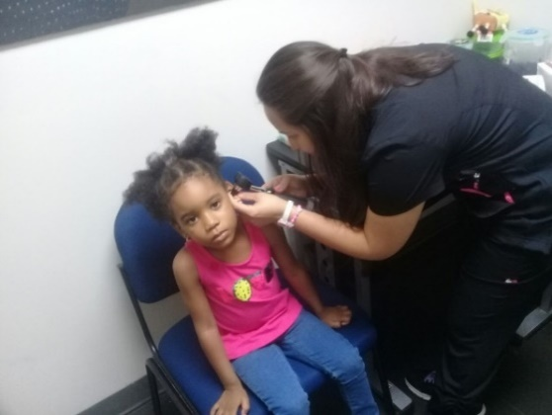
- Language therapy with our friend Lucas.

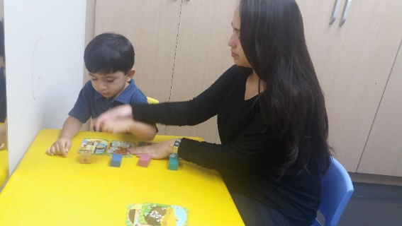
- Language therapy with our friend Josué.

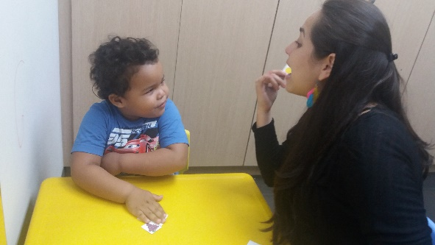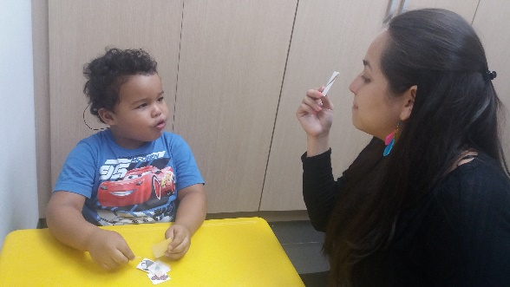
XXII Parent and Teacher Session

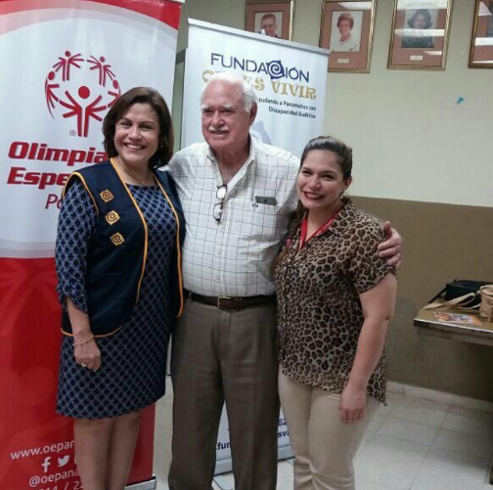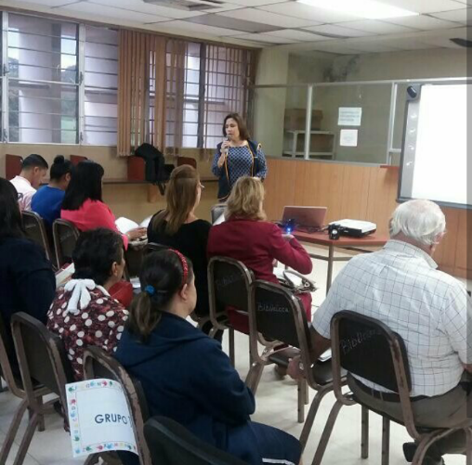
The exhibitors: Lic. Analida Pitty from FUNDACION OIR ES VIVIR, and Dra. Aurora Dominguez from OLIMPIADAS ESPECIALES.

We are extremely pleased with our recognition that made us PANAMA IN POSITIVE for our work in the foundation, we are the winning NGO in the NGO category IN POSITIVE 2017.

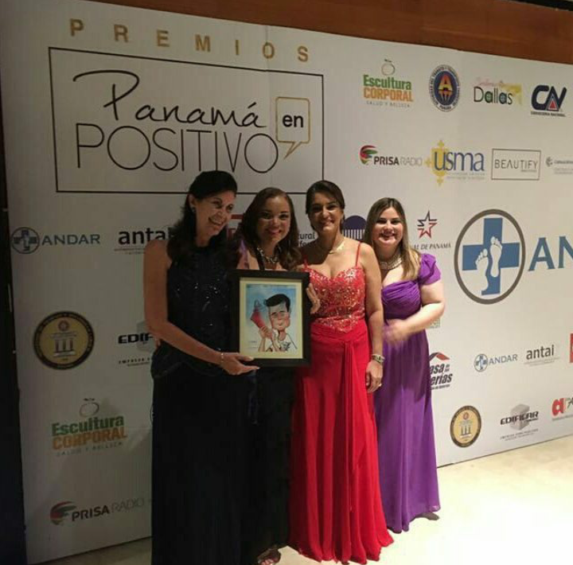
With the “Aprendo Escuchando” program!

We went to the City Kids school where we auditioned around 20 children from 1 to 4 years old.

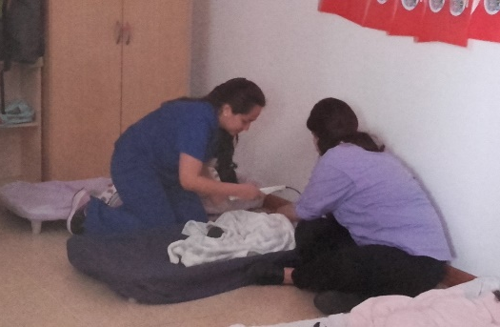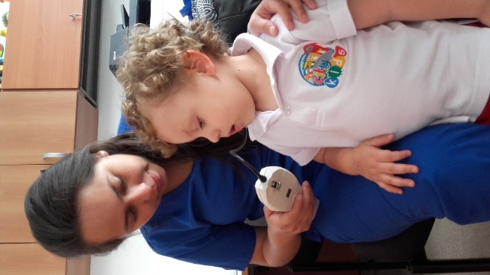
In our Clinic Located in Vía Fernández de Córdoba!
Language therapy.
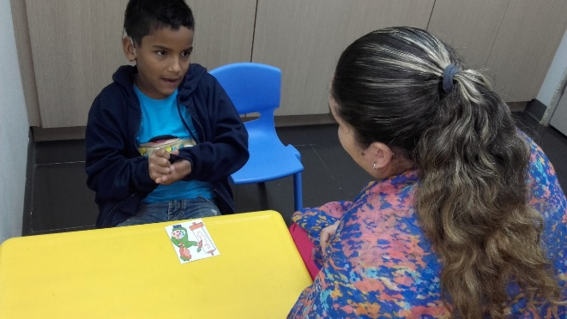
Audiometry and Impedance
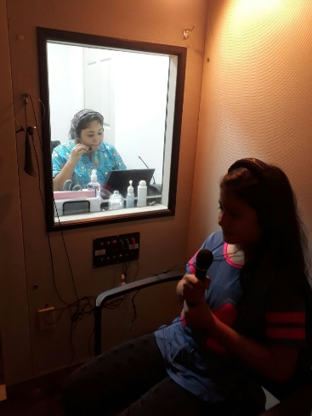 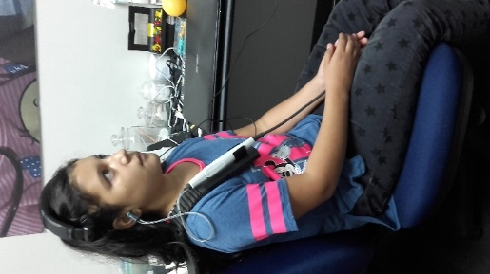
24 attentions were made to employees of the advertising company Stratego, every day there are more companies that join the business hearing health campaign.
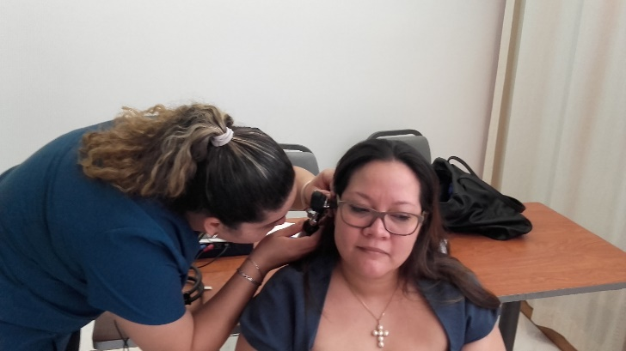

Attentions were made around 95 athletes from different disciplines from “Olimpiadas Especiales”. It was a pleasure to work with them.

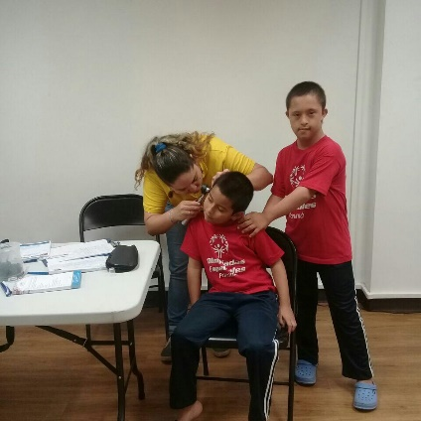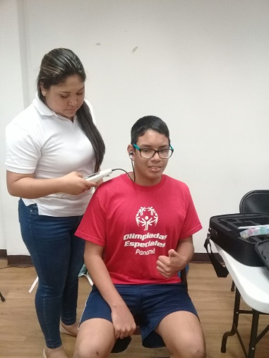

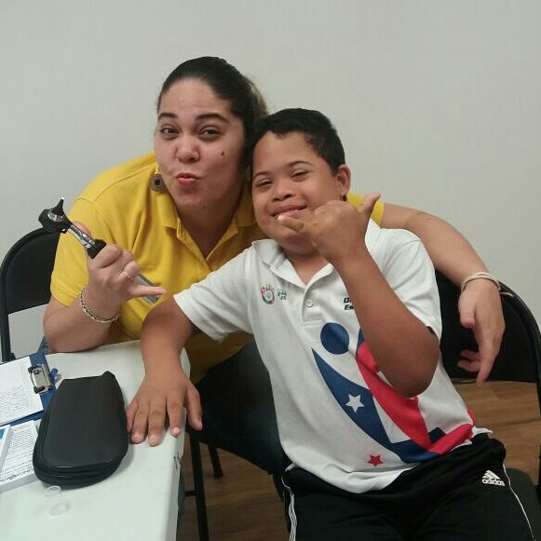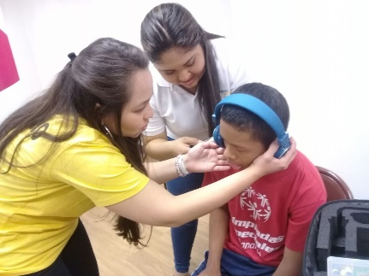

We went to Cinepolis El Dorado, to the event "Let's go to the cinema" in which we could share with the students of the Martin Luther King School. It was a beautiful event.

