FOV SEPTEMBER 2016 BULLETIN

HEARING IS VITAL FOR THE DEVELOPMENT OF LANGUAGE AND A GOOD SCHOOL OF PERFORMANCE.

It is important to make sure that in the first years of life and school, children hear well and there are no situations of undetected hearing loss, or temporary situations such as earwax or objects in the ear canal, which prevents the child from hearing well. To ensure the auditory health of our children, this month together with the Ministry of Social Development we visited the schools:

C.E.B.G. SANTA MARIA DE LOS ANGELES
September 2, 2016

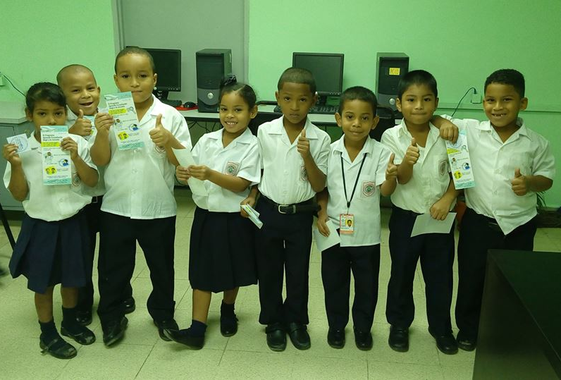

RICARDO J. ALFARO ELEMENTARY SCHOOL and C. E.B.G. JARDIN NUEVO BELEN
September 22, 2016

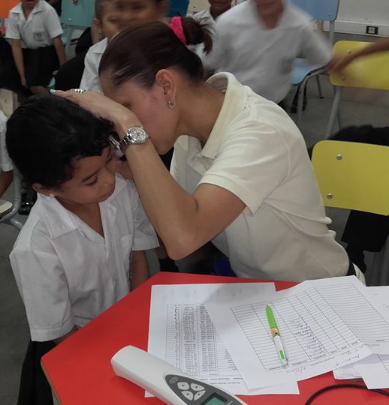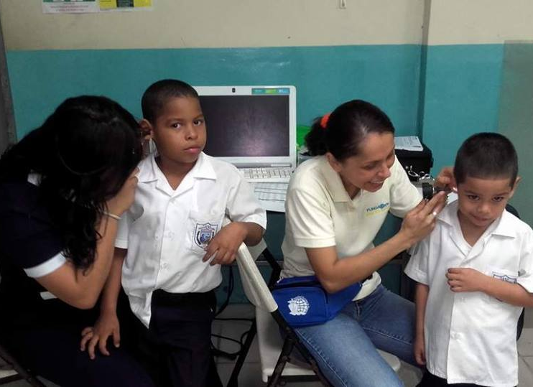

C.E.B.G. LA SIESTA
October 11, 2016

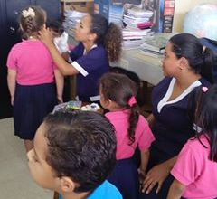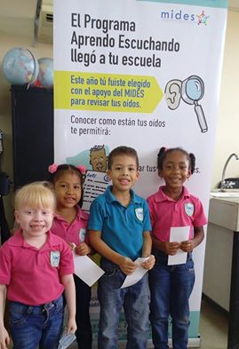

C.E.B.G. REINO DE LOS PAISES BAJOS and C.E.B.G. REPUBLICA DE EL SALVADOR
October 23, 2016

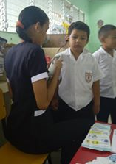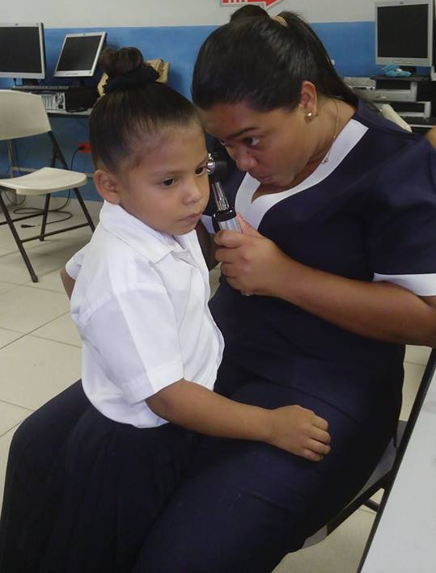

C.E.B.G. GRAN BRETAÑA
November 20, 2016

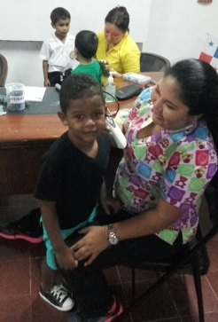

C.E.B.G. CIRILO MARTINEZ
November 21, 2016

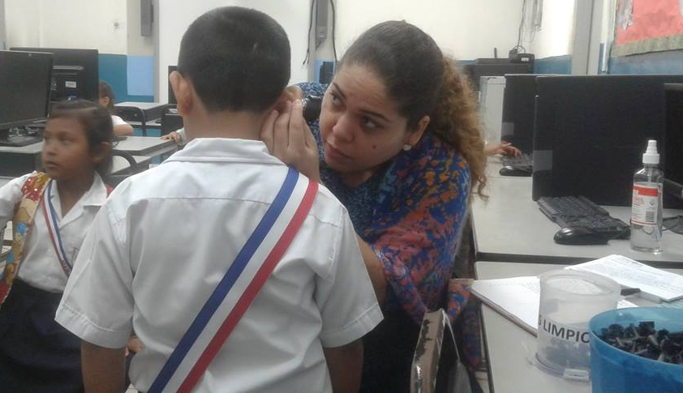

Additional we perform hearing tests in:

LAS CLARAS CENTER FROM VOCES VITALES
September 12, 2016

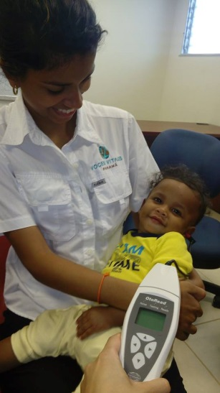

JUVENILE LEADERSHIP WORKSHOP OF THE PANAMA ROTARY CLUB
September 13, 2016

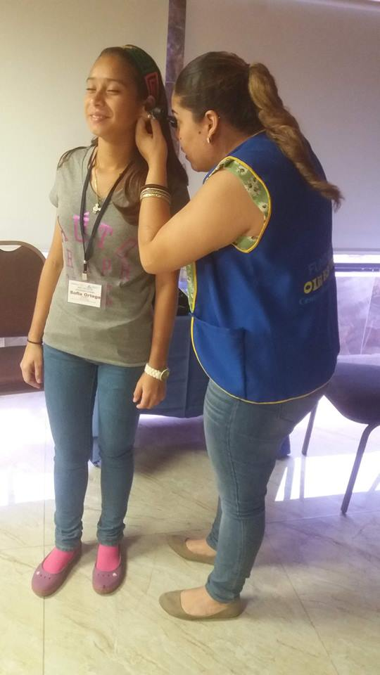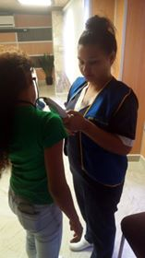

Hearing exams at the health fair of the Wyndham Panama Albrook Mall Hotel.
October 10, 2016

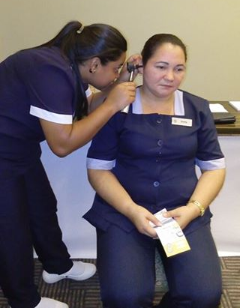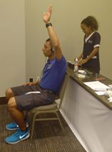

CEFACEI El Chorrillito - El Tecal at Arraiján
November 20, 2016

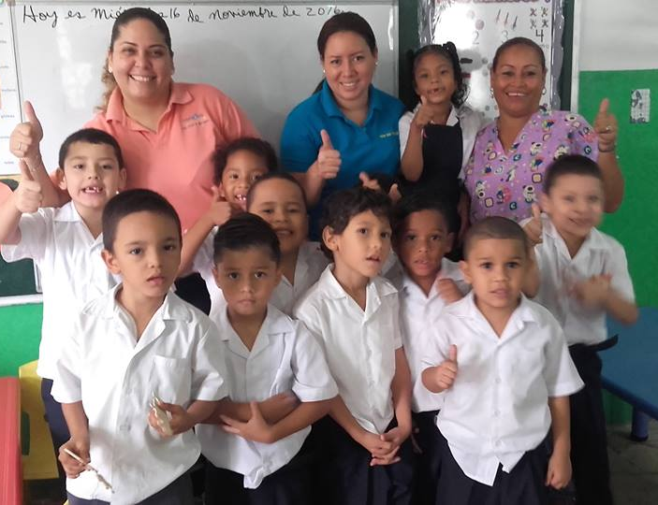

PARTICIPATION IN FAIRS
Educate the population about hearing, hearing care and the time in which they should perform the auditory exams.
September 7, 2016

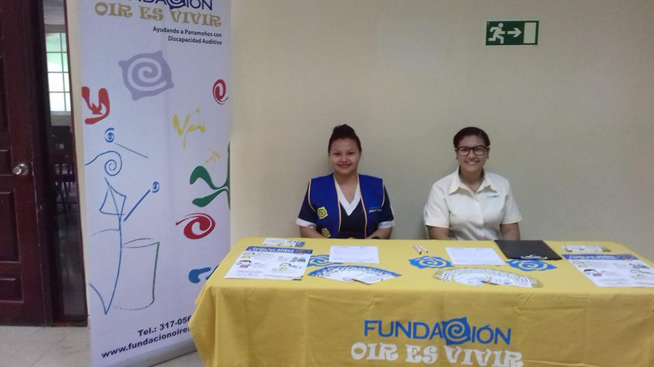

PROVIDING EDUCATION ON HEARING HEALTH

Students of UDELAS of third year of the career of Speech Therapy, observe the materials and instruments to make molds of hearing aids as part of teaching in FOV. Thanks to our team of certified speech therapists who give new students the opportunity to learn new skills.
September 22, 2016

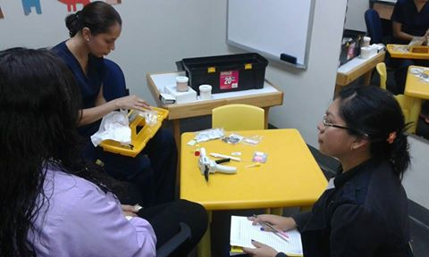

Session of parents and teachers at Caja de Ahorros, completely free.
October 18, 2016

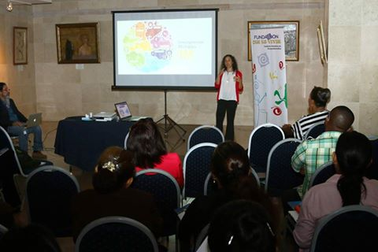

Your donations allow us to continue to carry hearing health!
We received the donation from ABC'N ME Preschool who for the second consecutive year support the work of our Foundation through this donation.
September 30, 2016
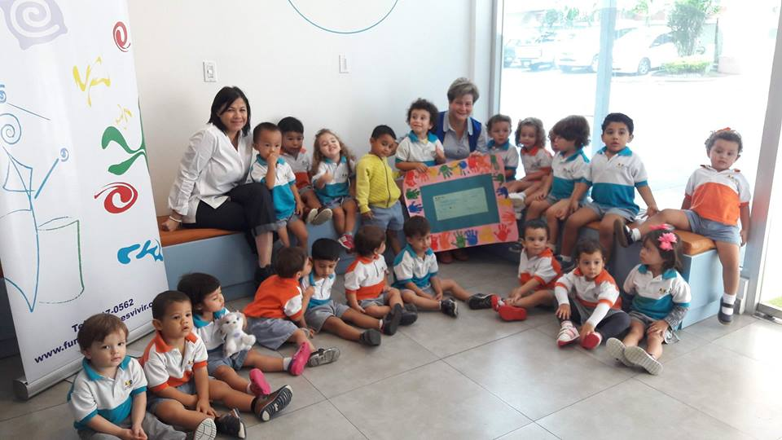

We bring auditory health to rural communities!

Gira a la Pintada, Coclé

November 12, 2016

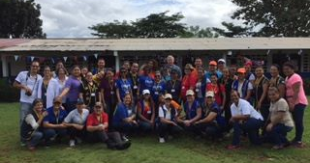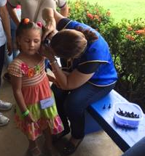

Participation in the radio program of Keyra de Gracia "Conóceme sin Límites" from SER TV, where we had the opportunity to share with the listeners the work we do in Fundación and to make our services available again.
December 6, 2016
