

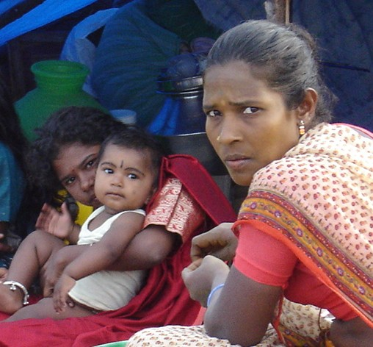
Near Chennai (Madras), India, survivors face recreating their
lives and livelihoods from a nearly unfathomable wreckage

Earthquake and Tsunami Relief and Rehabilitation Fund

Goal: $2.5 Million

Overview

Sunday morning, December 26, dawned clear and bright over the Indian Ocean, but the weekend calm was soon shattered by a powerful earthquake off the western edge of Sumatra, Indonesia. Shortly afterward came the eerie sight of the ocean taking a deep breath – from India to Thailand to Indonesia, people watched the water recede hundreds of yards from the shore in a matter of moments – followed by towering tsunamis that crashed into coastlines all around the region. The death toll has surpassed 150,000 and is still rising.

CARE is on the ground in the most affected zones, including India, Indonesia, Sri Lanka and Thailand, and we are responding to people in need as rapidly as possible. We join the governments of the stricken countries to reach those in need in the most efficient and effective manner possible. In addition to the funding we are currently negotiating with the U.S. Canadian, Australian and British governments and the European Union, CARE seeks resources from generous donors in the U.S. for our multi-country response. And for our work in India in particular, we seek $2.5 million, which will allow our experienced staff there the flexible funding we need to ensure that crisis-affected communities not only can survive the immediate crisis but rebuild their lives and livelihoods in the coming two years.

India

The destructive waves took the lives of more than 13,600 people along the eastern and southern coasts of India, according to best government estimates, and affected the lives and livelihoods of well over 1.2 million more. CARE’s most experienced disaster response staff in India rushed to the disaster zone within hours after the waves struck.

Since our initial assessments in the two states, we have locally procured and are distributing large volumes of relief supplies to flood-affected people in hard-hit coastal areas. Foremost among these items are water purification materials and oral rehydration salts to stave off the worst effects of water-borne diseases; we are also distributing clothing, plastic sheeting to be used for temporary shelter, sleeping mats and sheets, hygiene materials, cooking utensils and basic medicines. CARE has reached roughly 50,000 people with these emergency supplies.

Our current distribution to displaced families in Tamil Nadu includes:

- 10,000 water tanks (100 liter capacity each)
- 20,000 clothing kits (1 dhoti, 2 lungis, 1 sari, 1 petticoat, 2 towels)
- 20,000 family hygiene kits (bath soap, laundry soap, disinfectant, cotton, comb, sanitary pads, mirror)
- 30,000 packets oral rehydration salts
- 650,000 water purification tablets
- 10,000 cooking kits (2 cook pots, 2 plates, l ladle, 2 metal tumblers)

At the same time, we are mapping out our mid-term strategy to help tens of thousands of families begin to stabilize, return to the routines of school and work, and rehabilitate their means of securing a livelihood. As an initial action plan, we are aiming to reach a minimum of 20,000 households – at least 100,000 people – who are among the most acutely affected and who have the fewest familial, social and economic means to recover. Our plans, which we will carry out in Tamil Nadu’s Chennai, Cuddalore, Nagapattinam and Kanniyakumari districts, are briefly outlined below.

Mid-term: January to February 2005: In addition to our ongoing distribution of the type of supplies noted above, we continue our push to ensure basic sanitation conditions and clean drinking water, and thus help people reduce their risk of diseases linked to contaminated water. CARE’s work will include provision of latrines in camps for the displaced and in villages where survivors are regrouping, and to deliver clean water as needed. Moreover, we will offer programs to help people begin to overcome the psychological and social trauma they have endured.

Long-term: March 2005 Onward: CARE will stay in affected areas and help families and communities rehabilitate water sources (wells, piped systems) and rebuild their homes. We will provide fishing nets and assist in the repair of small to medium-sized fishing boats – most of those affected in coastal Tamil Nadu are fishers by trade – and help other families build poultry and goat stocks as a means of earning income. Most importantly, we will stay to help affected families reweave the social fabric of their lives after such tremendous loss.

CARE in India

CARE began its relief and development assistance work in India 54 years ago with a focus on providing nutritious food to school children. Over the past five decades, CARE has built an impressive food aid distribution infrastructure and provided supplementary food to millions of families in need. Because the country is prone to drought, floods, earthquakes, cyclones and other natural disasters, CARE has also been able to draw on our well-established infrastructure to respond immediately to emergencies and to be first on the scene with food and other lifesaving assistance as demonstrated during floods in Orissa and more recently in northern India, and following the Gujarat earthquake in 2001.

As India changes, however, so too does CARE’s work. Over the years, the world’s largest democracy has capitalized on the Green Revolution to the point that it now produces a grain surplus and has even become an international donor of food, responding to crises in countries like Afghanistan and Iraq. Despite India’s grain surplus, millions of people go hungry each year, unable either to grow enough food or earn enough income for survival. Underlying this contradiction are issues of unequal access and discrimination. CARE staff have become increasingly aware that they and the people with whom they work must address these underlying causes of poverty.

Today, CARE works in 11 of India’s 29 states, including four states (Bihar, Jharkhand, Orissa and Uttar Pradesh) where poverty is increasingly concentrated, according to the World Bank. In 2003, we partnered with more than 200 local nongovernmental organizations to transform the lives of 6 million poor and vulnerable people through programs in nutrition, health and HIV/AIDS; microfinance services; basic education; disaster preparedness and response; and tribal empowerment.

CARE’s talented pool of approximately 700 staff in India possess an unmatched combination of firsthand experience, historical knowledge, skills, resources and well-earned credibility that is powering our evolving approach to ending poverty.

Thank You

With the flexible resources in our India Relief and Rehabilitation Fund, CARE will rapidly reach those in need with emergency aid, and will help hundreds of thousands of families rebuild their shattered lives in the coming two years. We thank you for your gift to CARE.

January 3, 2005

A Dark New Year

Madhuri Dass, CARE India

January, 1, 2005. Chennai, India.

It is now exactly one week after the terrible tsunami that claimed tens of thousands of lives in south Asia. You would think that the mood in Chennai, capital of one of the worst affected areas in India, would be decidedly somber. Yet somehow, stores in downtown are not only open but are buzzing with holiday shoppers. Has the horror of the disaster not touched the lives of the people in this city?

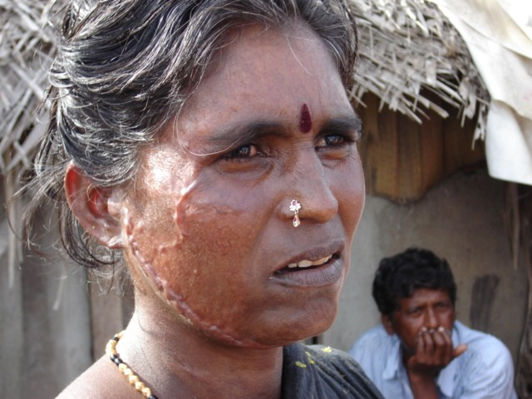
A quick trip to nearby Marina Beach, one of the largest city beaches in the world, is more telling. The killer waves primarily hit fishing communities like Marina Beach along the coast, and largely missed downtown Chennai. The mood in these hardest hit communities is very, very different. Most of the families living here, at the edge of the beach, had no disposable income before the disaster. And now that the tsunami has destroyed their means of livelihood, they have plenty to worry about. The tsunami has affected these poorest of poor much more that the rich.

Like other residents of Marina Beach, Kanagga was cleaning a catch of fish on the beach when the tsunami struck. Crouched on a stretch of sand in front of her home, she looked up when she heard a terrible noise to see the enormous waves approaching. Quickly running to safety with her family, Kanagga is lucky even to be alive. Her home, though damaged, still stands. However, many of her families’ possessions were washed away or severely damaged. What’s worse, her families’ fishing boat – their sole means of livelihood – ran aground and is now in need of much repair. Unlike nearby city dwellers, there will be no holiday celebrations this year in Kanagga’s home. Although the family went to church to offer prayers, they could simply not afford a meal to celebrate the occasion at home.
Survivors along the coast of Chennai are facing the sober realities of life after the disaster.

Kanagga’s was one of the first communities to receive relief in the form of food, owing primarily to its proximity to the city. But she worries about getting a new engine to power her families’ boat. “It is not easy for us to recover our loss,” says Kanagga. “We have to get back to earning a regular income again very soon, or we will not be able to eat.” None of the other fishermen in the community have gone out to sea either. Some say they have lost their nerve. Others believe that they will not be able to sell their catch because people fear contamination. They say they want to wait until the sea gives back all the dead. Hundreds of people are still missing in the state of Tamil Nadu.

The eastern coast road hugs the sea for some distance after we pass Chennai’s city limits. Dotted along the highway, quickly built camps house the newly displaced, who are now completely dependent on emergency relief for survival. Living conditions here are cramped and unhygienic. Some children play a ball game, while others just sit and stare. The men are huddled together figuring out what to do next, and the women are doing their best to set up home in makeshift conditions. CARE’s relief workers have already surveyed many such scenes. They are carrying out measures to make camp life a little easier for about 50,000 displaced families. Their task at the moment is to make sure that there are no gaps and no duplications in the distribution of items like clothing, cooking utensils, sleeping mats, blankets, and water.
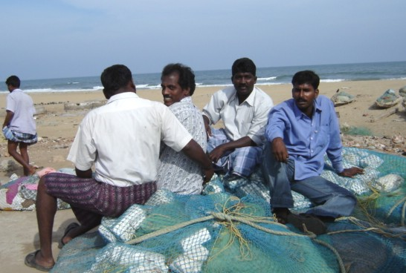
New Year’s Day at the emergency outpost in Chennai began with a quick team briefing for the experienced relief workers, deployed from CARE’s programs from around India, to take charge of operations in Tamil Nadu. They dispersed quickly to execute the plans for the day. They have been listening closely to the local survivors to ensure that their point of view is included in the relief efforts, and that the long-term rehabilitation effort – already being planned – is based on real need.
Fishermen along Marina Beach face the loss of their livelihood.

Godspeed to the CARE team, and to all those in the largest coordinated relief effort in recent history.

