LAVOSI
Las Voces Del Silencio
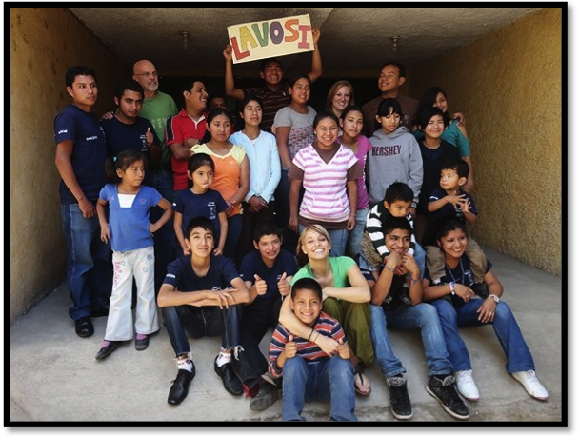

Our Vision:
To see a more just Guatemala where every citizen has an opportunity to receive the education and training they need to become productive members of their communities. To break the cycle of poverty and injustice that the deaf face every day by giving them the opportunities and acceptance that they can find in few places in Guatemala.

The School:
Las Voces Del Silencio (LAVOSI) is a school for the deaf in Jocotenango, Guatemala. At LAVOSI, pre-elementary and elementary classes (language, social studies, mathematics, history, etc.) are offered Monday - Friday, 7:30 a.m. to 12:30 p.m. LAVOSI also offers vocational training in the basic and fine arts, Guatemalan crafts, manual arts, general homemaking, baking, culinary arts as well as basic and advanced computer training. All classes are taught using the Guatemalan Sign Language.

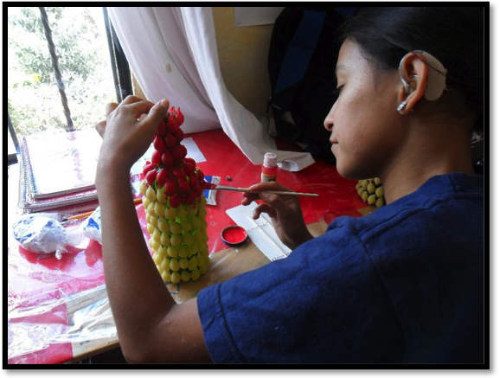

Our Plan:
Our plan is to hold a silent auction at the East Greenwich Fireman’s Hall on November 12, 2011. Our goal is to raise at least $1650 from the auction, raffles, and general donations. All of the funds raised will go directly to the LAVOSI School to help pay the rent and other building costs for the school building for the first six months of the 2012 school year. Any funds raised over this amount will be used to buy classroom materials, snacks, and eventually pay the teachers and support staff that all currently work as volunteers, or earn less than a living wage.

Where you come in:
This September we are looking to collect items to be auctioned and raffled off at the event. We would like to collect gift baskets, gift certificates, and any other items that would help to make our upcoming event a success, which in turn will help the children at LAVOSI to continue their education! If your business would be able to provide a donation of any size and financial value, it would be greatly appreciated. LAVOSI is supported by the non-profit 501(c) (3) tax-exempt organization “Friends of the Deaf”. Therefore, our tax identification code will be provided upon receipt of any and all donations. Please contact one of the representatives listed below about organizing an auction related, in-kind or monetary donation. Thank you!

Caitlin Smith
caitlinsmith@cox.net
401-497-2642

Chris Tackett
tachuela.24@gmail.com
(+502) 4168-7802

"Friends of the Deaf" is a non-profit 501(c) (3) tax-exempt organization that supports the LAVOSI School
http://www.friendsofthedeaf.org/

