Empower Women, Transform a Community in Cameroon: Cassava Processing Income Generation Project.
Progress Report #1
Since fundraising for the cassava-processing centre for the women of Ote village was completed at the end of August 2011, a number of activities have begun. Most of these activities have been carried out in Ote village, where the processing centre will be located. Some have also occurred in Buea, the headquarters of the organizing NGO, Food and Rural Development Foundation. These activities include:
- The money was received: 2.3 million FCFA.
- The sight for the project has been cleared. The women’s group is very busy at this time organizing for the timber (pictures of this still to come)
- The mud bricks for the processing centre have been made, and the processing centre is now being built from these bricks.
- The money for a bundle of zinc has been sent to Mamfe town, and the zinc has been purchased. The zinc will be used for the roof of the processing centre.
- Contacts have been made for a machinist to begin building the cassava grinding equipment.
Primarily, the Ote Women’s Common Interest Group (CIG) has led and participated in the events that have been carried out in Ote village. The president of this group has been organizing the group’s members, while the chief of Ote village and FORUDEF staff members, primarily James Assam, have been assisting and advising. These activities include choosing a site for the processing centre to be built, clearing and preparing this land to be built on, molding mud bricks to build the walls of the processing centre, and cutting timber for its frame and roof. There have not been any significant delays or difficulties, and these steps of the project are moving forward as planned. The Ote Women’s group is showing remarkable leadership and willingness to contribute their ideas and assistance.
FORUDEF staff working in Buea have selected a machinist/welder to construct the cassava processing equipment (sifter, grater, press, and frying pan). The welder is currently building the funnel chute for the grinding machine. FORUDEF staff are also price comparing and researching the purchase of a cassava grinder.
Barring any unexpected delays, this project is on schedule to be completed within the next two months. The expenses thus far reflect the initial budget; the current expense report is as follows:
Details | Amount  (FCFA) | Amount (USD) | Balance (FCFA) | Balance (USD)
 |  |  | 2,300,000 | 4,498.95
Transportation to Ote and back to inform women of grant and for organizing them to clear sight | 40,000 | 78.23
Bundle of zinc | 225,000 | 440.01
Advance for making funnel | 300,000 | 586.75
Total |  |  | 565,000 | 1,105.33
Balance |  |  | 1,735,000 | 3,395.30

Future steps will include completing construction of the processing site (building roof supports for the centre, attaching zinc roof), completing the construction of the processing equipment, transportation of the equipment from Buea to Ote village, a training workshop and demonstration of the equipment for the women, and the test phase of processing. As this project moves forward, FORUDEF will post additional reports.
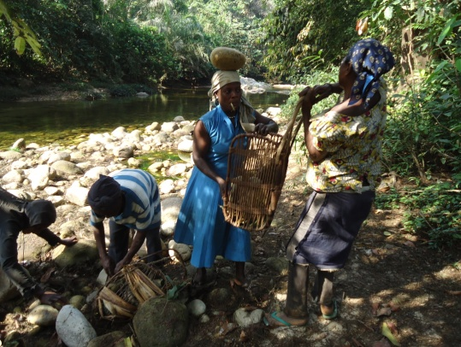
PHOTOS OF WOMEN PREPARATION GROUNDS FOR THE CONSTRUCTION OF THE CASSAVA PROCESSING CENTRE
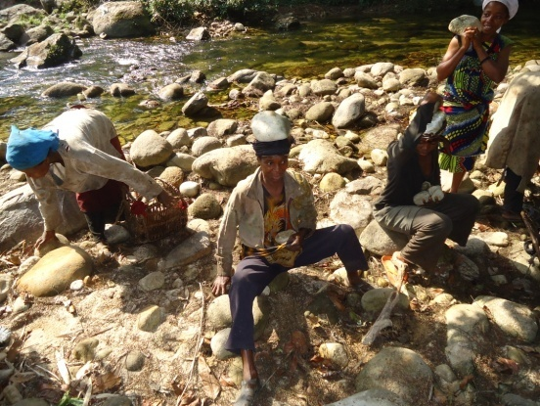

Gathering stones for construction
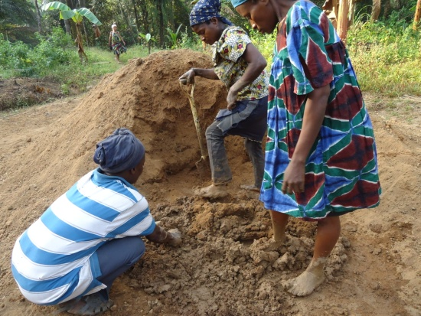
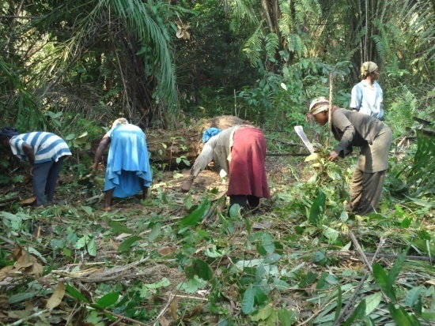

Clearing site Pounding mud for blocks
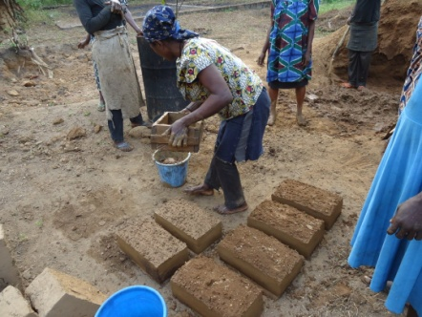

Moulding mud blocks Women’s president, member, and James
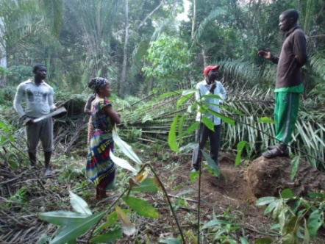

Chief, James, women’s president

