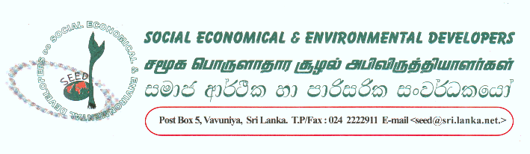
28.12.2004
URGENT APPEAL FOR HUMANITARIAN ASSISTANCE

We are all well aware about the consequences of the natural disaster and the crisis faced in our country on the 26th December 04 and so on.
Apart from the figures of the dead and identifying bodies, focusing on injured people and the rest who are alive need urgent assistance in various ways such as immediate relief supplies, (dry food, clothes and medicines) drinking water and shelters.
In view of addressing the above and to take care of the victims of a natural disaster we look forward your possible financial assistance. We as SEED are involved with all possible relief activities in affected areas and we are coordinating through NGO consortium in Vavuniya district and require immediate funds for our relief work.
Therefore we call your attention and request to provide your generous support urgently.
Please send this information to as many as possible.
Thanking you
Singham
Email: seedva@sltnet.lk

For details on how to help, please contact Singham or email TsunamiRelief@ashoka.org

