Stopping Early Pregnancy Tournament
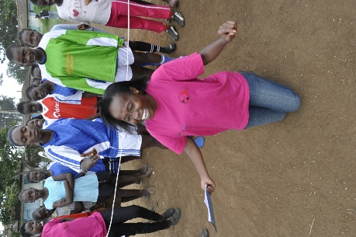
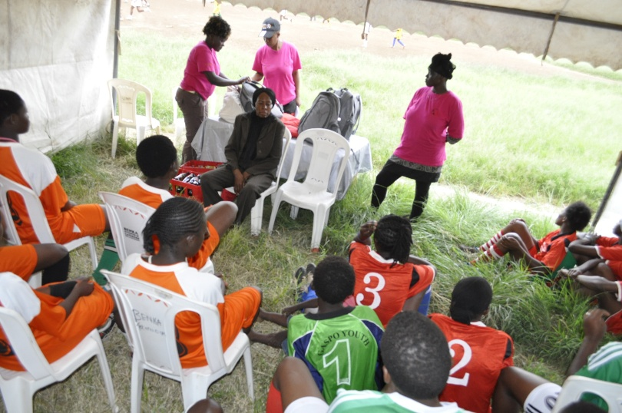
On Saturday, April 27, 2013, Vijana Amani Pamoja (VAP) hosted its first Stopping Early Pregnancy in Adolescents Football Tournament. Twelve teams of fifteen girls each joined VAP via invitation at the football pitch in Bihati, Nairobi for a day of fun, games and education. Throughout the event, the teams enjoyed friendly competition on the pitch in a tournament style round robin format. During downtime in between matches, the girls learned from peer educators the dangers of engaging in unprotected sex, especially while they were young. Focus was placed on abstinence and self-control, along with the dangers of abortions. The girls were warned of some of the challenges they would face if they became pregnant so early in life, include losing out on schooling, being an only parent and the increased potential for drug abuse, to name a few.

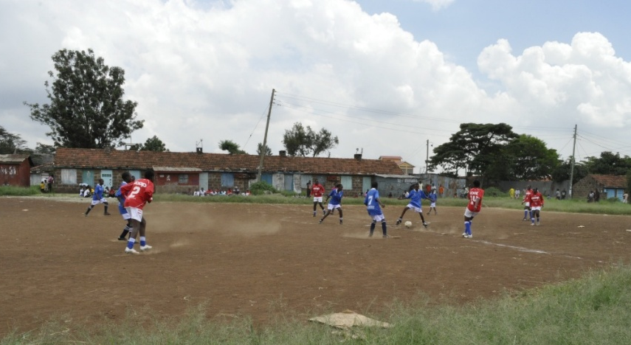
Energy and excitement ran high, for both competition and learning. One of the participants, Esther of the Golden Angels, had this to say: “We have come to learn and to play. We have learned about early pregnancies and abortion, and have learned how to abstain and how to control ourselves. We have really enjoyed the game, playing football, and eating!” Overall, the tournament was a success for all involved.

