A JOY TO SEE AGAIN: A CHILD PROSECUTED WITH 10 YEARS OF IMPRISONMENT

Thanks to the support of donors and supporters, the project,“Fight juvenile illegal detention in Burundi,” has experienced significant progress such that the number of children in pre-trial detention is decreasing.
However, it is necessary to maintain the momentum in the fight against illegal juvenile detention. For the past 3 months, 5 cases involving minors were assisted in the province of Cibitoke and 1 case in Bujumbura rural. One case is about Celeus, the co-accused of theft of home articles. The principal accused, who had already avowed the crime after being caught with stolen articles in his possession, was given provisional release. The IBJ lawyer, Astère Muyango, argued that the specific juvenile procedures introduced by the new Code of CriminalProcedureswere violated. The defense lawyer showed different procedural irregularities, which, according to him, violated the provision of Article 224 of the new law that declares any interrogation of a minor under 18 years void when it does not take place in the presence of a lawyer or any other person duly authorized by the judicial authority in charge of the case and who also has knowledge of juvenile justice matters.
The prosecution responded that the defendant was not a minor because he was 18 years old, having been born in 1996.
At this point, the defense lawyer relied on the content of Article 29 of the Penal Code, which sets penalties when the offender is under 18 at the time of the offense. In this case, the acts Celeus was charged for occurred in 2013. The prosecution continued to call for the defense to produce a document that proved his client was indeed a minor; the defense said the burden of the proof belonged to the prosecution and that this should have been produced before the date of the hearing. The defense lawyer continued that in such a case, the court had to consider the age stipulated by the prosecution in his notes to the court.
Thereafter, the prosecutor asked for an additional delay in order to summon the co-accused currently on bail. The defense said that this would violate legal provisions that protect minors since it is stipulated that the detention of a minor must be a measure of last resort. Since the prosecution did not do anything to summon the adult defendant on bail, the defense’s client should be released due to the prosecution’s negligence and the special protection afforded to the defendant.
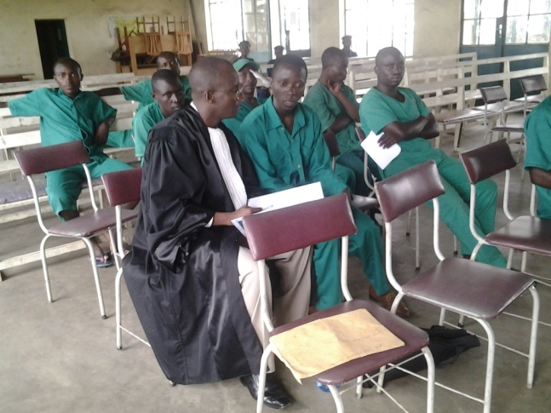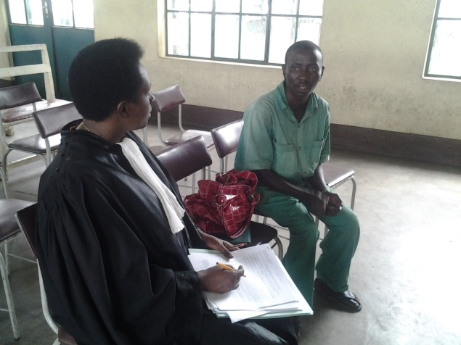
Lawyer Astère interviewing his client Lawyer Aline Nijimbere interviewing her client

A month later, one of Celeus’s family members called IBJ expressing his joy to once again see the child the prosecution had asked to punish with 10 years of imprisonment.
Despite this step reached in the fight against illegal juvenile detention in Burundi, IBJ finds it imperative to continue conducting training with the police and prosecutors in order to put particular emphasis on the nullities found in law where juveniles are interviewed without a lawyer present.

